DRAFT INTERNATIONAL SINGLE SPECIES ACTION PLAN FOR
THE CONSERVATION OF THE SHOEBILL

Introduction

This International Single Species Action Plan for the Conservation of the Shoebill (Balaeniceps rex) was initiated by the UNEP/AEWA Secretariat in 2012 and the action planning process was financially supported by the Swiss Federal Office for the Environment. The Plan has been compiled by Tim Dodman, on behalf of NatureUganda, with contributions from experts of the species’ range states and international organisations. A multi-stakeholder action-planning workshop for the Shoebill took place on the 9-12 October 2012 at the Uganda Wildlife Education Centre, Entebbe, Uganda, hosted by the Ministry of Tourism, Wildlife and Antiquities in Uganda and organised by NatureUganda. Following consultations with the range states and the AEWA Technical Committee, the draft International Single Species Action Plan was approved by the AEWA Standing Committee on an interim basis at its 9th Meeting in September 2013 following its mandate provided by Resolution 3.12.

The Action Plan follows the revised format for International Single Species Action Plans approved by MOP4 in September 2008.

Action requested from the Meeting of the Parties.

The Meeting of the Parties is invited to review this ISSAP and to adopt it for further implementation.

Agreement on the Conservation of African-Eurasian Migratory Waterbirds (AEWA)

International Single Species Action Plan for the Conservation of the Shoebill

Balaeniceps rex

AEWA Technical Series No. 51

September 2013

Prepared by

NatureUganda

With financial support from the

Federal Office for the Environment, Switzerland

and with in-kind support from the

Ministry of Tourism, Wildlife and Antiquities, Uganda

Support for this action plan:
The development and production of this action plan has been achieved with the financial support of the Federal Office for the Environment in Switzerland. The AEWA International Single Species Action-Planning Workshop for the Conservation of the Shoebill was held at the Uganda Wildlife Education Centre, Entebbe, Uganda, hosted by the Ministry of Tourism, Wildlife and Antiquities in Uganda and organised by NatureUganda. Workshop participants were also welcomed by the Mabamba Wetland Eco-Tourism Association at Mabamba Bay, where they were able to see a wild Shoebill and learn about ecotourism activities focused around Shoebills in Uganda.
Compiled by: Tim Dodman (E-mail for correspondence: tim@timdodman.co.uk)
List of contributors:
Burundi: Arsène Manirambona (ABO), Geoffroy Citegetse; Democratic Republic of the Congo: Donatien Muembo Kabemba & Paul N’lemvo Budiongo (ICCN), John Hart, Michel Hasson, Bryna Griffin (FZS); Ethiopia: Mihret Ewnetu Mulualem (EWCA), Yilma Dellelegn Abebe (EWNHS); Rwanda: Antoine Mudakikwa (Rwanda Development Board), Djuma Nsanzimana (REMA), Claudien Nsabagasani (ARCOS), Jean-Paul Ntungane (Forest of Hope Association); South Sudan: Khamis Adieng Ding & Minasona Lero Peter (MWCT), Paul Peter Awol (WCS-South Sudan); Sudan: Esmet Faki (Wildlife Research Centre); Tanzania: Jasson John (University of Dar es Salaam), Mzamilu Kaita (Wildlife Division), Maurus Msuha (TAWIRI); Uganda: Barirega Akankwasah (Ministry of Tourism, Wildlife and Heritage), Achilles Byaruhanga, Dianah Nalwanga, Geofrey Akule & Kenneth Sseguya (NatureUganda), Charles Tumwesigye (Uganda Wildlife Authority), Paul Mafabi & Vincent Barugahare (Ministry of Water & Environment), James Musinguzi (UWEC), Irene Nakalanzi (Shoebill Stork Foundation), Richard Ssemmanda, Derek Pomeroy; Zambia: Chansa Chomba (ZAWA), David Ngwenyama, Moses Nyoni (BirdWatch Zambia), Craig Reid (Bangweulu Wetlands Management Board), Moses Nyirenda (WWF Zambia), Frank Willems (Kasanka Trust); International & academic organisations: Sergey Dereliev, Dunia Sforzin, Birgit Drerup & Evelyn Moloko (UNEP/AEWA Secretariat), Paul Kariuki Ndang’ang’a & Julius Arinaitwe (BirdLife International - Africa Partnership Secretariat), Tom De Meulenaer & Robert Parry-Jones (CITES), Kerryn Morrison (EWT/ICF), Cathy King (Weltvogelpark Walsrode, Germany), Dr Arjun Amar & Dr Ralf Mullers (Percy FitzPatrick Institute of African Ornithology, University of Cape Town, South Africa); Other contributors: Lars Dinesen, Alfredo Guillet, Raymond Katebaka, Gerhard Nikolaus, Geneviève Renson, Lizanne Roxburgh, Patrick Triplet, Chris Wood.
Milestones in the production of this plan:
Stakeholder workshop: 9-12 October 2012, Entebbe, Uganda
Shoebill Round Table Discussion: 15 October 2012, 13th Pan-African Ornithological Congress, Arusha, Tanzania
First draft: 18 March 2013, submitted to the action-planning workshop participants and PAOC13 RTD participants
Second draft: 10 May 2013, submitted to the AEWA National Focal Points and to the AEWA Technical Committee for consultation
Final draft: 18-19 September 2013, reviewed and approved on temporary basis by the AEWA Standing Committee at its 9th Meeting, Trondheim, Norway
To be submitted to the 6th Session of the Meeting of the Parties to AEWA in 2015 for final approval
Geographical scope:
This International Single Species Action Plan requires implementation in the following countries regularly supporting Shoebill: Democratic Republic of the Congo, Ethiopia, Rwanda, South Sudan, Uganda, United Republic of Tanzania and Zambia. Some level of implementation may also be required in Burundi and the Central African Republic, where the Shoebill is deemed to be an occasional visitor.
Revisions:
This plan should be reviewed and updated every ten years. An emergency review will be undertaken if there is a significant change to the species’ status before the next scheduled review.
Recommended citation:
Dodman, T. (compiler) 2013. International Single Species Action Plan for the Conservation of the Shoebill Balaeniceps rex. AEWA Technical Series No. 51. Bonn, Germany.
Picture on the front cover:
Shoebill (Balaeniceps rex) © Jearu-Fotolia.com
Disclaimer:
The designations employed and the presentation of the material in this document do not imply the expression of any opinion whatsoever on the part of UNEP/AEWA concerning the legal status of any state, territory, city or area, or of its authorities, or concerning the delimitation of their frontiers and boundaries.

Table of Contents

List of Acronyms 4
Preface 5
Executive Summary 6
1. Biological Assessment 7
1.1 Taxonomy and Biogeographic Population 7
1.2 Distribution 7
1.3 Habitat Requirements 9
1.4 Survival and Productivity 9
1.5 Population Size and Trends 10
2. Threats 14
2.1 Threats Causing Increased Mortality 14
2.2 Threats Contributing to Low Productivity 16
2.3 Threats Causing Habitat Loss, Fragmentation and Degradation 18
2.4 Knowledge Gaps 22
3. Policies, Legislation and Ongoing Activities 23
3.1 Policy and Legislation 23
3.2 Site Protection and Management 24
3.3 Monitoring and Research Activities 25
4. Framework for Action 27
5. References 37
ANNEX 1: Occurrence of Threats in Range States 40
ANNEX 2: Key Sites 41
ANNEX 3: Legal Status, Conservation Measures & Monitoring 42
ANNEX 4: Names of the Shoebill in Different Languages 44

List of Acronyms

ABO Association Burundaise pour la Protection des Oiseaux
ACNR Association pour la Conservation de la Nature au Rwanda
AEWA Agreement on the Conservation of African-Eurasian Migratory Waterbirds
ARCOS Albertine Rift Conservation Society
BBC British Broadcasting Corporation
BWMB Bangweulu Wetlands Management Board
Cap Chapter
CBD Convention on Biological Diversity
CITES Convention on International Trade in Endangered Species of Wild Fauna and Flora
CMS Convention on the Conservation of Migratory Species of Wild Animals
COP Conference of Parties
DRC Democratic Republic of the Congo
DR Congo Democratic Republic of the Congo
EIA Environmental Impact Assessment
ET Ethiopia
EWT Endangered Wildlife Trust
FZS Frankfurt Zoological Society
GMA Game Management Area (Zambia)
GR Game Reserve (Tanzania)
GSMP Global Species Management Plan
IATA International Air Transport Association
IBA Important Bird Area
ICCN Institut Congolais pour la Conservation de la Nature
ICF International Crane Foundation
IUCN World Conservation Union
IWC International Waterbird Census
IWG International Working Group
MEA Multilateral Environmental Agreement
MSc Master of Science
MWCT Ministry of Wildlife Conservation and Tourism (South Sudan)
MWETA Mabamba Wetland Eco-Tourism Association
NGO Non-governmental Organisation
NP National Park
ONCFS Office National de la Chasse et de la Faune Sauvage (France)
PAOC Pan-African Ornithological Congress
PhD Doctor of Philosophy
Ramsar Convention on Wetlands (Ramsar, Iran, 1971)
REMA Rwanda Environment Management Authority
RST Review of Significant Trade
RW Rwanda
SEA Strategic Environmental Assessment
SS South Sudan
TAG Taxon Advisory Group
Tanzania United Republic of Tanzania
TAWIRI Tanzania Wildlife Research Institute
TFCI Trans Frontier Conservation Initiative (Ethiopia – South Sudan)
TRAFFIC Wildlife Trade Monitoring Network
TZ United Republic of Tanzania
UG Uganda
UNEP United Nations Environment Programme
UNESCO United Nations Educational, Scientific and Cultural Organization
UWEC Uganda Wildlife Education Centre
VU Vulnerable
WAZA World Association of Zoos and Aquaria
WCS Wildlife Conservation Society
WHC Convention concerning the Protection of the World Cultural and Natural Heritage
ZAWA Zambia Wildlife Authority
ZM Zambia

Preface

This International Single Species Action Plan (ISSAP) for the Conservation of the Shoebill (Balaeniceps rex) was commissioned by the UNEP/AEWA Secretariat to NatureUganda and financially supported by the Swiss Federal Office for the Environment (FOEN). Its compilation commenced with a workshop in October 2012 in Entebbe, Uganda, hosted by the Ministry of Tourism, Wildlife and Antiquities of Uganda, which was attended by government representatives and species experts from the key Range States of the Shoebill.

The ISSAP was subsequently compiled by Tim Dodman, on behalf of NatureUganda, with contributions from experts of the species’ Range States and international organisations. Following further consultations with the Range States and the AEWA Technical Committee, the ISSAP was adopted, on a temporary basis, at the 9th Meeting of the AEWA Standing Committee (18-19 September 2013, Trondheim, Norway). Its final adoption is expected in 2015, at the 6th Meeting of the Parties to AEWA.

Executive Summary

The Shoebill is a large unique waterbird confined to a rather restricted set of generally extensive freshwater swamps of eastern central tropical Africa. It thus has a fragmented distribution bound to this habitat and a low population, estimated at 5,000 - 8,000 birds. As the Shoebill has clearly been in decline in several areas, it is listed as Vulnerable in the IUCN Red List. The Shoebill occurs from South Sudan and Ethiopia in the north to northern Zambia in the south. It is resident in South Sudan, western Ethiopia, Uganda, Rwanda, eastern Democratic Republic of the Congo, western Tanzania and northern Zambia, with records also from Central African Republic, Burundi and Kenya.

The Shoebill prefers large freshwater swamps of grasses, reeds and papyrus, and is well adapted to floating vegetation. However, it avoids areas of swamp that are thickly vegetated, and requires open areas, especially for foraging and breeding. It feeds mainly on fish, especially larger fish that surface for air in stagnant waters, such as lungfish and catfish. The Shoebill is a long-lived bird, and pairs usually only raise one chick per breeding season. Shoebills are particularly vulnerable when swamps start to dry during their nesting period; breeding success is largely impacted by anthropogenic factors, mainly disturbance by livestock and people and destruction of nests and wider breeding areas by fire. Habitat conversion, degradation and disappearance constitute a significant threat to the bird’s long-term survival.

Shoebills are also threatened by the live bird trade. They are valuable birds, and the almost complete absence of breeding success in captivity maintains a constant pressure on the wild population for meeting trade demands. Trade in the Shoebill is currently (2013) banned in all Range States, but instances of illegal trade are still recorded. Shoebills are highly sensitive birds, and past exports have involved high mortality during capture, transit and captivity.

Another significant threat to Shoebills is oil exploration and extraction, especially in the Sudd in South Sudan, where significant developments have taken place, along with the dredging of access canals, which impact the hydrology of the swamps. Agricultural developments also threaten important Shoebill areas, notably at Gambella in western Ethiopia. Overall, the conversion of swamps to agriculture and other land uses remains a major long-term threat, whilst the wider impacts of climate change are likely to exacerbate these and other threats. Most threats can be attributed in part to wider over-arching issues, such as demographic pressure, poverty and weak land-use planning and governance. However, such threats would require major multi-disciplinary actions, which are beyond the remit of this species action plan.

Significant knowledge gaps remain about the Shoebill, including current information on numbers and trends at different sites, movements, breeding and foraging requirements, causes and extent of trade and the captive stock, as well as a clear indication of its current / potential economic value, especially through ecotourism. Although a high proportion of Shoebills reside in Ramsar sites, national protected areas and IBAs, this does not mean they are protected; resources and capacity to manage extensive swamps are severely limited.

The overall goal of this action plan is to increase the Shoebill’s population size and maintain its current range. The objectives are to reduce mortality and loss of birds; remove factors lowering productivity; significantly reduce further loss, fragmentation and deterioration of habitat; and fill key knowledge gaps. Proposed actions include to: maintain trade bans and develop a WAZA Shoebill Global Species Management Plan (especially for ex situ conservation); strengthen surveillance and raise awareness, especially with respect to fire; restrict livestock from core breeding areas; conduct proper EIA for oil and other developments; develop management plans for Shoebill areas; and invest communities with conservation responsibilities and promote community enterprises, notably ecotourism initiatives.

1. Biological Assessment

1.1 Taxonomy and Biogeographic Population

The Shoebill or Whale-headed Stork Balaeniceps rex (Gould 1851) is the only member of the family Balaenicipitidae of the order Pelecaniformes. The affinity of this family to other waterbird families is not entirely clear, and similarities to storks, pelicans, herons and Hamerkop have all been noted. Notwithstanding, the Shoebill is undoubtedly unique. Standing some 140 cm in height, it is a large long-legged grey bird of African swamps with long toes and an enormous bulbous bill which ends in a sharp hook.

The Shoebill is not migratory, but it is capable of covering long distances in flight, as evidenced by occasional vagrants recorded outside the core distribution area (e.g. Blancou 1978 & 1961, Renson 1998 & 2008). It is a strong flier, and has been recorded soaring on thermals by day. Despite this capability in the air, there is no evidence to suggest that the Shoebill makes regular long-distance movements. However, it does make seasonal movements, especially in larger floodplain systems, where large variations in water levels have significant effects on their habitat. It also lives in a number of transboundary areas. Shoebills have been reported to perform a limited north-south migration and secondary east-west movements in order to exploit seasonal changes in prey availability in the Lau River system west of the Sudd (Guillet 1978).

The Shoebill is considered as having one biogeographic population, i.e. the whole species population. However, the population, like its principal wetland habitats, is fragmented, and it has a disjointed distribution across its range. Its (potential) occurrence in some areas is not well known. The main sub-populations are distributed as described below in 1.2.

Regular mixing between these main sub-populations is not expected, although some dispersal may occur, supported by occasional records of vagrant birds, some outside their preferred habitats. Further research is needed to determine the degree of isolation of sub-populations.

1.2 Distribution

Table 1. Range States of the Shoebill

Resident | Non-breeding visitor | Probable vagrant
South Sudan | Burundi | Central African Republic
Ethiopia |  | Kenya
Uganda
DR Congo
Rwanda
Tanzania
Zambia

Core distribution
The Shoebill has a fragmented distribution across eastern central tropical Africa from South Sudan and Ethiopia in the north to Zambia in the south (Figure 1). It inhabits freshwater swamps, often within extensive floodplains or the margins of lakes. The main centres of population are:

- Swamps of the White Nile Basin in South Sudan, especially in the Sudd
- Gambella wetlands in western Ethiopia and eastern South Sudan
- Swamps of the Nile Valley and lakes in Uganda, including Lakes Albert and Edward, with records from the western parts of these lakes in eastern Democratic Republic of the Congo
- Akagera, eastern Rwanda / north-western Tanzania; Lake Victoria fringes, Tanzania / Uganda
- The Malagarasi, western Tanzania, with a recent report from the Malagarazi River in Burundi
- Lakes / swamps of the Lualaba and Lufira Rivers, including Upemba, southeast DR Congo
- Wetlands of Mweru Wantipa, northern Zambia
- Bangweulu Wetlands, Zambia

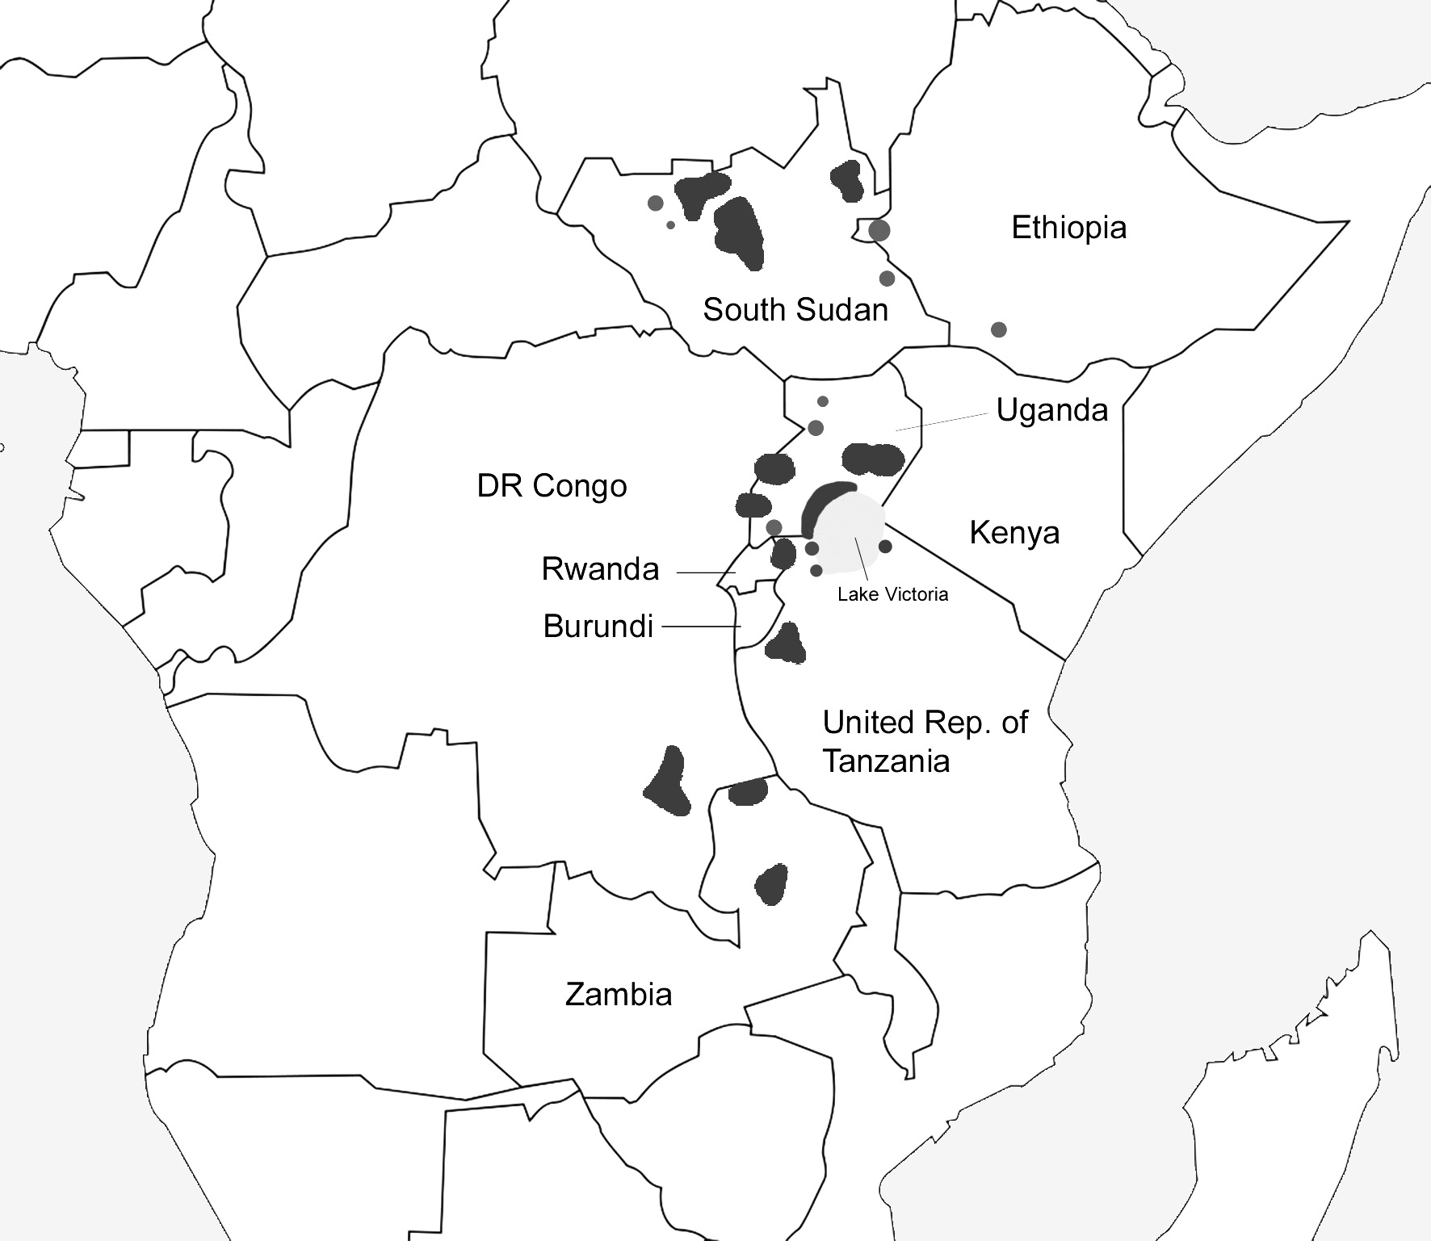

Figure 1. Core known distribution of the Shoebill (areas where vagrant or occasional are excluded)

Vagrancy / Occasional records
The Shoebill has been recorded occasionally from northern Central African Republic, especially along the Rivers Ouandjia and Oulou (a tributary of River Aouk), where it may have been resident (Blancou 1939 & 1961, Renson 2008). Although historical records exist, it may only be vagrant there now, though suitable habitat certainly exists. The Shoebill is an occasional visitor to the Malagarazi Swamps in Burundi, though it does not seem to be resident here. Wandering birds also occur from time to time at unexpected sites, for instance south of its main range in Zambia and east of its main range in Tanzania.

There are vagrant records from Kenya, with occasional local reports from Yala Swamp on Lake Victoria in the past, although this site (the only site in Kenya with extensive suitable habitat) was impacted by swamp drainage in the 1980s (Lewis & Pomeroy 1989). A lone immature Shoebill was present in Kenya for around 14 months on one occasion, mainly in Amboseli National Park (B. Finch, in litt. 2012). Historical occasional reports from Malawi and Botswana are unsubstantiated. Further information about Shoebill distribution in each range state is given under 1.5 Population Size and Trends.

1.3 Habitat Requirements

The Shoebill is a true swamp bird, and can be found in a variety of freshwater swamps. These vary from extensive open swamps of the Sudd to relatively small swamp-dominated lakes in Uganda. The Shoebill prefers large freshwater swamps overgrown with vegetation, grasses, reeds and papyrus; it walks easily over submerged vegetation and only occasionally perches in trees (Brown et al. 1982). In Bangweulu, Shoebills may use trees to scan foraging sites, display and perform courtship rituals (D. Ngwenyama, in litt. 2013). Preferred nesting habitats in the Sudd include large extensions of perennial vegetation, mainly reeds and sedges (e.g. Cyperus and Phragmites spp.) and flat plains dominated by aquatic grasses such as Echinochloa stagnina and Vossia cuspidata, often in the form of floating platforms (Guillet 1984).

Its principal prey is fish, though other swamp prey is also taken, including frogs, snakes and other birds. The Shoebill’s preferred fishing sites are in either shallow water or deep water with platforms of floating vegetation, in swamps that are low in oxygen and with an abundance of fish (Guillet 1978). Fish such as lungfish, bichirs (Polypteridae) and catfish are important prey, these fish often surfacing to gulp air in stagnant water (Brown et al. 1982). Shoebills may walk slowly to search for fish activity, then stand and wait for their prey, often for long periods; they thus require relatively undisturbed habitats. Due to the Shoebill’s technique of ‘collapsing’ onto its prey, it requires open flat spaces in order to flap its wings and regain its balance, hence its preference for fishing platforms, ideally in small clearings surrounded by tall dense vegetation (Guillet 1979). Shoebills thus avoid extensive areas of pure papyrus stands, which are largely impenetrable, and prefer mosaics of wetland habitats.

The Shoebill’s nest is mainly built in vegetation at water level, sometimes making use of small islets or mounds as a base; nesting areas must offer security and in some areas a preference is shown for deeper parts which are the last to dry up in the dry season, avoiding the easy reach of cattle and fires (Guillet 1984; John et al. 2012).

Overall, optimum sites of swamp habitat for fishing and nesting are scattered and limited, even in an extensive area of wetlands as in the Sudd Swamps of South Sudan, resulting in a discontinuous distribution (Guillet 1978), both across its entire range and at the site level.

1.4 Survival and Productivity

Although the average lifespan of the Shoebill in the wild is not clearly known, it is likely to be a long-lived bird. Birds in captivity have lived over 25 years old, with one bird living for at least 35 years (Muir & King 2013). It probably takes at least three years for birds to reach sexual maturity (Brown et al. 1982). The Shoebill is largely solitary, except when breeding, though small groups may occur.

Shoebills usually lay one to two eggs, very rarely three, and incubation lasts around 35 days (Renson 2008). Although it may be common for a pair of Shoebills to produce two eggs, they almost always only manage to raise one chick. As with some other birds, the older or stronger chick gains priority and favour when food or water is brought to the nest, and also shows aggressive behaviour to its sibling (Renson 2008). Recent footage in the Bangweulu Wetlands illustrated well an adult bird ignoring the pleadings of a weaker chick, which was subsequently fatally pecked by the stronger one (BBC 2013). Siblicide is commonplace in Shoebills and can occur within the first few days after hatching, or after a few weeks when the older chick is strong enough to kill its weaker sibling. It is thus likely that the second or weaker chick is essentially an insurance policy in case the stronger chick fails. Adults need to bring water and food regularly to the growing chicks and can only usually manage to rear one of them to fledging.

The breeding season lasts around 140-145 days or around 4.5 months, with period to fledging being about 95 days (Buxton et al. 1978, Guillet 1978). Breeding success is not well known. However, adults invest significant attention and effort in raising a chick, and success in raising at least one chick is likely to be reasonably high when conditions are favourable. Although chicks and eggs are vulnerable to predation by pythons and other predators, the main factor limiting breeding success is disturbance, especially when the onset of the dry season and lowering flood level render breeding areas accessible to people and livestock, and susceptible to fire.

Breeding density is probably quite variable across the Shoebill’s range, but is generally rather low. Densities (not necessarily breeding densities) of Shoebills in the Bangweulu Wetlands have been estimated at 0.16 birds per km² (Howard & Aspinwall 1984) and 0.14 birds per km², with a higher density of 0.31 birds per km² of potentially suitable habitat (Roxburgh & Buchannan 2010). In the Malagarasi, Parker (1984) suggests a density of 0.67 birds per km² of suitable habitat. In the Sudd, Fay et al. (2007) give a density estimate of 0.05 birds per km², though this takes in a large area of habitat unsuitable for Shoebills. Guillet (1984) estimated there to be less than 3 nests per km² in the flooded basins of the Lol and White Nile Rivers in South Sudan, whilst nesting sites for birds foraging the same area may be as much as 100 km apart.

1.5 Population Size and Trends

The total population size was estimated by Guillet to be no more than 14,900 (1978), based on research mainly carried out in (South) Sudan. In a desk study review for assessing waterbird population estimates in Africa, Dodman (2002) estimated there to be from 5,000 - 8,000 birds based on the following national estimates (Dodman 2002):

South Sudan: 5,000+
Uganda: 100-150
Tanzania: 200-500
DR Congo: <1,000
Rwanda: <50
Ethiopia: <50
Zambia: <500
Central African Republic: irregular

These estimates were adopted by Wetlands International (2002) and BirdLife International (2008). BirdLife International (2012) used the same figures to equate to an estimate of 3,300 - 5,300 mature individuals. Subsequently, renewed efforts have been made in some countries to estimate population sizes, with updates particularly noted for Zambia. An overview of distribution, population sizes and trends per country is provided below:

- South Sudan
Population size
The main population is undoubtedly in the Sudd and associated swamps in South Sudan. Guillet (1978) estimated there to be 9,600 Shoebills in (South) Sudan. There are estimates from Jonglei, in Sudan’s extensive Sudd swamps of 6,407 in the mid wet season, 5,143 in the early dry season and 4,938 in the late dry season based on (non-specific) aerial surveys in this area (Range Ecology Survey 1983).

More recently, Fay et al. (2007) estimated that the Sudd, including areas of Zeraf Reserve, contained 3,830 Shoebills in the dry season of 2007, based on 108 birds observed in the Jonglei survey block. Although a few aerial surveys have been carried out, these have largely been focused on mammals and have not necessarily focused on core Shoebill areas, whilst figures have also been extrapolated without taking different wetland habitats into close consideration.
In the late 1970s, Guillet (1978) considered the main centres of distribution to be:

- Lol River system, with concentrations at Adiang, Adorit (incorporating part of War Ajak toichs and War Dit toichs and nesting areas where the Alal and Anam rivers join the Lol River)
- Pongo River system, with an important area where the Pongo River divides as the Kyom and Lol Akweir
- Jur River system east of 28º15´E, including the Majak Juer toichs
- Bahr el Ghazal, especially between Makwoich, Lake Ambadi and Bentiu
- Tonj River system, with nest sites near Lol Akweir, Wunshwai, Manabuk and Akaltum
- Bar Gel and Bur Naam system
- Lau River system, especially at Lake Nyubor
- Bahr el Jebel (White Nile) system (Sudd)

Bird-focused aerial surveys of the core part of the Sudd between Bor and the Zeraf Game Reserve were conducted in April 2012 by MWCT, WCS and ONCFS, but results are not yet available. Estimates for other sites include 3-6 pairs in Guom swamp (part of Boma National Park), 15 pairs at Lake Nyubor, 50 pairs in Meshra Game Reserve (swamps of Bahr el Ghazal / Jur River) and 50 pairs in the Machar Marshes (K.A. Ding & P.P. Awol, in litt. 2012). An estimate of around 5,000 Shoebills in the swamps of South Sudan would still seem to be reasonable until recent data is analysed and other suitable swamps are surveyed.
Population trend
There is no clear information available on trends in the Sudd, as data from aerial surveys are not directly comparable, although the Shoebill is still well represented here, and there does not appear to be an obvious decline at least. However, west of the Sudd, Guillet (1978) reported that the Lol and Pongo River systems included many suitable nesting and foraging sites, whilst the Jur River system and Bahr el Ghazal were also important, although disturbance by cattle, fishing activities and burning were causing Shoebills to abandon some areas. The status of the Shoebill in these areas is not well known at present, although C. Wood (in litt. 2012) was able to see them daily in the vicinity of Bentiu (Unity State). However, there has no doubt been significant modification of wetland habitats in this area, along with disturbance and settlement, and Shoebill here are most likely to be in decline.

- Ethiopia
Population size
There is a small sub-population of Shoebills in southwest Ethiopia on the Weyto River, which may represent an extension of range from breeding areas nearby in South Sudan (Ash & Atkins 2009). The main confirmed area of occurrence is in Gambella District, especially in Gambella National Park, which supports freshwater swamps of the Baro and other rivers. Reconnaissance and training flights in Gambella carried out under the Trans Frontier Conservation Initiative (TFCI) in 2009 revealed over 40 birds, including one group of 14 (Abebe 2011, TFCI 2011).
Population trend
There are no historical counts of Shoebills in Gambella, so no trend data are available. However, major agricultural developments in Gambella pose a real threat to the Shoebill and surely have negative effects on the population, and a declining trend would seem likely. The population status in the Weyto River is unknown.

- Uganda
Population size
The Shoebill is fairly widespread in Uganda, and occurs in 12 of Uganda’s 30 IBAs (Byaruhanga et al. 2001). Sites include Lakes Bisina, Opeta and Nakuwa in the east (the latter is in the Lake Kyoga system), Lutembe Bay, Mabamba Bay, Nabujuzi wetland and Lake Nabugabo on the west side of Lake Victoria, Lake Mburo and Lake Edward in the southwest and Murchison Falls in the northwest. There are past estimates of 100-200 pairs and 400-600 birds (Carswell et al. 2005), whilst D. Pomeroy & A. Byaruhanga (in litt. 2001) considered that an estimate of 100-150 birds was probably realistic, based on results from various surveys, waterbird counts and data bank records. NatureUganda (in litt. 2012) estimated the population at 200-300 birds, which includes estimates from sites not yet researched.
Population trend
There is no clear trend information, although the Shoebill still appears to be scattered in suitable swamp habitats across much of the country.

- Rwanda
Population size
The Shoebill has been regularly observed in the swamps dominating the eastern sector of Akagera National Park, although extensive areas of the original park have been degazetted (Kanyamibwa 2001); less than 50 were estimated for this area in the 1990s (J-P. Vande weghe, in litt. in Baker & Baker 2002). The Shoebill is still resident in the area with a presumably small population that also utilises sites across the border in Tanzania. Sightings are rare however during the height of the rainy season, suggesting some movement between Rwanda and Tanzania. A couple of sightings of individual Shoebills were reported in wetlands of Kigali in May 2009 (Birding Rwanda 2009).
Population trend
It would seem likely that the population declined in the 1990s, when the Akagera basin was negatively impacted by encroachment and the civil war of 1994.

- Democratic Republic of the Congo
Population size
Shoebill records from DR Congo are not very well documented. It has been recorded nesting at Upemba National Park and other lakes and swamps of the Lufira Valley, as well as further north in the Virunga National Park at Lake Rutanzige (Lippens & Wille 1977, Demey & Louette 2001). The Shoebill was once considered ‘common’ on the lakes of the Lualaba River in Katanga, their northernmost locality being Mulongo at Lake Kabamba (Louette & Hasson 2011); it seems to be largely restricted to the Kamalondo region, a 200 km long marsh around the Lualaba River between Bukama and Mulongo, with seasonal occurrence in the Lufira Valley (M. Hasson, in litt. 2013). Demey et al. (2000) document records from Virunga National Park in 1992 and Vitshumi in 1994. Shoebills have also been seen several times at Lake Tchabuganga (Mertens 1986), also in the northeast. However, there has been no indication of numbers.
Population trend
No trend information is available.

- United Republic of Tanzania
Population size
Tanzania’s most important area for Shoebills is the Moyowosi-Kigosi-Malagarasi complex, which includes large areas of permanent swamps and floodplains in the west of the country. This area also includes wetlands of the Igombe and Ugalla rivers; Kasisi acts as a dry season refuge (John et al. in press). A number of aerial surveys in this area have taken place since the 1970s, summarised by Dinesen & Baker (2006), though the very diverse results are more likely due to different census techniques and seasons, varying methods of extrapolations and data interpretation than real changes in population. John et al. (in press) particularly question some massive extrapolations. Parker (1984) estimated a population of 300 birds in about 200 km² of suitable habitat (based on a count in 1972).
Malagarasi population estimates of the Tanzanian Wildlife Conservation Monitoring based on general wildlife aerial surveys vary from 2,260 in 1990 to 235 in 1998, though the areas covered and the area used as the basis for the extrapolations varied considerably (Dinesen & Baker 2006). In 1992, 578 birds were counted in a survey carried out by helicopter of all the known Shoebill core areas, this being extrapolated to an estimated population of 2,489 birds (Jones & Hill 1994). A rapid count in less than half of the expected Shoebill core areas produced 56 birds in November 2001, possibly indicating around 134 birds if similar extrapolation methods to those used in the 1990s were applied (Dinesen & Baker 2006). It seems most likely that the current population is in the low hundreds.
Shoebills are found in a few other sites in western / north-western Tanzania, especially along the Kagera River Basin, where John et al. (in press) estimate a dozen pairs, including along the Ngono River and Lakes Rushwa and Rwakanjunju. Other sites include the Burigi-Biharamulo Game Reserves (where it is likely to be breeding resident in lakeside swamps), and the Masirori Swamp on the Mara River east of Lake Victoria (Baker & Baker 2002). Numbers are likely to be low in all these areas.
Population trend
The Shoebill and its habitat are under severe pressure in Tanzania and, whilst conflicting estimates make it difficult to establish trends, the population is most likely in decline (Dinesen & Baker 2006, Nahonyo & Msuya 2008, John et al. in press).

- Zambia
Population size
In Zambia, the Bangweulu Wetlands is the most important site, where a minimum of 232 birds was estimated to occur in 1983 (Howard & Aspinwall 1984). However, numbers counted were much lower in the 1990s, despite an irregular series of aerial surveys conducted in the 1990s. A specific Shoebill aerial survey was conducted by microlight in 2006, yielding an initial estimate of between 240 and 530 birds for the survey area based on 20 birds actually counted (Roxburgh et al. 2006). Combining these data with satellite imagery and extrapolation to the full extent of potentially suitable habitat yielded a much higher estimate of 1,300 (Roxburgh & Buchannan 2010), although these estimates are themselves under revision (L. Roxburgh, in litt. 2013).
Elsewhere, the Shoebill is known from the past at Mweru Wantipa, north Zambia, but there is little recent information from here and no indication of numbers. There are occasional records from Kasanka NP, whilst wandering birds have been recorded at Kampemba on the Luapula River, the Itawa Swamps in Ndola, the Lufupa/Kafue River confluence and Lukanga Swamps (Dowsett et al. 2008). Shoebill is also occasional in Tondwa GMA, west of the southern end of Lake Tanganyika (Leonard 2005).
Population trend
Given the large range in population estimates for Bangweulu, it is not possible to establish the population trend. However, Shoebills here are certainly prone to a number of threats, which most likely impact the population. Numbers at Mweru Wantipa may have decreased since construction of a dam and subsequent rises in water level (Leonard 2005); their current status there is unknown.

- Central African Republic
The status of the Shoebill in Central African Republic is unclear. There are definite historical records, and the species is included in a list of birds of the country in Delvingt & Lobão Tello (2004). If the Shoebill is resident here, then the population is likely very small. No trend information is available.

- Burundi
A. Manirambona (in litt. 2013) indicates that Shoebills used to be recorded regularly at Malagarazi Swamp on the border with Tanzania until the 1980s, when part of the area was developed for the sugar industry, amongst other pressures. However, Schouteden (1966) does not mention Shoebill in a national bird inventory. The Shoebill appears to be an occasional visitor to swamps of southwest Burundi, and may never have been resident. There is no information on trends.

2. Threats

The results of the threat analysis are presented in Figures 2 and 3. Significance scores reflect the average of individual scores chosen by the Shoebill Action Plan workshop participants. Unreferenced statements result directly from information presented at the workshop.

Threat ranking key:
Score | Significance
1 | Critical
2 | High
3 | Medium
4 | Low
5 | Local
6 | Unknown

2.1 Threats Causing Increased Mortality

Fire
Fire is a significant threat to Shoebills in all Range States. Fires are set for a number of reasons, especially for renewing grassland for livestock and hunting (of ungulates). Fires impact Shoebills by removal of suitable habitat, direct mortality and burning of nests. Fires during the breeding season are the most destructive and may kill young birds not yet able to fly. However, the long-term effect of fire on habitat conversion and opening up swamps to various disturbance factors is likely more significant.
→ Significance: High

Illegal trade
Illegal trade of Shoebill appears to take place in all Range States and some neighbouring countries. Insufficient law enforcement due to limited resources for policing and low institutional capacity of law-enforcement agencies are particularly relevant causal factors. A key driving force of the trade is likely to be the (perceived) high market price. Trade in Shoebills is currently illegal in all Range States. There are accounts of trade across boundaries, and an injured bird in southwest Burundi was most likely a victim of illegal trade (A. Manirambona, in litt. 2013, G. Citegetse, in litt. 2012). There are recent reports of Shoebills being traded in Zambia, and Shoebill guardians drawn from local communities have been employed in Bangweulu by the BWMB to guard Shoebill nests.

Shoebills can fetch a high price on the international market, with past reports of birds selling for some 10,000 USD in Saudi Arabia and Dubai. The United Arab Emirates may be a conduit for trade; wild-caught animals may be transferred directly to the final destinations, for instance by private planes and military aircraft (K. Morrison, in litt. 2012). It is noteworthy that with the exception of three live birds imported by Qatar from Tanzania in 2010, CITES trade data records from 1987 to 2011 do not show any (re-)exports of Shoebills to or from the Middle East, which may give rise to concern regarding the source of Shoebills held in captivity in this region.
→ Significance: High

Legal international trade (potential)
Balaeniceps rex has been included in Appendix II of CITES since 1987. This appendix lists species that are not necessarily threatened with extinction but that may become so unless international trade is closely controlled. International trade in specimens of Appendix II species may be authorized by the granting of export permits or re-export certificates, through which the trade is traceable. These should only be issued if the relevant authorities are satisfied that the specimens were legally obtained, and that trade will not be detrimental to the survival of the species in the wild.

Historically, 55 Shoebills were recorded as imports between 1860 and 1952, though the country of origin was only recorded for 33 birds, 31 of which came from Sudan (M. Jones, in litt. 1999). Apparently some 500 Shoebills were captured in South Sudan for export in the mid 1970s, but all died in Khartoum Zoo (L. Brown, in litt. 1985). CITES trade data on authorized international trade in Shoebill indicate very low levels involving principally live birds. From 1987 to 2011, the CITES trade database recorded some 220 live Shoebills in trade, including re-exports from and between non-Range States. In order of importance, exporting Range States were Tanzania (123 live birds), Zambia (35), DRC (28) and Uganda (8). From 2000 to 2011, trade peaked in 2005 and 2006 (some 15 birds exported in each of these years), followed by a decline to just two birds in 2011. The main countries of import in 2001-2011 were Singapore (19), the United States of America (18) and Japan (13). During this period, birds were also imported by Austria, Belgium, China, the Czech Republic, France, Germany, Mexico, Qatar and Switzerland.

If exporting Range States would authorize international trade in Shoebills that would not be in compliance with CITES provisions concerning its legality, sustainability and traceability, than this could represent a threat to the species. CITES compliance mechanisms to address such circumstances include the Review of Significant Trade (RST), which focuses on the non-detrimental nature or sustainability of authorized exports. For fauna, the RST process is conducted by the CITES Animals Committee. This Committee has never seen the need to include Shoebill in its RST process, meaning that on the basis of recorded trade levels and information available to the Animals Committee, the Secretariat, Parties or other relevant experts, the authorized trade in Shoebill has not been regarded as a matter of concern. In recent years, recorded export levels have further declined to just a few individuals per year, and all Range States have now banned or suspended trade, making the RST process unwarranted at present.

The unusual and unique appearance and large size of the Shoebill render it of high interest to zoos and private collections. In late 2012 there were 40 Shoebills in captivity in 16 WAZA-registered zoos, two of which had managed to rear Shoebills in captivity for the first time (Muir & King 2013). Trade figures suggest that there may be additional Shoebills in non-WAZA-registered zoos and private collections. For instance, in 2012, only two Shoebills were present in a WAZA-registered zoo in Singapore, while a total of 19 Shoebills were legally imported by Singapore in 2005-2006. CITES trade data indicate that in 2003 16 Shoebills were re-exported from Togo in 2003, although there is no earlier record of Togo importing Shoebills (CITES trade database).

Tanzania has traditionally been an important bird exporting nation of the Shoebill’s range. Although Shoebills were banned from export trade during certain periods, there were still instances of capture, and some Shoebills were exported under ‘special permits’ (Leader-Williams & Tibanyenda 1996). The clandestine export of live wild animals has long been recognised as an issue, and some export instances caused much controversy (e.g. an export of giraffes and wild birds on a Qatari military plane in 2010). In December 2011, the Government of Tanzania banned the capture, importation and exportation of wild animals (including live birds) in partial implementation of the Wildlife Conservation (Capture Animals) (Prohibition) Order, 2011 to allow the government time to devise new procedures and conditions governing the export trade, including a thorough review of fees (The Guardian 2011). There have also been significant mortality issues in Tanzania’s overall bird trade (e.g. Leader-Williams & Tibanyenda 1996).

At the moment (2013), all Shoebill Range States have banned or suspended international trade in the species. If some trade were to resume, this would need to be conducted in strict compliance with CITES. There are three areas of particular concern, of which the first two pertain to the establishment of robust Non-Detriment Findings to ensure that trade - if allowed - is sustainable and not having negative effects on wild populations; and the third to the need to improve the ex situ management of Shoebills:

- Shoebills have been captured from sites with small and declining populations.
- If not well cared for, Shoebills die very easily during transit and in holding pens; when 4 Shoebills were exported to Belgium from Tanzania, at least 20 birds were caught, with 16 (all adults or fully grown) dying during this process – some during transit to Dar es Salaam and most while being kept in cages in Dar es Salaam (G. Nikolaus, in litt. 2013). Thus, this one export may have accounted for up to 10% of the population of wild Shoebills in Tanzania. Although CITES and IATA provisions regarding the transport of live birds that enter international trade exist, pre-export and quarantine mortality requires much more attention and stringent measures to minimize losses.
- Although the numbers of birds in registered zoos are rather low compared to many other species, Shoebills remain notoriously unsuccessful at breeding in captivity. Only two zoos have been known to produce chicks – two in 2008 and one in 2009. This means that captive populations are not self-sustained and need to be replenished with wild birds if they are to be maintained.

Concerned by trade impacts on population status, the Danish CITES Management Authority developed a proposal in 2006 to transfer the Shoebill in CITES Appendix I at the 14th Conference of the Parties (COP14) of the convention, though this was not formally presented to the COP. An earlier formal proposal was put forward to CITES COP6 by The Netherlands in 1987.
→ Significance: Medium (High if legal trade resumes)

Subsistence hunting
Subsistence hunting has been recorded as a threat in Uganda, where it appears to be quite localised and partly due to traditional / cultural practices. It does not seem to be a widespread threat. Shoebills have been recorded as being killed for food elsewhere, including in Malagarasi, Tanzania (though this practice is not likely to be common here).
→ Significance: Local

Killing by fishermen
In Uganda, some Shoebills also appear to have been killed by fishermen, some of whom have a traditional belief that the Shoebill is a bad omen and can have a negative impact on their fishing, merely by its presence.
→ Significance: Local

2.2 Threats Contributing to Low Productivity

Livestock trampling and disturbance
Livestock are an important feature of many floodplain systems in eastern Africa, moving seasonally according to the rains and extent of flood. They also utilise smaller wetlands across rural Africa. Shoebills regularly come into contact with cattle, especially in South Sudan and Tanzania, where they visit major floodplains, also in Zambia. Livestock are a particular threat during dry season grazing when they can graze deep into swamps, and when seeking water. Shoebills are particularly prone to disturbance and trampling from livestock during breeding.
→ Significance: High

Disturbance / chasing by fishermen
In some areas the Shoebill is perceived as competitor for fish and may be disturbed intentionally. However, most disturbance is probably accidental, a simple factor of people and birds utilising the same resources. The Shoebill needs quiet, undisturbed areas for fishing and may move out of some suitable areas if frequently disturbed. However, where people do not cause disturbance, Shoebills can be quite confiding and tolerant of man.
→ Significance: Medium

Removal of eggs / chicks by fishermen
Fishermen are the only people likely to come across Shoebill nests fairly regularly. There are several reports of eggs or chicks being removed, especially in Zambia and Tanzania, usually for anticipated trade. There are cases in Zambia of chicks being ‘held hostage’ in fishing camps to extend the normal Shoebill tourism season, i.e. chicks captured and kept for tour operators to show tourists (M. Nyoni, in litt. 2013).
→ Significance: Medium; High in Zambia

Settlements (fishing camps, cattle camps, illegal settling)
Human settlements have capacity to cause Shoebills significant disturbance, although this is not always the case; impacts are greatest in breeding areas. Temporary fishing and cattle camps are the most usual settlements, whilst in some areas refugee settlements have affected wetlands, particularly in the border regions of Rwanda-Tanzania-Burundi. Whilst settlements may be disallowed in some areas, enforcement of appropriate legislation is invariably limited.
→ Significance: Medium

Disturbance by river transport
There may be low level impact on Shoebills where the River Nile meanders through the Sudd.
→ Significance: Low

Disturbance by Phoenix palm leaf cutters
Phoenix palm leaves are collected from the floodplains in the Malagarasi for artisanal crafts (weaving baskets and mats), representing a local low level of disturbance.
→ Significance: Local

Flooding of nesting areas
Shoebills often build nests on floating vegetation, so flooding is not usually an issue; irregular flooding of nests due to catchment deterioration is reported as a threat in Akagera (Rwanda).
→ Significance: Local

Kleptoparasitism and foraging interference
African Fish Eagles Haliaeetus vocifer have been repeatedly observed stealing Shoebill catches (fish) in the Malagarasi wetlands especially in dry seasons (Nahonyo & Msuya 2008, John 2013), where Cattle Egrets Bubulcus ibis were also observed to disturb foraging Shoebills (John & Lee 2012). As Shoebills must frequently feed chicks over a long period, kleptoparasitism and foraging interference could impact on chick development. As this is a local natural threat, no mitigating actions are proposed.
→ Significance: Low & Local

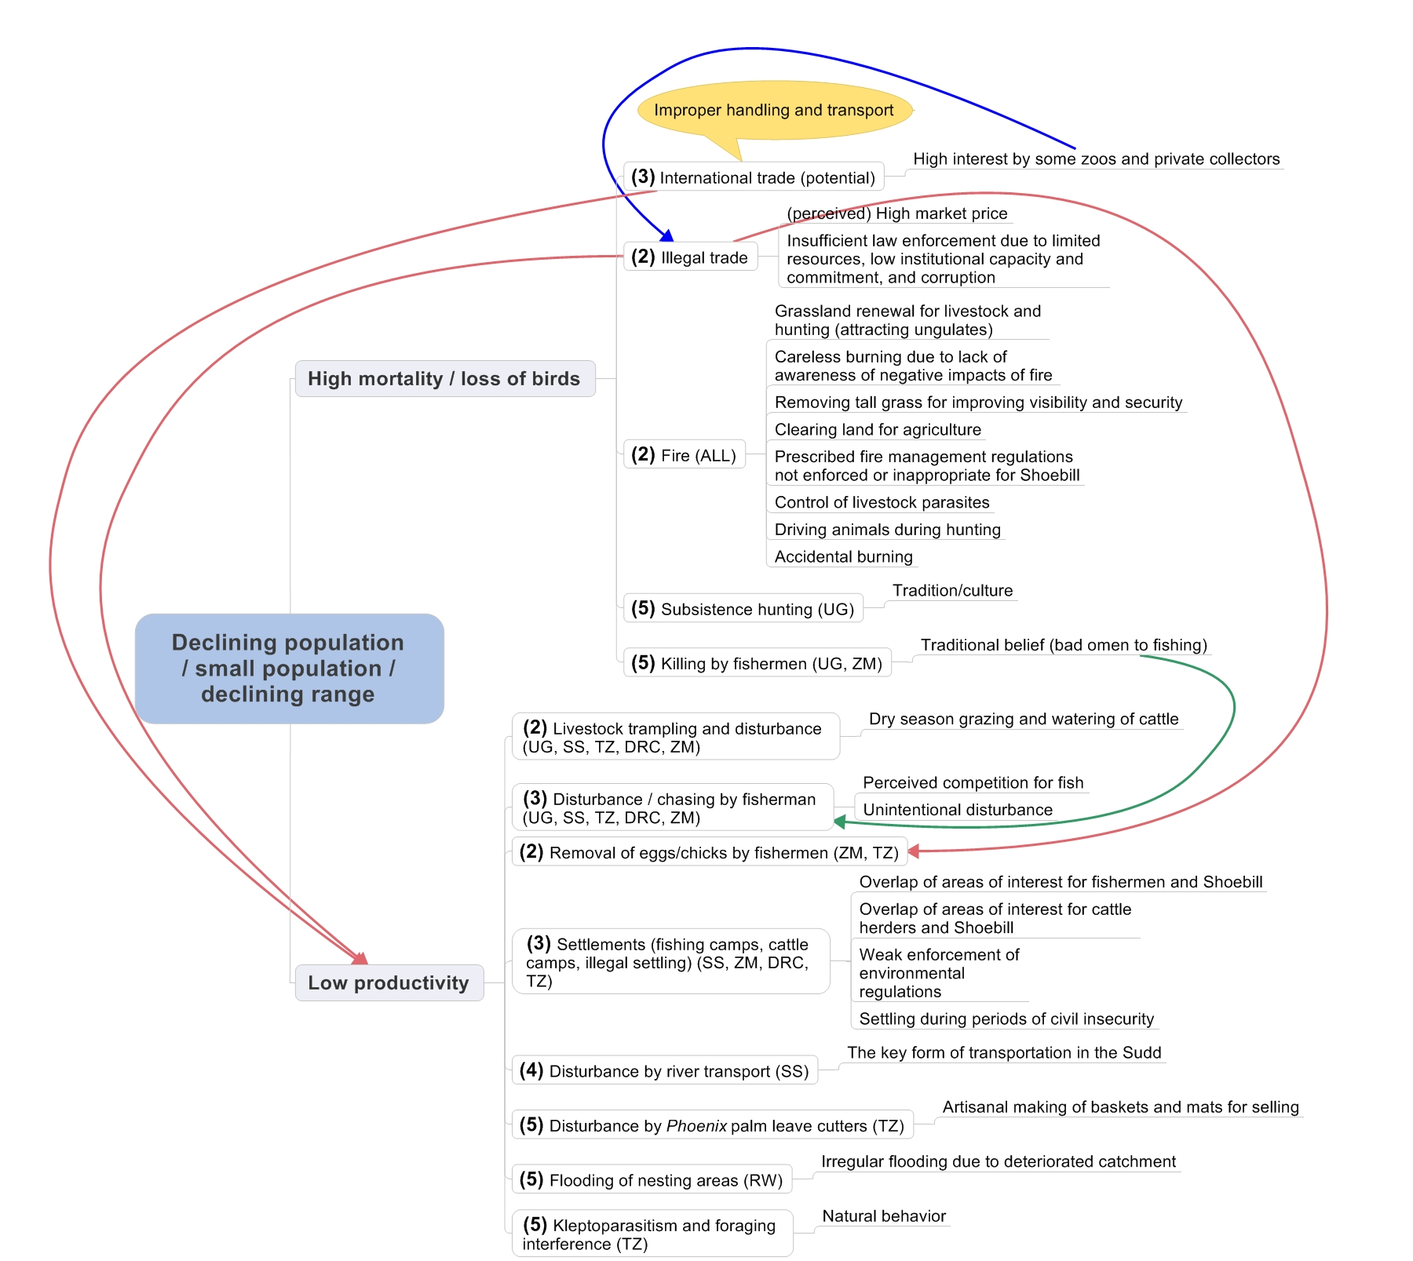

Figure 2. Problem tree analysis: Threats causing a high mortality and low productivity resulting in a declining or small population or a reduced range (1=critical, 2= high, 3=medium, 4=low, 5=local, 6=unknown)

2.3 Threats Causing Habitat Loss, Fragmentation and Degradation

Fire
See 2.1. As well as impacting birds directly, fire can have significant impacts on the Shoebill’s habitat and can also contribute to conversion of swamps to drier habitats, no longer suitable for Shoebills.
→ Significance: High

Oil exploration and extraction
Oil occurs in the Sudd and the potential occurrence in Shoebill areas in Uganda and perhaps elsewhere. Oil exploration has occurred widely in the Sudd, with extraction now underway in several concessions, some of them very close to favoured Shoebill areas. Impacts can include disturbance, changes in hydrology due to access canals and pollution.
→ Significance: High
Agricultural development
Across the world wetlands are prone to conversion to agricultural development, due to the presence of much needed water and often productive soils. Large-scale agricultural developments can occur on a large scale quite rapidly, as is the case in the Gambella region of Ethiopia. There are also impacts in the Malagarasi (Tanzania) and an emerging threat of significant agricultural development in parts of the Sudd and other Shoebill areas of South Sudan. Agricultural impacts in Uganda tend to be at a more local scale, including subsistence agriculture.
→ Significance: High

Dredging canals
Dredging of canals as transport corridors for oil companies and for crop irrigation is a threat to Shoebill habitat in the Sudd. Large canals can drain water from neighbouring swamps, which can impact important breeding and feeding areas, especially in the dry season. The infamous Jonglei Canal which was partially constructed in the 1970s to 1980s to divert water from the Sudd would no doubt have had impacts on flooding levels in the swamps, including in important Shoebill areas.
→ Significance: Medium

Overgrazing
Traditional livestock husbandry in parts of Africa attaches high value to the numbers of animals, especially cattle. There are seasonally high densities of cattle in wetland areas, including in swamps during the dry season. High grazing pressure can result in degradation and even loss of swamps. Particularly high numbers of cattle are found in South Sudan, where there are also high numbers of migratory grazing ungulates. Overgrazing is also an issue in the Malagarasi, though at a more local level in Uganda and possibly in DR Congo.
→ Significance: Medium

Chemical pollution
The exact impacts of chemical pollution in Shoebill areas is not well documented, but this is nevertheless a threat in some areas, especially in Uganda, where there is run-off of agrochemicals and disposal of tannery effluent into Lake Victoria. Oil pollution is a permanent threat to habitats and biodiversity in the Sudd. All over, policies that should limit chemical pollution are only weakly enforced.
→ Significance: Medium

Siltation
Degraded catchments can have long-term impacts on swamps, especially where there has been deforestation and other impacts in catchment headwaters. This likely impacts swamps suitable for Shoebills in Rwanda, Burundi and in southern DR Congo.
→ Significance: Medium

Mineral mining (artisanal and industrial)
Mining for gold and other minerals is an issue in the Lufira basin in DR Congo, whilst limestone mining for cement production is an issue in Uganda.
→ Significance: Low

Habitat transformation by invasive species
Aquatic weeds affect wetland habitats across Africa. The impact on Shoebill habitat seems greatest in the Malagarasi, where weeds such as Nile cabbage can proliferate.
→ Significance: Low

Papyrus cutting
Papyrus is cut widely for building materials, crafts and other uses. Low-level cutting rarely causes a problem, but in some parts it can become quite extensive, and may also cause disturbance.
→ Significance: Low

Horticulture
Horticulture is a local but significant threat on Lake Victoria in Uganda, notably around Entebbe, where flower farms favour locations close to the international airport for easy export. There are prime Shoebill habitats in this area.
→ Significance: Local

Climate change
Changing climates invariably impact wetlands in Africa, and it is not unusual for abnormally high or low or unseasonal rainfall to impact floodplains and other freshwater wetlands in tropical central eastern Africa. However, there is not enough quantitative information at present relating to the projected impact of a changing climate on the Shoebill. Water level increase in Akagera may be the main reason of local Shoebill migration and reduction in breeding areas (D. Nsanzimana, in litt. 2013).

In this Action Plan, climate change is considered as a supra-threat, in that the effects on the ground of climate change would likely be reflected in an intensity of one or more of the threats listed above. For instance, a drying climate overall would result in greater pressures of fire, livestock, disturbance and habitat transformation. Therefore, no additional actions are proposed for addressing climate change impacts, whilst it is acknowledged as an over-arching and cross-cutting factor to keep well in mind, both when monitoring Shoebills, managing sites and implementing conservation action.

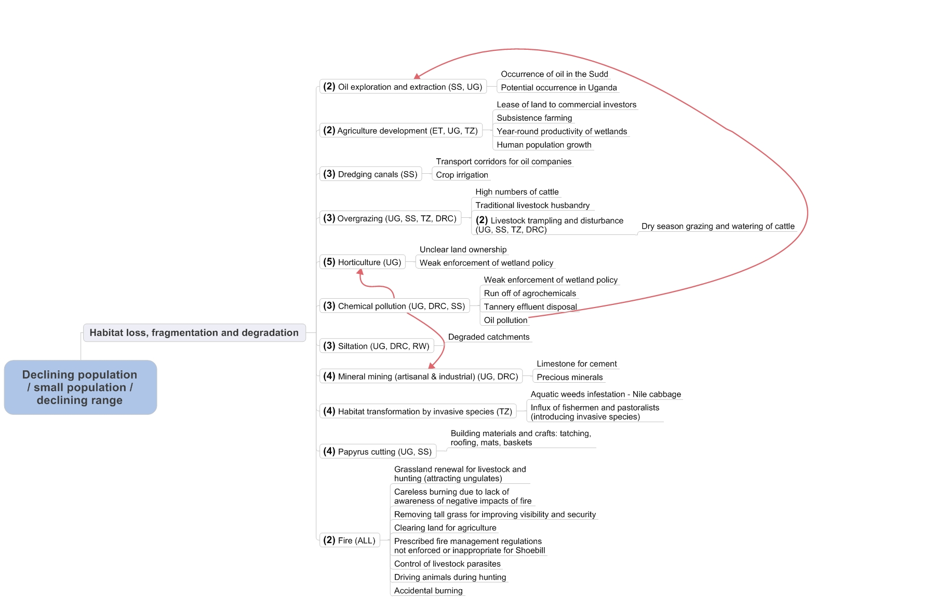

Figure 3. Problem tree analysis: Threats causing habitat loss, fragmentation and degradation resulting in a declining or small population or a reduced range (1=critical, 2= high, 3=medium, 4=low, 5=local, 6=unknown)

2.4 Knowledge Gaps

Insufficient knowledge is not a threat per se to the Shoebill, but there are significant information gaps that hinder effective implementation of species management and conservation, as illustrated in Figure 4. Meeting these knowledge gaps should form an essential part of the action plan.

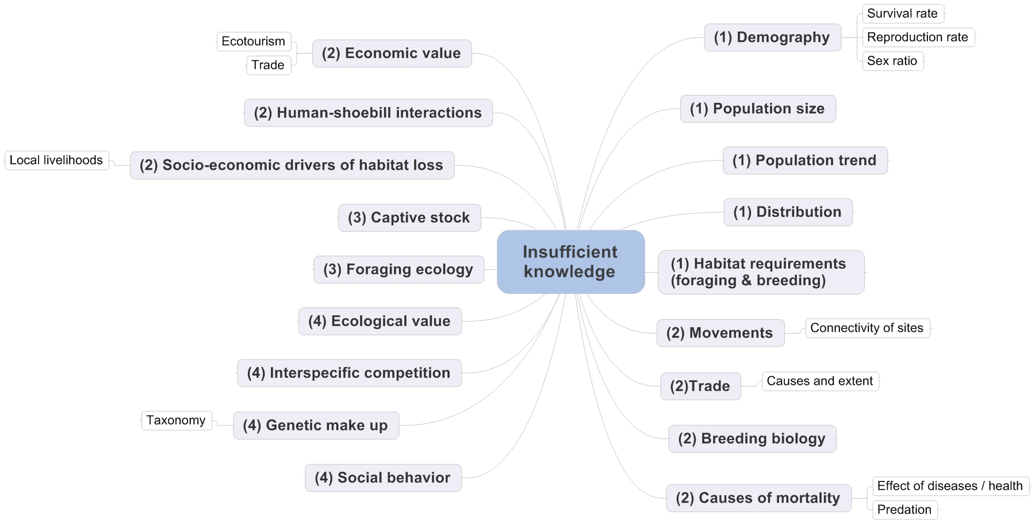

Figure 4. Problem tree analysis: Shoebill knowledge gaps (1=critical, 2= high, 3=medium, 4=low, 5=local, 6=unknown)

The most pressing knowledge gaps relate to information about the Shoebill itself, notably its demography, population size and trend and a more accurate distribution. Guillet (1979, 1984) has published information on habitat requirements in the Sudd, but this level of information is lacking for some other areas, whilst repeating such ground surveys in the Sudd now presents security issues (M.L. Peter, in litt. 2012). Recent research has taken place in Zambia, including investigating reproduction rates and survival, and several birds were fitted with GPS-transmitters. Although some devices stopped transmitting after a few months, others were continuing to provide hourly information on the position of the Shoebills; results continue to come in and will be analysed mainly during 2014 (R. Mullers, in litt. 2013).

Aspects such as site connectivity and breeding biology are also poorly known, whilst it is important to gain a much clearer understanding of Shoebill trade, as well as a full inventory of the captive stock of birds. Filling the knowledge gaps in DR Congo is a priority, which could be achieved through involving students (R. Simanda, in litt. 2012).

As well as the need to fill knowledge gaps in economic value and human-Shoebill interactions, there is also need to gain a better understanding of local livelihoods and the socio-economic drivers threatening Shoebill habitat, and related incentives that could potentially support management efforts.

3. Policies, Legislation and Ongoing Activities

3.1 Policy and Legislation

International level
At the international level, the Shoebill is:
- Classified as Vulnerable (VU) in the IUCN Red List of Threatened Species, meeting criterion C2a(ii), indicating that it has a single small declining population (fewer than 10,000 mature individuals) within a broad Extent of Occurrence.
- Listed on Appendix II of the Convention on International Trade in Endangered Species of Wild Fauna and Flora (CITES), which states that trade must be controlled in order to avoid utilization incompatible with the species’ survival.
- Listed in Table 1 Column A category 1(c) of the African-Eurasian Migratory Waterbird Agreement (AEWA).

Table 2. Membership of Range States in Multilateral Environmental Agreements (MEAs)

Range State | AEWA | CBD | CMS | CITES | Ramsar | WHC
South Sudan*
Ethiopia | X | X | X | X |  | X
Uganda | X | X | X | X | X | X
Rwanda |  | X | X | X | X
Tanzania | X | X | X | X | X | X
DR Congo |  | X | X | X | X | X
Zambia |  | X |  | X | X | X
Burundi |  | X | X | X | X | X
CAR |  | X |  | X | X | X

* Before gaining independence in 2011, South Sudan was a part of Sudan and thus a member of most MEAs, with the Sudd being a designated Wetland of International Importance (Ramsar site). This new country is in the process of ratifying MEAs as an independent state.

Ramsar CPs are expected to develop site management plans for Ramsar Sites and to take the proper management of Shoebill habitats into account at Ramsar Sites where the Shoebill occurs (Annex 2).

National level
At the national level, the Shoebill is fully protected in all Range States. Nowhere is it a game species for which hunting or harvest/collection permits can be issued, and at present, none of the Range States allow trade in, or export of wild Shoebills. The Shoebill is not well represented in national Protected Area networks: in South Sudan, some core breeding areas fall outside protected areas and may therefore be particularly vulnerable. Table 3 illustrates some relevant national legislation, whilst the protected area status of key sites is shown in Annex 2.

However, despite formal protection measures in all Range States, there are clear shortcomings in the implementation of these measures, causing the Shoebill and its habitats to remain widely threatened.

Table 3. National policies and legislation

Country | Relevant national policies | Shoebill specific legislation
South Sudan | - Wildlife Act, 2003 | Shoebill is totally protected under the Wildlife Act, within and outside protected areas.
Ethiopia | - WDC&U Regulation no. 163/2008 | No hunting licenses are issued for Shoebill.
Uganda | - Uganda Wildlife Policy, 1999  - Uganda Wildlife Act (Cap 200), 1996  - National Environment Act (Cap 153)  - Uganda Tourism Act | Shoebills are fully protected in Uganda under these legislations.
Rwanda | - Rwanda National Parks  - Environmental Law  - Biodiversity Policy, 2009  - Ministerial order no. 007/2008 establishing the list of protected species  - National Wetland Conservation Program,  2002-2030 | Shoebills are fully protected in Akagera National Park (their only site of usual occurrence).
DR Congo | - Conservation Law, 1969  - Environmental Law, 2011  - Hunting Law, 1982  - Forestry Code, 2002  - National Protected Areas Conservation Strategy, 2004  - National Biodiversity Conservation Strategy, 2009 | The Shoebill has a total protection status on the basis of these legislations.
Tanzania | - Wildlife Conservation Act (Cap 283), 2009  - Wildlife Policy, 1998 (revised 2007)  - Tanzania National Parks Act (Cap 284)  - National Environment Policy, 1997  - National Environment Management Act, 2004 | The Shoebill is protected from trade and consumptive use under the Wildlife Act. The export of Shoebills is currently prohibited under a moratorium on the export of all birds from Tanzania.
Zambia | - Section 30 of the Zambia Wildlife Act No. 12, 1998  - Protected Animal under Statutory Instrument No. 3 of 1971 of the National Parks and Wildlife Act (Cap 316) | The Shoebill is a protected species under the Zambia Wildlife Act (implemented by the Zambian Wildlife Authority).

3.2 Site Protection and Management

Annex 2 provides details of the protection status and management of key sites where Shoebills are found, and Annex 3 details some recent conservation measures in these and other areas. A brief overview by country is provided below:

- South Sudan
The Shoebill is not well represented in protected areas in South Sudan. Whilst there are sizeable National Parks and Game Reserves in the country, the core areas of Shoebill distribution are largely excluded from them. Of the protected areas where Shoebill does occur: Zeraf GR is of difficult access and subject to disturbance especially in the northern sector, Shambe NP only includes a relatively small area of Shoebill habitat, which is of difficult access, whilst Shoebill numbers in the better-resourced Boma NP are rather low. There is no shortage of protected area staff in the wildlife ministry (MWCT), but there are few management procedures and resources, whilst capacity is generally low. The core Sudd area is a Ramsar Site, but there is no management plan in place for this.
- Ethiopia
Gambella NP is currently under a programme of management support, protection and research after many years of low attention. The Weyto River area is unprotected, though not far from Stephanie NP.

- Uganda
The Shoebill is reasonably well represented in protected areas in Uganda, including National Parks, Ramsar Sites and IBAs. Ramsar Sites and IBAs in Uganda do afford some measures of conservation management, and it is encouraging to note community-based protection at a few sites, notably Mabamba Bay. Shoebills are well protected at Lake Mburo NP, Murchison Falls NP and Queen Elizabeth NP (which includes part of Lake Edward). The main unprotected site is Lake Kyoga.

- Rwanda
The Akagera NP is fully protected and under effective management. The park was heavily threatened for a period by encroachment by refugees, livestock and creeping settlements, and parts of the park were degazetted. However, the main wetland areas in the east of the park have remained fairly intact, and whilst Shoebills and other animals may have declined, there are reasonable prospects for their recovery / survival here, especially with the growing importance of ecotourism in the country.

- Democratic Republic of the Congo
The main protected area supporting Shoebills is the Parc National d’Upemba in Katanga Province in the southeast. The park is managed by the Congolese Wildlife Authority ICCN and currently receives technical, management and financial support from the Frankfurt Zoological Society. However, activities are severely disrupted by recurring security issues, and park staff and family members have been killed. Management is not easy in such situations, and activities such as mining, poaching and encroachment still impact this diverse park. Southeast of the park, the Lufira Valley is unprotected, although it is a Biosphere Reserve.

- United Republic of Tanzania
The Shoebill is not represented in any of Tanzania’s National Parks, but does occur in a few Game Reserves. The largest of these, Moyowosi and Kigosi, also form the Malagarasi-Muyovozi Ramsar Site, designated partly to conserve Shoebill and its habitat. However, this vast area faces a number of threats, especially agricultural and livestock encroachment, fires, disturbance and direct persecution. Whilst Ramsar site management plans exist, resources for effective management seem to be limited.

- Zambia
Most of the Bangweulu Wetlands is under some form of management / protection, and a few National Parks are in close proximity. The Bangweulu Wetlands Management Board (BWMB), formed by African Parks, the Zambia Wildlife Authority (ZAWA) and representatives of the community, is responsible for management and law enforcement. Whilst this recent development should improve protection status of Shoebills in Bangweulu, the management of extensive swamps on the ground is not easy, and the wetlands are well utilised, so surveillance of fishermen, livestock, fire and other potential threats is certainly a challenge. Much of the area important for Shoebills is also a Ramsar Site.

3.3 Monitoring and Research Activities

Monitoring
The only coordinated monitoring activity covering the Shoebill is the International Waterbird Census (IWC), in which all Range States have participated at one time or another. However, participation is not always regular, whilst many Shoebill sites are not routinely monitored, so as yet the IWC does not provide a good basis for population monitoring of the Shoebill. There have been irregular aerial surveys in South Sudan and Zambia (see ‘Research activities’), which have the potential to provide useful data for monitoring population and distribution.

There have been no long-term efforts to monitor breeding success, though some breeding birds / nests have been monitored during research projects in South Sudan, Tanzania and Zambia.

Research activities
There have been a few research initiatives focused on the Shoebill in the wild, notably in South Sudan, Tanzania and Zambia, whilst some public awareness activities have taken place in Uganda. Some notable past and current research activities are illustrated in Table 4.

Table 4. Research activities and surveys of / relating to Shoebills

Country | Research & approx. dates | Main researcher(s) | Publications
South Sudan | Ecology, foraging & nesting behaviour, functional morphology (1977-78) | Alfredo Guillet | Guillet (1979), Guillet (1984), Guillet et al. (1985)
 | Development studies in the Jonglei Canal Area including aerial wildlife surveys (1980s) | Stephen Cobb | Range Ecology Survey (1983)
 | Sudd aerial wildlife surveys (2007 - present) | Falk Grossmann, Paul Peter Awol, Paul Elkan | Fay et al. (2007)
 | Sudd aerial waterbird surveys (2012) | Falk Grossmann, Pierre Defos Du Rau, Tim Dodman | Grossmann et al. (in prep.)
Ethiopia | Aerial wildlife surveys of Gambella (2009-2010) | TFCI Task Force | TFCI (2011)
Uganda | Shoebill rescue and rehabilitation, study of captive birds (long-term; captive birds since 1960s), feeding | UWEC;  Willem Möller | Möller (1982)
 | MSc study on Shoebill status & distribution, Murchison Falls | Patrick Sempala | Sempala (1999)
Tanzania | Literature review & aerial surveys, the Malagarasi (2001) | Lars Dinesen & Marc Baker | Dinesen & Baker (2006)
 | Applied research of Shoebill and Wattled Crane, the Malagarasi (2004-2007) | Cuthbert Nahonyo | Nahonyo & Msuya (2008)
 | PhD research of Shoebill and Wattled Crane, the Malagarasi (2005-2012) | Jasson John | John et al. (2012)
Zambia | Filming of Shoebills in Bangweulu and associated behaviour studies (1975) | Cindy Buxton | Buxton et al. (1978)
 | Aerial wildlife surveys (1983) | Geoffrey Howard & Dylan Aspinwall | Howard & Aspinwall (1984)
 | Behaviour studies, photography and field observations, Bangweulu Wetlands (1992-97) | Geneviève Renson | Renson (1998 & 2008)
 | Aerial Shoebill survey, Bangweulu Wetlands (2006) | Lizanne Roxburgh | Roxburgh & Buchanan (2010)
 | Conservation of Shoebills in the Bangweulu Wetlands (ongoing) | David Ngwenyama (2011), Ralf Mullers & Arjun Amar (current) | Ngwenyama (2012)

Some of the most in-depth field research activities were the studies of Alfredo Guillet in the 1970s in the Sudd. These, and specific research carried out in Zambia in the 1970s and 1990s (Buxton et al. 1978, Renson 1998 & 2008), have yielded significant information on foraging techniques, nesting habits, breeding ecology and other information relating to their conservation. Recent research in the Malagarasi and current research in the Bangweulu Wetlands, benefiting from more modern research tools, will add to this earlier information.

4. Framework for Action

Goal:
Increase the Shoebill’s population size and maintain its current range

Indicators:
- Long-term: Species removed from globally threatened categories on the IUCN Red List and from Column A, category 1 of the AEWA Table 1
- Mid-term: Stability / increase in well-monitored sub-populations

Purpose:
Improve the current conservation status and knowledge base of the Shoebill within the next 10 years.

Objectives:
- Reduce mortality and loss of birds
- Minimise and control principal factors lowering productivity
- Significantly reduce further loss, fragmentation and deterioration of habitat
- Fill key knowledge gaps about the Shoebill, including development of a long term knowledge base

Results:

Table 5. Results, indicators and means of verification

Result | Indicators | Means of verification
- Legal trade does not impact on the population | - National trade bans maintained  - Strict adherence to CITES provisions in case current bans are lifted  - Management agreements for Shoebill under WAZA  - No negative impact on wild populations through any resumption of legal trade | - National legislation  - CITES trade database  - Shoebill Global Species Management Plan (GSMP) proposal submitted to WAZA by Range States  - National trade data; WAZA publications and monitoring of WAZA institutions
- Illegal trade is minimised | - Improved protection measures for Shoebills in all Range States  - Enhanced surveillance  - Communities, customs, officers and other law enforcement officers, and prosecutors aware of legal status of Shoebill and relevant protection measures, including trade rules  - Communities and other stakeholders are aware of consequences of infractions | - Legislation  - Site measures (e.g. Shoebill guards) & reports  - Surveillance reports  - Questioning / interviews with stakeholders  - Number of seizures, prosecutions or arrests
- Impact by livestock is minimised in Shoebill breeding areas | - Livestock kept away from sensitive areas  - Shoebill breeding areas protected  - Pastoralists aware of need to avoid Shoebill territories | - Livestock data  - Protection measures adopted & implemented in breeding areas  - Pastoralist awareness (e.g. interviews)
- Disturbance by fishermen is minimised in breeding areas | - Fishing communities do not disturb Shoebills, especially during breeding  - Fishing communities benefit from Shoebill presence through associated projects  - Fishermen aware of need to avoid Shoebill territories | - Records from site managers (verification not easy from all sites)  - Community-based income-generation / other activities underway involving fishermen  - Fishermen awareness (e.g. interviews)
- Temporary settlements are restricted in breeding areas | - No new settlements in key Shoebill breeding areas | - Site monitoring (reports)
- Negative impacts of oil & gas exploration and production on Shoebill habitats are minimised and mitigated | - Shoebill and its habitat are properly catered for in SEAs  - Transparent EIAs conducted that take full account of Shoebill | - SEAs available  - EIA reports
- Loss, fragmentation and degradation due to agriculture developments are minimised | - Shoebill areas known and safeguarded against agricultural development  - Management plans developed for all Shoebill sites, which include protection measures for Shoebill habitats  - High ‘positive’ awareness of Shoebills within farming communities | - EIAs of agricultural plans, with procedures for Shoebill conservation outlined  - Management plans available for all Shoebill sites, and records to illustrate their implementation  - Interviews with farming communities
- Chemical pollution at Shoebill sites is minimised | - Bylaws regarding chemical pollution developed / implemented | - Development of bylaws  - Records of any chemical pollution incidents in Shoebill areas
- Catchments of Shoebill sites are sustainably managed | - Sustainable land use principles in place | - Cross-sectoral land use assessments
- Fires are minimised and controlled in Shoebill habitats | - High community awareness of fire regulations and destructive impact of fires  - Fire regulations enforced | - Records of fire incidents  - Interviews with local communities  - Site records
- Local communities benefit from the conservation of Shoebills and their habitat | - Community-based enterprises established, including Shoebill-focused ecotourism initiatives and other incentives  - Local communities have capacity to manage Shoebill habitats  - Local communities actively involved in Shoebill management (e.g. surveillance, monitoring) | - Community ecotourism and other initiatives up and running; incentives for Shoebill and habitat conservation recognised  - Measurable capacity increments  - Community eco-guards / Shoebill guards; guides

Table 6. Actions, time scales and responsibilities

Result | Action | Priority | Time scale | Organisations responsible
- Legal trade does not impact on wild populations | - Maintain the national bans on trade, unless strong cases for resumption are approved | High | Ongoing | CITES management authorities in Range States
 | - In case trade resumes, strictly comply with all CITES provisions, monitor impacts of trade at national and regional level, and consider national and regional management plans to support such trade | High | Short | CITES management authorities in Range States
 | - Develop guidelines for capturing, transporting, handling, caring & rearing of Shoebills (in case trade is resumed) | Medium | Short | WAZA-appointed Shoebill GSMP Convenor / TAG Chair for Storks
 | - Develop a Global Species Management Plan for the Shoebill under WAZA that includes collaboration between ex situ collections and in situ conservation programmes and husbandry management | Medium | Medium | WAZA-appointed Shoebill GSMP Convenor / TAG Chair for Storks
 | - Should trade resume, Range States ensure that birds are only exported to zoos and collections meeting standards set under action 1.1.4 | High | Medium – Ongoing | CITES management authorities in Range States
- Illegal trade is minimised | - Provide strict protection to the Shoebill under domestic legislation in each Range State, including high penalties for offenders | High | Short – Ongoing | AEWA implementation authorities / Ministries responsible for Wildlife
 | - Harmonise legislation across the Range States according to appropriate regional frameworks | Medium | Medium – Long term | Ministries responsible for Wildlife
 | - Range States strengthen their institutional and law enforcement capacity | High | Ongoing | Wildlife management authorities
 | - Strengthen surveillance on the ground at national and transboundary levels | High | Ongoing | Wildlife management authorities
 | - Generate and share intelligence on illegal trade across countries and cooperate under Interpol, Lusaka Agreement and TRAFFIC | High | Ongoing | Wildlife management authorities
 | - Raise awareness amongst local communities, traders, customs, law enforcement officers, judiciary and wider public | High | Ongoing | Wildlife management authorities, NGOs, conservation education institutions
- Impact by livestock is minimised in Shoebill breeding areas | - Provide alternative water sources during dry season through management planning | Medium | Long term | Wildlife management authorities
 | - Restrict livestock from core breeding areas through management planning | High | Ongoing | Site managers & communities
 | - Provide protection status to core breeding areas | High | Medium | Ministries responsible for Wildlife or Wetlands
- Disturbance by fishermen is minimised in breeding areas | - Raise awareness amongst fishermen and local communities | High | Ongoing | NGOs & conservation education institutions
 | - Develop community-based management plans for core breeding areas, involving local fishing groups | High | Medium | Ministries responsible for Wildlife or Wetlands; NGOs; communities
- Temporary settlements are restricted in breeding areas | - Restrict settlements through management planning | Medium | Ongoing | Wildlife management authorities; community leaders; local government
- Negative impacts of oil & gas exploration and production on Shoebill habitats are minimised and mitigated | - Ensure Shoebill and its habitats are considered in SEAs | High | Ongoing | Wildlife management authorities
 | - Ensure proper EIA is carried out, monitored and evaluated for all steps of oil & gas exploration and production developments, and considers the Shoebill and its habitat requirements | High | Ongoing | Wildlife management authorities
 | - Ensure compliance with the EIA approved conditions | High | Ongoing | Wildlife management authorities
- Loss, fragmentation and degradation due to agriculture developments are minimised | - Ensure Shoebill habitats are considered in land use planning | High | Ongoing | Wildlife management authorities
 | - Develop management plans for Shoebill sites | High | Medium | Ministries responsible for Wildlife or Wetlands; NGOs; communities
 | - Raise awareness amongst farming communities, investors and agricultural institutions | High | Ongoing | NGOs; conservation education institutions; wildlife management authorities
 | - Develop guidelines for Shoebill-friendly agricultural and other resource uses | Low | Medium – long term | AEWA Shoebill IWG
- Chemical pollution at Shoebill sites is minimised | - Develop bylaws for Shoebill sites under wetland policies | Medium | Medium – Long term | Local governments
 | - Strengthen cross-sectoral harmonisation and collaboration | Low | Medium – Long term | Local governments; site managers
- Catchments of Shoebill sites are sustainably managed | - Lobby other sectors for sustainable land use | Low | Ongoing | Wildlife management authorities; NGOs
- Fires are minimised and controlled in Shoebill habitats | - Raise awareness amongst local communities | High | Ongoing | Local governments; NGOs; site managers
 | - Incorporate appropriate fire control measures in management plans | Medium | Medium – Long term | Wetlands management authorities; local governments
 | - Enforce fire regulations and implement appropriate response procedures | Medium | Ongoing | Local governments; site managers
- Local communities benefit from the conservation of Shoebills and their habitat | - Promote sustainable wetland-based enterprises or community development initiatives, especially in ecotourism and alternative income generation | High | Medium | NGOs; Wildlife / Wetlands management authorities
 | - Build capacity within local communities for Shoebill conservation and sustainable enterprises | High | Medium - Ongoing | NGOs; Wildlife / Wetlands management authorities
 | - Establish local conservation groups, e.g. Site Support Groups, at key Shoebill sites | High | Medium - Ongoing | NGOs; Wildlife / Wetlands management authorities; local governments

Supporting notes on Actions

1.1.4: Along with the GSMP, the development of a Global Conservation Strategy (GCS) for the management of Shoebills at the international level could be considered that links in situ and ex situ conservation activities for the recovery and/or long-term maintenance of captive and wild populations. This would be an appropriate forum to discuss ‘sustainable trade options,’ i.e. were trade to resume. A potential option might be the removal of second eggs or weak second chicks from nests in the wild, for captive breeding / reintroduction or in order to meet the demand from zoos / collections, as a means to stem illegal trade in wild birds. As Shoebills almost always only ever raise one chick, even when more than one egg is laid, careful removal of a second egg or chick should not directly impact the population. Such actions would have to be extremely well managed and indirect impacts assessed.
1.2.6: This should include sensitisation at border controls.
3.2.2: Developing and implementing management plans is relevant for most results, especially when Shoebill needs are built into them, e.g. through zoning to protect core Shoebill areas. There is potential to make greater use of conventions, especially the Convention on Wetlands to improve management of Ramsar Sites where Shoebills occur through adoption and implementation site-specific plans, with frameworks in place to monitor the status of sites.
3.6.1: Ecotourism guidelines and by-laws should be developed to ensure that Shoebills are not disturbed during tourism operations.
3.6.2: Ensure local communities benefit from Shoebill research and conservation, e.g. hire local communities as guards (as occurs in Bangweulu) and guides.

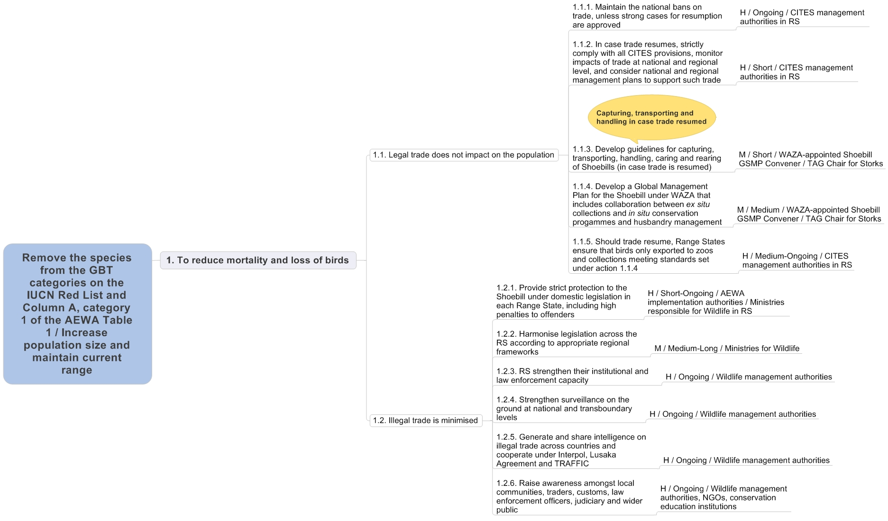

Figure 5. Proposed actions and their priorities for reducing Shoebill mortality and loss of birds

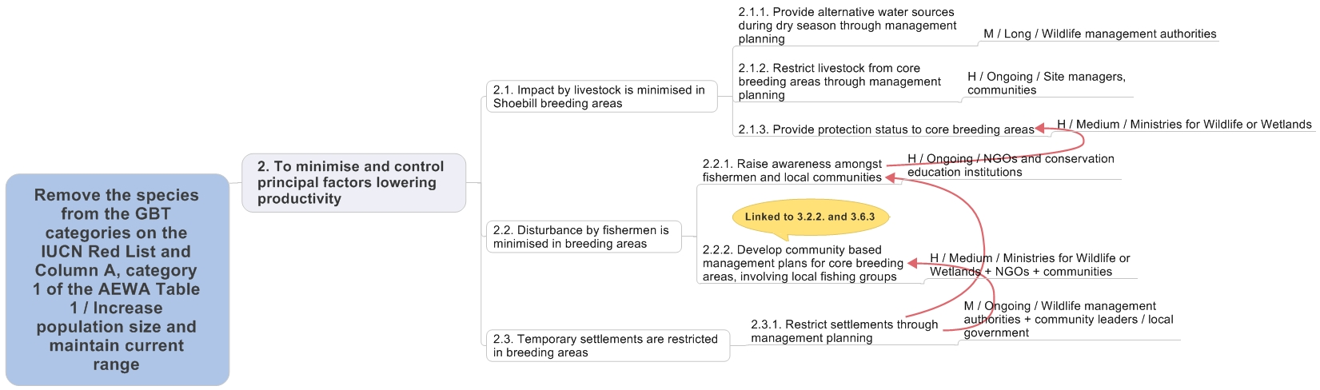

Figure 6. Proposed actions and their priorities for minimising and controlling principal factors lowering Shoebill productivity

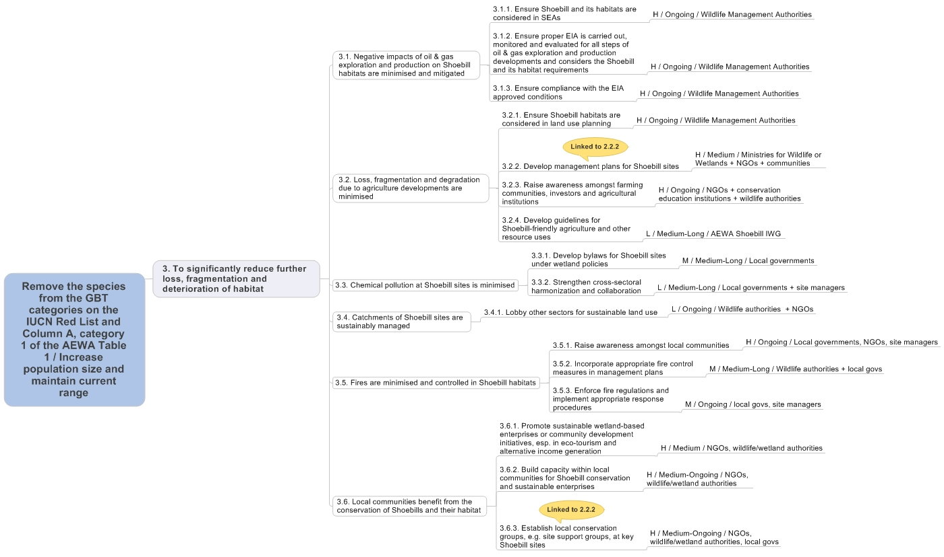

Figure 7. Proposed actions and their priorities to significantly reduce further loss, fragmentation and deterioration of habitat

Figure 8. Proposed actions and their priorities for filling Shoebill knowledge gaps (1-5)

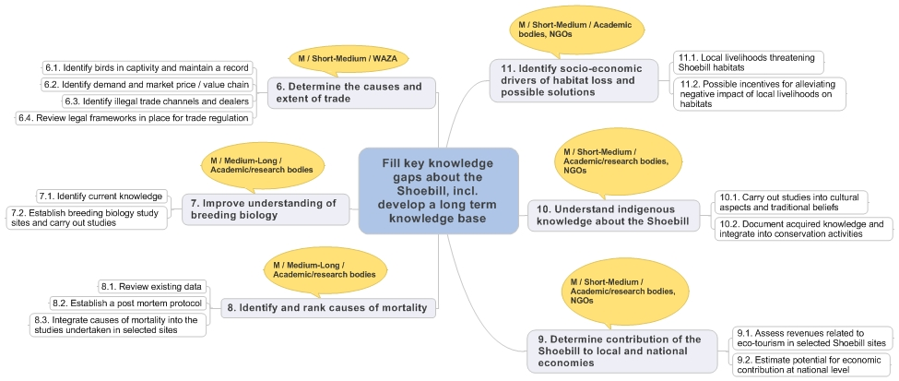

Figure 9. Proposed actions and their priorities for filling Shoebill knowledge gaps (6-10)

References

Abebe, Y.D. 2011. Preliminary results of a survey of water birds and wetlands in Gambella region, Western Ethiopia. Unpublished report to the Wings Over Wetlands Project. Addis Ababa.
Ash, J. & Atkins, J. 2009. Birds of Ethiopia and Eritrea: an atlas of distribution. Christopher Helm, London.
Baker, N.E. & Baker, E.M. 2002. Important Bird Areas in Tanzania: A first inventory. Wildlife Conservation Society of Tanzania, Dar es Salaam, Tanzania.
BBC. 2013. ‘Monster’ bird reveals dark side. http://www.bbc.co.uk/nature/20938650.
Birding Rwanda. 2009. Shoebill Balaeniceps rex. http://rwandabirdingguide.blogspot.co.uk/2009_05_01_archive.html.
BirdLife International. 2008 & 2012. Species factsheet: Balaeniceps rex. Downloaded from http://www.birdlife.org on 08/09/2008 and on 07/03/2013.
Blancou, L. 1939. Le Balaeniceps rex en Afrique Équatoriale Française. L’Oiseau et la Revue Française d’Ornithologie, Paris.
Blancou, L. 1961. A propos du Bec-en-sabot en Afrique Équatoriale Française. L’Oiseau et la Revue Française d’Ornithologie, Paris.
Brown, L. H., Urban, E.K. & Newman, K. 1982. The Birds of Africa Volume I. Academic Press, London / San Diego.
Buxton, L., Slater, J. & Brown, L.H. 1978. The breeding behaviour of the shoebill or whale-headed stork Balaeniceps rex in the Bangweulu Swamps, Zambia. Af. J. Ecol. 16(3): 201-220.
Byaruhanga, A., Kasoma, P. & Pomeroy, D. 2001. Important Bird Areas in Uganda. East African Natural History Society, Kampala.
Carswell, M., Pomeroy, D., Reynolds, J. & Tushabe, H. 2005. The Bird Atlas of Uganda. BOU, Oxford.
Delvingt, W. & Lobão Tello, J.L.P. 2004. Découverte du nord de la Centrafrique. ECOFAC.
Demey, R. & Louette, M. 2001. Democratic Republic of Congo. In: Fishpool & Evans (2001).
Demey, R., Herroelen, P. & Pedersen, T. 2000. Additions and annotations to the avifauna of Congo-Kinshasa (ex-Zaïre). Bull. B.O.C. 12(3): 154-172.
Dinesen, L. & Baker, M. 2006. Status of Shoebill Balaeniceps rex in Malagarasi, Tanzania. Bull ABC Vol 13 No 1.
Dodman, T. 2002. Waterbird Population Estimates in Africa. Wetlands International, Dakar. Unpublished consultation draft.
Dowsett, R.J., Aspinwall, D.R. & Dowsett-Lemaire, F. 2008. The Birds of Zambia. Tauraco Press & Aves, Liège.
Fay, M., Elkan, P., Marjan, M. & Grossmann, F. 2007. Aerial Surveys of Wildlife, Livestock, and Human Activity in and around Existing and Proposed Protected Areas of Southern Sudan, Dry Season 2007. WCS / Government of Southern Sudan.
Fishpool, L.D.C. & Evans, M.I., eds. 2001. Important Bird Areas in Africa and associated islands: Priority sites for conservation. Newbury & Cambridge, UK: Pisces Publications & BirdLife International (BirdLife Conservation Series No. 11).
Gould, J. 1851. On a new and most remarkable form in ornithology. Proceedings of the Zoological Society of London 1851:1-2.
Guillet, A. 1978. Distribution and conservation of the shoebill (Balaeniceps rex) in the Southern Sudan. Biol. Conserv. 13: 39-49.
Guillet, A. 1979. Aspects of the foraging behaviour of the shoebill. Ostrich 50: 252-255.
Guillet, A. 1984. Ecological and ethological aspects of the nest of the Shoebill. Proc. V. Pan. Afr. Orn. Congr. 231-236.
Guillet, A., Doyle, W.S. & Rüther, H. 1985. The combination of photogrammetry and finite elements for a fine grained functional analysis of anatomical structures. Zoomorphology 105: 51-59.
Howard, G. W. & Aspinwall, D.R. 1984. Aerial censuses of Shoebills, Saddlebilled Storks and Wattled Cranes at the Bangweulu Swamps and Kafue Flats, Zambia. Ostrich 55: 207-212.
Hughes, R.H. & Hughes, J.S. 1992. A Directory of African Wetlands. IUCN, Gland & Cambridge.
John, J.R.M. 2013. Responses of large wetland bird species to seasonality and human disturbance in the Malagarasi floodplains, western Tanzania. PhD thesis, Seoul National University.
John, J.R.M. & Lee, W-S. 2012. First record of the Association of Cattle Egret Bubulcus ibis with Shoebill Balaeniceps rex. Ostrich 83: 171-173.
John, J.R.M., Nahonyo, C.L., Lee, W-S. & Msuya, C.A. 2012. Observations on nesting of shoebill Balaeniceps rex and wattled crane Bugeranus carunculatus in Malagarasi wetlands, western Tanzania. Afr. J. Ecol. 51: 184-187.
John, J.R.M., Nahonyo, C.L., Lee, W-S. & Msuya, C.A. (in press). Shoebill population estimates in Tanzania from 2,500 in 1990 to <200 birds in 2011: what went wrong? Proceedings of the 8th TAWIRI Scientific Conference, 8 December 2011, Arusha, Tanzania.
Kanyamibwa, S. 2001. Rwanda. In: Fishpool, L.D.C. & Evans, M.I., eds. Important Bird Areas in Africa and associated islands: Priority sites for conservation. Newbury & Cambridge, UK: Pisces Publications & BirdLife International (BirdLife Conservation Series No. 11).
Leader-Williams, N. & Tibanyenda, R.K. (Eds.) 1996. The Live Bird Trade in Tanzania. IUCN, Gland & Cambridge.
Leonard, P. 2005. Important Bird Areas in Zambia: Priority sites for conservation. Zambian Ornithological Society, Lusaka.
Lippens, L. & Wille, H. 1977. Les Oiseaux du Zaïre. La Présidence de la République du Zaïre, Kinshasa.
Louette, M. & Hasson, M. 2011. Birds of Katanga. Royal Museum for Central Africa, Tervuren.
Mertens, H. 1986. Contribution à l’ornithologie du Parc national des Virunga. Gerfaut 76: 213-219.
Möller, W. 1982. Beobachtungen zum Nahrungserwerb des Schuhschnabels (Balaeniceps rex). J. Orn. 123: S 19-28.
Muir, A. & King, C.E. 2012. Management and husbandry guidelines for Shoebills Balaeniceps rex in captivity. International Zoo Yearbook 47: 181–189.
Nahonyo, C.L. & Msuya, C.A. 2008. Final report on the applied research on two bird species of conservation importance: Shoebill Stork (Balaeniceps rex) and Wattled Crane (Bugeranus carunculatus) in Malagarasi-Moyowosi Ramsar Site. University of Dar es Salaam.
Ngwenyama, D.C. 2012. Challenges of shoebill Balaeniceps rex conservation in the Bangweulu Swamps, Zambia. Programme & Abstracts of the 13th Pan-African Ornithological Congress 14-21 October 2012, Arusha, Tanzania.
Parker, I.S.C. 1984. Shoebill Balaeniceps rex and Wattled Crane Grus carunculatus in the Moyowosi swamp, Tanzania. Scopus 8:24-25.
Range Ecology Survey. 1983. Development studies in the Jonglei Canal area. Technical assistance contract for range ecology survey, livestock investigations and water supply. Final report. Glasgow, Khartoum & Rome: Mefit Babtie.
Renson, G. 1998. Observations sur la reproduction du Bec-en-Sabot Balaeniceps rex en Zambia de 1992 à 1997. Alauda 66: 81-96.
Renson, G. 2008. Sur les traces du roi des marais. Kubik editions, Paris.
Roxburgh, L. & Buchanan, G.M. 2010. Revising estimates of the Shoebill (Balaeniceps rex) population size in the Bangweulu Swamps, Zambia, through a combination of aerial surveys and habitat suitability modelling. Ostrich 81(1): 25-30.
Roxburgh, L., Stjernstedt, R., Mwizabi, D. & Droppelmann, K. 2006. Shoebill survey in Bangweulu Swamps, Zambia under the Wetlands International ‘AEWA/BUWAL IWC 2006’. Technical Report to Wetlands International. Zambian Ornithological Society, Lusaka.
Sempala, P.S. 1999. Abundance of large waterbirds with special reference to the Shoebill. MSc thesis (unpubl) Makerere University, Uganda.
Shouteden, H. 1966. La Faune Ornithologique du Burundi. Musée Royal de l’Afrique Centrale, Tervuren.
TFCI. 2011. Aerial survey Report: Gambella; Reconnaissance 2009 & Census 2010. Trans Frontier Conservation Initiative.
The Guardian. 2011. Ban on export of wild animals takes effect. 15 December 2011. IPP Media, Dar es Salaam.
Wetlands International. 2002. Waterbird Population Estimates – Third Edition. Wetlands International Global Series No. 12. Wageningen, The Netherlands.

ANNEX 1: Occurrence of Threats in Range States

Threat | Significance | South Sudan | Ethiopia | Uganda | Rwanda | DR Congo | Tanzania | Zambia
Fire | High | X | X | X | X | X | X | X
Illegal trade | High | X | X | X | X | X | X | X
(Legal) International trade (potential) | Medium | X | X | X | X | X | X | X
Subsistence hunting | Local |  |  | X
Killing by fishermen | Local |  |  | X |  |  |  | X
Livestock trampling and disturbance | High | X |  | X |  | X | X | X (Medium)
Disturbance / chasing by fishermen | Medium | X |  | X |  | X | X | X (Local)
Removal of eggs / chicks by fishermen | Medium |  |  |  |  |  | X | X (High)
Settlements (fishing camps, cattle camps, illegal settling) | Medium | X |  |  |  | X | X | X
Disturbance by river transport | Low | X
Disturbance by Phoenix palm leaf cutters | Low |  |  |  |  |  | X
Flooding of nesting areas | Low |  |  |  | X
Oil exploration and extraction | High | X |  | X
Agricultural development | High |  | X | X |  |  | X
Dredging canals | Medium | X
Overgrazing | Medium | X |  | X |  | X | X
Chemical pollution | Medium | X |  | X |  | X
Siltation | Medium |  |  | X | X | X
Mineral mining (artisanal and industrial) | Low |  |  | X |  | X
Habitat transformation by invasive species | Low |  |  |  |  |  | X
Papyrus cutting | Low | X |  | X
Horticulture | Local |  |  | X

- Levels of significance were selected by workshop participants. The most significant threats to long-term survival are the impacts of fire and trade.
- Fire is a particular threat to breeding birds and breeding success.
- Although trade in Shoebills is currently prohibited by all Range States, illegal trade takes place, and there is a permanent demand on account of the bird’s uniqueness and very low breeding success in captive birds. Potential legal trade remains a threat especially due to mortality issues in trade.
- Livestock present a threat to Shoebills, especially to breeding birds during the dry season, and most notably in South Sudan and Tanzania.
- Oil exploration and extraction invariably present environmental threats, and these are most significant in South Sudan, where major oil developments are present in the Sudd, some very close to key Shoebill areas. Direct impacts include pollution and habitat loss; indirect threats include impacts on flooding patterns (due to dredging) and rendering Shoebills more accessible.
- Agricultural development is a particular threat in Ethiopia, with large areas of wetlands being given over to agriculture in Gambella.

ANNEX 2: Key Sites

Country | Name | Area (ha) | Lat | Lon | Estimated numbers | Protected Area Names | Protection Status | International Designation
South Sudan | Sudd (Bahr-el-Jebel system) | 5,700,000 | 08º00'N | 31º00'E | ca. 4,000 | Zeraf Game Reserve, Shambe National Park | ca. 15% | Ramsar Site
South Sudan | Swamps of Lol / Pongo / Kuom River Systems | 50,000? | 08º00'N | 28º00'E | ? | Unprotected | 0 | -
South Sudan | Bahr al Ghazal & Meshra swamps | 400,000 | 08º26'N | 29º16'E | 150 | Unprotected | 0 | -
South Sudan | Lakes & swamps of Lakes State | >30,000 | 06º34'N | 30º28'E | 100 | Shambe National Park | ca. 15% | -
South Sudan | Machar Marshes | 900,000 | 08°27'-09°58'S | 32°11'-34°09'E | 150 | Unprotected | 0 | -
Ethiopia | Gambella | 457,500 | 07º52'N | 34º00'E | ca. 50 | Gambella National Park | 100% | -
Uganda | Lake Kyoga | 560,000 | 00º33'-01º56'N | 32º18'-34º00'E | ? | Unprotected | 0 | Ramsar Site (Lake Nakua)
Uganda | Mabamba Bay | 16,500 | 00º05'N | 32º20'E | ? | Mabamba Bay Wetland | ca. 50% | Ramsar Site
Tanzania | The Malagarasi | 3,250,000 | 5ºS | 31ºE | 100-500 | Moyowosi –Kigosi & Ugalla GRs; Malagarasi-Muyovozi Wetlands* | ca. 90% | *Ramsar Site
Rwanda | Akagera | 90,000 | 01º45'S | 30º38'E | ? | Akagera National Park | 100% | -
DR Congo | Upemba | 1,000,000 | 9°50' - 8°45'S | 25°50'-27°10'E | ? | Parc National de l’Upemba | 100% | -
Zambia | Bangweulu Wetlands | 1,100,000 | 10°33'-12°17'S | 29°15'-30°43'E | 200-1,300 | Bangweulu, Chambeshi & Kafinda GMAs | ca. 20% | Ramsar Site

ANNEX 3: Legal Status, Conservation Measures & Monitoring

A. National Legal Status

Country | Legal protection | For game species, give opening/closing dates of hunting season
South Sudan | Yes | Not applicable
Ethiopia | Yes | Not applicable
Uganda | Yes | Not applicable
DR Congo | Yes | Not applicable
Rwanda | Yes | Not applicable
Tanzania | Yes | Not applicable
Zambia | Yes | Not applicable

Although the Shoebill is on Appendix II of CITES, it is currently not permissible to hunt, capture or trade Shoebills in any Range State.

B. Recent Conservation Measures

Although no formal national Shoebill action plans are in place, conservation measures are underway in most countries. These include the following recent and ongoing activities (for the period 2010-2013):

South Sudan
- Aerial surveys and population monitoring in the Sudd led by WCS-South Sudan and MWCT.
- Training in wetland / waterbird monitoring led by ONCFS and Wetlands International.
- National considerations in place for field research of Shoebills through national universities, e.g. University of Juba (to MSc or PhD level).

Ethiopia
- Aerial surveys in Gambella and conservation initiatives underway through the TFCI, including improved management of Gambella National Park and community-based activities.
- Trans-boundary conservation agreements for Gambella region between Ethiopia and South Sudan.

Uganda
- Community-based Shoebill ecotourism at Mabamba led by MWETA with support of NatureUganda and other partners. Other community-based initiatives also under development.
- Awareness-raising activities led by NatureUganda, UWEC and others.
- Establishment of the Shoebill Stork Foundation with a special focus on community-based conservation and awareness of the Shoebill and its habitat.
- Shoebills conserved and monitored in a number of protected areas, including Murchison Falls, Queen Elizabeth and Lake Mburo National Parks.
- An MSc study on population and distribution in Murchison Falls National Park.
- Shoebill is nationally known as a key asset for ecotourism.

Rwanda
- Shoebill strongly valued as an ecotourism asset, increasing its status in Akagera.

Democratic Republic of the Congo
- The Parc National d’Upemba receives technical, management and financial support from the Frankfurt Zoological Society, although activities are disrupted by recurring security issues.

United Republic of Tanzania
- Research into breeding and behaviour in the Malagarasi, with conservation recommendations developed.
- Bird trade moratorium (2011).

Zambia
- Ongoing programme of integrated research led by the BWMB (ZAWA / African Parks) and Percy FitzPatrick Institute in cooperation with the Kasanka Trust. This research seeks to provide practical conservation recommendations for the Shoebill in the Bangweulu Wetlands.
- In Bangweulu, local fishermen have been hired as Shoebill guards, especially to protect nests, bringing local economic benefits. This creates awareness, and communities share the benefits.
- Management support for Bangweulu Wetlands GMA.
- The Shoebill is a key ecotourism asset in Bangweulu; Shoebill Island Camp is managed by the Kasanka Trust, which also provides management and research support to ZAWA.
- A rescued reintroduced Shoebill named Kapotwe has gained popularity and renown.

C. Ongoing Monitoring Schemes for Shoebill

Country | Is there a national survey / monitoring programme? | Is there a monitoring programme in protected areas?
South Sudan | Some aerial survey  monitoring ongoing | Not especially; surveys do not target protected areas
Ethiopia | No | No
Uganda | About 10 Shoebill sites  included in IWC | Some protected areas included in IWC
DR Congo | No | No
Rwanda | No | No
Tanzania | IWC & Shoebill research,  the Malagarasi | No
Zambia | Applied Shoebill research programme underway, Bangweulu | Bangweulu is partially protected

Note: Whenever the IWC takes place, the Shoebill is always a target species for monitoring.

D. Overview of the Coverage of the Shoebill in Networks of Designated Sites

Country | Percentage of national population included in IBAs | Percentage of population included in Ramsar sites | Percentage of population included in protected areas under national law
South Sudan | 70% | 70%?  (Sudd is a Ramsar Site, though South Sudan has not ratified yet) | 10% (Shambe, Zeraf)
Ethiopia | 75% | 0% | 75%
Uganda | 70% | 70% | 40%
DR Congo | 70% | 5% | 30%
Rwanda | 100% | 0% | 100%
Tanzania | 100% | 80% | 90%
Zambia | 100% | 80% | 70%

Note: These percentage figures are all estimates. It is not possible to establish accurate percentage figures whilst information on numbers at individual sites is either lacking or contradictory, as is the case for almost all sites.

ANNEX 4: Names of the Shoebill in Different Languages

Language | Name
Scientific | Balaeniceps rex (= king whale head)
English | Shoebill, Whale-headed Stork, Shoebill Stork
French | Bec-en-sabot
Kiswahili | Korongo Domokiatu (= shoe bill) / Korongo-nyangumi
Kigoma / Tabora | Bungunusi
Luganda | Bulwe
Ataeso | Ekudududu
Lusoga | Nkumakinyumo (= waiting for fish)
Katanga | Motula / Motuta / Mututa
BaLamba | Fumpa fumpa
Nuer | Bany-yeelped
Collo | Okoum Wadjwok (= the son of God)
KinyaRwanda | Munwarukweto (= shoe bill)
Bisa | Pumpunta
chiBemba | Ipumambao (= one that beats the otter, or one that drums on wood)
Arabic | Abu Markoob ابو مركوب
Danish | Træskonæb
Dutch | Schoenbekooievaar
Finnish | Kenkänokka
German | Schuhschnabel
Italian | Becco a scarpa
Portuguese | Bico-de-tamanco, Bico-de-sapato
Spanish | Picozapato
Swedish | Träskonäbb

A toich is a seasonally flooded area in South Sudan.
Key sites are defined as areas that would qualify as internationally important, i.e. that likely support >65 Shoebills (1% level, according to current population estimate of 5,000 - 8,000 birds). Some sites are included for which no counts or site population estimates have been made.
Area of whole management unit or designated area, NOT area of Shoebill habitat. Most areas taken from Hughes & Hughes (1992) and Fishpool & Evans (2001).
The only sites that qualify as internationally important sites for Shoebill are the Sudd (Bahr-el-Jebel system), the Malagarasi and the Bangweulu Wetlands, all extensive wetlands where aerial surveys have taken place and site population estimates derived. Potential key sites are also shown in the table, but no estimated numbers presented.
These figures estimate the amount of the site under formal protection; it does not represent in a measure of actual protection on the ground.
There are several lakes in this area supporting Shoebills, including Lakes Nyubor, Nuong & Yirol. The coordinates refer to Lake Yirol.

