DRAFT INTERNATIONAL SINGLE SPECIES ACTION PLAN FOR THE
CONSERVATION OF THE GREY CROWNED CRANE

Introduction

This draft International Single Species Action Plan (ISSAP) for the Conservation of the Grey Crowned Crane (Balearica regulorum) was commissioned to the International Crane Foundation / Endangered Wildlife Trust Partnership, South Africa and was compiled by Kerryn Morrison. The action planning process was financially supported by the Federal Office for the Environment in Switzerland, The Nature and Biodiversity Conservation Union – NABU, Dohmen Family Foundation and Kölner Zoo.

Drafts of the plan went through rigorous consultations with experts followed by official consultation with government officials in the range states. The draft plan was approved for submission to MOP6 by the Technical Committee at its 12th Meeting in March 2015 and the Standing Committee at its 10th Meeting in July 2015.

This Action Plan follows the revised format for Single Species Action Plans approved by the
4th Session of the Meeting of the Parties to AEWA in September 2008.

Action requested from the Meeting of the Parties

The Meeting of the Parties is invited to review this draft ISSAP and to adopt it for further implementation.

Agreement on the Conservation of African-Eurasian
Migratory Waterbirds (AEWA)

DRAFT INTERNATIONAL SINGLE SPECIES ACTION PLAN FOR THE CONSERVATION OF THE
GREY CROWNED CRANE

Balearica regulorum

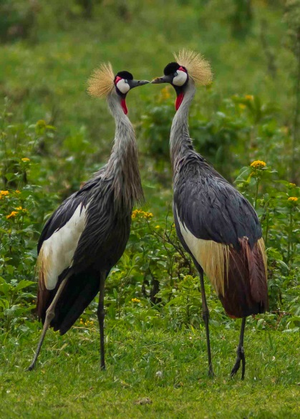
January 2015

Prepared by
International Crane Foundation / Endangered Wildlife Trust Partnership

With funding from
the Federal Office for the Environment in Switzerland

Compiled by: Kerryn Morrison
E-mail for correspondence: kerrynm@ewt.org.za / kerryn@savingcranes.org

Support for this action plan:
The development and production of this action plan has been prepared with the financial support of the Federal Office for the Environment in Switzerland, The Nature and Biodiversity Conservation Union – NABU, Dohmen Family Foundation and Kölner Zoo. The AEWA Single Species Action-Planning Workshop for the Conservation of the Grey Crowned Crane was held at Musanze, Rwanda, hosted by the Rwanda Environment Management Authority and organised by the International Crane Foundation / Endangered Wildlife Trust Partnership. Workshop participants were also given a tour of Rugezi Marsh where the opportunity to see Grey Crowned Cranes was provided, thanks to the Kitabi College of Conservation and Environmental Management in Rwanda.

List of contributors:
Ann & Mike Scott (Namibia Crane Working Group), Barirega Akankwasa (Ministry or Tourism and Wildlife, Uganda), Clarissa Kawera (Rwanda Environment Management Authority, Rwanda), Claudien Nsabagasani (Albertine Rift Conservation Society - ARCOS, Rwanda), Damien Nindorera (National Institute for Environment and Nature Conservation - INECN, Burundi), Derek Pomeroy (Makerere University, Uganda); Djuma Nsanzimana (Rwanda Environmental Management Authority - REMA, Rwanda), Fadzai Matsvimbo (BirdLife Zimbabwe), Griffin Shanungu (International Crane Foundation / Endangered Wildlife Trust Partnership and Zambia Wildlife Authority), Harriet Mostert-Davies (Endangered Wildlife Trust, South Africa), Humbu Mafuma (Department of Environmental Affairs, South Africa), James Gichiah Njogu (Kenya Wildlife Services, Kenya), James Harris (International Crane Foundation and Wetlands International / IUCN Crane Specialist Group), Jimmy Muhoozi Muheebwa (NatureUganda, Uganda), Kabelo Senyatso (BirdLife Botswana), Kabemba Donatien Muembo (Institut Congolais pour la Conservation de la Nature - ICCN, DRC), Kerryn Morrison (International Crane Foundation / Endangered Wildlife Trust Partnership), Kizungu Robert Byamana (OBIKOK, DRC), Laurent Ntahuga (Association Burundaise pour la Protection de la Nature - ABO, Burundi), Marie Laetitia Busokeye (Rwanda Environment Management Authority - REMA, Rwanda), Marshall Banamwana (Kitabi College of Conservation and Environmental Management - KCCEM, Rwanda), Megan Diamond (Endangered Wildlife Trust, South Africa), Michael Flyman (Botswana), Nascimento António (Ministry of Environment, Angola), Nathaniel Gichuki (University of Nairobi, Kenya), Neil Baker (Tanzanian Bird Atlas, Tanzania), Olivia Mufute (Zimbabwe Parks and Wildlife Management Authority, Zimbabwe), Osiman Mabhachi (International Crane Foundation / Endangered Wildlife Trust Partnership), Paul Kariuki Ndang’ang’a (BirdLife International Africa Secretariat, Kenya), Richard Beilfuss (International Crane Foundation), Sadiki Lotha Laisser (Ministry of Natural Resources and Tourism: Wildlife Division, Tanzania), Serge Joram Nsengimana (Association pour la Conservation de la Nature au Rwanda - ACNR, Rwanda), Sergey Dereliev (UNEP/AEWA Secretariat), Stephanie Aken (Endangered Wildlife Trust, South Africa), Stephanie Tyler (Botswana), Stephen van der Spuy (Pan African Association of Zoos and Aquaria - PAAZA), Tanya Smith (Endangered Wildlife Trust, South Africa), Telesphore Ngogo (Rwanda Development Board, Rwanda), Tim Dodman, Twakundine Simpamba (Zambia Wildlife Authority, Zambia), Werner Schroeder (The Nature and Biodiversity Conservation Union – NABU, Germany), William Mgoola (Department of National Parks and Wildlife, Malawi), William Olupot (Nature and Livelihoods, Uganda), Wilma Lutsch (Department of Environmental Affairs, South Africa).

Milestones in production of this plan:
10-13 September 2013: Action Planning Workshop, Musanze, Rwanda
2 September 2014: 1st consultation draft submitted to the action planning workshop participants
18 November 2014: 2nd draft submitted to the Range States and to the AEWA Technical Committee for consultation
3-6 March 2015: 3rd draft submitted to the AEWA Technical Committee for consultation
8-10 July 2015: 4th draft submitted to the AEWA Standing Committee for approval to be submitted to the AEWA MOP
9-14 November 2015: Final draft submitted for approval to the 6th Session of the Meeting of the Parties to AEWA (9-14 November 2015, Bonn, Germany)

Geographical scope:
This Single Species Action Plan requires implementation in the following countries supporting Grey Crowned Cranes: Burundi, Democratic Republic of Congo, Kenya, Mozambique, Rwanda, South Africa, Tanzania, Uganda, Zambia and Zimbabwe. Some level of implementation may also be required in Angola, Botswana, Malawi, Namibia and South Sudan, where very small populations of Grey Crowned Cranes are also found.

Revisions:
This plan should be reviewed and updated every ten years. An emergency review will be undertaken if there is a significant change to the species’ status before the next scheduled review in 2025.

Recommended citation:
Morrison, K. (compiler) 2015. International Single Species Action Plan for the Conservation of the Grey Crowned Crane Balearica regulorum. AEWA Technical Series No. XX.

Photo credit:
Grey Crowned Crane pair, Rwanda: Sergey Dereliev (UNEP/AEWA), www.dereliev-photography.com

Table of contents

Table of contents 5
List of Acronyms 7
Foreword 8
EXECUTIVE SUMMARY 8
1 – BIOLOGICAL 9
1.1 General Information 9
1.2 Taxonomy and Systematics 9
1.3 Distribution 9
1.4 Habitat Requirements 12
1.5 Productivity and Survival 13
1.6 Life history 13
1.7 Population Size and Trends 14
2 - THREATS 19
2a. Threats causing reduced adult and juvenile survival / increased functional loss of birds (removal from the wild) (Figure 2) 19
2b. Threats causing reduced breeding success and reproductive rates (Figure 3) 22
2c. Threats causing a high degree of habitat loss, fragmentation and degradation (Figure 4) 24
2d. Knowledge gaps and needs (Figure 5) 29
3 – POLICIES AND LEGISLATION 31
4 - FRAMEWORK FOR ACTION 37
5 – INTERNATIONAL COORDINATION OF ACTION PLAN IMPLEMENTATION 47
6 - REFERENCES 47
Annex 1: Ranking of threats by country 50
Annex 2: Key sites 52
Annex 3: Legal status, conservation measures & monitoring 55
Annex 4: Mind maps showing the actions and priorities for each of the objectives 58
Annex 5: Names of the Grey Crowned cranes in some different languages 60
Annex 6: Modelling Report for the Grey Crowned Crane Population 61
6.1 Modelling approach and key questions 61
6.2 Modelling task 61
6.3 Conceptual model of the life cycle of Grey Crowned Cranes 61
6.3.1 Notes on reproduction 62
6.3.2 Notes on survival 63
6.4 The baseline model 63
6.4.1 Input parameters 64
6.4.2 Output data 66
6.4.3 Notes on the baseline model output 66
6.5 Baseline model for East African populations 66
6.6 Demographic sensitivity analyses 66
6.6.1 Outputs of sensitivity analyses run online baseline data from KZN 67
6.7 Key population drivers: knowledge gaps and priorities for action 70
6.8 Modelling questions revisited: final summary 71
6.9 References 71
Annex 7: International Working Group Terms of reference 72
Goals 72
Role 72
Remit 72
Membership 72
Meetings 73
Reporting 73
Financing 73

List of Acronyms

ABN Association Burundaise pour la Protection de la Nature
ACNR Association pour la Conservation de la Nature au Rwanda
AEWA Agreement on the Conservation of African-Eurasian Migratory Waterbirds
ARCOS Albertine Rift Conservation Society
CITES Convention on International Trade in Endangered Species of Wild Fauna and Flora
CMS Convention on the Conservation of Migratory Species of Wild Animals (Bonn)
COP Conference of Parties
DRC Democratic Republic of Congo
DR Congo Democratic Republic of Congo
EIA Environmental Impact Assessment
EWT Endangered Wildlife Trust
GCC Grey Crowned Cranes
IBA Important Bird Area
ICCN Institut Congolais pour la Conservation de la Nature
ICF International Crane Foundation
INECN National Institute for Environment and Nature Conservation
IUCN World Conservation Union
IWC International Waterbird Census
KCCEM Kitabi College of Conservation and Environmental Management
NABU The Nature and Biodiversity Conservation Union
NGO Non-Governmental Organisation
PAAZAB African Association of Zoos and Aquaria
PhD Doctor of Philosophy
Ramsar The Convention on Wetlands (Ramsar, Iran, 1971)
REMA Rwanda Environment Management Authority
SEA Strategic Environmental Assessment
TAWIRI Tanzania Wildlife Research Institute
UNEP United Nations Environment Programme
UNESCO United Nations Educational, Scientific and Cultural Organization
VU Vulnerable
WAZA World Association of Zoos and Aquaria
ZAWA Zambia Wildlife Authority

Preface

EXECUTIVE SUMMARY
Grey Crowned Cranes Balearica regulorum, icons of Africa’s wetlands and grasslands, are found scattered across their range in Africa, which extends from South Africa in the south to Uganda and Kenya in the north. Divided by the Zambezi River system, two sub-species are recognized, namely the East African Grey Crowned Crane B.r.gibbericeps to the north and the Southern African Grey Crowned Crane B.r. regulorum in the south. Due to the decline of the species of up to 80% over the past 45 years, the species is now listed as Endangered on the IUCN Red Data List.

Grey Crowned Cranes are found in mixed wetland – grassland / open savannah systems. They are dependent on wetlands for nesting, and can hatch and rear up to four chicks in a breeding attempt. They are monogamous and highly territorial during the breeding season, coming together in flocks in the non-breeding season. Floater flocks of non-breeding adults, sub adults and juveniles can be found all year round. Omnivorous, they forage in wetlands, grasslands and in open savannas, preferring grass seeds, insects and other invertebrates. They are also highly opportunistic and are often found foraging in agricultural lands. At night, and when resting during the day, Grey Crowned Cranes can most often be found in tall trees or on tall infrastructure, such as electricity poles or pylons.

Grey Crowned Cranes, due to their charisma and beauty, are highly sought after for the captive trade market, where they often have low productivity and relatively high mortality rates. As a result, there is a constant pressure on wild populations across Africa for chicks. Also contributing to reduced breeding success is human disturbance which keeps adult cranes from tending to nests and their chicks. These two threats are further exacerbated by habitat loss and degradation of the wetlands on which they depend, most often caused by agricultural encroachment, afforestation, changes in hydrology, mining and siltation; providing easier access into wetlands which usually results in increased disturbance and provides easier access to chicks. Although there are several other threats to the species, the collision and electrocution of cranes with power lines is another significant threat, and one that has the potential to significantly increase as many parts of Africa undergo electrification.

We have significant gaps in our knowledge of the species, their habitats and the threats posed to them, all of which require understanding so that effective conservation action can be developed. This includes in particular our knowledge on the status and demography of the species; the characteristics of the wetlands they require for nesting and the availability of such habitats; the plans for and potential impact of infrastructural development at key cranes sites; and a full understanding of the trade chains and demand markets.

This Single Species Action Plan aims ultimately to remove the Grey Crowned Crane from the globally threatened categories on the IUCN Red List and from Column A, Category 1 of the AEWA Table 1. To achieve this, the Action Plan outlines activities to stabilize current populations and maintain the current range and area of occupancy for the East African sub-species; and increase the population size and maintain the current range and area of occupancy for the Southern African sub-species. The objectives are to reduce adult and juvenile mortality and loss of birds; increase breeding success and reproductive rates; reduce significantly further loss, fragmentation and degradation of habitats; and fill key knowledge gaps about Grey Crowned Cranes. Proposed actions include the improvement of legislation enforcement, increasing awareness on several issues, addressing the crane trade, reducing the impact of power lines, securing sites important to cranes, and ensuring sustainable management and use of key sites. It will only be through a highly collaborative approach involving governments, NGO’s, research institutions, zoos, power utility companies and other organisations, in a multi-disciplinary and multi-pronged manner that the future of Grey Crowned Cranes in Africa will be secured.

1 – BIOLOGICAL

1.1 General Information
Grey Crowned Cranes Balearica regulorum, icons of Africa’s grasslands and wetlands, are highly revered by many cultures and are valued for their beauty and charisma. Standing around 106 cm tall, they can easily be recognized by their grey body, predominantly white wings with feathers of brown and gold, white cheek patches, a red gular sack under the chin and their characteristic crown of stiff golden feathers. There are two sub-species, which are most easily distinguished by their facial features. The East African Grey Crowned Crane B. r. gibbericeps has a larger area of bare red skin above the white cheek patch than the Southern African Grey Crowned Crane B.r. regulorum. Males and females are virtually indistinguishable, although males tend to be slightly larger. Although individuals and sexes cannot be differentiated by their call, Budde (2001) determined that the individuals of a pair adapt their calls to that of their mate, allowing for pair discrimination.

The Grey Crowned Crane is listed as Endangered in the 2012 IUCN Red Data List because threats such as habitat loss and the illegal removal of birds and eggs from the wild have resulted in a decline of up to 79% over the past 45 years (BirdLife International 2012). The East African sub-species is experiencing a long-term population decline with fragmenting range and a rapidly contracting area of occupancy. The Southern African sub-species has a declined population with a fragmenting range and a contracting area of occupancy. The Southern African Grey Crowned Crane is also listed in Column A, categories 1b and 1c and the East African Grey Crowned Crane in Column A, categories 1b and 3c of the AEWA Table 1^{a/}.

1.2 Taxonomy and Systematics
The Grey Crowned Crane Balearica regulorum (Bennett 1834) is one of 15 extant species of crane in the world. Within the family Gruidae, only two of the crane species are found in the Balearicinae Sub-Family, namely the Grey Crowned and Black Crowned Balearica pavonina Cranes. The most ancient of the cranes, crowned cranes pre-date the other extant crane species by tens of millions of years. Their coiled trachea producing a honking call and their long hind toe or hallux, providing crowned cranes with the ability to grasp onto structures for roosting or perching, are unique characteristics in this crane sub-family. Grey Crowned Cranes have two sub-species, namely the East African B.r. gibbericeps and the Southern African B.r.regulorum Grey Crowned Cranes.

Class: Aves
Order: Gruiformes
Family: Gruidae
Sub-family: Balearicinae
Genus: Balearica
Species: regulorum
Sub species: regulorum and gibbericeps
Alternative names: Crested Crane; French: Grue couronnée

1.3 Distribution
Grey Crowned Cranes undertake variable movements in response to the abundance and distribution of food and nesting sites (Pomeroy 1980; Brown 1992; Dodman 1996a & b). Some of these movements traverse national boundaries.

The two sub-species of Grey Crowned Crane are separated by a generally recognized biogeographical boundary following the Zambezi River valley.

Table 1: Range states of the Grey Crowned Crane ¹

Countries with more than 500 Grey Crowned Cranes | Countries with less than 500 Grey Crowned Cranes | Countries with less than 20 Grey Crowned Cranes
East African Grey Crowned Crane
DRC | Angola | Malawi
Kenya | Burundi | South Sudan
Uganda | Northern Mozambique
Tanzania | Rwanda
Zambia
Southern African Grey Crowned Crane
South Africa | Southern Mozambique | Botswana
Zimbabwe |  | Namibia
¹ Although this table represents countries where Grey Crowned Cranes are found, it is acknowledged that the cranes found in any one country could be part of a transboundary or regional population.

Core distribution
The Grey Crowned Crane occurs from eastern Demographic Republic of Congo (DRC), southern Uganda and Kenya in the north to south-eastern South Africa in the south. The main centres of distribution, containing at least 1% of each of the populations for the Southern (at least 75 individuals) and East African Crowned Cranes (at least 250 individuals) respectively are:

Southern African Grey Crowned Crane
- Drakensberg Foothill Grasslands of KwaZulu-Natal and northern Eastern Cape Provinces of South Africa.
- Highveld Grasslands of South Africa, encompassing in particular the Chrissiesmeer Lakes District, Steenkampsberg Wet Grasslands and Enkangala Grasslands.
- Driefontein Grasslands located in the central region of Zimbabwe.
- The irrigated farms and pans in the Nkayi and Lupane districts in the western region of Zimbabwe.

East African Grey Crowned Crane
- The Bulozi Floodplains, encompassing Liuwa Plains and the Barotse Floodplain in western Zambia, and extending north westwards into eastern Angola.
- The Luangwa valley in Zambia.
- Kafue Flats and associated breeding grounds in Zambia.
- The northeast Lake Victoria Basin in western Kenya encompassing in particular Busia Grasslands, Kingwal Swamp and Saiwa Wetlands.
- The west-southwest Lake Victoria Basin, encompassing the Kabale wetlands of south western Uganda and Rugezi Marsh and surround of northern Rwanda, and extending marginally westwards into the catchment of Lake Edward.
- Kaku-Kiyanja Wetland and surrounds in south-central Uganda on the western shore of Lake Victoria.
- Kampala and its immediate surrounds in Uganda.
- The Usangu Flats in south western Tanzania.
- The Ngorongoro Conservation Area in Tanzania.

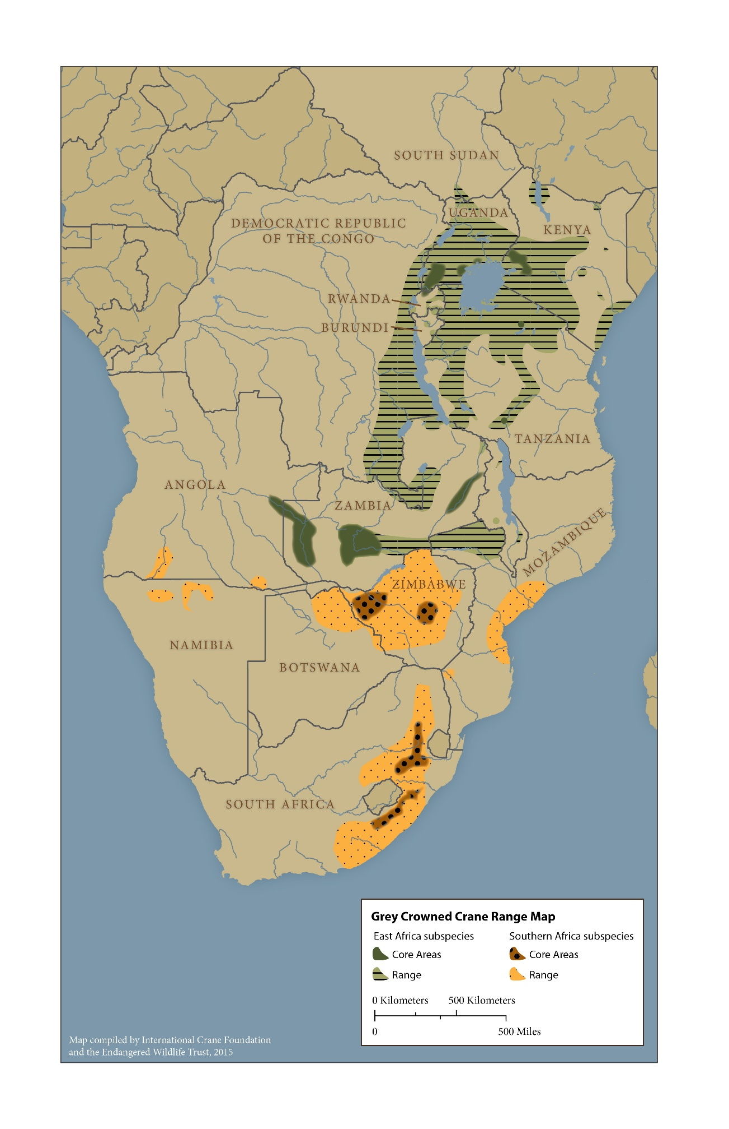
Figure 1. The distribution and main centres of distribution (core distribution) of the two sub-species of Grey Crowned Crane as described in 1.3.

1.4 Habitat Requirements
Grey Crowned Cranes require a mixed wetland-grassland habitat, and are often found in wetlands, on riverbanks, around dams, in open savannas and in short to medium height grasslands adjacent to such sites (Pomeroy 1987; Urban 1988; Meine & Archibald 1996; Stabach et al. 2009). They are also often found foraging in agricultural land wherever available, in close proximity to the habitats listed here (Pomeroy 1980; Gichuki & Gichuki 1992; Gichuki 2000; Muheebwa-Muhoozi 2001).
They nest within or on the edges of permanent or temporary wetlands; but will also use well vegetated farm dams. They have adapted to habitat transformation, and in Uganda Olupot et al. (2009) recorded 47% of nests within wetlands that were only partly disturbed, 35% in wetlands that had been severely disturbed and only 18% in intact wetlands. In KwaZulu-Natal, South Africa, 77% of nests were found in partially dammed wetlands, and 23% in natural wetlands (McCann & Wilkins 1995). Morrison et al. (1998), however, found through their research in Mpumalanga, South Africa, that the cranes avoided wetlands with adjacent land uses that had a significant impact on the wetland. In eastern Uganda, Olupot (2014) found that nests were most often located towards the middle of wetlands, and were even occasionally found in rice fields. The nests themselves are found within tall reedy wetland vegetation (e.g. Typha or Cyperus reed beds), concealed from terrestrial predators and screened from view (Muheebwa-Muhoozi 2001; Olupot 2014). They are however, easily seen from the air and appear as bulls eyes within wetlands. The area around nests is trampled up to 20 metres in diameter, supposedly to reduce the chance of predation (Walkinshaw 1973; Pomeroy 1980; Tarboton 1992; McCann & Wilkins 1995; Morrison 1998; Smallie 2002; Ewbank 2003). They have also, on very rare occasions, been known to nest in trees (Steyn & Ellman-Brown 1974; Steyn & Tredgold 1977; Ewbank 2003).

Grey Crowned Cranes forage in short to medium height open grasslands, feeding on grass seeds, small toads and frogs, insects and other invertebrates (Pomeroy 1980; Frame 1982; Gichuki 2000; Muheebwa-Muhoozi 2001). Mundy et al. (2000) found many small stones within the stomach of an adult Grey Crowned Crane, most likely ingested to help break down the hard and fibrous plant material they feed on. They are, however, also frequently found foraging in agricultural lands, including pastures, irrigated areas, fallow fields, newly harvested cereal crops and newly planted cereal crop (Pomeroy 1980; Gichuki & Gichuki 1992; McCann & Wilkins 1995; Morrison 1998; Gichuki 2000; Muheebwa 2001; Muheebwa-Muhoozi 2001). They have also been known to eat the seed from ripening cereal crops (Pomeroy 1987). Soya beans, ground nuts, millet, potatoes and maize appear to be the crops of choice for cranes (Pomeroy 1980; Muheebwa-Muhoozi 2001). Their use of agricultural lands unfortunately often brings them into conflict with farmers as a result of both the actual and perceived damage caused to crops (Katondo 1996; Smallie 2000). The Grey Crowned Crane’s generalist foraging strategy though has resulted in them adapting to human settlement and they are therefore often seen in human-modified environments (Meine & Archibald 1996; McCann & Wilkins 1995). This has even extended to Kampala’s main rubbish dump in Uganda, where a flock of up to 95 Grey Crowned Cranes has been feeding daily in recent years (Nachuha et al. 2012; Ndibaisa 2013).

Grey Crowned Cranes roost primarily in tall trees in the vicinity of wetlands. Very often, and where available in the absence of indigenous tree species, Eucalyptus, wattle and pine trees whose high bare branches command a good view are used (Walkinshaw 1964; Allan 1996; Pomeroy 1980). In Uganda, Grey Crowned Cranes most often roost in Milicia excelsa, Cupressun spp, Chlorophora excelsa and Ficus spp (Pomeroy 1980; Muheebwa 2001; Olupot 2014). Shanungu (pers. comm.) recorded roosting on the ground in wetlands or in Acacia trees in both the Kafue Flats and Liuwa Plains in Zambia, akin to Frame’s (1982) reports of cranes roosting in Acacia xanthophloea in the Serengeti National Park and in short grasslands in the Ngorogoro Conservation Area in Tanzania. Olupot (2014) also reported ground roosting sites in natural and man-made wetlands in Uganda. Grey Crowned Cranes will also roost on high voltage pylons making them vulnerable to electrocution (Muheebwa 2001; Ndibaisa 2013; Morrison pers. comm.). Although Nachuha et al. (2013) and Olupot (2014) found Grey Crowned Cranes in eastern Uganda most often roosting with other cranes, they did occasionally find them roosting in mixed colonies with pelicans, egrets and other birds. The cranes leave their roosts between dawn and an hour after dawn and return around nightfall (Pomeroy 1980; Muheebwa 2001; Olupot 2014).

1.5 Productivity and Survival
Grey Crowned Cranes have a low breeding success rate which improves with experience and the length of time a pair bond has been in place (Pomeroy 1987; Gichuki 1996). There is strong evidence to suggest that only a portion of the adult population breeds in any one year, and can be as low as 50% in drier years (Pomeroy 1987; Ewbank 2003).

Grey Crowned Cranes lay between one and four eggs at a time and between one and four chicks can be raised by the pair; Gichuki (1996) though recorded a maximum of 3 eggs at any nest in Kenya. Due to their secretive nature when breeding, nests and chicks are often difficult to find or see and hence it is not easy to determine clutch size and hatching success. In the north eastern parts of the Eastern Cape of South Africa, an average clutch size of 2.55 eggs (Smallie 2002) has been recorded. Tarboton (1992), however, reported a slightly bigger mean clutch size of 2.69 eggs for the former Transvaal in South Africa. In East Africa, an average clutch size of 2.41 eggs in Kenya (Gichuki 1996) and 2.56 eggs in Uganda (Pomeroy 1980) have been reported. Pomeroy (1980) noted though that clutch size seemed to vary with altitude in Uganda, with pairs nesting above 1500 m producing on average 2.17 eggs / nest, and those below 1500 m laying on average 2.72 eggs / nest.

Mafabi (1991), Smallie (2002) and Ewbank (2003) reported that nests failed due to predation of eggs (particularly by crows), flooding of nests, destruction of nests by people, and cases of nest abandonment. Muheebwa (2001) though reported no significant egg loss in Uganda, but noted that adults usually left the nest after the first two eggs had hatched, abandoning the remaining eggs. Re-nesting occurred if clutches were lost early in the season. With these egg losses, Gichuki (1996) recorded an average clutch size at hatching of 2.08 chicks in Kenya.

Fledging success rates vary considerably not only temporally and spatially, but also in the way that they are calculated and reported, making it difficult to compare between regions and time periods. In South Africa, averages between 0.61 (Smallie 2002; Smallie 2003) and 1.7 fledglings per pair that hatched chicks (Filmer et al. 1985) have been reported. Analyses of Grey Crowned Crane data from KwaZulu-Natal in South Africa, for purposes of population modelling (Appendix 6) for this report, found an average of 1.05 fledglings per pair that attempted to breed. In Uganda, averages of 1.3 (Pomeroy 1980), 0.8 (Muheebwa 2001) and 1.5 fledglings per pair that hatched chicks (Muheebwa pers. comm. in 2013) have been recorded, and Gichuki (1996) reported 1.32 fledglings per pair in Kenya.

Pomeroy (1987) estimated that the first year mortality of cranes in Uganda and Kenya was 45%, decreasing to 10 – 20% in their second year and falling to 4.9% from three years old onwards. Mark recapture survival analyses on Grey Crowned Crane data from KwaZulu-Natal, South Africa for the population modelling (Appendix 6) for this report suggests a 35.3% mortality rate for cranes between fledging and one year, and a mortality rate of 7.2% annually thereafter.

Although no substantiated data on the longevity of cranes is available, Gichuki (1996) estimated that cranes live to 20 years of age, and Pomeroy (1987) estimated between 15 and 20 years. A generation time of 15 years was used for the IUCN Red Data List uplisting to Endangered. This, however, was estimated from personal communications with several Grey Crowned Crane experts, rather than from data and hence could be revised once improved data on the species have been collected.

1.6 Life history
Maturing at between four and five years of age, Grey Crowned Cranes are monogamous once they develop their pair bonds. In Kenya, however, pair bonds are formed at two to three years of age and after a year of monogamy, the pair will start to breed (Gichuki 1996). Pomeroy (1987) though suggests that Grey Crowned Cranes first breed at between 4 and 6 years old. Pair bonds are strengthened by unison calling, mutual preening of the neck and elaborate dancing (Pomeroy 1980), even when within a flock. Although Gichuki (1993) witnessed divorces between pairs, this was unusual and he found that pairs usually stayed together.
Grey Crowned Cranes are territorial in the breeding season, using an average home range of 23.3 km² (2 330 ha) in South Africa (Tarboton 1992), and 6 km² (600 ha) in Kenya (Gichuki 2000). Home ranges though do differ in size dependent on food availability, and breeding pairs and families have smaller home ranges than non-breeding flocks. Gichuki (2000) found that breeding birds moved on average 3.14 km from their nest each day, whereas non-breeding birds moved on average 6.72 km from a roost site daily. Although they appear to return to the same wetland each season to breed, they seldom re-use the same nest.
Timing of breeding varies according to the rains, with most Grey Crowned Cranes nesting in the wetter seasons when nests are most inaccessible (Pomeroy 1987; Muheebwa 2001). In South Africa, the breeding season extends from October to March, with peak egg laying occurring between November and January (McCann & Wilkins 1995; Morrison 1998; Smallie 2002; Ewbank 2003). In Tanzania, the cranes nest predominantly from December to May (Frame 1982; Pomeroy 1987), in Kenya they nest between December and June (Urban et al. 1984; Gichuki 1996; Gichuki 2000) and in the Luangwa Valley of Zambia, they nest in February (Konrad 1987). Uganda though is an anomaly and although Grey Crowned Cranes can be found breeding in any season, they have two distinct egg laying peaks –December and June. These two peaks coincide with the drier seasons which, in a country with high rainfall, reduces the risks of flooding and also coincides with the abundance of seeds and insects following the rainy seasons (Pomeroy 1980; Muheebwa 2001).
Incubation is 26-30 days (Maclean 1993; Gichuki 1996; Holtshausen 1996; Gichuki 2000; Muheebwa 2001). Both individuals of the pair take turns in incubating the eggs and share parental duties (Mafabi 1991; Meine & Archibald 1996), crushing the egg shells and covering them with grass following hatching (Mafabi 1991). Adult males spend more time defending resources in the territory and females on rearing chicks (Gichuki 2000). Chicks are fed by the parents up to 60 days old and then feed with the parents in the same foraging patches to 120 days (Gichuki 1996).
Chicks fledge at between 100 and 120 days (Gichuki 1996). Once fledged, the family group will usually move into a flock and remain with the flock for the non-breeding season. The juveniles associate with their parents for seven to ten months (Gichuki 1996). The breeding pair will then return to their nesting area the following season to nest again, leaving the chick in the non-breeding flock. Although relatively small in size, these non-breeding flocks cover bigger distances, increasing in size as family groups join the flock and localising their movements in the non-breeding season (McCann & Wilkins 1995), where they will often be found alongside main breeding wetlands or areas (Tarboton 1992). Young cranes can be distinguished up to the age of one year old, but only reach full adult size at two years old (Pomeroy 1980).

In South Africa, flocks range in size from 7 to 300 birds, with flocks larger than 10 usually recorded in the non-breeding season; the biggest flocks being found in the Eastern Cape (Geldenhuys 1984; Tarboton 1992; Smallie 2000; McCann 2003). The larger flocks are most often seen on agricultural lands (Filmer et al. 1986). In Uganda, flocks of up to 350 cranes have been recorded in the mid and extreme south western parts of Uganda. They are mostly seen on rangelands and other agricultural lands (Muheebwa 2001). In 2012 a flock of around 600 Grey Crowned Cranes was observed on and around the Eldoret Airport in Kenya (Eshiamwata pers. comm.).

1.7 Population Size and Trends
The Grey Crowned Crane was considered the most common crane in Africa in 2004 with the population estimated at 50,000 to 64,000 individuals (Beilfuss et al. 2007). It has, however, been experiencing a steady long term decline across much of its range. When this species was uplisted from Least Concern to Vulnerable in the 2009 Red List update, there was some evidence to suggest that declines may have exceeded a rate of 50% during the past three generations or 45 years (Beilfuss et al. 2007), but data were regarded as patchy and an overall decline of 30-49% was considered a more reasonable estimate.

With the addition of more complete data, overall estimates suggest that the species’ global population has declined by over 50% in 19 years, and when these data are extrapolated to a period of 45 years, assuming an exponential trend, the calculated rate of decline is c.65-80%. This sharp decline, together with the fact that the issues causing this decline have been in existence since the 1960’s and are showing no signs of abating, has led to the uplisting of Grey Crowned Cranes from Vulnerable to Endangered in the 2012 Red List update (Birdlife International 2012). The Southern African Grey Crowned Crane is also listed in Column A, categories 1b and 1c and the East African Grey Crowned Crane in Column A, categories 1b and 3c of the AEWA Table 1^{a/}.

The status of the Grey Crowned Cranes sub-species was defined as follows in the Rwandan workshop:
- East African sub-species: Significant long-term population decline with fragmenting range and rapidly contracting area of occupancy.
- Southern African sub-species: Declined population with fragmenting range and contracting area of occupancy.

Grey Crowned Cranes are most abundant in Kenya, South Africa and Uganda, albeit that Kenya and Uganda have and continue to suffer significant declines in population. South Africa currently has the most stable and viable population on the African continent and the large floodplains of Zambia support a substantial and increasing population. Burundi, Mozambique, Rwanda, Tanzania and Zimbabwe all have relatively smaller, but still viable populations of between 100 and 2000 birds each. Botswana, Malawi and Namibia have very few Grey Crowned Cranes remaining, and the status of the species in the Angola and the Democratic Republic of Congo is largely unknown. Of note is that Southern Sudan has recently reported sightings of Grey Crowned Cranes, a new species for the country, but still in very low numbers. This is likely a range extension of the species up the Nile River, from the northern parts of Uganda (Dodman pers. comm.)

In collaboration and discussion with a number of experts in each of the range states in which Grey Crowned Cranes are found, Morrison & Baker (2012) estimated the number of Grey Crowned Cranes in each country. These, together with information collected at the action planning workshop and discussions for the 6th AEWA Conservation Status Review of Waterbird Population Estimates, outline the current estimated number of Grey Crowned Cranes in each country (Table 2). These are however only estimates and the varying opinions in the workshop on the numbers in each country highlight the need for improved estimates to be determined.

Table 2: Estimated number of Grey Crowned Cranes per country

Country | 1985 (Urban 1988) | 2014
East African Grey Crowned Crane
Angola | 100 | 0 - 100
Burundi | <600 | 10- 100
DRC | 5 000 | 300 – 1000
Kenya | 35 000 | 10 000 - 12 500
Malawi | 100’s | 0 - 100
Northern Mozambique | 1 000’s | 50 - 100
Rwanda | <1 000 | 50 -500
South Sudan | 0 | 0 - 10
Tanzania | Low 1000’s | 600 - 1000
Uganda | 35 000 | 6 500 – 8 000
Zambia | 1 000’s | 2 000 – 2 500
East African sub-species total | >90 000 | 19 500 – 26 000
Southern African Grey Crowned Crane
Botswana | 100 | <20
Southern Mozambique | 1000’s | >250
Namibia | 100 | <20
South Africa | Low 1000’s | 6 500
Zimbabwe | Several 1000’s | 200 - 700
Southern African sub-species total | 10 000 | 7 000 - 7 500
TOTAL | >100 000 | 26 500- 33 500

- Angola
Population size and trends
In 1985, it was estimated that Angola probably had around 100 Grey Crowned Cranes. A recent exploratory visit to the Cuvelai Catchment in south-eastern Angola though had no sightings of Grey Crowned Cranes and none of the local communities approached knew this crane (Scott & Scott 2014). Mendelsohn (pers. comm.) also reported no Grey Crowned Cranes during mammal surveys of the Bulozi Floodplain in eastern Angola, but reported the potential for good numbers due to the suitable habitat available. Nascimento (pers. comm.) though noted that Grey Crowned Cranes were regularly seen in the Cuando Cubango Province west along the Cunene River to around Xangongo in the Cunene Province. Their current status is completely unknown for the country.

- Botswana
Population size and trends
The Botswana Grey Crowned Crane population is currently about 20 individuals, lower than the estimated 100 in 1985. However, according to Tyler (pers. comm.) the estimate in 1985 was likely an overestimate, and it is likely that Botswana has never had a significant number of birds. However, this species is not considered a resident in the country, with scattered pairs or small flocks observed only during ideal conditions. Only three breeding records have been documented for the country: a pair breeding at Nata Delta in February 1984 (Skinner 1997); two adults with two downy chicks were seen at Nata Delta in October 1997 (Ray Lovett and Val Lovett pers. comm.) and a pair with a half grown chicks was seen in the Nata Delta in mid-April 1998 (Julia Dupree pers. comm.).

- Burundi
Population size
Prior to the 1960’s Grey Crowned Cranes were wide spread and commonly seen across Burundi, with less than 600 reported in the range wide population estimate in 1985. They are now rarely seen, and only in small family groups across the country. Burundi currently has less than 100 Grey Crowned Cranes left, with recent sightings of family groups at the northern tip of Lake Tanganyika, on the Burundian Plateau in Gitega Province, the lacustrine area in the Kirundo Province and in the Malagarazi River Basin in Rutana Province.

Population trends
Grey Crowned Cranes are declining in Burundi, attributed largely to the fast increasing rural human population which has resulted in the significant transformation of the landscape to agriculture, hence destroying the crane’s habitat. In addition, the cranes are caught for food, the captive trade markets and for domestic holdings.

- Democratic Republic of Congo (DRC)
Population size
In 1985, it was estimated that there were around 5 000 Grey Crowned Cranes in the DCR. They were particularly prevalent in Kivu and Katanga in the past. We have no data on the population size at this time, but they are still seen in the Virunga National Park, Mont Hoyo, Lake Kivu, Ruzizi Plain, Lake Tanganyika, Lualaba (Katanga), Upempa National Park, Kataga Kasai, Maniema and Kivu.

Population trends
Despite no data on the status of the population, it is widely accepted that the species is in decline. This is largely due to the pressure being placed on Grey Crowned Crane habitat as human populations increase primarily through agricultural development, water development projects, mining, activities related to fishing and habitat destruction.

- Kenya
Population size
Kenya probably has between 10 000 and 12 500 Grey Crowned Cranes at present, down from an estimated 35 000 in 1985. They are widespread and are found across 40% of the country. The majority of the population is found in the western parts of Kenya, followed by the central region and parts of the Rift Valley.

Population trends
The crane population has declined significantly in Kenya. This decline is attributed mainly to habitat loss, the subdivision of large scale farms into smaller units and the change of land use to crops less suitable for cranes.

- Malawi
Population size
Although several hundred Grey Crowned Cranes were estimated for Malawi in 1985, they have declined significantly in the country, with only the occasional pair or flock moving through very periodically. For example, a flock of between 20 to 50 birds was reported in South Rukuru between 2012 and 2013 (Mgoola pers. comm.).

Population trend
Declining. This is probably primarily due to the high human population densities and transformation of suitable habitat to agriculture and other land uses.

- Mozambique
Population size
Mozambique’s Grey Crowned Crane population has declined from several 1 000 in 1985 to around 250 individuals. The species primarily occurs south of the Zambezi River, in Gorongosa National Park, the Zambezi Delta, and Banhine National Park, and is presumed to be the southern Africa sub-species. The status of the northern Mozambique population, in and around Niassa National Park, is unknown.

Population trend
The Grey Crowned Crane population in Mozambique appears to stable in central Mozambique, and is possibly in decline elsewhere. Threats likely include reduced water availability due to large dams and water diversions, uncontrolled fires, and (unconfirmed) egg and chick theft.

- Namibia
Population size and trends
The current Namibian population stands at less than 20 birds, down from an estimated 100 individuals in 1985. Similar to Botswana, the species is not considered a resident population, but rather that scattered individuals visit the country during ideal conditions.

- Rwanda
Population size
In 1985, it was estimated that Rwanda was home to more than 1 000 Grey Crowned Cranes. The population is currently estimated to be between 300 and 500 individuals, distributed between the main wetland systems in the country. Rugezi Marsh is the primary site for Grey Crowned Cranes in the country, but they are also found in Akagera National Park, Kamiranzovu Wetland inside Nyungwe National Park, Nyabarongo Wetland and Akanyura Wetland. The latter two, although Important Bird Areas, have no protected area status or protection.

Population trend
Grey Crowned Cranes are declining in Rwanda largely due to their removal from the wild for the domestic pet trade and habitat loss primarily to agriculture. The “Peat to Power” plans for Rwanda, whereby peatlands will be removed for power generation will no doubt escalate this decline further.

- South Africa
Population size
The South African population of Grey Crowned Cranes is the only increasing population across their range. They have increased from a few 1 000 birds in 1985 to an estimated 6 500 in 2012. The population is found along the eastern highland grasslands of the country, with the primary population found on private land in the southern Drakensberg region, traversing the northern parts of the Eastern Cape Province and the southern reaches of the KwaZulu-Natal Province.

Population trend
The species is increasing in the country, with an estimated 44% increase between 2001 and 2012. However, threats to the species include habitat loss, the illegal removal of birds for the captive trade market, collisions on overhead wires, electrocutions on electrical infrastructure and poisoning.

- South Sudan
Population size
Grey Crowned Cranes have only recently been recorded in South Sudan and are most likely birds from Uganda moving north along the Nile River as far north as Juba (Dodman pers.comm.)

Population trend
The species is increasing purely through it being a new species for the country. However, the current trend is largely unknown.

- Tanzania
Population size
With a population estimate of a few 1 000 in the 1985 population estimate for Tanzania, the country currently has less than 2 000 individuals and no real evidence to suggest that there are more than a
1 000. They are widespread across the country, with two non-breeding concentrations on the North West slopes of Mount Kilimanjaro and in the caldera of Ngorogoro Crater. Breeding has been recorded from the northern parts of the country (including Serengeti National Park, Tarangire National Park, Arusha National Park, Lake Manyara National Park and Katavi National Park) and in Usangu, which has been incorporated into Ruaha National Park.

Population trend
The Grey Crowned Crane population in Tanzania has and continues to decline significantly. This decline is attributed to habitat degradation, mining, poisoning and the captive trade market.

- Uganda
Population size
From an estimated population of 35 000 in 1985, the species has declined to a current level of between 6 500 and 8 000 individuals. Although widespread across south-western, southern and south-eastern parts of the country, they are concentrated in the Mbarara / Bushenyi, Masaka and Kabale Regions in the south-western parts of the country.

Population trends
Grey Crowned Cranes have declined by up to 80% over the past 40 years in the country. This has been attributed to habitat loss, capture of cranes for the captive trade markets and human disturbance around nesting sites, resulting in lower breeding productivity.

- Zambia
Population size
In 1985, the population in Zambia was estimated at less than 1 000 individuals. Recent estimates put the population at more than 2 000 individuals. Key sites for cranes in Zambia include Liuwa Plains National Park and the entire Barotse Floodplain in western Zambia, Lochinvar and Blue Lagoon National Parks on the Kafue Flats, Kafue National Park, South Luangwa National Park and Tondwa Pans.

Population trends
The Zambian population, although potentially in decline in some areas, is likely stable to increasing country wide. This is largely due to the fact that the key areas for Grey Crowned Cranes in the country are National Parks and are afforded some degree of protection. That said, the encroachment of the alien invasive Mimosa pigra on the Kafue Flats, uncontrolled fires and human disturbance all pose a serious threat to the species.

- Zimbabwe
Population size
Zimbabwe was home to several 1 000 Grey Crowned Cranes according to the 1985 estimates. However, no country wide surveys have ever been completed and current estimates for the country are completely unknown. They are distributed primarily in Matabeleland.

Population trends
The population is widely believed to be in a decline due to habitat loss, habitat fragmentation, land use changes, and the increased frequency of drought and fires.

2 - THREATS

Grey Crowned Cranes face manifold threats throughout their range. These can be grouped as 2a) threats causing reduced adult and juvenile survival/increased functional loss of birds; 2b) threats causing reduced breeding success and reproductive rates as well as 2c) threats leading to a high degree of habitat loss, fragmentation and degradation. The individual threats and their significance for each sub-species are outlined below. The results of the threat analysis are presented in Figures 2, 3 and 4. A summary of the significance of each threat per country can be found in Annex 4. In addition, prevailing knowledge gaps and information needs are outlined in 2d.

2a. Threats causing reduced adult and juvenile survival / increased functional loss of birds (removal from the wild) (Figure 2)

Illegal trade (domestic and international: safari parks, other captive facilities - including private and public collections and breeding centres , non-associated zoos, hotels or businesses for ornamental use, private gardens for status or ornamental use, prisons)
A large number of Grey Crowned Cranes are removed illegally from the wild each year for the captive domestic and international trade markets. It is acknowledged as well that in some instances, legal trade is used to legalize illegally wild caught chicks. This happens when traders claim that legal pairs in their possession, bred the chicks up for trade, when these were in fact caught illegally from the wild. In some instances, illegal trade results through a lack of awareness and understanding. However, in the vast majority of cases, people are aware of the illegal nature of trade, but they are driven by the economics that accrue at various levels within the trade chain, fuelled further by the fact that the lack of enforcement of relevant environmental legislation and awareness and understanding in judicial systems results in little to no legal action.

Significance: High for the East African sub-species, Medium for the Southern African sub-species

Power line collision and electrocution
Through conservation efforts in South Africa, both power line collisions and electrocutions have been identified as key threats to the species. This will become an increasing threat in the future as the increase of electricity supply across Africa escalates and the electrification network expands. Many of these existing and planned networks and lines are poorly located, with very limited capacity for specialist input into environmental impact assessments for new power lines. This is further exacerbated by the lack of enforcement of environmental impact assessment legislation, and the lack of awareness and cooperation from both the conservation sector and utility companies involved with these developments. Finally, the absence of a cost-effective mitigation device for use in Africa significantly affects engagement in processes aimed at proactively addressing this threat.

Significance: Potentially high for East African sub-species, Medium for Southern African sub-species

Poisoning
Cranes succumb to poisoning for various reasons. They are often deliberately poisoned in retaliation for or to prevent the damage that they cause to agricultural crops. This is unfortunately often as a result of the absence of cost-effective and affordable methods of preventing crop damage. They can also be poisoned accidentally when other species are being hunted for food. However, cranes are seldom eaten when poisoned as they do not have a crop where food is stored after being eaten and before entering the stomach; poisoned food therefore enters straight into the stomach of the bird and its bloodstream, which has people’s heightened awareness of the chances of being poisoned when eating a crane that has ingested poisoned food. Although less of a concern, cranes are also poisoned when agro-chemicals are used irresponsibly or inappropriately on lands. All of these reasons for poisoning are enhanced through the lack of enforcement of environmental and other relevant legislation.

Significance: Medium for both East and Southern African sub-species

(Potential) International legal trade in wild birds (Safari Parks, organisation-linked zoos, other captive facilities)
Grey Crowned Cranes are listed on Appendix II of CITES. The legal trade in cranes to international captive markets was a significant threat in the past. Large numbers of wild caught cranes were exported to Europe, North America and Asia. In recent years though, legal trade of wild caught cranes has declined, with the last CITES recorded wild caught exports from Zambia and Tanzania, and wild caught imports into the USA and China in 2011 (CITES Secretariat 2013). Notably, international trade between 2000 and 2012 consisted primarily of captive bred live birds for commercial and zoological purposes. Most wild caught trade in Grey Crowned Cranes between 2000 and 2012 originated from Tanzania and Sudan, the latter being a country that only recently became a range state for the species. The Arab Emirates, followed by China, have the highest cumulative import of Grey Crowned Cranes between 2000 and 2012 (CITES Secretariat 2013).

The Grey Crowned Crane was included in the Animal Committee’s Review of Significant Trade (document AC24 Inf.4) at its 24th meeting in April 2009 in Geneva. At the 16th CITES Conference of the Parties held in Bangkok, Thailand in 2013, trade in Grey Crowned Cranes from Rwanda, Uganda and Tanzania was suspended. This suspension will remain in place until the country in question can prove that export will not be detrimental to the wild population and that they are able to successfully monitor export permits granted and actual exports, with the goal of limiting exports in order to maintain the species.

Legal trade, however, remains a threat to the species due to a lack of adequate regulations and law enforcement within several of the range countries. This can be exacerbated by a lack of awareness of the current CITES decisions, the trade threat to the species and the identification of the species itself. The potential therefore for this threat to become more relevant in future years is a possibility and should be carefully monitored.

Significance: Medium for East African sub-species, Low for Southern Africa sub-species

Hunting and Trapping
Adult cranes and chicks are sometimes hunted or trapped and killed for food or for ornamental purposes. As charismatic birds known for their monogamous nature, Grey Crowned Cranes are also hunted for traditional medicine. The lack of enforcement of environmental legislation further exacerbates these practices as individuals involved realise that they are unlikely to be persecuted.

Significance: Medium for East African sub-species, Low for Southern African sub-species

Diseases
Disease has the potential to significantly affect Grey Crowned Crane populations. The proximity of cranes to domestic fowl largely as a result of their adaptation to living in close proximity to human settlements, and increasingly so as their natural habitat declines, brings cranes into contact with the diseases that domestic fowl carry or spread. In natural environments, Grey Crowned Cranes will also come into contact with diseases, either carried by long distance migrants or where a natural disease outbreak occurs. Lastly, the release or escape of captive cranes carrying diseases, that were contracted whilst in captivity and in proximity to other captive birds could potentially bring wild cranes into contact with diseases. Although currently a low threat, it does have the potential to become far more significant.

Significance: Unknown for East African sub-species, Low for Southern African sub-species

Domestic legal trade in wild birds
There is currently no legal domestic trade in wild caught cranes. However, lack of regulations, proper enforcement and awareness do contribute to this threat. Of particular concern is the trade in wild caught chicks as captive bred, when traders legalize these through legal pairs that they have under permit.

Significance: Low for East and Southern African sub-species

Collision with telecommunication infrastructure
As with power lines, the telecommunication infrastructure is increasing across Africa. Although a minimal threat at the moment, cranes do collide with overhead lines causing serious injury or mortality. An increase in the installation of multiple telecom masts can be observed, each for a different telecommunications company. With the lack of awareness and cooperation of both conservation agencies and the telecommunications companies, and the lack of enforcement of environmental impact assessment legislation, this will become an increasing threat to cranes.

Significance: Low for East and Southern African sub-species

Predation by dogs
Predation by feral dogs or uncontrolled pets is a localised problem across the range of the cranes. It is a particular problem where dogs are commonly kept as pets, resulting often in a large feral dog population, a number of families not providing sufficient control of their pets and more generally, a complete lack of awareness of the packing and killing instinct of dogs when not under control.

Significance: Low for East and Southern African sub-species

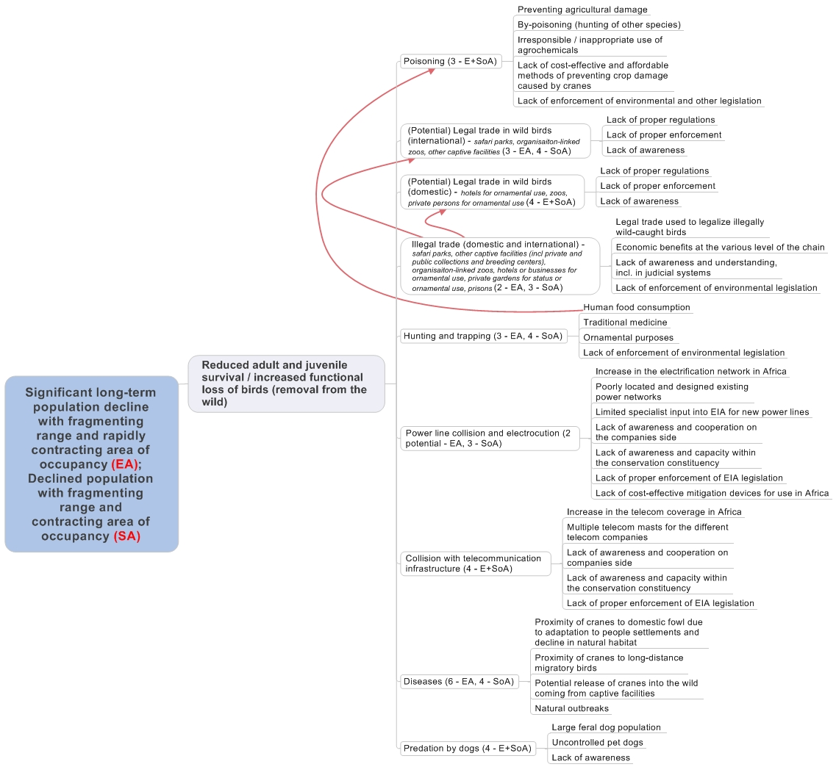

Figure 2 – Problem tree analysis: Threats causing reduced adult and juvenile survival / increased functional loss of birds (i.e. removal from the wild) (1 = critical, 2 = high, 3 = medium, 4 = low, 5 = local, 6 = unknown) (EA – East African sub-species; SA= Southern African sub-species)

2b. Threats causing reduced breeding success and reproductive rates (Figure 3)

Human disturbance
Grey Crowned Cranes, although one of the most adaptable of the crane species, has a sensitivity to human activity which is particularly relevant when in close proximity to nesting or chick rearing sites. High levels of activity and disturbance will often result in nest sites no longer being used or chosen. If used, the crane’s time is spent more on watching for danger than on incubating, feeding or rearing the chicks, often resulting in the mortality of one or more of the chicks. These disturbances come in the form of livestock herding, harvesting of wetland vegetation for livestock fodder and craft making, fishing and the movement of fishermen between sites, farming in wetlands, collection of water or its use for washing and hunting. In the vast majority of cases, the lack of awareness of the people in the vicinity of the nest site, particularly with regard to their impact on the birds, is significant.

Significance: High for East African sub-species. Medium for Southern African sub-species

Illegal trade (Domestic and International)
As above in 2a

Significance: High for the East African sub-species, Medium for the Southern African sub-species

Flooding and drought
Grey Crowned Cranes are dependent on wetlands for breeding. Making their nests within permanently wet areas of the wetland, usually in the wet season, chicks and nests are afforded some protection from predators. However, this behaviour renders them susceptible to flooding, which either results in the loss of suitable breeding habitat or the flooding of nests which drown eggs or small chicks. The impact of flooding is exacerbated in some areas by river regulation and changes in runoff due to catchment degradation, which result in rapid and less predictable flood peaks. At the other extreme, drought will result in unsuitable nesting habitat as access to the nest site is made easier. Changes in these hydrological states occur as a result of changes in the climate, human infrastructure (such as dams or roads), catchment degradation and the general lack of awareness that developments have on ecosystem services, and in this case, hydrology.

Significance: Medium for East and Southern African sub-species

Diseases
As above in 2a

Significance: Unknown for East African sub-species, Low for Southern African sub-species

Natural predation
Cranes have always been predated on to some degree. However, as the extent of natural habitat declines, predator pressures are likely to increase as they eke out an existence in areas that have sufficient prey items, which often also results in the diversification of prey.

Significance: Low for Southern and East African sub-species

Trampling by livestock
High densities of livestock will encourage the use of all habitats irrespective of their suitability. This will result in their use of the wetter parts of the landscape and can result in the trampling of chicks. This is however, a low threat to Grey Crowned Cranes.

Significance: Low for Southern and East African sub-species

Egg collection
Grey Crowned Crane eggs are sometimes collected for human consumption, particularly by fishermen who travel long distances, remaining away from home for extended periods of time. Although illegal, the lack of enforcement of environmental legislation perpetuates this behaviour.

Significance: Low for East and Southern Africa sub-species

Predation by dogs
As in 2a above
Significance: Low for East and Southern African sub-species

Fire
As below in 2c

Significance: Low for East and Southern African sub-species

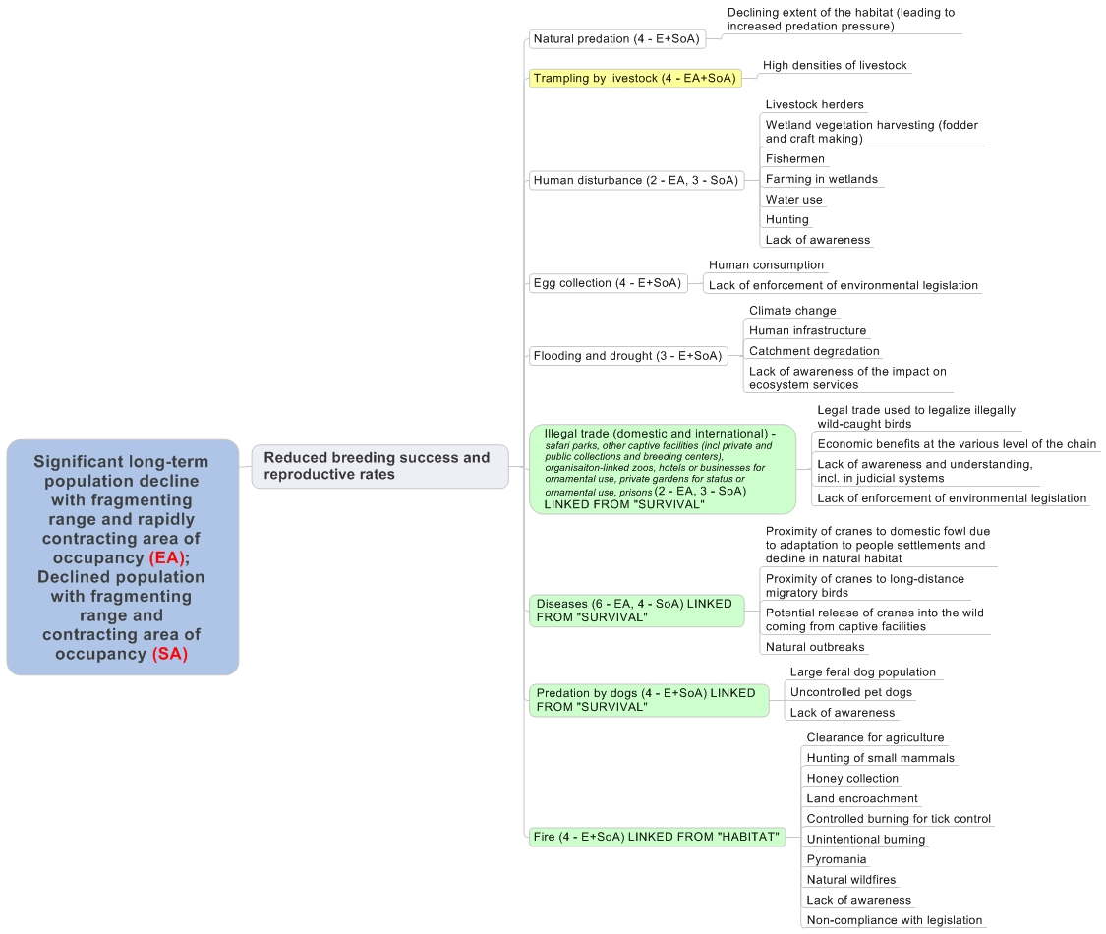
Figure 3 – Problem tree analysis: Threats causing reduced breeding success and reproductive rates (1 = critical, 2 = high, 3 = medium, 4 = low, 5 = local, 6 = unknown) (EA = East African sub-species, SA = Southern African sub-species)

2c. Threats causing a high degree of habitat loss, fragmentation and degradation (Figure 4)

Agriculture
Rapidly growing human populations, together with inadequate land use planning and scarcity of land, has resulted in the encroachment of agriculture into wetlands. This has included both commercial intensification of crops such as flowers, sugar cane, rice and maize, and subsistence agriculture, whereby local communities rely on these lands for their daily livelihoods and for moderate income generation. In many instances this encroachment - although areas are still used by foraging cranes - renders the area completely unsuitable for nesting or chick rearing. Although cranes can adapt to using small remnant wetlands, fragmentation and the edge effect from disturbance are increasing.

Significance: High for East African sub-species, Medium for Southern African sub-species

Eucalyptus afforestation in wetlands
Eucalyptus plantations for timber, construction wood, fire wood and power line poles are increasing. These plantations straddle both the wetlands and their catchments, creating a complete exclusion zone for cranes for any of their life history requirements, except for roosting sites.

Significance: Medium for East African sub-species, High for Southern African sub-species
Mining (brick making, peat, coal, gold, oil (potential))
Many of the wetlands that Grey Crowned Cranes depend upon are being considered for resource extraction of one source or another. In most cases, wetlands are completely destroyed for use by cranes, exacerbated further by the lack of proper enforcement of the environmental impact assessment legislation.

Significance: Medium for East African sub-species, High for Southern African sub-species

Change of hydrological regime
Grey Crowned Cranes are dependent on wetlands for nesting, and require a hydrological regime which is wet enough to provide protection of the nest and small chicks, and yet dry enough for the eggs not to be in water when laid on a platform. Changes in the hydrological regime of these wetlands significantly affect the habitat these cranes require for breeding. Dam construction will often result in flooding of sections of a wetlands and a drying of those sections of the wetland downstream of the dam wall. Water diversions and water abstraction for agriculture both affect the wetland by reducing the water in the system. Climate change further exacerbates these situations. These human induced changes are often caused by a lack of awareness of the impact that such development has on the ecosystem services and a lack of proper enforcement of the environment impact assessment legislation.

Significance: Medium for East African sub-species, High for Southern African sub-species

Siltation
East Africa, in particular, has undergone large scale transformation over the past several decades. This has included varying levels of deforestation across most of the catchments for wetlands important to Grey Crowned Cranes. This, together with improper agricultural practices that deplete the soils and stream bank cultivation or intensive livestock grazing, result in high levels of siltation into wetlands. A lack of enforcement of environmental legislation has further exacerbated the situation, allowing for such practices to progress unheeded. In some situations, this has and can result in a change in the hydrological and subsequently in the vegetation structure of these wetlands, rendering them less suitable for Grey Crowned Cranes.

Significance: High for East African sub-species and Medium for Southern African sub-species

Drainage
Wetlands are drained to improve conditions for crop production and to provide easier access for livestock grazing. Although the reason for the drains is related to a transformation of the habitat for agricultural practices, these drains also affect the hydrology of the wetland and its vegetation. This affect will be experienced not only around the site of the drains but also downstream, the extent of which will be determined by the slope and characteristics of the wetland itself. Although drains in wetlands are illegal, a lack of enforcement of the legislation means that this practice continues uncontested.

Significance: Medium for East and Southern African sub-species

Livestock herding
Livestock herding is not in itself a threat to the habitats that Grey Crowned Cranes depend upon. However, this is dependent on the grazing capacity and practices carried out in each region. Overstocking results in both overgrazing and in intensive trampling of wetlands, both changing the vegetation structure and hydrology of the wetland. Intensive grazing by smaller herds of livestock can also result in impacts on the wetland, seen at a more localised level. Both of these practices are exacerbated by the lack of available land for pastoralists outside of wetlands, experienced particularly in overpopulated countries.

Significance: Medium for East and Southern African sub-species

Infrastructure development (renewable energy –wind and solar, urbanisation, roads, industry)
Growing economies in developing countries almost always bring with them the need for energy, industry and roads for transporting both people and goods between economic centres. The lack of proper enforcement of the Environmental Impact Assessment legislation results in a poor understanding of the environmental impacts of these developments which are then poorly positioned with minimal to no mitigation measures implemented.

Significance: Medium for East and Southern African sub-species

Subdivision of land
With a growing human population across the range of Grey Crowned Cranes, land is a sought after commodity. Increasing human populations translates into more land for agriculture being required as a whole. This is exacerbated further as farming units are reduced in size as inheritances require that land is shared between family members. In many instances, the size of these units is hugely constraining on livelihoods and the demand for more land is consequently increasing. All of this is further exacerbated by land tenure policies which differ between areas and countries, complicating the manner in which the challenges can be resolved.

Significance: Medium for East and Southern African sub-species

Pollution
Sources of pollution vary considerably: agrochemicals used in agricultural practices filter into wetlands; unregulated effluent discharge can flow directly into water resources; industries’ lack of compliance with the conditions of permits for operation result in waste products flowing into water resources; and there is also a deliberate pollution or poisoning of water resources for example for elephant poaching. In all instances, these activities continue or result due to a lack of enforcement of legislation and little adherence to the Environmental Impact Assessment legislation.

Significance: Medium for East African sub-species, Low for Southern African sub-species

Invasive alien plants (Mimosa pigra etc)
The invasion of wetlands by alien invasive plants can change the hydrology and natural vegetation composition of wetlands, rendering wetlands less suitable for Grey Crowned Cranes. This is particular evident in Kafue Flats in Zambia where an invasion of Mimosa pigra has rendered large parts of the floodplain completely unsuitable to cranes. The spread of Mimosa in this system has resulted largely due to a change in the flooding regime due to the management of hydro-electric schemes on either side of the floodplain.

Significance: Medium for East African sub-species, Low for Southern African sub-species

Fire
Fire is and always has been a prominent part of the African grasslands and savannas. However, the different fire regimes, as they vary in timing, frequency and intensity, can have vastly differing effects on the ecological integrity of ecosystems. Controlled fires, used as a management tool for habitat improvement in grasslands and wetlands can benefit Grey Crowned Cranes by providing suitable habitats required for nesting and foraging. However, uncontrolled, unintentional or poorly planned fires, started often through a general lack of awareness of the consequences, to clear land for agricultural purposes, as a result of hunting of small mammals, or when smoking bees out of hives for honey collection, can have detrimental effects on the ecosystems, and sometimes on the communities that live within or adjacent to them. In many situations too, these fires are illegal. As Grey Crowned Cranes breed in the wet season, it is unlikely that fires will directly result in chick loss. Habitat degradation though may well result in reduced breeding success.

Significance: Low for East and Southern African sub-species

Fish production
Small scale fish farms for local food production result in a complete removal of the wetland suitable to Grey Crowned Cranes.

Significance: Low for East and Southern African sub-species

Natural vegetation succession
High grazing pressure can result in the succession of the vegetation composition and structure to those less suitable to Grey Crowned Cranes.

Significance: Low for East and Southern African sub-species

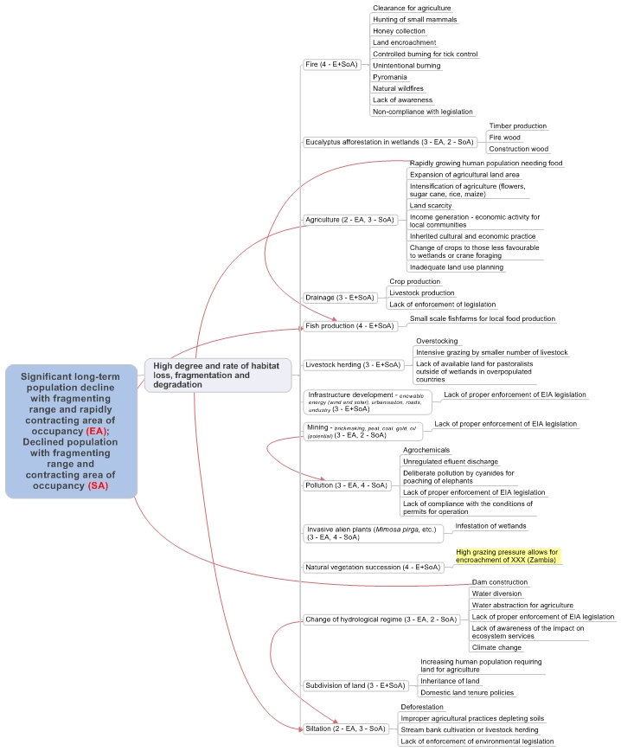

Figure 4 – Problem tree analysis: Threats causing a high degree of habitat loss, fragmentation and degradation (1=critical, 2 = high, 3 = medium, 4 = low, 5 = local, 6 = unknown) (EA = East African sub-species, SA = Southern African sub-species)

2d. Knowledge gaps and needs (Figure 5)

Insufficient knowledge is not a threat per se to the Grey Crowned Crane, but there are significant information gaps that hinder effective implementation of species management and conservation, as illustrated in Figure 5. Meeting these knowledge gaps form an essential part of this action plan.

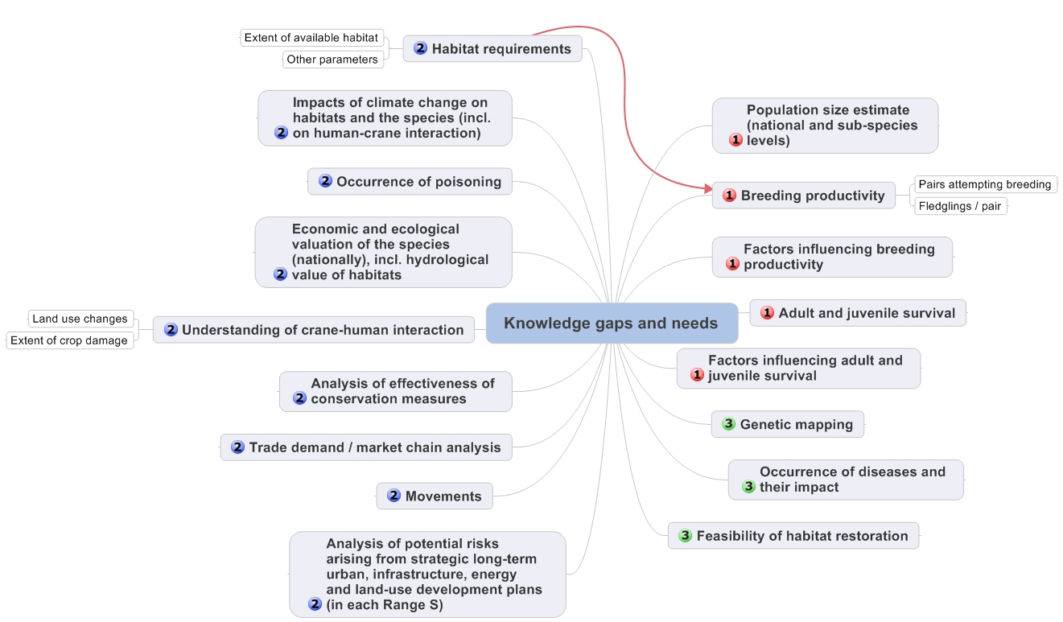

Figure 5 – Problem tree analysis: Grey Crowned Crane knowledge gaps (1=essential; 2=high; 3=medium)

The most pressing knowledge gaps relate to information about the Grey Crowned Crane itself, notably its population size and demography. Although some of these data are available for South Africa for analyses, this basic information is largely lacking from all other range states, and most certainly in a format that would provide a good understanding of the species biology or for assessing baseline information and trends.

It is well documented that Grey Crowned Cranes are dependent on wetlands for breeding, and that a number of factors threaten this habitat. However, there is little understanding of the characteristics that Grey Crowned Cranes require in a wetland, how much suitable habitat is available and how the various wetland characteristic affect the cranes’ demographic parameters. The impacts of climate change on both the cranes themselves and their habitats, and the interrelatedness between them, are also poorly understood.

In terms of threats, there are a number of gaps in knowledge, all of which are important to understand when developing mitigation measures and conservation plans to address these. With the Grey Crowned Crane’s range covering third world countries, development in terms of energy and infrastructure and changes in land use will occur. An understanding of the risks arising from these from a strategic and long term perspective is needed, so that effective plans to mitigate these threats can be developed. From a species perspective, the interaction between cranes and people needs to be understood, especially as these relate to crop damage and land use changes; and the occurrence, extent and reasons for poisoning incidents. Although there is information on the supply of Grey Crowned Cranes for the captive trade market, a better understand is still needed on the demand side of the trade and the market chains used in the trade in order to effectively address the threat. More broadly, the economic and ecological value of the species and the habitats that they depend upon, will provide objective information for developers and decision makers.

Ultimately, the impact of the conservation action being implemented needs to be measurable. This is only possible with a full understanding of the key factors that can be measured in order to obtain a sensitive and relevant measure of success.

As populations become even smaller and the decline continues, genetics and disease will begin to play a bigger role as drivers in the population’s decline. Although not necessarily a priority gap in knowledge that needs to be filled at this time, these two factors need to be considered and reviewed over time. Likewise, the feasibility of habitat restoration is an important factor, but one that can only be achieved once we understand the habitats that the crane requires and the threats to these.

3 – POLICIES AND LEGISLATION
Policy and legislation

International level
At the international level, the Grey Crowned Crane is:
- Classified as Endangered in the IUCN Red List of Threatened Species, meeting criterion A2acd and 4acd, because threats such as habitat loss and the illegal removal of birds and eggs from the wild have driven very rapid declines during the past three generations (45 years). This decline was as a result of direct observation (a), a decline in area of occupancy, extent of occurrence and/or quality of habitat (c), and as a result of actual or potential levels of exploitation (d).
- Listed on Appendix II of the Convention on International Trade in Endangered Species of Wild Fauna and Flora (CITES), which states that trade must be controlled in order to avoid utilization incompatible with the species’ survival.
- The Southern Africa Grey Crowned Crane sub species Balearica regulorum regulorum is listed in Table 1 Column A category 1(c) due to its population being less than 10 000 individuals, and the East African sub species B. r. gibbericeps is listed in Table 1 Column A category 3(c) as a result of their long term decline, of the African Eurasian Migratory Waterbird Agreement (AEWA). Both sub-species are also listed in category A1b as the species is globally threatened on the IUCN Red Data List.

Table 3. Membership of range states in Multinational Environmental Agreements (MEAs)

Range State | AEWA | CBD | CMS / Bonn | CITES | Ramsar | WHC
Angola |  | X | X | X |  | X
Botswana |  | X |  | X | X | X
Burundi | X | X | X | X | X | X
D R Congo |  | X | X | X | X | X
Kenya | X | X | X | X | X | X
Malawi |  | X |  | X | X | X
Mozambique |  | X | X | X | X | X
Namibia |  | X |  | X | X | X
Rwanda | X | X | X | X | X | X
South Africa | X | X | X | X | X | X
South Sudan*
Tanzania | X | X | X | X | X | X
Uganda | X | X | X | X | X | X
Zambia |  | X |  | X | X | X
Zimbabwe | X | X | X | X | X | X

* Before gaining independence in 2011, South Sudan was a part of Sudan and thus a member of most MEAs, with the Sudd being a designated Wetland of International Importance (Ramsar site). This new country is in the process of ratifying MEAs as an independent state.

National level
At the national level, the Grey Crowned Crane is essentially protected in all range states. Nowhere is it a game species for which hunting permits are available. It is a protected species in all range states, none of which permit trade / export of Grey Crowned Cranes at present. The Grey Crowned Crane is not especially well represented by national Protected Area networks, except in Zambia. Table 3.2 illustrates some relevant national legislation, whilst protected area status of key sites is shown in Annex 2.

Table 4. National policies and legislation

Country | Relevant national policies | Grey Crowned Crane specific legislation
Angola | - Environmental Bases Law, Law No 5/98 of 19 June. | Grey Crowned Cranes are protected as a species when they occur within a national park.
Botswana | - Wildlife Conservation and National Parks Act, 1992 | Grey Crowned Cranes are listed as a protected species in this Act
Burundi | - Environmental code, June 2000  - Law No 1/10 of May 30, 2011 on the Establishment and Management of Protected Areas in Burundi  - NBSAP, February 2013 | Grey Crowned Cranes are protected as a bird species and an Endangered species under these legislations
D R Congo | - Conservation Law (1969)  - Environmental Law (2011)  - Hunting Law (1982)  - Forestry Code (2002)  - National Protected Areas Conservation Strategy (2004)  - National Biodiversity Conservation Strategy (2009) | The Grey Crowned Crane is protected on the basis of these legislations.
Kenya | - The constitution of Kenya 2010  - Wildlife Conservation Act (2014)  - Environment Management and Coordination Act (EMCA) | Grey Crowned Cranes are protected on the basis of these legislations.
Malawi | - National Parks and Wildlife Act
Mozambique | - National Biodiversity Conservation Strategy
Namibia | - Nature Conservation Ordinance No. 4 of 1975  - Environment Management Act (Act 7 of 2007) | Grey Crowned Cranes are protected on the basis of this legislation. They are listed as Near Threatened in Namibia.
Rwanda | - The National Constitution (2003)  - Organic Law No 04/2005 of 08/04/2005  - Environmental Law (2005)  - The Ministerial Order No 007/2008 of 15/08/2008  - Rwandan Panel Code (2010)  - Rwanda National Parks | Grey Crowned Cranes are covered in these legislations as wild animals or endangered species, and are specifically mentioned in the Ministerial Order which prevents hunting of the species.
South Africa | - Constitution of the Republic of South Africa Act (Act 108 of 1996)  - National Environmental Management Act (Act 107 of 1998)  - National Environmental Management: Protected Areas Act (Act 57 of 2003)  - National Environmental Management Biodiversity Act (Act 10 of 2004)  - Protected under all Provincial Ordinances in South Africa (between 1973 and 2005)  - Protected under all Provincial Ordinances in South Africa (between 1973 and 2005) | Grey Crowned Cranes are specifically listed as a Threatened or Protected Species, affording them full protection nationally. This is further endorsed on a Provincial level where they may be referred to specifically, or protection inferred through categories.
South Sudan* | - Wildlife Act, 2003 | The Grey Crowned Crane is totally protected under the Wildlife Act, within and outside of protected areas.
Tanzania | - National Wildlife Act (Cap 283), 2007  - Wildlife Policy 1998 (revised 2007)  - Tanzania National Parks Act (Cap 284)  - National Environment Policy, 1997  - National Environment Management Policy, 2004 | Grey Crowned Cranes are protected from trade and consumptive use under Wildlife Act. Presently there is a moratorium on bird export from Tanzania
Uganda | - The Constitution (1995)  - The Uganda Wildlife Policy (1999)  - The Uganda Wildlife Act (Cap. 200) of 2000  - Problem Animal Management and Vermin Control Strategy (2002)  - The Local Governments Act (1997).  - MTTI Policy of wildlife (1999)  - National Environment Act (Cap 153)  - National Parks Act (Cap 227)  - National Tourism Act | Grey Crowned Cranes are protected in Uganda under these legislations.
Zambia | - Section 23 of the Zambia Wildlife Act No. 12, 1998 | The Grey Crowned Crane is a protected species under the Zambia Wildlife Act when in a National Park (implemented by the Zambia Wildlife Authority).
Zimbabwe | - Parks and Wildlife Act (1975, amended in 2001)  - Environmental Management Act  - Forest Act  - Rural District Councils Act | Grey Crowned Cranes are recognised as a Specially Protected Species under the Parks and Wildlife Act and hence through this and the other legislation, are afforded protection

Site protection and management

Annex 2 provides details of the protection status and management of key sites where Grey Crowned Cranes are found, and Annex 3 details recent conservation measures in these and other areas. A brief overview by country is provided below, excluding those countries who hold only small populations of Grey Crowned Cranes:

- Angola
The Grey Crowned Crane is found in the newly created National Park of Luengue – Luiana, where is benefit from this protection status.

- Burundi
Burundi’s Grey Crowned Cranes are found largely outside of protected areas. However, small populations are found in the following National Parks: Kibira National Park, Rusizi National Park, Ruvubu National Park. In addition, cranes are found in Bururi Forest Nature Reserve and Malagarazi Nature Reserve. The level of protection and management of these sites is intermediate.

- Democratic Republic of Congo (DRC)
Most Grey Crowned Cranes in the DRC are found outside of protected areas. The Virunga National Park and Parc National d’Upembe in Katanga Province both hold populations of Grey Crowned Cranes. However, although protected, they are severely threatened by unrest and guerrilla activities, resulting in poor management of these Parks and very little protection. Parc National d’Upembe is managed by Institut Congolais pour la Conservation de la Nature (ICCN) and currently receives technical, management and financial support from the Frankfurt Zoological Society. However, activities are severely disrupted by recurring security issues, and park staff and members of their families have been killed. Management is not easy in such situations, and activities such as mining, poaching and encroachment still impact this diverse park.

- Kenya
The vast majority of Kenya’s Grey Crowned Cranes are found on private, government or communally owned land. Small populations though are found in Amboseli National Park, Masai Mara National Park, Naivasha National Park and Saiwa Swamp National Park and are all afforded high levels of protection. A number of Important Bird Areas are home to Grey Crowned Cranes, but levels of protection are low and management is dependent on the communities involved and the support that they receive.

- Malawi
All recent sightings of Grey Crowned Cranes have been outside of protected areas, specifically along the Rukuru River. This area is under considerable threat from plans to build a dam/weir for irrigation expansion under the Rural Irrigation Development Project. This area needs an urgent survey to determine the population of Grey Crowned Cranes and to determine whether they breed in the area.

- Mozambique
Grey Crowned Cranes in Mozambique are mainly associated with protected areas. The main concentration of Grey Crowned Cranes in Mozambique occurs in the Gorongosa-Marromeu conservation area in central Mozambique. The complex includes Gorongosa National Park, Marromeu Special Reserve, four hunting concessions, and connecting buffer areas. Although the species is fully protected in these areas, they are surrounded by densely populated areas and the species is threatened by uncontrolled fires and hydrological changes resulting from surrounding land uses and management. Small flocks of Grey Crowned Cranes have also been observed in Banhine NP and the quasi-protected San Sebastian peninsula. The status of the species in Niassa National Park of northern Mozambique is uncertain.

- Rwanda
The biggest populations of Grey Crowned Cranes in Rwanda are found within two sites strongly protected by the government, namely the Rugezi Marsh (a Ramsar Site and Important Bird Area) and Akagera National Park. The latter is fully protected and under effective management. The other wetlands where Grey Crowned Cranes are found do not have any level of protection and are all threatened with peat extraction for power generation. If this happens, complete wetlands will be removed, with special concern for the Akunyura and Nyabarongo Wetlands, both of which are designated for peat to power projects and also hold good crane populations.

- South Africa
The vast majority of South Africa’s Grey Crowned Cranes are found on private land. However, 40 – 50 pairs are found within provincial Nature Reserves, namely: Chelmsford, Spioenkop, Karkloof, Umvoti Vlei, Umgeni Vlei, The Swamp, Himeville, Coleford, Ntsikeni, Bill Barnes Crane and Oribi Nature Reserve in KwaZulu-Natal Province; Sterkfontein and Seekoeivlei Nature Reserves in the Free State Province. Across their range, there are also a number of Ramsar Sites and Important Bird Areas that have Grey Crowned Cranes, but the security of these sites is tenuous and management varies considerably.

South Africa has a Biodiversity Stewardship Programme that provides the opportunity for landowners to voluntarily enter into legally binding agreements with the government. Depending on the level of commitment, with Nature Reserve and Protected Environment being the highest levels, these properties are entered into the Protected Area network of the country and are afforded some protection against unsustainable development. These categories of protection are outlined under the National Environmental Management: Protected Areas Act (Act no 57 of 2003). In addition, these farms are required to be managed sustainably for biodiversity and for their water resource value. At the time of writing 60 000 ha have been declared as the Chrissiesmeer Protected Environment – an area important for Grey Crowned Cranes, and a host of other sites are in process.

- Tanzania
Tanzania’s Grey Crowned Cranes are well protected within the country’s National Park network. National Parks holding good populations of Grey Crowned Cranes include: Ngorogoro Crater, Serengeti National Park, Ruaha National Park, Katavi National Park, Tarangire National Park, Arusha National Park and Lake Manyara National Park. These parks all have high levels of protection and management is relatively good, although capacity for bird conservation is very limited. The crane also occurs in a few Game Reserves, the largest of these, Moyowosi and Kigoso, also forming the Malagarais-Muyovozi Ramsar Site. This site faces a number of threats, especially agricultural and livestock encroachment, and management action is limited.

- Uganda
Very few of Uganda’s Grey Crowned Crane population falls within a formally Protected Area. Nabajuzzi and Songo Bay, both Ramsar Sites, are the only two sites with populations of Grey Crowned Cranes that are recognised nationally. Nyamuriro and Kaku Kiyanja are both currently under consideration for Important Bird Area status. Neither Ramsar nor Important Bird Area status afford the sites good levels of protection and management of these sites is dependent on the community involved and the support that they are provided.

- Zambia
Grey Crowned Cranes are well protected in Zambia’s National Park network. Liuwa National Park, with the highest population of Grey Crowned Cranes is well managed with good support too from Africa Parks. Lochinvar and Blue Lagoon National Parks, straddling the Kafue Flats are less well managed. South Luangwa National Park is very well managed and strongly protected. However, conservation efforts in these protected areas are mostly focused on large mammals and little attention is given to birds in general. Thus there is insufficient support in conservation efforts aimed at safeguarding the Grey Crowned Crane populations. Geothermal mining is under consideration for Lochinvar National Park on the Kafue Flats, and the potential for other such unsustainable developments within National Parks is of concern.

- Zimbabwe
The vast majority of Zimbabwe’s Grey Crowned Cranes are outside of protected areas. Hwange National Park is the only fully Protected Area that has cranes. The Driefontein Grasslands and Middle Zambezi Valley are both Important Bird Areas and Ramsar Sites, which raises the profile of these areas, but does little to reduce threats to them.

Monitoring activities

The only coordinated monitoring activity covering Grey Crowned Cranes in the region is the International Waterbird Census (IWC), in which only seven (Burundi, Kenya, South Africa, Tanzania, Uganda, Zambia and Zimbabwe) of the 15 range countries have participated at one time or another. However, participation is not always regular and most of the sites monitored do not contain Grey Crowned Cranes, except for the Kafue Flats in Zambia. The IWC therefore does not provide a good basis for population monitoring of Grey Crowned Cranes.

Burundi has conducted a number of site monitoring programmes over the recent past. This included Rusizi National Park, the protected landscape of the northern lakes and Malagarazi wetland with EC/RSPB funding between 2007 and 2011. The same areas were also monitored between 2006 and 2009 through Wetlands International funding.

In South Africa, Coordinated Avifaunal Roadcounts, conducted twice a year, include Grey Crowned Cranes. These data are stored at the University of Cape Town’s Animal Demography Unit and has provided information on both population trends and habitat use. The Endangered Wildlife Trust and Ezemvelo KwaZulu-Natal Wildlife have conducted annual aerial surveys over the KwaZulu-Natal Province for the past 20 years, providing reliable data on the population trend and distribution. These data are stored both within Ezemvelo KwaZulu-Natal Wildlife and at the Endangered Wildlife Trust.

In Uganda, data on Grey Crowned Cranes have been collected since 2002. These data are stored at Nature Uganda and the National Biodiversity Data Bank at Makerere University, and have the potential to provide useful data for monitoring trends in the population and their distribution. In 2012, Nature Uganda completed a survey of cranes across the southern and south western regions of Uganda. In 2014, Nature and Livelihoods conducted a survey on Grey Crowned Cranes in the eastern parts of Uganda, allowing for a comparison between this survey and the survey completed by Paul Mafabi as part of his master’s thesis in 1991.

In the early 2000’s a number of aerial surveys were conducted by the International Crane Foundation, Endangered Wildlife Trust, Zambian Crane and Wetland Project and Zambian Wildlife Authority on large birds over the flood plains of Zambia. Working reports are available for each of these surveys. Consistent surveys have been conducted on the Kafue Flats covering Lochinvar and Blue Lagoon National Park. These biannual waterbird surveys conducted by the Zambia Wildlife Authority and BirdWatch Zambia could provide valuable useful information on the status and trends of the Crowned Cranes population in this ecosystem. The International Crane Foundation and Endangered Wildlife Trust recently established a program for the conservation of cranes and wetlands in Zambia, in partnership with the Zambia Wildlife Authority that includes regular monitoring of Grey Crowned Crane numbers, distribution, and threats for their strongholds in the Kafue Flats and Liuwa Plains.

In Zimbabwe, BirdLife Zimbabwe has conducted a number of surveys of cranes in the Driefontein Grasslands. These data are available and have the potential to provide useful information on population trends and distribution.

Although South Africa has some data on breeding success, there has been no concerted effort to monitor breeding success across the region. However, starting in the 2014 breeding season, standardised breeding data have been collected from all International Crane Foundation / Endangered Wildlife Trust Partnership supported conservation sites in South Africa, Rwanda, Uganda and Kenya.

4 - FRAMEWORK FOR ACTION

Goal: Downgrade the species from the globally threatened categories on the IUCN Red List and from Column A, Category 1 of the AEWA Table 1.

Indicators: Species downgraded from the globally threatened categories on the IUCN Red List and from Column A, Category 1 of the AEWA Table 1.

Purpose: Identify indicators to quantify the target we are aiming at within the 10 year lifespan of the plan; stabilize current population size and maintain current range and area of occupancy for the East African sub-species; and increase the population size and maintain current range and area of occupancy for the Southern African sub-species; and.

Objectives:

- Reduce adult and juvenile mortality and loss of birds
- Increase breeding success and reproductive rates
- Reduce significantly further loss, fragmentation and degradation of habitats
- Fill key knowledge gaps about Grey Crowned Cranes

Results

Table 5. Results, indicators and means of verification

Result | Indicators | Means of verification
- Poisoning incidents do not contribute to the decline in the population | - Increasing or stable population | - Survey data and community information
- Legal trade in wild birds does not contribute to the decline in the population | - Increasing or stable population  - Increased breeding success | - Non detriment findings  - Survey data  - Breeding success data
1.3 No illegal trade is taking place | - No reports of illegal trade  - Increasing or stable population  - Improved breeding success | - National authority data base  - Customs and port data  - CITES data vs country trade data
1.4 Hunting and trapping are significantly reduced | - Increasing or stable population  - No reports of hunting or trapping received | - Population surveys
1.5 No significant mortality is caused by power lines | - Roost / breeding sites are effectively mitigated  - Only bird friendly structures are constructed  - Proactive mitigation (bird flight diverters and insulation) on new and existing infrastructure/  - Power lines erected according to best practice and EIA guidelines | - NGO or government country databases  - Authorisations provided for power line developments  - Audits conducted on recommendations and authorisations provided
2.1 Grey Crowned Cranes are not disturbed during the breeding season | - Increased breeding productivity | - Breeding success data
2.2 Impact of drought and flooding on Grey Crowned Cranes is minimised | - Breeding success maintained or improved | - Breeding success data
3.1 Afforestation does not occur in or close beside Grey Crowned Crane habitat | - No afforestation close to or in Grey Crowned Crane habitat | - Land use maps and satellite telemetry
3.2 Destruction and degradation of Grey Crowned Crane habitats by agricultural practices are avoided | - Grey Crowned Cranes present and breeding  - Good breeding productivity | - Surveys  - Breeding success data
3.3 No further draining of Grey Crowned Crane wetland sites | - No new drains in wetland sites important to Grey Crowned Cranes | - Satellite imagery  - Conservation projects on the ground
3.4 Livestock grazing does not degrade Grey Crowned Crane habitats | - Grey Crowned Cranes still present with good breeding productivity | - Survey data  - Breeding productivity data
3.5 Infrastructure development on Grey Crowned Crane sites is minimal | - Grey Crowned Cranes still present with good breeding productivity | - Survey data  - Breeding productivity data  - Development authorisations / permits
3.6 Impact of mining on Grey Crowned Crane sites is minimal | - Grey Crowned Cranes still present with good breeding productivity | - Survey data  - Breeding productivity data  - Development authorisations / permits
3.7 Pollution does not adversely impact on Grey Crowned Cranes and their habitats | - Grey Crowned Cranes still present with good breeding productivity | - Survey data  - Breeding productivity data  - Development authorisations / permits
3.8 Impact of invasive alien plants (AIP) on Grey Crowned Cranes is reduced and /or prevented | - Grey Crowned Cranes still present with good breeding productivity | - Survey data  - Breeding productivity data  - Satellite imagery or maps showing reduction in invasion
3.9 Hydrological regimes of key Grey Crowned Crane sites are maintained as close as possible to natural status | - Grey Crowned Cranes still present with good breeding productivity | - Survey data  - Breeding productivity data  - Satellite imagery or maps showing reduction in invasion
3.10 Impacts of land subdivision on Grey Crowned Crane habitats are minimised | - Grey Crowned Cranes still present with good breeding productivity | - Survey data  - Breeding productivity data  - Satellite imagery or maps showing reduction in invasion
3.11 Siltation of Grey Crowned Crane sites is minimised | - Grey Crowned Cranes still present with good breeding productivity | - Survey data  - Breeding productivity data  - Satellite imagery or maps showing reduction in invasion

Table 6. Results and actions under objective 1: to reduce adult and juvenile mortality and loss of birds

Result | Action | Priority | Time scale | Organisations responsible
- Poisoning incidents do not contribute to the decline in the population | - Develop and / or identify cost-effective and affordable methods of crop damage prevention | Essential | Medium | Scientific bodies
 | 1.1.2 Strengthen regulation on import, possession and use of poisons | Medium | Medium | Relevant state authorities
 | 1.1.3 Strengthen enforcement of regulations on use of poisons | Medium | Medium | Relevant state authorities
 | - Campaign for responsible use of poisons | Medium | Medium | Relevant state authorities
1.2 Legal trade in wild birds does not contribute to the decline of the population | - Maintain suspension of legal trade until the population has increased significantly | Essential | Ongoing - Rolling | Relevant state authorities; CITES
 | - If reopened, trade shall be based on non-detrimental findings | Essential | Immediate | Relevant state authorities
 | - If legal trade reopened, introduce universal identification of traded birds | Essential | Immediate | Relevant state authorities
 | - Raise awareness amongst important target groups on the detrimental impact of trade in a declining population | High | Rolling | Relevant state authorities
1.3 No illegal trade is taking place | - Regional zoo associations implement studbooks and regional management plans for Grey Crowned Cranes | Essential | Short | Regional Zoo Associations
 | - WAZA implements a Global Species Management Plan for Grey Crowned Cranes | High | Short | WAZA
 | - Increase penalties for illegal trade of Grey Crowned Cranes, where necessary | Essential | Ongoing - Medium | Relevant state authorities
 | - Strengthen enforcement of regulations on illegal trade | Essential | Rolling | Relevant state authorities
 | - Raise awareness within the judicial systems, customs and other enforcement agencies | Essential | Rolling | Relevant state authorities, NGOs
 | - Raise awareness within the local communities on the illegality of Grey Crowned Crane trade | Essential | Rolling | Relevant state authorities, NGOs
 | - Raise awareness within the end segment of the illegal market chain | Essential | Rolling | Relevant state authorities, NGOs, Zoo Associations
 | - Develop and implement an effective system to manage and control birds already in captivity | Essential | Short-Rolling | Relevant state authorities, NGOs, Zoo Associations
1.4 Hunting and trapping are significantly reduced | 1.4.1 Raise awareness amongst local communities | Medium | Rolling | Relevant state authorities, local governments, NGOs
 | - Strengthen enforcement of relevant legislation / regulation | Essential | Rolling | Relevant state authorities
 | - Generate difference income opportunities for hunters and trappers | Medium | Medium-Rolling | Relevant state authorities, NGOs
1.5 No significant mortality is caused by power lines | 1.5.1 Develop and apply cost effective and affordable mitigation measures | High | Ongoing - Rolling | Relevant state authorities, utility companies
 | 1.5.2 Comprehensive and objective SEA / EIA procedures take full account of Grey Crowned Cranes and its habitats | Essential | Ongoing-Rolling | Relevant state authorities, utility companies
 | 1.5.3 Proactively cooperate with spatial planning agencies and utility companies | Essential | Rolling | Relevant state authorities, NGOs
 | 1.5.4 Fully implement the resolutions and apply conservation guidelines on avoiding and mitigating impact of power lines on birds adopted under AEWA and CMS | Essential | Intermediate-Rolling | Relevant state authorities, utility companies
 | 1.5.5 Raise awareness and / or provide training amongst target groups | High | Ongoing - Rolling | NGOs

Table 7. Results and actions under objective 2: to increase breeding success and reproductive rates

Result | Action | Priority | Time scale | Organisations responsible
2.1 Grey Crowned Cranes are not disturbed during the breeding season | - Acquire land at key sites | Low | Long | Relevant state authorities, NGOs
 | - Designate key sites as protected areas | Essential | Long | Relevant state authorities
 | - Ensured organised and regulated use of sites by local communities (e.g. through management plans) | Essential | Ongoing - Rolling | Relevant state authorities, local governments, NGOs
 | - Raise awareness amongst local communities about their impact on Grey Crowned Cranes | Essential | Ongoing-Rolling | Relevant state authorities, local governments, NGOs
2.2 Impact of droughts and flooding on Grey Crowned Cranes is minimised | 2.2.1 Develop and / or manage catchment management plans for key watersheds (taking into account effects of climate change) | High | Long - Rolling | Relevant state authorities, local government, NGOs
 | 2.2.2 Operation of dams and other water infrastructure takes full account of the needs of cranes and wetland ecosystem services | High | Long - Rolling | Relevant state authorities
 | - Raise awareness amongst relevant target groups on ecosystem services of wetlands | Essential | Ongoing-Rolling | Relevant state authorities, NGOs

Table 8. Results and actions under objective 3: to significantly reduce further loss, fragmentation and degradation of habitat

Result | Action | Priority | Time scale | Organisations responsible
- Afforestation does not occur in or close beside Grey Crowned Crane habitat | - Proactively seek prevention of planned afforestation potentially impacting on Grey Crowned Crane habitat | High | Rolling | Relevant state authorities, NGOs
 | 3.1.2 Introduce and / or enforce regulation on afforestation in and around wetlands | Essential | Medium - Rolling | Relevant state authorities, NGOs
3.2 Destruction and degradation of Grey Crowned crane habitats by agricultural practices are avoided | 3.2.1 Provide alternative livelihoods in order to reduce extent or agriculture and protect ecosystem services in key Grey Crowned Crane sites | High | Ongoing - Rolling | Relevant state authorities, NGOs
 | 3.2.2 Provide best practice guidelines for environmentally friendly agriculture at Grey Crowned Crane sites | High | Short | Scientific bodies, NGOs, relevant state authorities
 | 3.2.3 Support local communities to implement these guidelines at key Grey Crowned Crane sites | High | Medium- Rolling | Relevant state authorities, NGOs
 | 3.2.4 Carry out EIA of large scale commercial agricultural schemes for Grey Crowned Crane sites | Essential | Rolling | Relevant state authorities, companies
 | 3.2.5 Introduce and / or enforce regulation on agriculture development in and around wetlands | Essential | Ongoing - Rolling | Relevant state authorities
 | 3.2.6 Monitor and engage in planning of agriculture development (at site, or higher level, as necessary) | Essential | Rolling | Relevant state authorities, NGOs
3.3 No further draining of Grey Crowned Crane wetland sites | 3.3.1 Strengthen enforcement of relevant legislation preventing drainage of wetlands | Essential | Rolling | Relevant state authorities
 | Actions 2.2.1 and 3.2.5 will contribute to achieving Result 3.3
3.4 Livestock herding does not degrade Grey Crowned Crane habitat | Actions 3.2.1 and 3.2.6 apply, but with focus on sustainable herding
- Infrastructure development impact on Grey Crowned Crane sites is minimal | Actions 1.5.2 and 1.5.3 will contribute to achieving Result 3.5
3.6 Impact of mining on Grey Crowned Crane sites is minimal | Actions 1.5.2 and 1.5.3 will contribute to achieving Result 3.6
3.7 Pollution does not adversely impact on Grey Crowned Crane and its habitat | 3.7.1 Introduce and / or strengthen enforcement of relevant legislation and regulations | Essential | Rolling | Relevant state authorities
 | 3.7.2 Raise awareness amongst key target groups | High | Rolling | Relevant state authorities, NGOs
 | 3.7.3 Monitor water quality in Grey Crowned Crane habitats | Essential | Rolling | Relevant state authorities
3.8 Impact of Invasive Alien Plants (IAP)on Grey Crowned Cranes is reduced and / or prevented | 3.8.1 Identify Grey Crowned Crane sites in need of invasive alien plant control | Medium | Short | Relevant state authorities, Scientific bodies, NGOs
 | 3.8.2 Reduce area colonised by invasive alien plant species using various acceptable methods | High | Ongoing - Rolling | Relevant state authorities, NGOs
 | 3.8.3 Raise awareness amongst local communities of the impact of invasive alien plants on wetlands and their ecosystem services | High | Ongoing-Rolling | Relevant state authorities, NGOs
 | 3.8.4 Monitor vulnerable Grey Crowned Crane sites to prevent invasion by alien plants | Medium | Rolling | Relevant state authorities, NGOs
 | 3.8.5 Promote and encourage enforcement of relevant international and national regulations | Essential | Rolling | Relevant state authorities, NGOs
 | 3.8.6 Create incentives for local communities or other users to get involved in the control of invasive alien plan species | High | Rolling | Relevant state authorities, NGOs
3.9 Hydrological regimes of key Grey Crowned Crane sites are maintained as close as possible to natural status | Actions 2.2.1 and 2.2.3 will contribute to achieving Result 3.9
3.10 Impacts of land sub division on Grey Crowned Crane habitats are minimised | Actions 2.1.1 and 2.1.4 and 3.2.1 to 3.2.6 will contribute to achieving Result 3.10
3.11 Siltation of Grey Crowned Crane sites is minimised | Actions 2.2.1to 2.2.3 will contribute to achieving Result 3.11

Table 9. Results and actions under objective 4: to fill key knowledge gaps about Grey Crowned Cranes

Result | Action | Priority | Time scale | Organisations responsible
4.1 The population size is estimated and population trends determined | 4.1.1 Develop standardised monitoring protocols and conduct population surveys | Essential | Ongoing – rolling | Relevant state authorities, Scientific bodies, NGOs
4.2 Breeding productivity data are collected to determine the baseline and to monitor trends | 4.2.1 Develop standardised monitoring protocols | Essential | Ongoing – rolling | Relevant state authorities, Scientific bodies, NGOs
 | 4.2.2 Conduct monitoring, starting at least at key sites for cranes or at sites where crane conservation projects are active | Essential | Ongoing - rolling | Relevant state authorities, Scientific bodies, NGOs
4.3 Factors influencing breeding productivity understood | 4.3.1 Research project conducted | Essential | Short | Scientific bodies, NGOs
4.4 Adult and juveniles survival known | 4.4.1 Develop and implement standardised data collection protocols for all mortality cases and to monitor survival. | Essential | Ongoing – rolling | Scientific bodies, NGOs
4.5 Factors influencing adult and juveniles survival understood | 4.5.1 Research project conducted | Essential | Short - Medium | Scientific bodies, NGOs
4.6 Understand the habitat requirements of cranes | 4.6.1 Research project conducted | High | Short - medium | Scientific bodies, NGOs
4.7 Impact of climate change on the habitat and the species understood | 4.7.1 Research project conducted | High | Medium | Scientific bodies, NGOs
4.8 Improved understanding of the occurrence of poisoning | 4.8.1 Research project conducted in relevant countries where poisoning occurs | High | Short - medium | Scientific bodies, NGOs
4.9 The economic and ecological value of the species known | 4.9.1 Research project conducted | High | Medium | Scientific bodies, NGOs
4.10 Understand the aspects and implications of crane-human interaction | 4.10.1 Research project | High | Medium | Scientific bodies, NGOs
4.11 An analysis of effectiveness of conservation measures developed | 4.11.1 Develop protocols to measure the effectiveness of conservation measures and encourage uptake of the protocol | High | Short – medium | Relevant state authorities, Scientific bodies, NGOs
4.12 The trade demand and market chains understood | 4.12.1 Research project conducted | High | Short – medium | Scientific bodies, NGOs
4.13 Spatial and temporal movement patters understood | 4.13.1 Research project conducted | High | Medium | Scientific bodies, NGOs
4.14 The potential risks arising from strategic long-term urban, infrastructure, energy and land-use development plans analyses and assessed | 4.14.1 Research project conducted | High | Short – Medium | Scientific bodies, NGOs
4.15 The genetic profile of Grey Crowned Cranes mapped | 4.15.1 Research project conducted | Medium | Long | Scientific bodies, NGOs
4.16 Occurrence of diseases and their impact understood | 4.16.1 Research project | Medium | Long | Scientific bodies, NGOs
4.17 Feasibility of habitat restoration known | 4.17.1 Research project | Medium | Long | Scientific bodies, NGOs

5 – INTERNATIONAL COORDINATION OF ACTION PLAN IMPLEMENTATION

Appropriate organizational and management structures are vital to the successful and coordinated implementation of the Action Plan. To this end, an AEWA Grey Crowned Crane International Working Group (AEWA GCC IWG) consisting of designated government representatives and national experts from all range states as well as experts from the international conservation community will be convened by the AEWA Secretariat following the adoption of the plan. The IWG will coordinate and guide the implementation and further development of the activities foreseen in the Action Plan. Under the framework of the Action Plan and the International Working Group, range states are encouraged to establish National Working Groups and to develop and adopt National Action Plans for the Grey Crowned Crane. Guidelines for the establishment of the IWG and National Working Groups are presented in detail in Annex 7.

6 – REFERENCES

Allan DG. 1996. Grey Crowned Cranes in Transkei, South Africa. In: Beilfuss RD, Tarboton WR, Gichuki NN. (eds) 1996 Proceedings 1993 African Crane and Wetland Training Workshop. International Crane Foundation, USA 407
Beilfuss RD, Dodman T and Urban E. 2007. The status of cranes in Africa in 2005. Ostrich 78 (2): 175-182.
BirdLife International. 2012. Balearica regulorum. In: IUCN 2013. IUCN Red List of Threatened Species. Version 2013.1. <www.iucnredlist.org>. Downloaded on 24 October 2013.
BirdLife International. 2014. Species factsheet: Balearica regulorum. Downloaded from http://www.birdlife.org on 19/10/2014.
Brown CJ. 1992. The status of cranes in Namibia. In: Proceedings of the First Southern African Crane Conference, (eds) Porter DG, Craven HS, Johnson DN & Porter MJ, Southern African Crane Foundation, Durban. pp. 73-78.
Budde C. 2001. Individual features in the calls of Grey Crowned Cranes, Balearica reguloum gibbericeps. Ostrich 72 (3 &4) 134-139.
CITES Secretariat. 2013. Briefing paper prepared by the CITES Secretariat. Unpublished report. CITES Secretariat. pp 23.
Dodman T. 1996a. Distribution of cranes in Zambia. In: Proceedings 1993 African Crane and Wetland Training Workshop, (eds) Beilfuss RD, Tarboton WR & Gichuki NN. International Crane Foundation, Baraboo, Wisconsin. pp. 251-254.
Dodman T. 1996b. Present status and distribution of cranes in the Kafue Flats, Zambia, with reference to population estimates of the 1980’s. In: Proceedings 1993 African Crane and Wetland Training Workshop, (eds) Beilfuss RD, Tarboton WR & Gichuki NN. International Crane Foundation, Baraboo, Wisconsin. pp. 255-259.
Ewbank D. 2003. History of the Grey Crowned Crane in Matabeleland, Zimbabwe. Indwa 1:33-36
Filmer R and Hotshausen G. 1986. Results of the Southern African Crane Census 1985/1986. Unpublished report. Transvaal Nature Conservation Division. 27pp
Frame GW. 1982. East African crowned cranes breeding ecology and behaviour in northern Tanzania. Scopus 6: 60 - 69
Geldenhuys JN. 1984. The status of cranes (Aves: Gruidea) in the Orange Free State. S. Afr. J. Wildl. Res. 14 (1): 15-18
Gichuki NN & Gichuki CM 1992. The behaviour of Grey Crowned Cranes breeding in North Swamp, Naivasha, and its implications for their conservation. VII Pan African Ornithological Congress 63 - 70
Gichuki NN. 1993 Factors affecting the reproductive success of the Grey Crowned Cranes. PhD Thesis, Cambridge University. pp 196.
Gichuki NN. 1996. Factors affecting reproductive success in crowned cranes. In: Beilfuss RD, Tarboton WR, Gichuki NN (eds) 1996 Proceedings 1993 African Crane and Wetland Training Workshop. International Crane Foundation, USA. pp. 175-181
Gichuki NN. 2000. Influence of breeding on foraging behaviour and diet of crowned cranes. Ostrich 71: 74-79
Holtshausen K. 1996. Conservation of cranes in Zimbabwe. In: Proceedings 1993 African Crane and Wetland Training Workshop, (eds) Beilfuss RD, Tarboton WR & Gichuki NN. International Crane Foundation, Baraboo, Wisconsin. pp. 333-335.
Kanyamibwa, S. 1996. Grey Crowned Cranes as indicators for wetland conservation in Rwanda. In: Proceedings 1993 African Crane and Wetland Training Workshop, (eds) Beilfuss RD, Tarboton WR & Gichuki NN. International Crane Foundation, Baraboo, Wisconsin. pp 199 - 201
Konrad PM. 1987. Rainy season ecology of South African Grey Crowned Cranes in the Luangwa Valley Zambia. In Proceedings of the 1983 International Crane Workshop. (eds) Archibald GW & Pasquier RF. International Crane Foundation, Baraboo, Wisconsin. pp 337 – 344
Mafabi PG. 1991. The ecology and conservation status of the Gray Crowned Crane in Uganda. In: Harris JT, ed. Proceedings 1987 International Crane Workshop, Qiqihar, China. Baraboo, Wisconsin: International Crane Foundation. pp 363-367.
McCann K and Wilkins H. 1995. A study of the annual biology and movement patterns of the three crane species in the KwaZulu-Natal Midlands – for the purpose of aiding the selection of the route for the Ariadne-Venus 400kV transmission power line. pp. 65. unpublished report.
Morrison K. 1998. Habitat utilization and the population ecology of cranes in the Dullstroom area of the Mpumalanga Province. Master thesis. Centre for Wildlife Management, Faculty of Biological and Agricultural Sciences, University of Pretoria, Pretoria.
Morrison KL & Bothma J du P. 1998. Wetland nesting sites of Wattled and Grey Crowned Cranes on the Steenkampsberg Plateau, South Africa. S Afr J Wildl Res 28 (4) 110-120
Morrison, K and Baker, N. 2012. Grey Crowned Cranes in peril – A status review and threat assessment. Abstract for the 13th Pan African Ornithological Congress, Tanzania.
Meine CD and Archibald GW. 1996. The cranes: status survey and conservation action plan. IUCN, Gland , Switzerland, and Cambridge.
Muheebwa J. 2001. Assessing the biology of the Grey Crowned Crane; Balearica regulorum, in Uganda. Masters thesis. Makerere University, Kampala. Uganda.
Muheebwa-Muhoozi J. 2001. The status of Grey Crowned Cranes, breeding in Uganda, with special reference to breeding. Ostrich Supplement No 15:122 – 125.
Mundy PJ & O’Donoghue FT 2000. Stones in the stomachs of cranes. Honeyguide 46 (2) p 155 – 156.
Ndibaisa, D. 2013. Assessing the breeding status of the Grey Crowned Crane (Balearica regulorum) in Kampala wetlands, Uganda. A Rocha Uganda.
Nachuha, S & Quinn, JL. 2012. The distribution of colonial waterbirds in relation to a Ugandan rice scheme. Waterbirds 35. 590-598.
Olupot W, Mugabe H and Plumptre A. 2009. Species Conservation on human-dominated landscapes: the case of crowned crane breeding and distribution outside of protected areas in Uganda. Unpublished report.
Olupot W. 2014. Mapping Threats to Grey Crowned Cranes in Eastern Uganda: Results of a rapid assessment of populations for conservation action. Nature and Livelihoods’ Technical Report No. 4. Completed for the Endangered Wildlife Trust and International Crane Foundation Partnership.
Pinto 1983 in Dean WRJ 2000: The Birds of Angola. An Annotated Checklist. BOU Checklist n.º 18.
Pomeroy DE. 1980a. Aspects of the ecology of crowned cranes Balearica regulorum in Uganda. Scopus 4: 29 – 35 (June 1980)
Pomeroy DE. 1980b. Growth and plumage changes of the Grey Crowned Crane Balearica regulorum gibbericeps. Bull BOC 100, 219-223.
Pomeroy DE. 1987. The ecology and status of crowned cranes in East Africa. In: Proceedings 1993 African Crane and Wetland Training Workshop, (eds) Beilfuss RD, Tarboton WR & Gichuki NN. International Crane Foundation, Baraboo, Wisconsin. pp 323-330
Scott A & Scott M. 2014. In search of Blue Cranes in south-central Angola. Namibia Crane News 52. pp 1 - 4
Skinner N. 1997. The breeding seasons of birds in Botswana: 111. Non-passerine families (Ostrich to skimmer). Babbler 32: 10-23.
Smallie J. 2000. Crop Damage by GCC Balearica regulorum in the NE Cape. In: Proceedings of the 12th South African Crane Working Group workshop 22-23 November 2000. pp 21-28
Smallie J. 2002. Cranes and Power lines in the Eastern Cape. Crane Link 12: 18.
Smallie J. 2003. Breeding biology of the Grey Crowned Crane, Balearica regulorum in the north-Eastern Cape. Indwa 1: 2-10
Staboch JA, Laporte N and Olupot W. 2009. Modelling habitat suitability for Grey Crowned Cranes (Balearica regulorum gibbericeps) throughout Uganda. International Journal of Biodiversity and Conservation. Vol 1 (5). Pp 177-186.
Steyn P & Ellman-Brown P. 1974. Crowned crane nesting in a tree. Ostrich 45: 40-41.
Steyn P & Tredgold D. 1977. Crowned cranes covering eggshells. Bokmakierie 28 (3): 82.
Tarboton WR. 1992. The population status of the crowned crane in the Transvaal. In Porter DJ, Craven HS, Johnson DN, Porter MJ (eds) Proceedings of the First Southern African Crane Conservation December 1989, Natal, RSA. The Southern African Crane Foundation, Durban, South Africa. pp 10-19
Tyler SJ. 2012. A review of waterbird counts in Botswana 1991 – 2010. Babbler Special Supplement No 4. BirdLife Botswana. 214 pp
Urban EK 1988. Status of cranes in Africa. In: Backhurst GC (ed) Proceedings of the 6th Pan-African Ornithological Congress, Francistown (Botswana). pp 315–329. Sixth PAOC Organizing Committee, Nairobi, Kenya
Urban EK 1996. Status of cranes in Africa, 1994. In: Beilfuss R, Tarboton W and Gichuki N (eds) Proceedings of the 1993 African Crane and Wetland Training Workshop, Maun, Botswana. Pp 53–59. International Crane Foundation, Baraboo, Wisconsin,
Walkinshaw LH. 1964. The African crowned cranes. The Wilson Bulletin 76(4):355-77.
Walkinshaw LH. 1973. Cranes of the world. Winchester Press, New York, USA.

Annex 1: Ranking of threats by country

Grey Crowned Crane - overview of national significance scores per threat driver (1 – Critical; 2 – High; 3 – Moderate; 4 – Low; 5 – Local; 6 – Unknown; Blank cell – Not applicable)

(compiled by the Grey Crowned Crane action planning workshop participants, 9-13 September 2013, Musanze, Rwanda)

Driver | Rwanda  500 ind. | Burundi  100 ind. | Uganda  7,000 ind. | DRC  ? 5,000 ind. | Kenya  12,000 ind. | Tanzania  1,500 ind. | Zambia  2,000 ind. | East Africa | Zimbabwe  2,000 ind. | RSA  7,000 ind. | South Africa
Poisoning | 6 |  | 3 | 4 | 3 | 5 | 6 | 3 | 4 | 3 | 3
Legal trade in wild birds (int) – potential |  |  | 4 | 3 | 5 | 2 | 6 | 3 | 4 |  | 4
Legal trade in wild birds (dom) – potential |  |  |  | 3 |  | 4 | 6 | 4 | 4 |  | 4
Illegal trade (dom & int) | 2 | 4 | 3 | 4 | 5 | 6 | 5 | 2 | 5 | 3 | 3
Hunting and trapping | 3 | 4 | 2 | 4 | 4 | 4 | 6 | 3 |  | 4 | 4
Power lines | 6 | 4 | 2 | 6 | 4 | 4/6 | 6 | 2 potential | 4 | 3 | 3
Telecom infrastructure | 6 | 3 | 3 | 6 | 6 | 6 | 6 | 4 | 4 | 4 | 4
Diseases | 6 | 6 | 6 | 5 | 5 | 6 | 6 | 6 | 6 | 4 | 4
Predation by dogs | 6 | 4 | 6 |  | 5 | 6/4 | 6 | 4 |  | 4 | 4
Natural predation | 6 | 4 | 6 |  | 4 | 6 eggs / 4 adults | 4 | 4 | 6 | 3 | 4
Livestock herding | 5 | 4 | 5 |  | 4 | 4 | 4 | 4 | 4 | 2 | 4
Human disturbance | 2 | 3 | 3 | 3 | 3 | 3 | 4 | 2 | 3 | 3 | 3
Egg collection | 4 | 3 | 4 | 6 | 5 | 6 | 3 | 4 | 5 | 4 | 4
Flooding and drought | 3 | 4 | 3 | 3 | 4 | 3 | 3 | 3 | 2 | 3 | 3
Fire | 4 | 3 | 4 | 4 | 5 | 4 | 2 | 4 | 3 |  | 4
(Eucalyptus) afforestation |  |  | 3 | 2 | 3 | 4 |  | 3 |  | 2 | 2
Agriculture | 2 | 2 | 2 | 2 | 1 | 4/2/5 | 4 | 2 | 3 | 3 | 3
Drainage | 3 | 3 | 3 | 3 | 3 | 5 | 6 | 3 |  | 2 | 3
Fish production | 4 | 3 | 4 | 2 | 5 | 4 | 6 | 4 |  | 4 | 4
Cattle herding | 5 | 3 | 3 |  | 4 | 5/4 | 3 | 3 |  | 2 | 3
Infrastructure development | 3 | 4 | 3 | 4 | 4 | 4 | 6 | 3 | 4 | 3 | 3
Mining | 3 | 3 | 4 | 3 | 5 | 5 | 6 | 3 | 4 | 2 | 2
Pollution | 4 | 3 | 3 |  | 4 | 4 | 2 | 3 | 5 | 3 | 4
Invasive alien plants | 5 | 3 | 4 |  | 4 |  | 1 | 3 |  | 4 | 4
Natural vegetation succession | 6 | 6 | 4 |  |  |  | 2 | 4 |  | 4 | 4
Change of hydrological regime | 6 | 4 | 3 | 4 | 3 | 4 | 2 | 3 | 4 | 2 | 2
Sub-division of land | 6 | 1 | 3 | 4 | 3 | 4 | 5 | 3 | 3 | 3 | 3
Siltation | 3 | 2 | 2 | 4 | 1 | 3 | 4 | 2 | 3 | 4 | 3
- The most significant threats to the long term survival of the Grey Crowned Crane are the impacts of illegal trade, human disturbance, power line, agricultural development and siltation

Annex 2: Key sites

Country | Name | Area (ha) | Lat | Long | Estimated numbers | Protected Area Names | Protection Status | International Designation
Southern African Grey Crowned Crane
South Africa | Moist Drakensberg foothill grasslands of the southern Kwa-Zulu Natal and northern Eastern Cape Provinces | 670 000 | 30º 14’ 48.58” S | 29º 20’ 40.99” E | 2 500 | Largely unprotected | Unprotected | KwaZulu-Natal Mistbelt Grasslands IBA, Franklin Vlei IBA, Mount Curry Nature Reserve IBA, Penny Park IBA
South Africa | Enkangala Grasslands, straddling northern KwaZulu-Natal, southern Mpumalanga and the north-eastern Free State | 1 600 000 | 27° 21’ 03.96” S | 30° 07’ 58.63” E | 600 | Kwamandlangimpisi Protected Environment, but largely unprotected | Largely unprotected | Grasslands IBA
South Africa | KwaZulu-Natal Midlands | 280 800 | 29° 29’ 21.74” S | 30° 12’ 59.31” E | 150 | Largely unprotected | Unprotected | Umgeni Vlei is a Ramsar Site; Umvoti Vlei IBA; Hlatikulu Nature Reserve IBA, Karkloof Nature Reserve IBA
South Africa | Mpumalanga Highveld Grasslands, encompassing in particular Chrissiesmeer Lakes District and Steenkampsberg Wet Grasslands | 280 000 | 25° 40’ 58.42” S | 30° 00’ 58.50’ E | 300 | Chrissiesmeer Protected Environment; Greater Lakenvlei Protected Environment; Verloren Valei Nature Reserve | Limited protection | Verloren Valei Nature Reserve is a Ramsar Site, Steenkampsberg IBA, Chrissies Pans IBA
Zimbabwe | Driefontein Grasslands encompassing districts of Gutu, Chirumanzu and Chikomba located in the central region of Zimbabwe | 20 000 | 17° 59′  S | 25° 52′  E | Driefontein Grasslands (approx. 100) | Not protected | No formal national protection status | Driefontein Grasslands is an IBA and Ramsar site
Zimbabwe | Western region of the country, (irrigated farms and pans in the Nkayi and Lupane districts) | 80 000 | 18° 56′  S | 27° 46′  E | likely to be over 75 | Larger proportion not protected but includes the Mbazhe Pan, listed as a Bird Sanctuary managed by the Parks and Wildlife Management Authority. | Largely unprotected | None
East African Grey Crowned Cranes
Kenya | The north-east Lake Victoria Basin in western Kenya encompassing the counties of Busia, Bungoma, Nandi, Uasin Gishu and Trans-Nzoia |  | 0° 27’ 39.38”  N | 34° 06’ 41.64” E | 1000 – 2000 | Largely unprotected  Saiwa Swamp National Park incorporated | Largely unprotected | Yale Swamp (part of Busia County) is an IBA
Uganda | The west-southwest Lake Victoria Basin, encompassing southwestern Uganda and northern Rwanda, and extending marginally westwards into the catchment of Lake Edward. |  | 1° 24’ 59.29” S | 29° 59’ 23.79” E | 1000 - 1200 | None | Not Protected | Only Nyamuriro has international designation as an IBA
Uganda | Kaku-Kiyanja Wetland and surround in south-central Uganda |  |  |  |  | None | Not Protected | None
Zambia / Angola | The Bulozi Floodplains, encompassing Liuwa Plains and the Barotse Floodplain in western Zambia, and extending north westwards into eastern Angola | 900,000 ha; | 15° 15' S | 023° 15' E | >1000 | Luiwa Plains National Park, Zambezi West Game Management Area. | National Park | Ramsar Site, IBA
Zambia | The Luangwa valley | 250,000 ha; | 12° 40' S | 032° 02' E | 400 - 1000 | Largely protected as National Park of Game Management Area. Major Parks include: South Luangwa, National Park, North Luangwa National Park, Luambe National Park | National Park, Game Management Area (GMA) | Ramsar Site, IBA
Zambia | Kafue Flats and associated breeding grounds | 600,500 ha; | 15°41'S | 027°16'E | 200-500 | Lochinvar and Blue Lagoon National Park, Kafue Flats Game Management Area | National Park, Game Management Area (GMA) | Ramsar Site, IBA

Annex 3: Legal status, conservation measures & monitoring

A. National legal status

Country | Legal protection | For game species, give opening/closing dates of hunting season
Burundi | Yes | Not applicable
Democratic Republic of Congo | Yes | Not applicable
Kenya | Yes | Not applicable
Rwanda | Yes | Not applicable
South Africa | Yes | Not applicable
Tanzania | Yes | Not applicable
Uganda | Yes | Not applicable
Zambia | Yes | Not applicable
Zimbabwe | Yes | Not applicable

Although the Grey Crowned Crane is on Appendix II of CITES, it is currently not permissible to hunt, capture or trade Shoebills in any Range State.

B. Recent conservation measures

Country | Is there a national action plan for the species? | Is there a national Grey Crowned Crane project / working group?
Burundi | No | No
Democratic Republic of Congo | No | No
Kenya | No | No
Rwanda | No | No
South Africa | In preparation | Yes, the EWT African Crane Conservation Programme
Tanzania | No | No
Uganda | In preparation | No
Zambia | No | No
Zimbabwe | Yes | Yes, the National Wetlands Committee

Angola
- Grey Crowned Cranes are protected in the Luengue - Luiana National Park which was declared in 2011.

Burundi
- Grey Crowned Cranes are valued in the country both as a bird watching attraction and as indicators of ecosystem health.

Democratic Republic of Congo
- Grey Crowned Cranes are respected by local communities and are a bird watching attraction for the country.

Kenya
- The Kipsaina Crane and Wetland Conservation Group, in partnership with the ICF/EWT Partnership, have been involved with community conservation projects for cranes and wetlands in the western parts of the country.

Rwanda
- Project at Rugezi Marsh to conserve cranes, improve livelihoods and increase the value that the local community places on the Marsh, led by the IICF/EWT Partnership, the Albertine Rift Conservation Society (ARCOS) and the Kitabi College for Conservation and Environmental Management.
- The Rwandan Development Board, in collaboration with a number of organisations and individuals are addressing the issue of domestication and illegal trade in Grey Crowned Cranes.

South Africa
- The EWT, in partnership with ICF, has full time projects in all key Grey Crowned Crane areas in South Africa. These focus on awareness, monitoring, securing key sites under a protected area status and sustainable management.

Tanzania
- A PhD study is being conducted by Bridget Amulike, a student from the University of Massachusetts, and supported by the ICF/EWT Partnership and Neil Baker, looking at Grey Crowned Crane distribution, breeding and reasons for their decline.

Uganda
- A Community-based Crane and Wetland Conservation Programme under NatureUganda, and in partnership with the International Crane Foundation / Endangered Wildlife Trust, has been active since 2002 at Kaku Kiyanja, Nyumuriro and Kabale Wetlands and in Busheny in Uganda.
- Nature and Livelihoods, a local NGO, partnered with the ICF/EWT Partnership in 2014 to survey Grey Crowned Cranes in the eastern parts of Uganda. They are also looking at a number of small scale projects and studies.

Zambia
- Most of Zambia’s Grey Crowned Cranes are found in protected areas. Although being afforded considerable protection, mammals are the primary focus of attention and little attention is given to birds in general. That said, Grey Crowned Cranes are a considerable tourist attraction and hence do have national value.
- The ICF/EWT Partnership, in collaboration with the Zambian Wildlife Authority recently initiated the Zambian Crane and Wetlands Conservation Project. This project will focus on monitoring, threat mitigation and research to better understand the species.

Zimbabwe
- BirdLife Zimbabwe regularly conducts monitoring and community based conservation in the Driefontein Grasslands, with a focus on cranes. There is also currently a project being conducted under the Conservation Leadership Programme around human-wildlife conflict around cranes and crop damage

A number of countries have active Important Bird Area projects which include Site Support Groups, monitoring and community projects.

C. Ongoing monitoring schemes for Grey Crowned Cranes

Country | Is there a national survey / monitoring programme? | Is there a monitoring programme in protected areas?
Burundi | No, but the International Waterbird Census is carried out periodically at 6 sites | Period surveys have been conducted in Rusizi National Park and Malagarazi Wetland
Democratic Republic of Congo | No | No
Kenya | No, but the International Waterbird Census is carried out periodically at some of the sites where cranes occur | No
Rwanda | No
South Africa | To some degree, yes –although they cover a large area, they do not cover the full Grey Crowned Crane range, These programmes include Coordinated Waterbird Counts, Avifaunal Road Counts. Annual aerial surveys are also conducted annually under the EWT and Ezemvelo KwaZulu-Natal Wildlife over thee KwaZulu Natal range of the Grey Crowned Crane. | Very few Grey Crowned Cranes are in protected areas at this time.
Tanzania | No, but the International Waterbird Census is carried out periodically at some of the sites where cranes occur | Periodic surveys, which include Grey Crowned Cranes, are conducted in some of the National Parks and Nature Reserves
Uganda | No, but periodic surveys in key areas do happen
Zambia | No, but regular International Waterbird Counts are conducted regularly at nine sites that have Grey Crowned Cranes | Yes, surveys are conducted in Lochinvar, Blue Lagoon, Kafue, South Luangwa, Chikuni, Nsumbu and Liuwa National Parks
Zimbabwe | No, but more than 20 sites with Grey Crowned Cranes are included in the regular International Waterbird Counts | Through the Waterbird Censuses

Annex 4: Mind maps showing the actions and priorities for each of the objectives

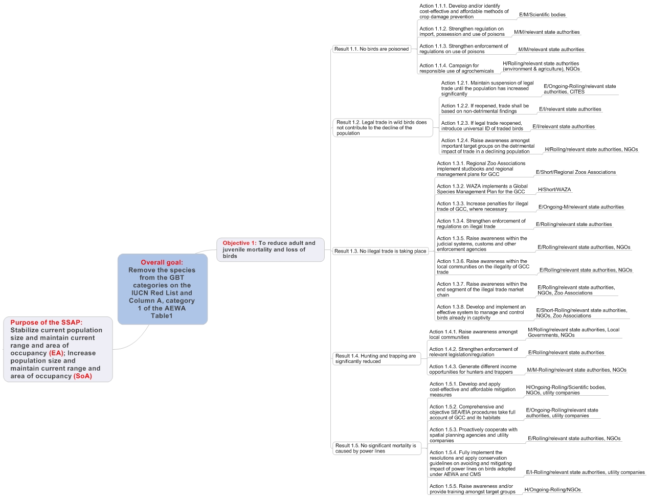

Figure 6. Proposed actions and their priorities for reducing Grey Crowned Crane juveniles and adult mortality and loss of birds
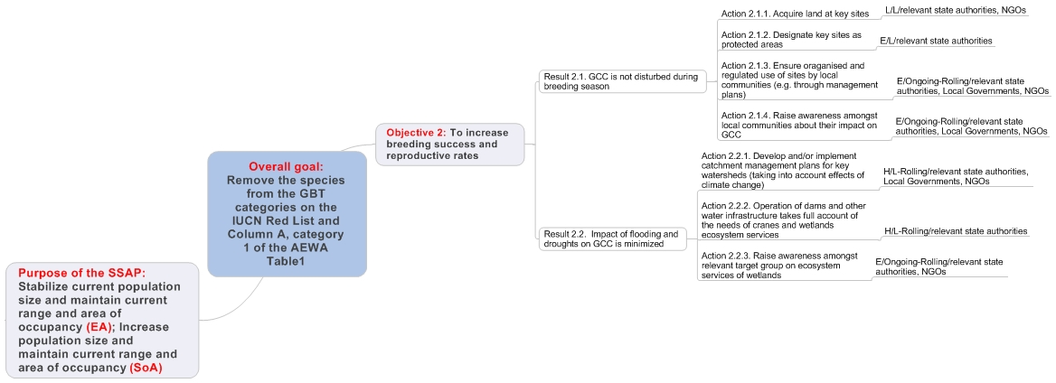

Figure 7. Proposed actions and their priorities for increasing breeding success and reproductive rates of Grey Crowned Cranes
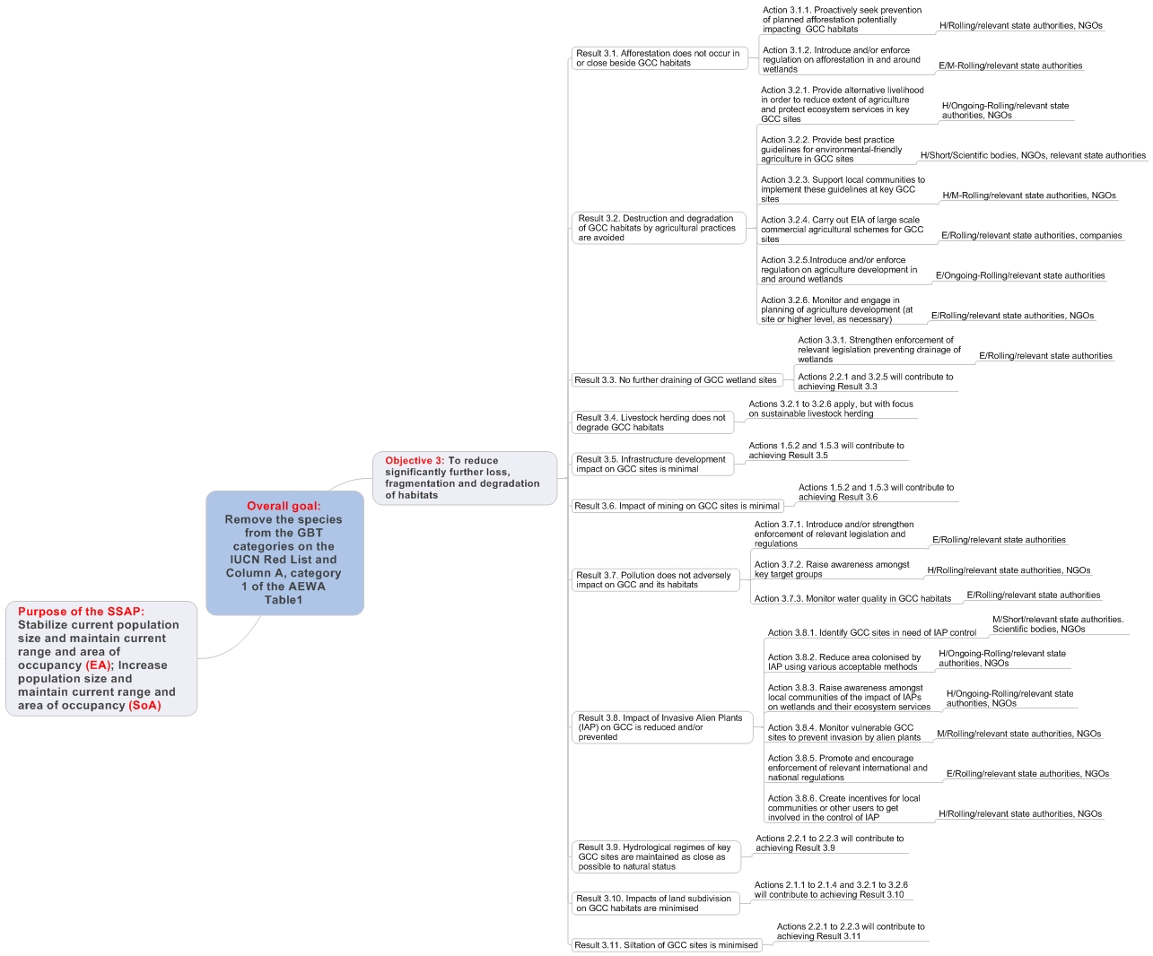
Figure 8. Proposed actions and their priorities for reducing significantly further loss, fragmentation and degradation of Grey Crowned Crane habitat

Annex 5: Names of the Grey Crowned cranes in some different languages

Language | Name
Scientific | Balearica regulorum
English | Grey Crowned Crane, Crested Crane
French | Grue couronnée
Portuguese | Gru-Coroado
Burundi - Kirundi | Umusambi
Democratic Republic of Congo | Gauraka, Gamraka, Kumaro
South Africa - Afrikaans | Mahem
South Africa – Xhosa | Ihem
South Africa - Zulu | uNuhemu
Tanzania - Swahili | Korongo Taji
Uganda – Ankole | Entuuha
Uganda - Buganda | Engali
Uganda - Bugisu | Wawalu
Uganda Northern | Walu
Zimbabwe – Shona | Wori-wori; Horowani
Zimbabwe – Indebele | Holwane
Danish | Grá Krontrane
Dutch | Grijze Kroonkraanvogel
Finnish | Etelänkruunukurki
German | Kronenkranich
Italian | Grigio incoronato gru
Portuguese | Cinza guindaste coroado
Spanish | Gris grulla coronada
Swedish | Grå krontrana

Annex 6: Modelling Report for the Grey Crowned Crane Population

6.1 Modelling approach and key questions
The population modelling approach taken during the workshop was initiated by drawing up a list of key questions considered useful for improving our understanding of Grey Crowned Crane (GCC) population dynamics, in the context of developing a strategic plan of action for their conservation across their range.

The following questions were formulated:

- Can we build a series of simulation models with sufficient detail and precision that can accurately describe the dynamics of GCC populations in
  - southern Africa, and
  - East Africa.
- What are the primary demographic factors influencing population trends in GCCs?
- What are the predicted impacts of current and potential future
  - changes in habitat quantity (loss)?
  - changes in habitat quality (degradation, disturbance)?
  - levels of harvest?
- What are the most significant knowledge gaps with respect to drivers of GCC trends? (Research priorities)
- What future management actions are likely to have the most positive impact on GCC populations? (Prioritisation of actions)

6.2 Modelling task
The modelling task was therefore to develop a baseline model which best approximates the current population dynamics of GCCs, taking into account knowledge of the current population parameters and carrying capacity. The baseline model can then be used to predict the outcome of different scenarios so as to improve decision-making in respect of management.

6.3 Conceptual model of the life cycle of Grey Crowned Cranes
Figure 1 indicates conceptually the best understanding of GCC population dynamics and parameters (MacCann et al. 2000). The various life stages were defined in the model as follows:

- Eggs are laid by breeding adults.
- Chicks are hatched according to nesting success.
- Fledglings are produced at the age of 5 months (measured by the number of fledged birds per breeding pair)
- At one year of age, juveniles enter floater flocks, at which time their plumage becomes indistinguishable from that of adults.
- Non-breeding adults occur in floater flocks until they reach maturity.
- Upon reaching maturity, a large proportion of adult birds pair up and breed. The rate of pairing depends on whether habitat and mates are available; if not they remain in the floater population. GCCs have a fairly wide tolerance range of suitable breeding sites, and so it is assumed that a large proportion of the adult population breeds in any one year.

Figure 1: Conceptual model of the population dynamics of Grey Crowned Cranes (adapted from McCann et al. 2000)
C
Fledglings produced
(5 months)
D
Juveniles
(1-4 years)
in floater flocks
F
Breeding adults
(≥5 years)
in pairs
E
Non-breeding adults
(≥5 years)
in floater flocks
MORTALITY
MORTALITY
CATASTROPHE AFFECTING SURVIVAL
CATASTROPHE AFFECTING REPRODUCTION
A
Eggs laid (clutch)
B
Chicks hatch (broods)
Breeding
success
Fledgling survival

6.3.1 Notes on reproduction
Although stages A and B are important milestones in the GCC life cycle, field data for these stages are very sparse and difficult to collect. Conversely, fledging rates (i.e. the number of chicks per breeding pair that survive to 5 months) can be determined relatively easily and is a more robust measure. Breeding success is the outcome of the interaction between the proportion of females that breed and the mean number of chicks that each breeding female produces. Two ways to measure this are outlined in Table 1.

Table 1: Two alternative methods to calculate breeding success, defined as the mean number of fledglings produced per adult female
Measure of productivity | Alternative 1 | Alternative 2
Proportion of adult females breeding | The proportion of all females in the population that breed, where breeding is defined as the act of pairing up.  This is measured at time of nesting. | The proportion of all females in the population that successfully produced fledglings.  This is measured at the time of fledging.
Number of fledglings produced | The average number of fledglings produced per breeding female (where breeding is defined as per definition in Alternative 1). | The average number of fledglings produced per breeding female (where breeding is defined as per the definition in Alternative 2).

Table 2 provides an example of how the two alternate methods for calculating breeding success can arrive at the same results. For the purposes of modelling it is critical to ensure that appropriate measures are used.

Table 2: Example to illustrate two alternative methods for calculating breeding success
Alternative | Proportion of females breeding | Number of fledglings produced | Breeding productivity (fledglings per adult female)
1 | 0.8 | 0.80 | 0.64
2 | 0.4 | 1.6 | 0.64

6.3.2 Notes on survival
Although mortality factors are likely to impact on the adult floaters and breeders independently, VORTEX does not allow for the application of differential mortality rates within the same age class, so it was assumed that adult floaters and breeders were subject to the same mortality rates.

6.4 The baseline model
Due to the wide variation in demographic parameters and threats affecting GCCs across their range, it was agreed by workshop participants to develop a baseline model using demographic data from the South African population of GCCs in KwaZulu-Natal province (see Figure 2 for population trends since 2001). This population was chosen because (i) it is a population subject to few anthropogenic threats and therefore presents a "best-case" scenario of population dynamics in the absence of such threats, and (ii) relatively good demographic data are available for this population. This model would therefore provide a useful baseline on which to examine the outcomes of a range of alternative current and future scenarios.

Figure 2: Minimum population size of Grey Crowned Cranes in KwaZulu-Natal as recorded during aerial surveys between 2001 and 2012 (Source: Smith & Craigie 2012)

6.4.1 Input parameters
All simulations were run for 50 years with 100 iterations using VORTEX version 9.99c.

Input parameters for the baseline model were as follows:

- Definition of extinction
Extinction was defined as the complete absence of one or other sex.
- Number of populations
The KwaZulu-Natal population (South Africa) was modeled as one single population.
- Inbreeding depression
No inbreeding depression was incorporated as the population is probably large enough to withstand the effects of inbreeding.
- EV (reproduction) to be concordant with EV (survival)
In the absence of data to the contrary, it was assumed that environmental variation would affect reproduction and survival equally.
- Types of catastrophes
No catastrophic events were included in the baseline model.
- Monogamous, polyganous or hermaphroditic population
Grey Crowned Cranes are assumed to mate for life and are therefore classified as long-term monogamous breeders.
- Age at first reproduction for males and females
In the absence of adequate field data, the median age at first reproduction was assumed to be 5 years for both males and females.
- Maximum breeding age
Although there are records on the International Species Information System (ISIS) of adults in captivity living to 37 (females) and 35 (males), such long life-spans are likely to be unusual in wild populations and 20 years was chosen as conservative estimate of longevity for both sexes.
- Sex ratio at birth
No data exist for sex ratio at birth in South Africa, however observations in Kenya (Gichuki 1993) found that the ratio of adult males to adult females did not differ significantly from parity. An even sex ratio was therefore chosen (proportion of males at birth = 50).
- Density dependent breeding
No data exist to disprove the presence of density dependence, therefore density dependent reproduction was included in the model.
- Percentage adult females breeding
Field data from South Africa suggest that 81% of adult females form pairs. This value was used for the proportion of females breeding at low densities, P(0). The proportion breeding at carrying capacity (P(K)) was set at 50%, as Grey Crowned Cranes have a relatively wide habitat tolerance and are likely to make use of even sub-optimal breeding sites.
According to functions used for Blue Cranes (McCann et al. 2001), the Allee Parameter (A) was set at 1 and Steepness Parameter (B) set at 2, such that: % breeding = (81-((81-50)*((N/K)^2)))*(N/(1+N)).
- EV in % breeding
Not enough data exist to calculate inter-annual variation in breeding due to environmental variation, and therefore an arbitrary value of 12.5% was used in the baseline model (as per Eastern Sarus Crane models – CBSG 2000).
- Mean number of offspring per breeding female
Data collected by the Endangered Wildlife Trust (EWT) from 65 pairs in South Africa provide an estimate of 1.052 chicks per breeding female (including pairs with failed nests), with a standard deviation of 0.569.
- Mortality rates
Mortality rates were based on results from mark-recapture survival analysis run on EWT data from ringed birds in South Africa. Juvenile mortality (from fledging to 1 year) was set at 35.3% and survival of all age classes >1 was set at 7.2%. In the absence of robust estimates of environmental variation in survival rates, rates of 20% and 3% were set for juveniles (fledging – 1 year) and all other age classes, respectively (following rates used for Blue Cranes, McCann et al. 2001).
- % males in breeding pool
It was assumed that 100% of adult males were in the breeding pool.
- Population age distribution
The population was assumed to have a stable age distribution.
- Initial population size
The initial population size was set at 1950 individuals, to represent the population in KZN in 2001, based on aerial counts (Smith & Craigie 2012).
- Carrying capacity
The carrying capacity was arbitrarily set at 6,000 due to the lack of adequate information on the availability of wetland breeding habitat in KwaZulu-Natal. This figure was significantly higher than the peak minimum population size observed in 2012 from aerial counts.
- Trend in carrying capacity
No trend was set for carrying capacity.
- Harvest/supplementation
No harvest or supplementation was included in the baseline model, as these options have not been considered for Grey Crowned Cranes in KZN.

6.4.2 Output data
The baseline model was run producing the following population response (Table 3, Figure 3).

Table 3: VORTEX output data from the baseline model of the Grey Crowned Crane population in KZN, South Africa
Parameter | Scenario | Deterministic growth rate - r | Stochastic growth rate - r | SD r | N-extant | SD N-extant
Baseline | Base | -0.0010 | 0.0380 | 0.0820 | 5681.46 | 345.90

Figure 3: A comparison of the output of the baseline model (100 iterations) of the Crey Crowned Crane population in KZN and actual field observations from aerial counts (Smith & Craigie 2012). Year 01 represents 2001.

6.4.3 Notes on the baseline model output
Year 01 in Figure 3 represents the year 2001, while year 12 approximates the time of the most recent aerial census (2012). This population has a positive growth rate of r=0.038 (Table 3), indicating that the population is in deterministic increase (number of births outpace the number of deaths) and increases until it reaches carrying capacity, which in this case is set at 6,000. The positive stochastic growth rate suggests that the current observed increase is likely to be robust in the face of demographic and environmental fluctuations. In summary, this baseline model indicates that the KZN Grey Crowned Crane population is flourishing (as has been recorded from field observations) and is likely to be constrained by carrying capacity when it is reached.

6.5 Baseline model for East African populations
A review of available information for East African populations from published literature and unpublished sources found that there was inadequate demographic information to develop a robust baseline model for these populations. There simply is not enough data to quantitatively interrogate the drivers of decline. A decision was therefore made to run demographic sensitivity analyses on the South African baseline model, and to qualitatively explore the implications for East African populations of changes in key drivers.

6.6 Demographic sensitivity analyses
The baseline model was used to run sensitivity analyses to explore the relative impacts of different values of population parameters on the population growth rate (r) and projected final mean population size (N) of surviving populations after 50 years. The parameters examined and ranges tested are outlined in Table 4.

Table 4: Parameters and rates used in demographic sensitivity analyses
Parameter tested | Base value | Range tested
Carrying capacity | 6000 | 4000; 8000
Variation in K | 0 | 600; 1200
Age at first reproduction for males and females (years) | 5 | 4; 6
Maximum breeding age (years) | 20 | 15; 25
Sex ratio at birth (proportion males) | 50 | 45; 55
% females breeding at low density (P(0)) | 81 | 51; 61; 71
% females breeding at carrying capacity (P(K)) | 50 | 35; 40; 50
EV in % females breeding | 12.50% | 6.25; 25
Average number of offspring per breeding female | 1.052 | 0.64; 1.6
Juvenile mortality | 35.30% | 17.7; 53
Adult mortality | 7.20% | 10.8; 14.4

6.6.1 Outputs of sensitivity analyses run online baseline data from KZN
The results of sensitivity analyses are provided in Table 5, Figure 4 and Figure 5. When interpreting the simulation results it is important to be cognisant of the fact that the baseline model described a rapidly growing population that is constrained primarily by carrying capacity.

Table 5: The influence of various parameters on Grey Crowned Crane population dynamics
Parameter | Scenario | Number | Deterministic growth rate – r | Stochastic growth rate - r | SD r | N-extant | SD N-extant
Baseline | Base | 0 | -0.0010 | 0.0380 | 0.0820 | 5681.46 | 345.90
Initial K | K=4000 | 1 | -0.0010 | 0.0340 | 0.0800 | 3736.63 | 280.89
 | K=8000 | 2 | -0.0010 | 0.0410 | 0.0820 | 7602.25 | 529.74
Variation in K | SD in K=600 | 3 | -0.0010 | 0.0410 | 0.0770 | 5298.15 | 411.22
 | SD in K=1200 | 4 | -0.0010 | 0.0440 | 0.0730 | 4664.37 | 644.99
Age at first reproduction | 1st reprod=4 | 5 | 0.0090 | 0.0500 | 0.0850 | 5843.84 | 244.55
 | 1st reprod=6 | 6 | -0.0110 | 0.0300 | 0.0780 | 5561.06 | 492.66
Max breeding age | Max age=15 | 7 | -0.0240 | 0.0270 | 0.0820 | 5391.87 | 598.72
 | Max age=25 | 8 | 0.0100 | 0.0440 | 0.0810 | 5808.30 | 274.74
Birth sex ratio | Prop males=0.55 | 9 | -0.0100 | 0.0310 | 0.0780 | 5544.02 | 501.87
 | Prop males=0.45 | 10 | 0.0080 | 0.0400 | 0.0770 | 5750.22 | 333.28
% adult females breeding | %adfem=71,45 | 11 | -0.0130 | 0.0310 | 0.0800 | 5554.61 | 478.43
 | %adfem=61,40 | 12 | -0.0260 | 0.0220 | 0.0790 | 5176.23 | 707.36
 | %adfem=51,35 | 13 | -0.0420 | 0.0140 | 0.0780 | 3985.65 | 1119.16
EV in % females breeding | EV%fem=25 | 14 | -0.0010 | 0.0440 | 0.1020 | 5678.08 | 401.88
 | EV%fem=6.25 | 15 | -0.0010 | 0.0420 | 0.1010 | 5536.53 | 517.47
Fledglings/female | Fle/fem=0.64 | 16 | -0.0440 | 0.0100 | 0.0670 | 3311.93 | 940.67
 | Fle/fem=1.6 | 17 | 0.0390 | 0.0740 | 0.0940 | 5890.25 | 203.46
Juvenile mortality | JuvMort=17.7 | 18 | 0.0210 | 0.0540 | 0.0790 | 5832.54 | 265.23
 | JuvMort=53.0 | 19 | -0.0290 | 0.0190 | 0.0850 | 4822.61 | 1030.01
Adult mortality | AdMort=10.8 | 20 | -0.0370 | 0.0180 | 0.0850 | 4687.92 | 880.35
 | AdMort=14.4 | 21 | -0.0740 | -0.0090 | 0.0870 | 1401.41 | 667.30

B
A
D
C
E
Figure 4: Results of demographic sensitivity analyses (1-21), illustrating the influence of demographic rates on final size of simulated populations. A – effects of carrying capacity (analyses 1-4); B, C, D – effects of reproductive rates (analyses 5-17); E – effects of mortality rates (analyses 18-21). Please refer to Table 4 for details of parameter ranges.

Figure 5: The relative influence of changes in demographic rates on (a) stochastic growth rates, and (b) the final size of population simulations. Numbers on the x-axis refer to the following parameters: 1 - K=4000; 2 - K=8000; 3 - SD in K=600; 4 - SD in K=1200; 5 - 1st reprod=4; 6 - 1st reprod=6; 7 - Max age=15; 8 - Max age=25; 9 - Prop males=0.55; 10 - Prop males=0.45; 11 - %adfem=71,45; 12 - %adfem=61,40; 13 - %adfem=51,35; 14 - EV%fem=25; 15 - EV%fem=6.25; 16 - Fle/fem=0.64; 17 - Fle/fem=1.6; 18 - JuvMort=17.7; 19 - JuvMort=53.0; 20 - AdMort=10.8; 21 - AdMort=14.4.
(a)
(b)

6.7 Key population drivers: knowledge gaps and priorities for action
Based on the sensitivity tests using the baseline model built from South African data, four key demographic parameters appear to drive population dynamics for GCC:
- Percentage of adult females breeding
- Breeding success
- Adult mortality
- Juvenile mortality
Although demographic data from East Africa were not adequate to develop a realistic representation of these populations, workshop participants were able to qualitatively assess how the threats to GCCs across their range may influence the key demographic drivers. The outcome of these discussions is summarized in Table 6.
Table 6: The potential influence of different causes of decline on GCC demographic rates
Cause of decline | Proportion of females breeding | Breeding success | Juvenile mortality | Adult mortality
Loss of habitat  including conversion to agriculture, mining | ↓ | ↓ | ↑ | ↑
Degradation of habitat  including disturbance, encroachment | ↓ | ↓ | ↑ | ↑
Direct mortality  including fire, poisoning, persecution, poaching, power line collisions | - | ↓ | ↑ | ↑

GCC population dynamics appear to be very sensitive to rates of adult mortality. In our model, just a 7.2% increase in adult mortality rates resulted in negative growth rates – the only sensitivity analysis with a negative growth rate among the range of scenarios we tested. It is conceivable that an increase of this nature could be observed, given that adult mortality is likely to be strongly impacted by habitat transformation and encroachment, but particularly by the projected increased threat from power lines across the GCCs range. Understanding the links between key demographic drivers and major threats to GCCs is fundamental for developing effective strategies for their long-term conservation. Table 7 provides some priority research questions in this regard.

Table 7: Key demographic research questions for GCCs
Critical demographic factors | Questions
Proportion of females breeding  What proportion of females breed/pair up? | What is the influence of habitat loss and degradation? Rates of habitat loss/degradation? Links to proportion breeding?
Breeding success  How many chicks are produced per pair? | How is this influenced by direct pre-fledging mortality? Fire, poisoning, persecution, poaching, etc. What is the influence of habitat loss and degradation?
Juvenile mortality  What % of fledglings survive to 1 year? | How is this influenced by direct post-fledging mortality? Fire, poisoning, persecution, poaching, collisions, etc. What is the influence of habitat loss and degradation?
Adult mortality  What % of adults survive each year? | How is this influenced by direct causes of mortality? Fire, poisoning, persecution, poaching, collisions, etc. What is the influence of habitat loss and degradation?

Priorities for action include establishing standardized and efficient monitoring protocols to determine levels of critical demographic variables at key sites, with a particular focus on east African populations where the picture is least complete, but where the most dramatic population declines have been recorded. Research efforts should focus on obtaining high-quality, robust demographic data from a sub-sample of sites, rather than attempting to superficially cover all populations.

6.8 Modelling questions revisited: final summary
Question | Workshop outcome
- Can we build a series of simulation models with sufficient detail and precision that can accurately describe the dynamics of GCC populations in  - southern Africa, and  - East Africa. | We were able to use population data from South Africa to develop a baseline model that reasonably represented population dynamics of the GCC population in KwaZulu-Natal. Data from East Africa were insufficient to develop a baseline model for this region.
- What are the primary demographic factors influencing population trends in GCCs? | The primary demographic drivers of GCC population dynamics are the percentage of adult females breeding, breeding success, and adult and juvenile mortality. Adult mortality is probably the most important driver.
- What are the predicted impacts of current and potential future  - Changes in habitat quantity (loss)?  - changes in habitat quality (degradation, disturbance)?  - levels of harvest? | Although we were unable to use VORTEX to run simulated scenarios for East African populations, workshop participants made some predictions about the expected directional influence of current and potential future threats on the primary demographic variables.
- What are the most significant knowledge gaps with respect to drivers of GCCtrends? (Research priorities) | Key knowledge gaps include the lack of basic information on the primary demographic variables influencing GCC population dynamics (especially in East Africa), but also include the lack of understanding of the impacts of important threats on these variables. Substantive strides can be made towards filling these gaps through the adoption of standardized monitoring protocols for key GCC populations.
- What future management actions are likely to have the most positive impact? (Prioritisation of actions) | Management actions that lead to a reduction in adult mortality should be given priority.

6.9 References
Conservation Breeding Specialist Group (SSC/IUCN). 2000. Eastern Sarus Crane PHVA Final Report. CBSG, Apple Valley, MN.
Gichuki N. 1993. Factors affecting the reproductive success of the Grey Crowned Crane. PhD dissertation. University of Cambridge, Cambridge, UK.
McCann K, Burke A, Rodwell L, Steinacker M & Seal US. 2000. Population and habitat viability assessment for the Wattled Ccrane (Bugeranus carunculatus) in South Africa. Final report from the workshop held 31 July-2 August 2000 in Wakkerstroom, South Africa.
McCann K, Morrison K, Byers A, Miller P & Friedmann Y (editors). 2001. Blue Crane (Anthropoides paradiseus). A Population and Habitat Viability Assessment Workshop. Final Workshop Report. Conservation Breeding Specialist Group (SSC/IUCN), Apple Valley, MN.
Smith T & Craigie J. 2012. Minimum population size and distribution of Blue, Grey Crowned and Wattled Crane in KwaZulu-Natal, South Africa, determined by an aerial survey during July 2012. Unpublished EWT/EKZNW report.

Annex 7: International Working Group Terms of reference

Goals
- Reduce adult and juvenile mortality and loss of birds
- Increase breeding success and reproductive rates
- Reduce significantly further loss, fragmentation and degradation of habitats
- Fill key knowledge gaps about Grey Crowned Cranes

Role
The role of the AEWA Species Working Group will be to:
- coordinate and catalyse the implementation of the International Single Species Action Plan (SSAP) approved by the AEWA Meeting of the Parties;
- stimulate and support Range States in the implementation of the SSAP; and
- monitor and report on the implementation and the effectiveness of the SSAP.

Remit
The AEWA Species Working Group will:
- set priorities for action and implement them;
- coordinate the overall international implementation;
- raise funds for implementation;
- assist Range States in producing national action plans;
- ensure regular and thorough monitoring of the species populations;
- stimulate and support scientific research in the species necessary for conservation;
- promote the protection of the network of critical sites for the species;
- facilitate internal and external communication and exchange of scientific, technical, legal and other required information;
- assist with information in determination of the red list status and population size and trends of the species;
- regularly monitor the effectiveness of implementation of the SSAP and take appropriate action according to the findings of this monitoring;
- regularly report on the implementation of the SSAP to the AEWA Meeting of the Parties through the National Focal Points; and
- update the international SSAP in [year when the SSAP is due for revision] or as required.

Membership
The AEWA Species Working Group will comprise (1) designated representatives of national state authorities in charge of the implementation of AEWA and (2) representatives of national expert and conservation organisations as invited to the national delegations by the state authorities from all major Range States.

Countries regularly supporting the species: Burundi, Democratic Republic of Congo, Kenya, Mozambique, Rwanda, South Africa, Tanzania, Uganda, Zambia and Zimbabwe. Some level of implementation may also be required in Angola, Botswana, Malawi, Namibia and South Sudan.

The Chair of the AEWA Species Working Group may invite and admit international expert and conservation organisations as well as individual experts as observers to the Species Working Group, as necessary.

Officers
A Chairperson of the Species Working Group will be elected amongst its members.

A full-time or part-time Coordinator post will be based in an institution or an organization, ideally from one of the major Range States. The Coordinator will be in charge of the day-to-day operations of the Species Working Group and shall act in close cooperation with the Chairperson and the AEWA Secretariat.

The designated representatives of national state authorities will act as National Focal Points for the SSAP and will be the main contact persons for the Chairperson and the Coordinator.

Meetings
The Species Working Group should aim to hold face-to-face meetings once every three years. Other face-to-face meetings may be arranged as circumstances allow (e.g. back-to-back meetings with other international fora). Between meetings, business will be conducted electronically via Species Working Group’s website and list server.

Reporting
A thorough report on the implementation of the SSAP will be produced according to a standard format with contributions from all Range States and submitted for inclusion into the general International Review on the Stage of Preparation and Implementation of Single Species Action Plans to the AEWA Meeting of the Parties. Reports shall also be prepared by each Range State to a format agreed by the Species Working Group and presented at each face-to-face meeting of the Species Working Group. Other reports will be produced as required by the AEWA Technical Committee or the AEWA Secretariat.

Financing
The operations of the Species Working Group, including the coordinator post, are to be financed primarily by its members and, if applicable, by its observers; the AEWA Secretariat cannot commit regular financial support and may only provide such if possible. Funding for SSAP activities of the Species Working Group or its members is to be sought from various sources.

To be added before publication
Key sites are defined as areas that would qualify as internationally important, i.e. that likely support >310 Grey Crowned Cranes (1% level, according to current population estimate of <31,000 birds). Some sites are included for which no counts or site population estimates have been made.
Area of whole management unit or designated area, NOT area of Grey Crowned Crane habitat.
These figures estimate the area of occupancy for the core distribution of cranes; it does not represent a measure of actual protection on the ground.

