DRAFT INTERNATIONAL SINGLE SPECIES ACTION PLAN FOR THE CONSERVATION OF THE MADAGASCAR POND HERON ARDEOLA IDAE

Introduction

The Single Species Action Plan for the Conservation of the Madagascar Pond Heron Ardeola idae was initiated jointly by CMS and AEWA in 2007. The plan covers the entire range of this intra-African migrant. The drafting of the plan was commissioned to the BirdLife International Africa Partnership Secretariat and was compiled by a team under the management of Paul Kariuki Ndang’ang’a.

The Technical Committee reviewed the draft plan in 2008 and it was also consulted with governmental officials at the range states of the species. At its 5th meeting in June 2008 the Standing Committee endorsed the draft plan for submission to MOP4.

Action requested from the Meeting of the Parties

The Meeting of the Parties is invited to review this SSAP and adopt it for further implementation. The SSAP will also be submitted for approval by the CMS governing bodies at the end of 2008.

Convention on Migratory Species

African-Eurasian Migratory Waterbird Agreement

International Single Species Action Plan
for the Conservation
of the Madagascar Pond Heron

Ardeola idae

Final draft
September 2008

Funded by
The Italian Ministry for the Environment

Compiled by
BirdLife International Africa Partnership Secretariat
Edited by: P. Kariuki Ndang’ang’a¹ and Eric Sande²
¹BirdLife Africa Partnership Secretariat P.O Box 3502 – 00100, Nairobi, Kenya
²Zoology Dept, Makerere University, P O Box 7062, Kampala, Uganda.

List of contributors
Alfred Owino (Kenya Wildlife Service), Charlie Marsh, Claudien Nsabasagani (Association pour la Conservation de la Nature au Rwanda – ACNR and Karisoke Research Center), David Stroud (UK, JNCC - AEWA TC observer), Dieudonné Bizimana (Association Burundaise pour la Protection des Oiseaux), Frank Hawkins (Conservation International), Fred Barasa (National Museums of Kenya), Gérard Rocamora (Island Conservation Society - Seychelles), Henry Ndithia (National Museum of Kenya), Jarton Shawa (South Luagwa Area Management Unit, Zambia), Jasson John (University of Dar Es Salaam), Jean Rushemeza (Management & Ecotourism in Protected areas , Burundi), Jelena Kralj (Croatia, AEWA Technical Committee, Julien Ramanampamonjy (ASITY Madagascar), Justin Gerlach (Nature Protection Trust for Seychelles), Lindsay Chong-Seng (Seychelles Islands Foundation), Lizanne Roxburgh (Zambian Ornithology Society), Luca Borghesio, Marc Salamolard (Société d'études ornithologiques de la Réunion - SEOR), Michel Clément, Michel Louette (Royal Museum for Central Africa), Mzamiru Kaita (Wildlife Division – Tanzania), Neil Baker (Tanzania Bird Atlas), Niels Kanstrup (Denmark, CIC, AEWA Technical Committee member), Potiphar Kaliba (National Museums of Malawi), Rivo Rabarisoa (ASITY Madagascar), Roger Safford (BirdLife International), Samuel Kamoto (Wildlife and Environment Society of Malawi), Sergey Dereliev (UNEP/AEWA Secretariat), Tim Dodman (Wetlands International)

Milestone in the production of the plan
Workshop: 14-16 April 2008
First Draft presented to experts 10 June 2008
Second Draft presented to Range states and AEWA Technical Committee: 29 July 2008
Final Draft: September 2008
Final Draft approved by AEWA:

Geographical Scope
This international Single Species Action Plan requires implementation in the following countries regularly supporting Madagascar Pond Heron: Burundi, Comoro Islands, Democratic Republic of Congo, France (Europa - Iles Eparses, administered from Réunion and Mayotte - eastern Comoro Island), Kenya, Madagascar, Malawi, Mozambique, Rwanda, Seychelles (Aldabra), Tanzania, Uganda, Zambia, Zimbabwe.

Reviews
This International Single Species Action Plan should be revised in 2018. An emergency review will be undertaken if there are sudden major changes liable to affect the population.

Table of Contents
List of Acronyms iii
Executive Summary 3
1. Biological Assessment 3
2. Available Key Information 3
3. Threats 3
4. Policy and Legislation for relevant management 3
5. Framework for action 3
6. Monitoring and Evaluation 3
References 3

List of Acronyms

ABO: Association Burundaise pour la Protection des Oiseaux
AEWA: Agreement on the Conservation of African-Eurasian Migratory Waterbirds
ASITY: ASITY Madagascar / the Malagasy League for Bird Conservation
CBD: Convention on Biological Diversity
CITES: Convention on International Trade in Endangered Species of Wild Fauna and Flora
CMS: Convention on the Conservation of Migratory Species of Wild Animals
DRC: Democratic Republic of Congo
IBA: Important Bird Area
INECN: Institut Nationale pour l’Environment et la Conservation de la Nature (Burundi)
EIA: Environmental Impact Assessment
MEEFT: Ministère de l’Environnement, des Eaux et Forêts et du Tourisme (Madagascar)
MINITERE: Ministry of Land, Environment, Mines and Water Resources (Rwanda)
ORTPN: Rwanda Office of Tourism and National Parks
PBZT: Parc Botanique et Zoologique de Tsimbazaza (Madagascar)
Ramsar: The Convention on Wetlands, signed in Ramsar, Iran, in 1971
SIF: Seychelles Islands Foundation
WHC: Convention concerning the Protection of the World Cultural and Natural Heritage, adopted by United Nations Educational, Scientific and Cultural Organization (UNESCO) in 1972

Executive Summary

The Madagascar Pond-heron Ardeola idae is listed as Endangered in the IUCN Red List. This is because it has a very small population (estimated at 2000-6000 individuals) which is undergoing a continuing decline. Whilst it remains fairly widespread in Madagascar, populations are low. It breeds from October to March in Madagascar, Aldabra (Seychelles), Mayotte (eastern Comoro Island, France) and Europa (Iles Eparses, administered from Réunion, to France). It has a large non-breeding range in Central and East Africa including the Comoro Islands, Mozambique, Zimbabwe, Zambia, Malawi, Tanzania, Kenya, Uganda, Burundi, Rwanda and the Democratic Republic of Congo; and is also a vagrant in Angola and Somalia.

The main threats directly or indirectly affecting the Madagascar Pond-heron include habitat destruction and degradation, human disturbance at nesting sites, reduced nesting sites leading to competition for nesting, feeding and roosting sites and collection of eggs and young birds. In Madagascar, there is increasing evidence of hybridisation with the much commoner Squacco Heron A. ralloides, although the latter does not breed on Mayotte, Aldabra or the Comoros.

The purpose of this action plan is to improve the current conservation status and knowledge base of the Madagascar Pond-heron within the next 10 years. The following are among the priority conservation actions recommended to address the identified threats in order to achieve this purpose: (1) regulate access to sites during the breeding season, including designing and implementing community-run control, (2) develop and/or support the implementation of existing management plans of the known breeding sites, (3) prevent development which will reduce species’ breeding habitat, (4) designate all breeding sites under national protected area legislation and as Ramsar sites, (5) implement EIA studies in the species habitats before any development, (6) make the status, threats and the species’ priority actions more known and appreciated by the general public, (7) perform coordinated censuses in all countries and conduct training for data collectors in identification, survey techniques in order to determine the actual population size and trends, (8) undertake research to determine the extent, impacts and causes of hybridisation of A. idae with A. ralloides, (9) implement field surveys to identify all breeding colonies in Madagascar and key sites in the non-breeding range, and (10) study the habitat requirements of the species.

Emphasis for site conservation activities will focus on Madagascar, Mayotte, Aldabra and Europa where the species breeds, because the main threats to the species’ survival appear to relate to breeding.
1. Biological Assessment

General Information | The Madagascar Pond-heron Ardeola idae is a small (45-48 cm) white heron with reddish legs. In breeding plumage it is all white, with long crest and scapular plumes. It has a blue bill and bare orbital skin, the former with dark tip. In non-breeding plumage, it is dark brown on crown and streaked dark brownish on mantle and underparts. It is found singly or in small groups, often with Squacco Heron A. ralloides or egrets. It nests colonially with other herons.  It is listed as Endangered in the 2008 IUCN Red List because it has a very small population that is undergoing a continuing decline as a result of many of its breeding colonies being heavily and increasingly exploited for eggs and young (BirdLife International 2008). This exploitation is exacerbated by pressures on its wetland habitats.  Currently, the Madagascar Pond-heron is listed in Appendix II (Migratory species conserved through Agreements) of CMS and in Column A, Categories 1b and 1c of the AEWA Table 1.
Taxonomy and systematics | Phylum: Chordata  Class: Aves  Order: Ciconiiformes  Suborder: Ardeae  Family: Ardeidae  Subfamily: Ardeinae  Genus: Ardeola (Boie)  Species: Ardeola idae (Hartlaub, 1860)  Ardea idae Hartlaub, 1860. Journal of. Orn. 8, p. 167; east coast of Madagascar.  Alternative names: Malagasy Pond Heron, Madagascar Squacco Heron  Taxonomic sources: Dowsett and Forbes-Watson (1993), Sibley and Monroe (1990, 1993)
Population development | There is one population which breeds in small colonies in many places in Madagascar (F. Hawkins per Dodman, 2002), on Aldabra, where the main known breeding site is Ile aux Aigrettes (Betts 2002), in Mayotte (2 breeding sites known: Clément com. pers.) and on the atoll of Europa in the Mozambique Channel. F. Hawkins (per Dodman 2002) believes that colony size in Madagascar is often less than 10 pairs, and there might be 100-200 colonies or perhaps substantially less, giving a maximum estimate of some 6000 birds, and minimum of 2000. One of the highest counts is from Lac Alarobia or Tsarasaotra near Antananarivo, where there were 162 individuals in January 1998 (Dodman et al. 1999). However, no other sites meet the previous 1% level of 100 (a threshold used for instance in the IBA programme, determined before the more recent, lower population estimate of 2000-6000). This is despite its occurrence at a large number of sites. This indeed suggests that numbers in Madagascar are nowhere high. The population on Mayotte is estimated to be between 50 and 100 individuals, with variation over the years; up to 10 nests were found in 2007 in mixed colonies with Cattle Egrets (Bubulcus ibis), but total nests of Madagascar Pond-heron was surely >10 (Clément com. pers.). Rocamora and Skerrett (2001) estimate the Aldabra population to be 20-50 pairs. The population on Europa numbered up to 15 pairs in 1996 (Le Corre and Safford 2001). The population estimate of 2,000-6,000 was therefore proposed based mainly on this breeding information.  Whilst the species remains fairly widespread, populations are low, and increasing exploitation at breeding sites is likely to increase the rate of population decline (ZICOMA 1999). As a result, a rapid and on-going population decline is suspected (BirdLife International 2008).
Distribution throughout annual cycle | Breeds on Madagascar, Aldabra in Seychelles, Mayotte (Comoro island, France), and Europa (France). It has a large non-breeding range in Central and East Africa including the Comoro Islands, Mozambique, Zimbabwe, Zambia, Malawi, Tanzania, Kenya, Uganda, Burundi, Rwanda and Democratic Republic of Congo (BirdLife International 2008); and is also a vagrant in Angola and Somalia (Dean 2000). Details of exact localities where the species has ever been recorded are provided in (Figure 1 and Annex 1). It is present almost throughout Madagascar, but is always uncommon (ZICOMA 1999). It is rare in the south and probably commonest in suitable wetlands in the west (Morris and Hawkins 1998).
Survival and productivity | No data.
Life History: Breeding | Breeds from October to March, beginning around the start of rains (rains begin around November). Colonial, usually in mixed colonies, in Madagascar especially with A. ralloides and with Bubulcus ibis in Mayotte; colonies formerly contained up to 1000 nests of present species. Nests in trees, bushes or shrubs near water, 0.5-4 m up; in mixed colonies, nests of present species tend to be higher than those of A. ralloides in Madagascar; In Mayotte, nests tend to be in the middle and lower than the nests of Bubulcus ibis in a mixed breeding colony located in a mangrove (Clément com. pers.); nest of interlaced twigs. Normally 3 eggs (2-4); incubation c. 20 days; chicks have buffy yellow down; start to leave nest at c. 15 days, and can feed alone at under 4 weeks old. Normally single clutch, but a second may be laid in February-March. Afterwards dispersing to mainland Africa to spend the non-breeding season.
Life History: Feeding | It feeds on small fish, reptiles (lizards and geckos), amphibians (frogs) and small invertebrates including grasshoppers and beetles. Mostly in fresh water habitat, usually at pond edges, dams and sluggish rivers in wooded areas or fringing vegetation. In Mayotte, despite breeding colonies being found in mangroves, feeding is in fresh water (M. Salamolard pers. com). It is a secretive, solitary feeder, only rarely forming flocks. On Aldabra, birds feed mainly alongside other heron species. Prey is caught mainly by walking slowly or standing motionless at water’s edge, in shallow water or on floating vegetation. Most of the feeding observations have been done from the breeding range.
Life History: Outside breeding season | No data.
Habitat requirements: Breeding | Shallow water bodies fringed with vegetation or with floating vegetation, including marshes, lakes, ponds, slow-flowing rivers, rice fields; mangroves on Aldabra and Mayotte. Typical forest species which takes refuge in trees when disturbed.
Habitat requirements: Feeding | (see below – outside breeding season) and above: in breeding season
Habitat requirements: Outside breeding season | Outside the breeding season, it is found along the banks of small streams, including those inside forest. It is also found on rice paddies, and more rarely in mangroves and on the seashore. Migratory but ad hoc data suggests some site fidelity and residence in suitable habitat; in Tanzania largely restricted to small wetlands, ponds, dams with adjacent bushes or small trees.

Figure 1: Distribution of Madagascar Pond-heron – localities where recorded (N & E Baker)

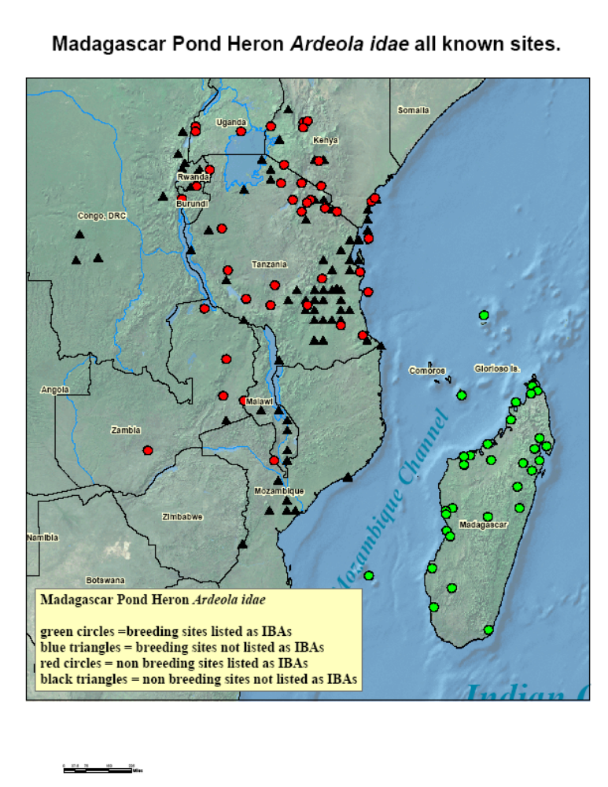
2. Available Key Information

Table 2.1: Global Population estimates of Madagascar Pond-heron

Breeding range | Wintering, or core non-breeding range | Estimate | Trend
Madagascar, Seychelles (Aldabra), Réunion (Europa), Mayotte | Burundi, Comoro Islands, DRC, Kenya, Malawi, Mozambique, Rwanda, Tanzania, Uganda, Zimbabwe and Zambia. Vagrant in Angola and Somalia | 2,000-6,000 | Declining

Table 2.2: National population estimates of Madagascar Pond-heron
Country | Breeding no. | Non-breeding no. | Quality | Year(s) of estimate | Population trend | Baseline population | References
Madagascar | 2000-6000 |  | ? | 2002 | Decline |  | F. Hawkins (in litt) per Dodman (2002)
Madagascar | 1000 |  |  | 2008 |  |  | Rene de Roland, L.A pers. com.
Europa (France) | 15 pairs | 10-50(2003) |  | 1996; 2003 |  |  | Le Corre and Safford (2001); Salamolard pers. com..
Mayotte (France) | 15 pairs (2003); 0 (2005)  10-20 pairs (2007) | 50-100 |  | 2003, 2005, 2007 | Stable to increasing | Recently found (2003) as breeding population | Rocamora 2004;  Clément pers com..
Seychelles (Aldabra) | 20-50 pairs |  |  | 2001? |  |  | Rocamora & Skerrett (2001)
Burundi |  | No data
Comoros |  | No data
DRC |  | No data
Kenya |  | No data
Malawi |  | No data
Mozambique |  | 100’s | Low | 2008 | No data | No data | L. Borghesio (pers. com)
Rwanda |  | No data
Tanzania |  | 100’s to low thousands | Low (best guess from 237 records over 30 years) | 1980-2007 | Decline | No data | Baker and Baker (in prep)
Uganda |  | No data
Zambia |  | No data

Table 2.3: Information from breeding colonies of Madagascar Pond-heron
Country | Colony | Year of breeding | No. of Breeding pairs | Mixed colony with? | Breeding success (no. fledgings/BP) | Legal status of the site | Conservation problem
Madagascar | Alarobia or Tsarasaotra Lake | 1996; 1997 | 234 pairs; 70 pairs | Ardeola ralloides, Bubulcus ibis, Egretta dimorpha, Egretta alba, Nycticorax nycticorax, Butorides striatus, Anas erythrorhyncha, Anas hottentota, Sarkidiornis melanotos, Dendrocygna viduata | Unknown -Difficult to count young birds - mixed | Private Park; Ramsar site | Nesting habitat small and high competition from species in the colony; some young MPH eaten by Nycticorax
Madagascar | Lac Amparihibe, Makira | 2004 | 6 adults | Tachyibaptus pelzenii | n= 3 | Temporary Protection (New Protected Area) | Natural catastrophe (cyclone)
Madagascar | Parc Botanique et Zoologique de Tsimbazaza | 1996; 1997; 2006; 2007; 2008 | 4; 8; 2; 3; 5 pairs | Ardeola ralloides, Bubulcus ibis, Egretta alba, Butorides striatus, Nycticorax, nycticorax, Egretta dimorpha, Melanophoyx ardesiaca, Ixobrychcus minutus | n =16; unknown; 5; 9; 14 | Botanical & Zoological Park | Disturbance by visitors; Site modification in an attempt to rehabilitate it (2007)
Mayotte, France | Bouéni Bay | 2003 (Nov); 2007 | 15 pairs; 10-20 pairs | Bubulcus ibis | unknown | none | Disturbance; No legal protection for site; probable collection of young birds (Rocamora 2004)
Mayotte, France | Tsingoni Bay | 2005; 2006 | (1- ?) | Bubulcus ibis | unknown | none | Disturbance
Seychelles | Aldabra, Ile aux Aigrettes
Reunión | Europa

3. Threats

Madagascar Pond-heron is listed as Endangered on the IUCN Red List of Threatened Species because it has a very small population which is undergoing a continuing decline due to a combination of factors. The main ones include: (1) its wetland habitats are facing large-scale ecological transformation due to drainage especially for agriculture; (2) there is increased competition from other herons (especially the commoner A. ralloides in Madagascar); (3) in Madagascar, there is increasing evidence of hybridisation with the much commoner Squacco Heron A. ralloides, although the latter does not breed on Mayotte, Aldabra or the Comoros; (4) many of its breeding colonies are heavily and increasingly exploited for eggs and young especially in Madagascar; and (5) Disturbance especially at breeding sites.

The inability to properly identify the species in the field, and differentiate it from the A. ralloides is another problem facing field workers and is likely affect any legislation in non-breeding countries.
Knowledge on the species is generally limited, especially regarding the following aspects (1) population size and trends; (2) location of all breeding sites in Madagascar; (3) details regarding extent, impact and causes of hybridisation with A. ralloides; (4) habitat requirements especially in the non-breeding range; and (5) ecology of the species. These knowledge gaps are obvious research priorities that need to be filled in order to conserve the species.

The threats facing this species are analysed in detail using a problem tree (Figure 2).

Figure 2: The Problem Tree

(a) Analysis of primary threats
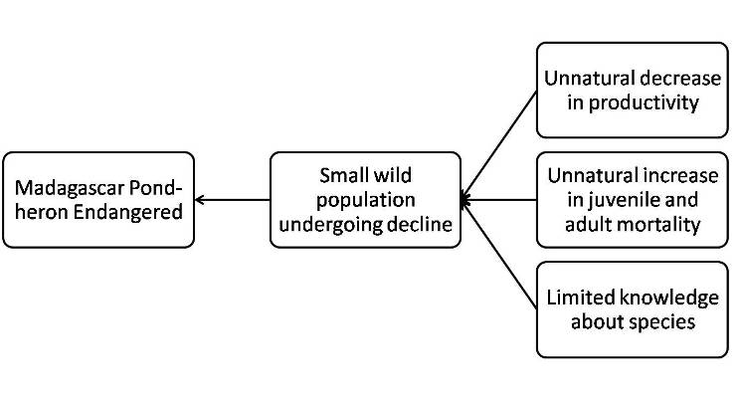

(b) Analysis of threats related to unnatural decrease in productivity
Key: ****=Critical, ***=High, **=Medium, *=Low, ? - unknown
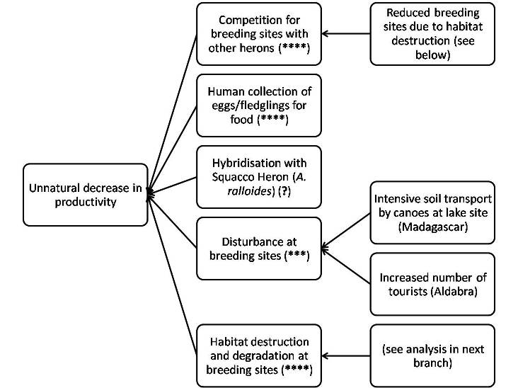

(b) Analysis of threats related to unnatural increase in adult mortality
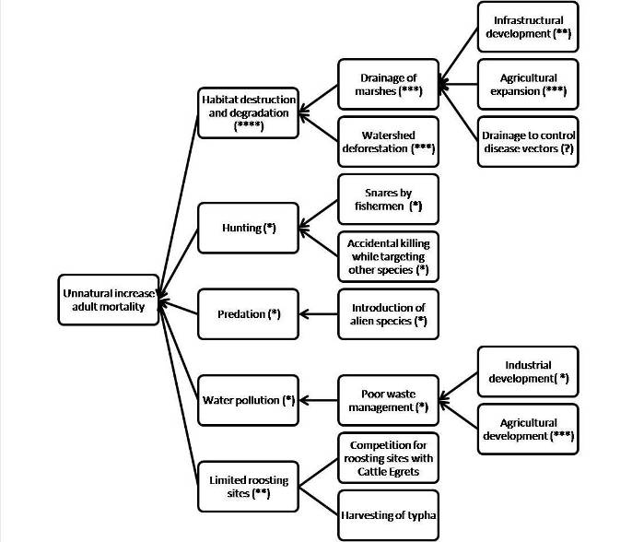
(b) Analysis of knowledge gaps
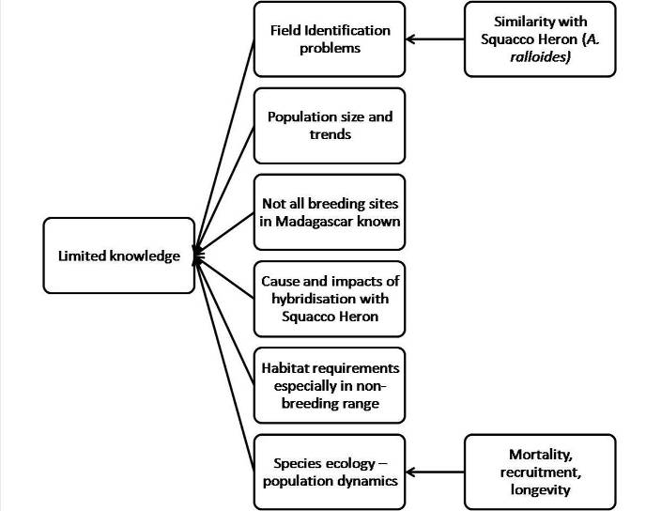

4. Policy and Legislation for relevant management

Table 4.1: International Conventions and agreements ratified by the range states
Country | CBD | CITES | AEWA | CMS | RAMSAR | WHC
Burundi | X | X |  |  | X | X
Comoros | X | X |  |  | X | X
DRC | X | X | X | X | X | X
Réunion (to France) | X | X | X | X | X | X
Kenya | X | X | X | X | X | X
Madagascar | X | X | X | X | X | X
Mayotte (to France) | X | X | X | X | X | X
Mozambique | X | X |  |  | X | X
Rwanda | X | X |  | X | X | X
Malawi | X | X |  |  | X | X
Seychelles | X | X |  | X | X | X
Tanzania | X | X | X | X | X | X
Uganda | X | X | X | X | X | X
Zambia | X | X |  |  | X

Table 4.2: National legislation relevant to Madagascar Pond-heron

Country | Status in National Red Data Book | National protection status | Law protecting species | Legal protection from killing, egg harvesting and nest destruction | Penalties | Highest responsible authority
Burundi | None | None | Decree Nbr 1/6 of 3rd March 1980 article 6 where it is stipulates that hunting is prohibited in Burundi protected areas; Environment Act- environmental Code adopted by edict nbr 1/010 of 30th June 2000 articles 89,90 and 147; Forest Code of 25th March 1985. | Yes |  | INECN
DRC | none | none | National Biodiversity Strategy |  |  | Ministry of Environment, Nature Conservation and Tourism
Europa
Kenya | none | With other threatened species in the Wildlife Act |  | Yes |  | Kenya Wildlife Service, KWS
Madagascar | EN | Category I, Class I : protected animals (=strict protection) | Decree N°2006-400 on the classification of species of wild fauna | Yes | Equivalent of 19200 to 38500 Euro fine plus 1 to 5 years of prison or one of the two penalty kinds | MEEFT (Ministère de l’Environnement, des Eaux et Forêts et du Tourisme) under the authority of the Minister
Malawi | None | Protected species | National Parks and Wildlife Act | ? | MK 4000 in default 2 years imprisonment | Department of National Parks
Mayotte | none | Protected species in Mayotte | Order n°347/DAF/list of protected species in Mayotte | yes | Unknown | Ministry of Environment, Ministry of Agriculture and Préfecture of Mayotte
Mozambique
Rwanda | None |  | Protected Area decree (1974) | Not yet | Fine for illegal hunting is being discussed by parliament | Rwanda Office of Tourism and National Parks (ORTPN) and Ministry of Land, Environment, Mines and Water Resources (MINITERE)
Seychelles | None
Tanzania | None; National SSAP for species in preparation | Wild animal category/ not within the hunting quota; Protected due to Global Red List status & AEWA | Wildlife Conservation Act (WCA) CAP 283 R. E. 2002; Wildlife Policy 2007 | Yes | Not set. Unknown | Wildlife Division within Ministry of Natural Resources and Tourism
Uganda
Union des Comores |  | All Ardeidae are “partly protected species»
Zambia | None |  | Wildlife Act |  |  | Zambia Wildlife Authority

5. Framework for action

Goal: To ensure favourable conservation status of the Madagascar Pond-heron.
Purpose: Improve the current conservation status and knowledge base of the Madagascar Pond-heron within the next 10 years

Table 5.1: Objectives and indicators
Objectives | Indicators
Objective 1: To reduce and manage human disturbance at breeding sites | No human disturbance during the presence of species at sites other than managed visits
Objective 2: To limit and reverse human activities that reduce or degrade the species’ habitat | Management actions on the ground aimed at maintaining the species’ habitat in at least 50% of key sites in 10 years.
Objective 3: To prevent exploitation of the species’ eggs and young. | No unmanaged access by people and animals in core areas during breeding season
Objective 4: To raise the species’ profile in the range states | At least one new Madagascar Pond-heron site gets legal protection status (Protected Area, or Community-based conservation in the first 5 years)
Objective 5: To determine the actual population size and trends and undertake appropriate training in proper field identification of A. idae. | Populations and trends determined
Objective 6: To determine the extent, impacts and causes of hybridisation of A. idae with A. ralloides. | Research outputs of scientific investigations
Objective 7: To establish the extent of the species’ range and distribution with a focus on identifying all breeding localities | Range and distribution mapped
Objective 8: To study the species’ survival and productivity, as well as life history outside the breeding season | Research outputs of scientific investigations
Objective 9: To determine the species’ habitat requirements  and preferences | Research outputs of scientific investigations

Table 5.2: Actions, their relative importance, time scale and lead agencies
Action | Priority | Time Scale | Lead agency
Objective 1: To reduce and manage human disturbance at breeding sites
1.1 Designate key breeding sites as Ramsar sites | Critical | 5 years | Government agencies
1.2 Develop and implement site visitation protocol for birdwatchers at the species’ sites | Low | 2 years | Government agencies, Conservation NGOs
1.3 Regulate access to sites during the breeding season, including designing and implementing community-run control of access. | Critical | Ongoing | Government agencies, Conservation NGOs, Community-based local conservation groups
1.4 Develop and or support the implementation of existing management plans of the known breeding sites | Critical | ongoing | Government agencies, Conservation NGOs
1.5 Prevent development which will reduce species’ breeding habitat | Critical | Ongoing | Government agencies, Conservation NGOs
1.6 Purchase some sites that hold key breeding colonies/ heronries as reserves | Medium | Medium | Government agencies, Conservation NGOs
Objective 2: To limit and reverse human activities that reduce or degrade the species’ habitat
2.1 Analyse the existing habitat images to establish the temporal changes of the species’ habitats in key sites using remote sensing | Medium | 2 years | Government agencies, Conservation NGOs
2.2 Designate all breeding sites under national protected area legislation | Critical | 5 years | Government agencies
2.3 Prevent development which will reduce species’ habitat | Critical | ongoing | Government agencies
2.4 Implement EIA studies in species habitats before any development | Critical | ongoing | Government agencies, Conservation NGOs
2.5 Prevent harvesting of Typha at species’ roosting sites | High | Ongoing | Government agencies, Conservation NGOs
2.6 Engage communities in conservation of species’ habitat through support and expansion of local conservation groups, e.g. SSGs and their activities | Medium |  | Government agencies, Conservation NGOs, Community-based local conservation groups
2.7 Develop and or/support the implementation of existing management plans of the known non breeding sites | High | Ongoing | Government agencies, Conservation NGOs
Objective 3: To prevent exploitation of the species’ eggs and young.
- (Activities as in objective 1)
Objective 4: Raise the species’ profile in the range states
4.1 Make the status, threats and the species’ priority actions more known and appreciated by the general public | critical | medium | Government agencies, Conservation NGOs
4.2 Develop and distribute advocacy materials e.g. posters, leaflets and put information on websites to raise awareness about the species in the public at national and regional levels | Critical | Medium | Government agencies, Conservation NGOs
4.3 Capture information about the species in field workers’ periodic reports in addition to other globally threatened, CMS/AEWA species | medium | ongoing | Government agencies, Conservation NGOs
4.4 Include Madagascar Pond-heron in media campaign (radio, TV, newspapers) together with other threatened, CMS and AEWA species | Medium | ongoing | Government agencies, Conservation NGOs
4.5 Include Madagascar Pond-heron in existing special events for threatened, CMS and AEWA species e.g. wetlands day, Bird Migratory days, etc. | High | Ongoing | Government agencies, Conservation NGOs
4.6 Include the species in relevant stakeholder meetings at local, national and regional levels | High | ongoing | Government agencies, Conservation NGOs
4.7 Include the species and other water birds in the ongoing training programs for staff, conservationists and students to improve species identification skills, survey techniques, etc | Medium | Ongoing | Government agencies, Conservation NGOs
4.8 Support and expand community conservation groups and their activities | Medium | ongoing | Government agencies, Conservation NGOs
Objective 5: To determine the actual population size and trends and undertake appropriate training in proper field identification of A. idae.
5.1 Develop identification kit and guide for herons | Medium | 1 year | Research institutions, Birding organisations, Government agencies, Conservation NGOs
5.2 Identify and investigate all of the suitable sites throughout Madagascar | High | 2 years | Research institutions, Birding organisations, Government agencies, Conservation NGOs
5.3 Develop a suitable census technique | High | 3 years | Research institutions, Government agencies,
5.4 Organise and conduct training for data collectors in identification, survey techniques and data management | High | ongoing | Research institutions, Government agencies, Wetlands International
5.5 Perform coordinated censuses in all countries | Critical | Ongoing | Research institutions, Government agencies, Wetlands International, Other NGOs
Objective 6: To determine the extent, impacts and causes of hybridisation of A. idae with A. ralloides
6.1 Design and implement a scientific study, e.g. genetic studies | Critical | 5 years | Research institutions, Government agencies
Objective 7: To establish the extent of the species’ range and distribution with a focus on identifying all breeding localities
7.1 Implement a field programme to identify all the breeding colonies in Madagascar | Critical | 3 years | Research institutions, Government agencies
7.2 Identify key sites in non-breeding range | Critical | 3 years | Research institutions, Government agencies
7.3 Initiate/strengthen waterbird databases in range states and ensure that the Madagascar Pond-heron is included | High | ongoing | Research institutions, Government agencies
7.4 Create an international network of people and institutions interested in the Madagascar Pond-heron and share information through the network | Medium | 1 year | Research institutions, Government agencies
7.5 Encourage birdwatchers to submit records to the network | Medium | ongoing | Research institutions, Government agencies
Objective 8: To study the species’ survival and productivity, as well as life history outside the breeding season
8.1 Design and implement a scientific study | Medium | 10 years | Research institutions, Government agencies
8.2 Undertake population modeling | Medium | 10 years | Research institutions, Government agencies
Objective 9: To determine the species’ habitat requirements
9.1 Design and implement a scientific study to undertake detailed research on the habitat requirements of the species | Critical | 10 years | Government agencies, Research institutions
9.2 Initiate a pilot programme for creation of artificial breeding sites/structures | Medium | 5 years | Research institutions, Government agencies

6. Monitoring and Evaluation

This will be done through tracking the level of implementation of various activities as outlined in the Actions table. A column will be added to this table in which assessment of progress (activity compared to indicator) will be explained. This table will be circulated to the Madagascar Pond-heron network for filling twice a year.
Activity | Priority | Time | Lead Agencies | Progress made (compare to indicators)

Twice per year, national contacts will evaluate progress nationally. The Africa Secretariat of BirdLife International in liaison with AEWA Secretariat will provide the global lead and the Madagascar Pond-heron network (working virtually by email) will fill in the table. The key driver persons for this process will be Julien Ramanampamonjy (breeding range) and Neil Baker (non-breeding range).

References

Bennun, L.A. and Njoroge, P. 1999. Important Bird Areas in Kenya. East Africa Natural History Society. Nairobi, Kenya.
Benson, C. W. and Penny, M. J. 1971. The land birds of Aldabra. Phil. Trans. R. Soc. Lond. Ser. B Biol. Sci. 260: 417-527.
Betts, M. (2002) A systematic list of the birds of Aldabra. ABC Bulletin 9(1): 32-42.
BirdLife International. 2008. Species factsheet: Ardeola idae. Downloaded from http://www.birdlife.org on
Chapin, J. P. .1953. Birds of the Belgian Congo. Bull. Amer. Mus. Nat. Hist. 75A, Part 3.
Clément, M., P. de Grissac & R. Rolland. 2008. Les Oiseaux de Mayotte. (Ed.: Naturalistes de Mayotte, Les guides naturalistes).
Dean, W.R.J. 2000. The Birds of Angola: An annotated checklist. BOU Checklist No. 18. British Ornithologists’ Union, Herts, U.K.
Dee, T. J. 1986. The Endemic Birds of Madagascar. Intern. Council for Bird Preservation (ICBP), Cambridge, U.K.
Dodman, T. 2002. Waterbird Population Estimates in Africa . Wetlands International consultation draft.
Dowsett-Lemaire, F. and Dowsett, R.J. 2006. The Birds of Malawi: an Atlas and Handbook. Tauraco Press.
Francoise & Robert Dowset- Lemaire, 2006: The birds of Malawi-An Atlas and Hand book, TauracoPress and Aves a.s.b.l Belgium.
Hantanirina I. 2006. Suivi écologique et socio economique dans les sites de conservation des zones humides au sein de la ZICO Complexe lac Ihotry – delta de la Mangoky. Asity internal report for BirdLife International Madagascar.
Irwin, M. P. S. (1981) The birds of Zimbabwe. Salisbury: Quest Publishing.
Langrand, O. 1990. Guide to the Birds of Madagascar. New Haven, USA: Yale University Press.
Langrand, O. and Wilmé, L. 1993. Protection des zones humides et conservation des espèces d’oiseaux endémiques de Madagascar. Proc. VIII Pan-Afr.Orn.Congr.201-208.
Le Corre, M. and Safford, R.J. (2001) La Réunion and Iles Eparses. Pp. 693-702 in Fishpool, L.D.C. and Evans, M.I., eds. Important Bird Areas of Africa and associated islands: Priority sites for conservation. Newbury and Cambridge, UK: Pisces Publications and BirdLife International (BirdLife Conservation Series No.11).Louette, M. 1988. La conservation des oiseaux à Mayotte. In (eds Thibault & Guyot) Livre Rouge des Oiseaux menacés des régions françaises d'Outre-Mer. ICBP. Monographie n°5. pp.: 197-207.
Louette, M. 2004. Oiseaux. In: Louette, M., D. Meirte and R. Jocque (eds). La faune terrestre de l’archipel des Comores. Studies in Afrotropical Zoology (MRAC, Tervuren). 293: 89-196.
Martinez-Vilalta, A. and Motis, A. 1992. Family Ardeidae (Herons) In: pp 376-429 del Hoyo, J., Elliot, A. and Sargatal, J. eds. Handbook of the Birds of the World. Vol. 1. Edicions, Barcelona.
Morris, P. and Hawkins, F. 1998. Birds of Madagascar: a photographic guide. Robertsbridge, UK: Pica Press.
Parker, V. 2005. Atlas of the birds if central Mozambique. Endangered Wildlife Trust & Avian Demographic Unit. Johannesburg and Cape Town.
Prigogine, A. 1976. Additions à l’avifaune du Zaire. Gerfaut 66: 307-308.
Rabarisoa R., Rakotonomenjanahary O., Ramanampamonjy J. 2006. Waterbirds of Baie de Baly, Madagascar. Waterbirds around the world. Eds.G.C.Boere,C.A. Galbraith & D.A. Stroud. The Stationery Office, Edinburgh, UK. pp.374-375.
Rabarisoa, R. 2001. Variation de la population des oiseaux d’eau dans le complexe des lacs de Manambolomaty, un site Ramsar de Madagascar. Ostrich Supplement No 15: 83-87
Rabarisoa. R. 2007. Inventories and assessment of wetlands between Andringitra and Andohahela National Parks, in the south-eastern region of Madagascar in order to get information on important wetlands which need conservation actions. BirdLife International Madagascar Programme. Internal report for Ramsar SGF.
Ramanampamonjy, J.R. 1997. Malagasy Pond Heron Ardeola idae Second survey 1996 in Antananarivo Province, Madagascar. PBZT Mars 1997. St Louis Zoo/MFG,
Razafimanjato, G., Sam, T.S. and Thorstrom, R. in Press: Waterbird monitoring in the Antsalova Region, western Madagascar.
Rene de Roland, L.A., Sam, T.S., Rakotondratsima, P.H., and Thorstrom, R. 2007. Rediscovery of the Madagascar pochard Aythya innotata. African Bird Club. Vol 14 (2): Pp 171-173.
Rio Tinto and BirdLife International 2006. Birdwatch Event report 2006. Birds species list at Fort Dauphin/Taolaganaro
Rocamora G. 2004. Les oiseaux des espaces naturels remarquables de Mayotte. Rapport SEF/DAF. Collectivités de Mayotte. 200 pp.
Rocamora, G., and Skerrett, A. Seychelles chapter pages 751-768 in FISHPOOL, L.D.C. and EVANS M.I. editors (2001) Important Bird Areas in Africa and Associated Islands: Priority sites for conservation. Newbury and Cambridge, UK. Pisces Publications and BirdLife International (BirdLife Conservation Series No.11).
Salvan, J. (1972) Statut, recensement, reproduction des oiseaux dulçaquicoles aux environs de Tananarive. L'Oiseau et R.F.O. 42: 35-51.
Salvan, J. 1970. Remarques sur l'evolution de l'avifaune Malgache depuis 1945. Alauda 38: 191-203.
Salvan, J. 1971. Observations nouvelles à Madagascar. Alauda 39: 37-42.
Wetlands International. 2002. Waterbird population estimates. 3rd. Wageningen, Netherlands: Wetlands International.
Wilmé, L. and Jacquet, C. 2002. Census of waterbirds and herons nesting at Tsarasaotra (Alarobia), Antananarivo, during the second semester of 2001. Working group on Birds in the Madagascar Region. Vol 2 (1): 14-21.
ZICOMA (1999) Zones d'Importance pour la Conservation des Oiseaux a Madagascar. Antananarivo:Projet ZICOMA.
Annex 1: Localities where the Madagascar Pond-heron has been recorded.
Site | IBA | No of records / notes | References
Madagascar
Montagne d'Ambre NP | MG003 |  | ZICOMA 1999
Analamera SR | MG004 |  | ZICOMA 1999
Akarana SR | MG006 |  | ZICOMA 1999
Nosy Be | MG011 |  | ZICOMA 1999
Masoala NP | MG017 |  | ZICOMA 1999
Sahamalaza Bay | MG018 |  | ZICOMA 1999
Ankobohobo wetlands | MG022 |  | ZICOMA 1999
Mahavavy delta | MG025 |  | ZICOMA 1999
Baly Bay NP | MG026 |  | ZICOMA 1999
Ankarafantsika SNR | MG027 |  | ZICOMA 1999
Marotandrano SR | MG029 |  | ZICOMA 1999
Namoroka Tsingy SNR | MG030 |  | ZICOMA 1999
Bemaraha Tsingy NP | MG037 |  | ZICOMA 1999
Bemamba wetlands | MG038 |  | ZICOMA 1999
Manambolomaty wetlands | MG039 |  | ZICOMA 1999, Rabarisoa 2001
Anjanaharibe CF | MG040 |  | ZICOMA 1999
Upper Rantabe CF | MG041 |  | ZICOMA 1999
Mananara-North NP | MG042 |  | ZICOMA 1999
Ambatovaky SR | MG043 |  | ZICOMA 1999
Lake Alaotra | MG046 |  | ZICOMA 1999
Mantadia NP | MG054 |  | ZICOMA 1999
Lake Itasy | MG058 |  | ZICOMA 1999
Tsiribihina Delta | MG059 |  | ZICOMA 1999
Menabe Forest complex | MG060 |  | ZICOMA 1999
Lake Ihotry HR | MG062 |  | ZICOMA 1999
Zombitse-Vohibasia NP | MG065 |  | ZICOMA 1999
Saint Augustin Forest | MG067 |  | ZICOMA 1999
Tsitongambarika CF | MG072 |  | ZICOMA 1999, Rabarisoa & all pers obs.
Bongolava wetland complex | - |  | BirdLife Madagascar 2005
Antongomena forest | - |  | Ramanampamonjy pers comm. *
Bekapika river rice fields | - |  | Ramanampamonjy & all per obs.
Betsiboka River | - |  | Ramanampamonjy pers comm.
PBZT | - |  | Ramanampamonjy pers comm.
Tsarasaotra Lake | - |  | Wilmé, L. and Jacquet, C. 2002
Road to Isorana | -
Lavaraty | - |  | Rabarisoa (2007)
Sanira | - |  | Rabarisoa (2007)
Lagune of Fort Dauphin | - |  | Rio Tinto/BirdLife International Madagascar.. BirdWatch Event report 2006.
Andranobe Lake | - |  | Ramanampamonjy pers comm.
Amparihibe Lake | - | Volcanic Lake inside intact forest | Lily-Arison and Sam The Seing
Matsaborimaitso Lake | - | Volcanic Lake inside intact forest | Lily-Arison and Sam The Seing
Comoros - Mayotte breeding sites
Baie de Boueni | YT004 | Found in 2003; 10-20 pairs in 2007 | Rocamora (2004); Clément (pers com)
Baie de Tsingoni |  |  | Clément com.pers
Comoros – Mayotte non-breeding sites
Lake Dziani Karehani |  | Many records – year & no: :1958 -4; 1983 -5; 1985 – 3; 1992 -7; 1993 -7; 1995 -7; 1996 – 7; 2003 -12; 2004 -37 | Loutte 2004; Clément (pers. com); Salamorand (pers com)
Pamandzi |  | 1 in 1965 | Clément and Salamorand (pers coms)
Near White Island |  | 1 in 1985 | Clément and Salamorand (pers coms)
Near Mramadoudour |  | 1 in 1994 | Clément and Salamorand (pers coms)
Dzoumonyé |  | 1 in 1994; 6 in 2003 | Clément and Salamorand (pers coms)
Retenue de Combani |  | 2 in 2003; 5 in 2004 | Clément and Salamorand (pers coms
Vasières des Badamiers |  | 1 in 2004 | Clément and Salamorand (pers coms
Miréréni |  | >1 in 2004 | Clément and Salamorand (pers coms
Chirongui |  | >1 in 2004 | Clément and Salamorand (pers coms
Tsimkoura |  | >1 in 2004 | Clément and Salamorand (pers coms
Mzouazia |  | >1 in 2004 | Clément and Salamorand (pers coms
Mounyambani |  | >1 in 2004 | Clément and Salamorand (pers coms
Dembéni |  | >1 in 2004 | Clément and Salamorand (pers coms
Ironibé |  | >1 in 2004 | Clément and Salamorand (pers coms
Comoros – non breeding sites
Grande Comore (Mitsamiouli) |  | 1 in 1969 | Louette, M (pers com)
Mohéli (Dziani Boudouni) |  | 2 in 1983; 1 in 1993 | Louette, M (pers com)
Anjouan (Pomoni) |  | Seen frequently | Louette, M (pers com)
Seychelles - Aldabra breeding sites
Aldabra atoll | SC020 |  | Betts (2002)
French 'Iles Eparses'
Europa atoll | RE012 | 15 pairs 1996
Malawi 7 sites
Lengwe NP | MW021 | no dates, sev records | Dowsett-Lemaire & Dowsett 2006
Hynde Dam, Limbe | - | 1, 1984 | Dowsett-Lemaire & Dowsett 2006
Lifu near Salima | - | 1988 | Dowsett-Lemaire & Dowsett 2006
Lilongwe sewage ponds | - | 1989 | Dowsett-Lemaire & Dowsett 2006
Namizimu, Liwonde NP | - | no dates | Dowsett-Lemaire & Dowsett 2006
Blantyre | - | no dates, sev records | Dowsett-Lemaire & Dowsett 2006
Elephant marsh | - | no dates, sev records | Dowsett-Lemaire & Dowsett 2006
Rwanda 8 sites
Akagera NP | RW003
Gashora | -
Butare | - | 7 specimens; formally Astrida | Prigogine 1976
Gisagara | - |  | Prigogine 1976
Kisenyi | - |  | Prigogine 1976
Kigali | ? |  | Prigogine 1976
Burundi 3 sites
Rwihinda Lake | BI001
Rusizi NP | BI004
Lake Tanganyika | -
Kenya 18 sites
Arabuko-Sokoke | KE007 |  | Brian Finch pers comm.
Sabaki river mouth | KE019 | 1, 2007 | Kenya Birdfinder
Nairobi NP | KE036 | regular, many records | Kenya Birdfinder
Amboseli NP | KE042 | 2 - | Kenya Birdfinder
Lake Baringo | KE044 |  | Brian Finch pers comm.
Lake Naivasha | KE048 |  | Brian Finch pers comm.
Lake Nakuru NP | KE049 | 1 - | Brian Finch pers comm.
Masai Mara | KE050 | 1, 1996 | Brian Finch, Dave Richards pers comm.
Busia grasslands | KE057 | 1, 2007 | Kenya Birdfinder
Manguo Swamp Limuru | - | 2, 2003, 06 | Don Tuner pers comm.
NAIROBI 8 SITES | - | multiple records | many refs
Ahero Rice Scheme | - |  | Brian Finch pers comm.
Lake Jipe | - |  | Brian Finch pers comm.
Eldoret | - |  | Brian Finch pers comm.
Thika Gethumbwini Estate | - | 1, 1997 | Don Tuner pers comm.
Malindi Golf Course | - | 1, 1997 | Kenya Birdfinder
Mombasa Msambweni | - | 1, 1997 | Kenya Birdfinder
Mombasa Bamburi NT | - | 1, 1995 | Kenya Birdfinder
Uganda 3 sites
Rwenzori Mts NP | UG005 | 1, Turner (1980)
Queen Elizabeth NP | UG007
Lutembe Bay | UG018
Zimbabwe 1 site
Chipinga |  | 1, 29 Sept 1923 | Irwin 1981
Zambia 7 Sites
Lochinvar NP | ZM011
South Luangwa NP | ZM019 | >30 at 5 sites
Shiwa Ngandu | ZM023
Sumbu NP | ZM035
Lukusui NP | ZM041
Sinde-Nyanje | -
Nakode | -
Mocambique 9 Sites (some overlap ?)
Vilanculos |  | 1, Aug 1999
? |  |  | Parker 2005
? |  |  | Parker 2005
? |  |  | Parker 2005
? |  |  | Parker 2005
? |  |  | Parker 2005
Ilha Suafo |  | 10-50 inds, May 2008 | Luca Borgesio
Mala Mala |  |  | Branch & Branch 1998
Squacco Vlei |  |  | Branch & Branch 1998
Democratic Republic of Congo 11 Sites
Merode | ? | 2 specimens | Prigogine 1976
Lusambo | ? |  | Prigogine 1976
Kabinda | ? |  | Prigogine 1976
Kamituga | ? | 6 specimens | Prigogine 1976
Lac Mokoto | ? |  | Prigogine 1976
Butembo | ? |  | Prigogine 1976
N. Kivu, région Kisenyi | ? |  | Prigogine 1976
Lulenga, Kivu | ? |  | Prigogine 1976
Moba, Katanga |  | see Chapin 1954 | Chapin 1932
Kasenga, Katanga |  | see Chapin 1954 | Prigogine 1976
Tshibati, Kivu |  | see Chapin 1954 | Prigogine 1976
Tanzania 99 sites, 20 IBAs, note that 14 did not previously qualify for this species
Arusha NP | TZ001 | Baker & Baker 2002 | tanzaniabirdatlas.com 7 records
Katavi NP | TZ002 | tanzaniabirdatlas.com | 1 record
Mikumi NP | TZ006 | Baker & Baker 2002 | tanzaniabirdatlas.com 13 records
Ruaha NP | TZ007 | tanzaniabirdatlas.com | 2 records
Serengeti NP | TZ009 | Baker & Baker 2002 | tanzaniabirdatlas.com 8 records
Tarangire NP | TZ010 | tanzaniabirdatlas.com | 3 records
Mafia Island | TZ012 | tanzaniabirdatlas.com | 3 records
Ngorongoro CA | TZ013 | tanzaniabirdatlas.com | 3 records
Mkomazi GR | TZ016 | tanzaniabirdatlas.com | 1 record
Moyowosi-Kigosi GR | TZ017 | tanzaniabirdatlas.com | 3 records but huge site
Selous GR | TZ018 | Baker & Baker 2002 | tanzaniabirdatlas.com 41 records
Dar es Salaam coast | TZ021 | tanzaniabirdatlas.com | 55 records
Eluanata Dam | TZ022 | tanzaniabirdatlas.com | 1 record
Kilombero Valley | TZ025 | Baker & Baker 2002 | tanzaniabirdatlas.com 17 records
Nyumba ya Mungu dam | TZ030 | tanzaniabirdatlas.com | 1 record
Lake Natron | TZ031 | tanzaniabirdatlas.com | sev records not yet entered
Lake Rukwa | TZ033 | tanzaniabirdatlas.com | 1 record but huge site
Usangu Flats | TZ038 | tanzaniabirdatlas.com | 1 record but huge site
Litipo FR | TZ051 | tanzaniabirdatlas.com | 1 record
Pemba Island | TZ076 | Baker & Baker 2002 | tanzaniabirdatlas.com 3 records
non IBA sites (some overlap) referenced to centre 1/4 degree square. 44 squares (multiple sites in some squares)
many of these records are single observations of single birds
lake shore camp |  | tanzaniabirdatlas.com
Malagarasi |  | tanzaniabirdatlas.com
Rungwa River |  | tanzaniabirdatlas.com
Smith Sound |  | tanzaniabirdatlas.com
Musoma |  | tanzaniabirdatlas.com
Mara forest |  | tanzaniabirdatlas.com
Grumeti River |  | tanzaniabirdatlas.com
Mbamba Bay |  | tanzaniabirdatlas.com
Kibebe |  | tanzaniabirdatlas.com
Mufindi Itona |  | tanzaniabirdatlas.com
Olasiti |  | tanzaniabirdatlas.com | 16 records
Tarangire NP south |  | tanzaniabirdatlas.com
Kilombero Sugar |  | tanzaniabirdatlas.com
Matundu FR |  | tanzaniabirdatlas.com
Igumbiro |  | tanzaniabirdatlas.com
Kilombero sth |  | tanzaniabirdatlas.com
Kivukoni |  | tanzaniabirdatlas.com
Ilonga |  | tanzaniabirdatlas.com
Mkuyu River |  | tanzaniabirdatlas.com
Moshi |  | tanzaniabirdatlas.com
Mwomero ANC |  | tanzaniabirdatlas.com
Morogoro |  | tanzaniabirdatlas.com
Nyamvisi River |  | tanzaniabirdatlas.com
Beho Beho |  | tanzaniabirdatlas.com
Madaba |  | tanzaniabirdatlas.com
Kibaoni |  | tanzaniabirdatlas.com
Luwele |  | tanzaniabirdatlas.com
Lulira |  | tanzaniabirdatlas.com
small pond !! |  | tanzaniabirdatlas.com
Mkata |  | tanzaniabirdatlas.com
Bagamoyo |  | tanzaniabirdatlas.com
Ruvu Valley |  | tanzaniabirdatlas.com
Selous GR |  | tanzaniabirdatlas.com
Rufiji River camp |  | tanzaniabirdatlas.com
Ngarambe |  | tanzaniabirdatlas.com
Nahomba Tundu |  | tanzaniabirdatlas.com
Kandalawe |  | tanzaniabirdatlas.com
Matundu |  | tanzaniabirdatlas.com
Ngezi FR |  | tanzaniabirdatlas.com
Pangani |  | tanzaniabirdatlas.com
Bwawani |  | tanzaniabirdatlas.com
Ndege Beach |  | tanzaniabirdatlas.com
Lake Kitere |  | tanzaniabirdatlas.com
in Selous GR ? |  | tanzaniabirdatlas.com

Migratory species that have an unfavourable conservation status or would benefit significantly from international co-operation organised by tailored agreements are listed in Appendix II to CMS. For this reason, the Convention encourages the Range States to conclude global or regional Agreements for the conservation and management of individual species or, more often, of a group of species listed on Appendix II.
AEWA provides for coordinated and concerted action to be taken by the Range States throughout the migration system of waterbirds to which it applies. Category 1: (a) Species which are included in Appendix I to the Convention on the Conservation of Migratory species of Wild Animals; (b) Species which are listed as threatened in Threatened Birds of the World (BirdLife International 2008); or (c) Populations, which number less than around 10,000 individuals.

