DRAFT INTERNATIONAL SINGLE SPECIES ACTION PLAN
FOR THE CONSERVATION OF THE
WHITE-WINGED FLUFFTAIL SAROTHRURA AYRESI

Introduction

The Single Species Action Plan for the Conservation of the White-winged Flufftail Sarothrura ayresi was initiated jointly by CMS and AEWA in 2007. The plan covers the entire range of this intra-African migrant. The drafting of the plan was commissioned to the BirdLife International Africa Partnership Secretariat and was compiled by a team under the management of Paul Kariuki Ndang’ang’a in association with organisations such as the Ethiopian Wildlife and Natural History Society, Middelpunt Wetland Trust, and Ezemvelo KZN Wildlife.

The Technical Committee reviewed the draft plan in 2008 and it was also consulted with governmental officials at the range states of the species. At its 5th meeting in June 2008 the Standing Committee endorsed the draft plan for submission to MOP4.

Action requested from the Meeting of the Parties

The Meeting of the Parties is invited to review this SSAP and adopt it for further implementation. The SSAP will also be submitted for approval by the CMS governing bodies at the end of 2008.

Convention on Migratory Species

African-Eurasian Migratory Waterbird Agreement

International Single Species Action Plan for the Conservation of the
White-winged Flufftail

Sarothrura ayresi

Final draft

September 2008

Funded by

the Italian Ministry for the Environment

Compiled by

BirdLife International Africa Partnership Secretariat

In cooperation with

Ethiopian Wildlife and Natural History Society

Middelpunt Wetland Trust

Ezemvelo KZN Wildlife

Development of this action plan was commissioned to the Africa Partnership Secretariat of BirdLife International by the secretariats of the Convention on the Conservation of Migratory Species of Wild Animals and the Agreement on the Conservation of African-Eurasian Migratory Waterbirds (AEWA), with funding from the Italian Ministry for the Environment.

Edited by: Eric Sande, P. Kariuki Ndang’ang’a, James Wakelin, Mengistu Wondafrash, Malcolm Drummond, Sergey Dereliev

List of contributors
Angus Middleton (FACE; AEWA Technical Committee observer), Anthony Cizek (UK), David Stroud (UK, JNCC (AEWA TC observer), Fadzai Matsivimbo (BirdLife Zimbabwe), Geremew Gebreselassie (Ethiopian Wildlife and Natural History Society), James Wakelin (Ezemvelo KZN Wildlife), Malcolm Drummond (Middelpunt Wetland Trust), Mengistu Wondafrash (Ethiopian Wildlife and Natural History Society), Mihret Ewnetu (Ethiopian Wildlife Conservation Authority), Niels Kanstrup (Denmark, CIC, AEWA Technical Committee member), Sergey Dereliev (AEWA), Tendai Wachi (Zimbabwe Parks and Wildlife Management Authority), Teshome Bejiga (Office of Africulture and Rural Development, Ada Berga District), Yigezu Kelkayeleh (Ada Berga Dairy Farm, representing the Holetta Agricultural Research Center that is managing the Dairy Farm).

Milestones in the production of the plan
Workshop: 26-28 May 2008
First Draft presented to experts: 16 June 2008
Second Draft presented to Range States and AEWA Technical Committee: 16 July 2008
Final Draft: September 2008
Final Draft approved by AEWA:

Geographical Scope
This international Single Species Action Plan requires implementation in the following countries regularly supporting White-winged Flufftail: Ethiopia and South Africa; and in Zimbabwe and Zambia where the species has been recorded.

Reviews
This International Single Species Action Plan should be revised in 2018. An emergency review will be undertaken if there are sudden major changes liable to affect the population.

Table of Contents

List of Acronyms ii
Executive Summary 2
1. Biological assessment 2
2. Available Key Information 2
3. Threats 2
4. Policy and legislation for relevant management 2
5. Framework for action 2
6. Implementation 2
References 2

List of Acronyms

ACNR: Association pour la Conservation de la Nature au Rwanda
AEWA: Agreement on the Conservation of African-Eurasian Migratory Waterbirds
BLZ: BirdLife Zimbabwe
CITES: Convention on International Trade in Endangered Species of Wild Fauna and Flora
CMS: Convention on the Conservation of Migratory Species of Wild Animals
DEAT: Department of Environment and Tourism (South Africa)
DWAF: Department of Water Affairs and Forestry (South Africa)
EPA: Environmental Protection Authority (Ethiopia)
ET: Ethiopia
EWCA: Ethiopian Wildlife Conservation Authority
EWNHS: Ethiopian Wildlife and Natural History Society
MoARD: Ministry of Agriculture and Rural Development (Ethiopia)
MWT: Ministry of Wildlife and Tourism (Ethiopia)
MWT: Middelpunt Wetland Trust
BLSA: BirdLife South Africa
NGO: Non-governmental Organisation
SA: South Africa
SSG: Site Support Group
ZOS: Zambian Ornithological Society

Executive Summary

The White-winged Flufftail Sarothrura ayresi is a globally Endangered species, with a declining population estimate of 700 individuals. It occurs in Ethiopia (known at three sites, the only known breeding sites), Zimbabwe (three records) and South Africa (known from nine sites).

The main threats to the White-winged Flufftail include grazing, cutting of sedges and grasses during the breeding season, increased transformation of natural habitat to cultivation, inundation of wetland habitat through the construction of dams, natural resource use by local people, habitat trampling by livestock and afforestation by eucalyptus. There is limited information on the population status and ecology of the species, which hampers implementable conservation action.

The purpose of this plan is to increase the population of flufftails through improving and increasing the extent of suitable habitat for the species. The priority actions identified are to:
- Facilitate enforcement of legislation to stop cultivation in the wetlands at the breeding sites
- Prevent any change (including inundation) of the species’ habitat arising through the building of dams
- Prevent inappropriate development which can negatively affect the species’ habitat
- Develop and implement schemes for managing the pressure of grazing at all breeding sites
- Prevent access to the wetland breeding sites, by resource users, during the breeding season
- Determine if there are multiple populations of the species
- Identify migration routes and stop-over sites of the species
- Determine the habitat requirements and preferences of the species
- Establish the extent of the species’ range and distribution
- Determine the population sizes and trends

Implementation of this action plan will be supplemented by the existing conservation plans already in place, namely the Ethiopian and South African White-winged Flufftail actions plans, the site management plans and the ongoing activities undertaken by the Site Support Group at Berga in Ethiopia and Middelpunt Wetland Trust in South Africa and Ethiopia.
1. Biological assessment

General Information | The White-winged Flufftail Sarothrura ayresi, is a small, secretive and little-known Rail endemic to Africa. The adult male has a chestnut head and both sexes have black-barred chestnut tail and white wing-patches on the secondary flight feathers. The best chance of seeing this secretive bird is during the wet season in upland marshes in eastern South Africa and central Ethiopia. It is categorised as globally Endangered in the 2008 IUCN Red List. This is because it has a very small range, with breeding proven at only three locations, which is believed to be undergoing a continuing decline in extent, area, and habitat quality, owing to the high rate of loss and degradation of its preferred habitat, seasonal marshland (BirdLife International 2008).  Currently, the White-winged Flufftail is listed in Appendix I (Migratory Species in danger of extinction) of CMS and in Column A, Categories 1a, 1b and 1c of the AEWA Table 1.
Taxonomy and Systematics | Class: Aves  Order: Gruiformes  Family: Rallidae  Genus: Sarothrura (Heine, 1890)  Species: Sarothrura ayresi (Gurney)  Coturnicops ayresi Gurney, 1877, Potchefstroom, South Africa.  Sometimes placed in Coturnicops, usually with, but sometimes without, other flufftail species. Ethiopian birds first described as Ortygops macmillani (Bannerman 1911). Forms a species pair with S. watersi. Monotypic.  Synonyms: Coturnicops ayresi; Ortygops macmillani.  Alternative name: White-winged Crake.  Taxonomic sources: Dowsett and Forbes-Watson (1993), Sibley and Monroe (1990, 1993).
Population and trend | The population in South Africa is estimated to be 235 birds (Taylor and van Perlo 1998), with a further with at least a further 210-215 pairs in Ethiopia i.e. probably 700 mature individuals in total (Wetlands International 2006, BirdLife International 2008).  The species’ population is suspected to be decreasing in line with levels of disturbance, loss and degradation in Ethiopia and South Africa (Atkinson et al. 1996; Taylor and van Perlo 1998; P.B. Taylor in litt. 1999; De Smidt and Evans 2003; Taylor and Grundling 2003; M. Drummond in litt. 2005; Wetlands International 2006). However, the likely rate of decline has not been estimated.  Whether a single population migrates between Ethiopia and Southern Africa, or each country hosts its own sub-population, is not yet known (Barnes 2000, Taylor and van Perlo 1998), although observations from a breeding site in Ethiopia discovered in 2005 show that the birds continue to breed into the dry season and may remain in Ethiopia after breeding, rather than migrate.  Despite the great distance separating this bird’s two centres of occurrence, and the lack of records from most of the intervening regions, there appears to be no significant morphological differences between South African and Ethiopian populations. Migration between the two widely separated distribution ranges in Eastern and Southern Africa is considered unlikely (Taylor and van Perlo 1998).
Geographical distribution | The White-winged Flufftail occurs in Ethiopia, Zimbabwe and South Africa and there is one reliable record from Zambia (Figure 1). Claimed records for Rwanda are unproven. The occupied breeding range has been estimated as 250 km² (Anon 1999). Currently in Ethiopia, the species has been recorded in three sites in the central highlands (the Weserbi wetlands, the Berga wetlands and the Bilacha, all wetlands near Addis Ababa), the only known breeding area for this species (Taylor 1998, Taylor 1999, Taylor and van Perlo 1998). In South Africa, the species is known from nine sites in KwaZulu-Natal and Mpumalanga (De Smidt 2003). In Zimbabwe, according to Cizek et al. (in prep), it was more regularly recorded from Harare during the high rainfall wet seasons of 1977 and 1979 than currently generally reported (c.f. e.g. BirdLife (2008)). It is known from three sightings at two different sites Jan-Mar 1977 and several sightings from a marsh below the disused Western Sewage Works, with another bird at the edge of the Marimba marsh, all Jan-Mar 1979 (Hopkinson and Masterson (1977, 1984)). These sightings most likely involved at least four individuals (but possibly more) at four different sites in the vlei ecosystems which formerly covered an extensive area of the western suburbs of Harare. An individual was recorded at a fifth site, Aisleby Farm, just south of Bulawayo 6 February 1988 (Hustler and Irwin 1995). It possibly bred in Zimbabwe in the 1950s (Taylor 1994).  In Ethiopia, it was formerly known from highlands around Addis Ababa (Sululta Plain, Akaki, Entotto and Gefersa), and at a lower elevation to the SW at Charada, Kaffa. From 1939 to 1957 small numbers were recorded occasionally in the Ethiopian highlands; subsequently one bird was seen near Sululta in August 1984 and 4 in Aug-Sep 1995, while an estimated 10-15 breeding pairs were present in August 1996 (Taylor 1996). In August 1997 a breeding population of at least 200 pairs was found in seasonal and permanent marsh at a new locality near Addis Ababa (Berga wetland) and it is probable that the species was widespread and locally numerous in the central Ethiopian highlands before intensive human pressure destroyed most of its seasonal marsh habitat (Taylor 1997a).  In Zambia there is one reliable record from near Chingola, Solwezi District (Brooke 1964). Sound records from Rwanda (Dowsett-Lemaire 1990) are questionable, sonagraphic analysis indicating that they are calls of the Crowned Crane (Taylor 1994).  In South Africa it was recorded only sporadically after its discovery in 1876, and since the early 1950s five highland sites in Southern KwaZulu-Natal and Eastern Transvaal, South Africa, have held small numbers (maximum overall annual counts 22-29 birds), three of these sites annually in 1990-1992, when regular observations were made. Recent surveys (Taylor 1997b) have identified five more sites in the Free State and KwaZulu-Natal where this bird probably occurs annually and the total population at the nine known sites may be 235 birds. In South Africa, the lack of recent records from coastal localities suggests that it may now be confined to the higher-altitude wetlands (Taylor 1994).
Distribution throughout annual cycle | The apparent lack of subspeciation has been thought to indicate that regular migration occurs between the bird’s Ethiopian and South African centres of distribution but the paucity of records from intervening regions, and an overlap in occurrence dates, make this unlikely (Collar and Stuart 1985), while birds may be present throughout the year at Berga wetland, a recently discovered marsh near Addis Ababa (Taylor 1997a). However, there may be periodic long-distance dispersal when numbers are high, allowing gene exchange between the Northern and Southern populations. The few records from Zimbabwe and Zambia may reflect such dispersal, and the species is possibly an occasional breeding migrant in Zimbabwe.  Much breeding habitat in the Central Ethiopian highlands, where most occurrences are recorded from Jun-Sep, is in a seasonal marsh and is thus unsuitable in the non-breeding season when migration may occur SW to lower-altitude, permanent marshes such as those at Charada, Kaffa (in the Jimma area), whence there is a May specimen (Taylor 1994, 1996). Guichard (1948) suggested that males arrive in breeding areas before females.  In South Africa, where recent records suggest that the species is normally migratory or nomadic, it is recorded from Aug-Mar and in May (Taylor 1994)
Survival and productivity | Due to the limited knowledge on the species’ ecology and population dynamics (Figure 2d), none of the available literature describes its survival and productivity.
Life History: Breeding | Season: Nest-building and egg-laying occur in Ethiopia during long rains in July-August. A juvenile recorded in South Africa in November is probably from an egg laid in August (Taylor 1994). Despite claims to the contrary, there is as yet no acceptable evidence that the species breeds in South Africa (Taylor 1994).  Nest: The first recorded nest was found in Ethiopia in 1999, and was situated in short grass (300-450 mm tall), in damp ground in an upland wetland that was drying out. The nest was built in a tuft of Eliocharis sedge, with its base 10 mm above the ground; it was a round ball with a side entrance, and was made with stems of grass and sedges, with live plant stems drawn over the top to form the roof. It measured: outside diameter 150 mm, cup diameter 95 mm and entrance diameter 48 mm. (Tarboton 2001). Further nest descriptions were made by Allan et al. (2006) based on records of seven (only one active) nests. The active one was c. 100m from the main watercourse in a waterlogged area with dense aquatic vegetation. The 12 cm wide and 17.5 cm height ball-shaped nest was built on a sedge (Cyperus sp.) tuft and its base was 1 cm above ground. It had a 5.5 cm wide and 6.5 cm wide side entrance  Eggs: A clutch of five pure white eggs from the nest found by Tarboton (2001) measured 27 x 20 mm. The clutch found by Allan et al. (2006) had four unmarked ivory-white eggs.  Chicks (Taylor 1996): Both sexes apparently feed and care for chicks. Adults lead observers away from young chicks by running through short vegetation, often across open patches, and hiding briefly in dense cover.  Observations in Ethiopia suggest that birds commence nesting immediately after arrival in the breeding habitat in late July and early August. The entire breeding cycle may occupy as little as six weeks, after which all birds may leave breeding habitat, which may have become unsuitable as a result of damage from grazing, trampling and cutting. Some birds may be able to raise a second brood elsewhere, before end of October, in late-developing habitat. Natural predation of eggs and young may be low at Ethiopian breeding sites.
Life History: Feeding | Stomach contents have been recorded as water insects, grain seeds and ‘vegetable mush’. Studies in Ethiopia (Taylor 1996, 1997b) have provided the following information: Adults take earthworms, small freshwater crustaceans, and the adults and larvae of aquatic and terrestrial insects such as Lepidoptera, Coleoptera (including Chrysomelidae) and Diptera. Small chicks are fed on crustaceans, Coleoptera (including Dytiscidae larvae) and Diptera (including large prey such as Tipulidae and Tabanidae larvae over 2cm long). Foraging has been observed from early to mid-morning and in the late afternoon.
Life History: Outside breeding season | Apart from sighting records no detailed observational data has been collected about the species ecology outside the breeding season.
Habitat requirements: Breeding | Most of the information on habitat requirements is derived from Taylor (1994, 1996). Ethiopian breeding habitat is seasonal; dense, lush, rapidly growing vegetation, 20-50cm (usually 20-40cm) tall, on firm ground which is flooded to a depth of 20cm (usually to 10cm). Dominant plants include sedges (Cyperus rigidifolius, C. afroalpinus and Eleocharis marginulata), grasses (Pennisetum schimperi and P. thunbergii) and forbs such as Uebelinia kigesiensis, Trifolium calancephalum, Ranunculus multifidus, Rumex marginulata, Haplocarpha schimperi, and a Polygonum species. Sedges and short grasses tend to dominate in the more shallowly flooded sites, which lie in depressions and at the bases of shallow slopes above seasonal wetlands, as well as within the wetlands themselves. Forbs and taller grasses dominate in the more deeply flooded areas of taller vegetation within the wetlands. The bird has been recorded breeding alongside the Red-chested Flufftail Sarothrura rufa in Ethiopia, occupying typical seasonally flooded vegetation types while the Red-chested Flufftail occurred in adjacent taller, sedge-dominated, permanently wet areas (P B Taylor unpubl.). In Ethiopia it occurs at 2,200-2,600m in the central highlands, and at 1,100m in the SW.
Habitat requirements: Feeding | In the breeding habitat, birds forage along muddy cattle tracks, at shallow pools, and at patches of cut vegetation and other small open areas in the dense cover, taking insects and other invertebrates from moist ground, mud and shallow water, and from flattened and low-growing vegetation; both adults and chicks apparently also forage in more deeply flooded vegetation (Taylor 1994, 1996).
Habitat requirements: Outside breeding season | In South Africa, 9 of the 10 important confirmed sites for the species are within the Eastern Uplands, Great Escarpment Mountains and Highveld peatland ecoregions, emphasising the importance of peat-based habitats (Taylor and Grundling 2003).  Non-breeding birds in South Africa occur for short periods alongside breeding Red-chested Flufftails in dense hygrophilous grasses (predominantly Leersia but also Andropogon, Paspalum, Eragrostis, Hemarthria, Arundinella and Aristida), sedges (Pycreus, Kyllinga, Fuirena, Eleocharis, Schoenoplectus, Mariscus, Carex and Cyperus) and rushes Juncus spp. Averaging 1m tall, on moist to shallowly flooded substrates, and for up to 4 months in dense sedges (principally Phragmites australis and reed-mace Typha capensis, 1-2m tall, on moist to deeply flooded ground not commonly inhabited by Red-chested Flufftails.  In Zimbabwe, birds were recorded from grass 50-100cm tall on dry to moist ground and also from muddy to shallowly flooded marshy ground with grass (Leersia, Hemarthria and Cynodon dactylon) and sedge (including Cyperus digitatus) cover (see Hopkinson and Masterson 1984). In Zambia, one bird was found in a pan-like marsh with emergent grass (Brooke 1964).  It is recorded at 1,300-1,400m in Zambia and Zimbabwe; in South Africa it occurs mostly at 1,100-1,900m and has been recorded rarely at c. 150m in coastal areas.

Figure 1. White-winged Flufftail distribution map (J. Wakelin)

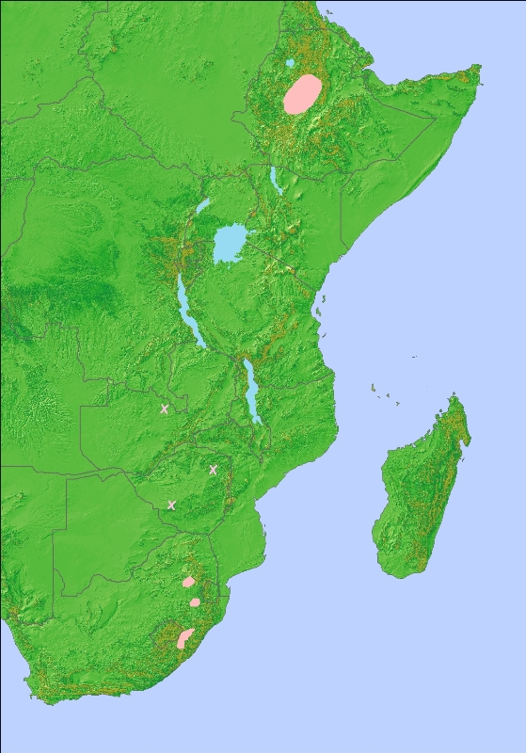

2. Available Key Information

Table 2.1: Key White-winged Flufftail Site Protection status in the range states

Country | Site name | Area | Breeding(BR)/non-breeding (NB)/both (BO) | Protection status | IBA? | Ramsar
Ethiopia | Berga floodplain | 410ha | BR | No | Yes | No
 | Weserbi wetlands | about 10 ha | Not confirmed | No | Yes | No
 | Bilacha wetland | Not known | BR | No | No | No
South Africa | Bedford/Chatsworth | 300ha | NB | Privately protected by Eskom | Yes | No
 | Franklin Vlei | 5 244ha | NB | No | Yes | No
 | Middelpunt Wetland | 60 ha | NB | Privately protected by MWT | Yes | No
 | Lakenvlei |  | Unconfirmed report | No | No | No
 | Murphy's Rust | 58ha | NB | No | Yes | No
 | Hebron | 30 ha | NB | No | No | No
 | Penny Park | 120 ha | NB | No | Yes | No
 | Vanger | 30 ha | NB | No | No | No
 | Wakkerstroom | 200 ha | NB | No | Yes | Yes
 | Seekoeivlei | 600 ha | NB | No | No | No
 | Ntsikeni Vlei | 1 070ha (wetland) 9 200ha (total reserve) | Unconfirmed occurrence but in close proximity to the other sites and suitable habitat | Yes proclaimed nature reserve | Yes | Yes
Zimbabwe | Harare (Monavale, Marlborough) | ? | ? | No | No | No
Zambia | Chingola, Solwezi? | ? | ? | No | No | No

3. Threats

Seasonal marshes are threatened by drainage (for cultivation and forestry), flooding by dams, catchment erosion, water abstraction, human disturbance, too-frequent burning, and excessive trampling and grazing by livestock and cutting of marsh vegetation for fodder (Atkinson et al. 1996, Taylor and van Perlo 1998). Observations in Ethiopia suggest that the species moves its chicks very soon after hatching to areas of denser vegetation where deeper flooding occurs before the vegetation at nest sites has grown enough for cutting by local people (Taylor et al. 2004). Grasses and sedges are cut for the culturally important Ethiopian coffee ceremony (De Smidt 2003). In Ethiopia, a serious problem is the unsustainable carrying capacity at which livestock is farmed and the concomitant habitat degradation as a result of this over-stocking. The peatlands of South Africa are threatened by cultivation, afforestation, grazing, water abstraction, peat fires, wetland draining and the resulting wetland headcutting and donga erosion, siltation, fences and developments such as roads and dams (Taylor and Grundling 2003). The construction of the Ingula pumped storage scheme at Bedford Chatsworth marsh in eastern Free State, South Africa, may cause disturbance and damage to habitat. This situation is being closely monitored by an on-site BirdLife South Africa Programme Manager.

In Zimbabwe the Harare sites are highly threatened by urban cultivation (A. Cizek. pers com). Whereas only c.1% of Greater Harare was cultivated in 1955 and c.18.5% in 1990, by 1994, c.36% was cultivated (Bowyer-Bower et al. 1996). By the 1999/2000 wet season, 70% of all open space in Harare was cultivated (Gumbo 2005). Since then the national economy has been deteriorating and urban agriculture must have increased significantly that there is very little intact dambo grassland left. Though unquantified, dumping into the marshy areas could be causing damage through leaching of poisons into water sources. Disturbance by humans and dogs is of concern too. Elsewhere in Zimbabwe, especially where there is much potential peatland habitat along the central watershed from Harare to the eastern districts, dambos on the former commercial farms are expected to come under greater trampling and grazing pressures. Many of the commercial farmers limited grazing in dambos, some fencing off the wettest parts of vleis, but the resettlement process has led to a loss of farm fences (A. Cizek. pers com).

White-winged Flufftail is one of the two species listed on Annex 2 of the AEWA Agreement that are judged to be critically threatened by climate change (Maclean et al. 2007). This is because of its small population and area of occupancy. Its habitat is also susceptible to climate change. At its Ethiopian breeding grounds, it may be vulnerable to warming, as it inhabits high altitude wetlands, and the topography at higher altitudes may be such that there are no suitable wetlands. It should be a research priority to establish whether this is indeed the case. Its habitat is also likely to be highly threatened by changes in rainfall regime, particularly in South Africa, which is predicted to be drier in the future. Seasonal wetlands are particularly vulnerable to lower precipitation, not only because such wetlands dry up completely or reduce in size, but because they may be threatened by increased water abstraction or wholesale conversion in response to agricultural demand. Establishing the extent to which this species can respond to changes in rainfall by moving between wetlands and the likely extent and locations of suitable wetlands should also be a research priority.

The current threats and data gaps were identified during the international workshop (Figure 2)

Figure 2: Problem Tree

- Level 1 branches
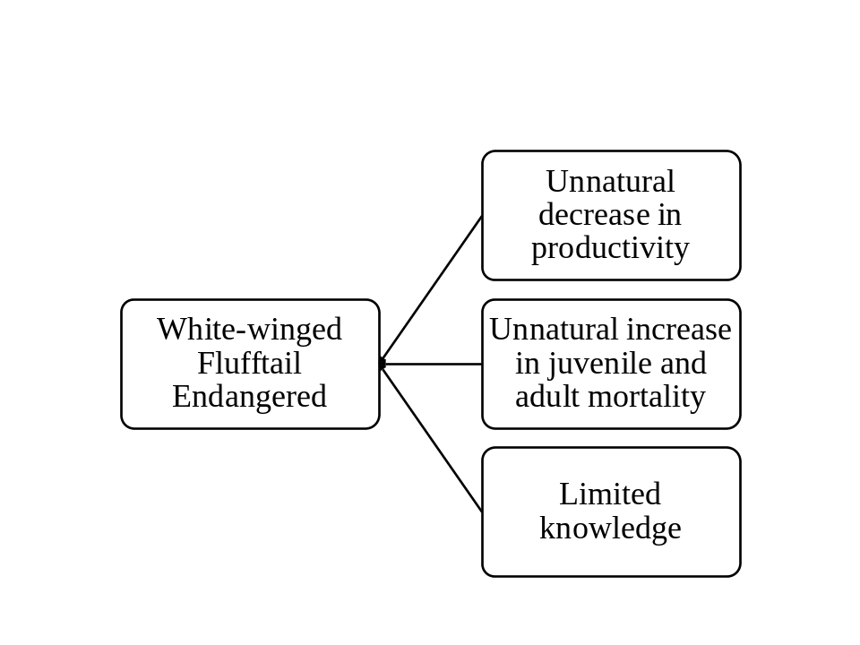
- First branch of the Problem Tree analysing threats leading to unnatural decrease in the productivity of the species
Key: ***Critical Impact, ** High Impact, * Low Impact; ET – applicable to Ethiopia, SA – applicable to South Africa, ZIM – applicable to Zimbabwe
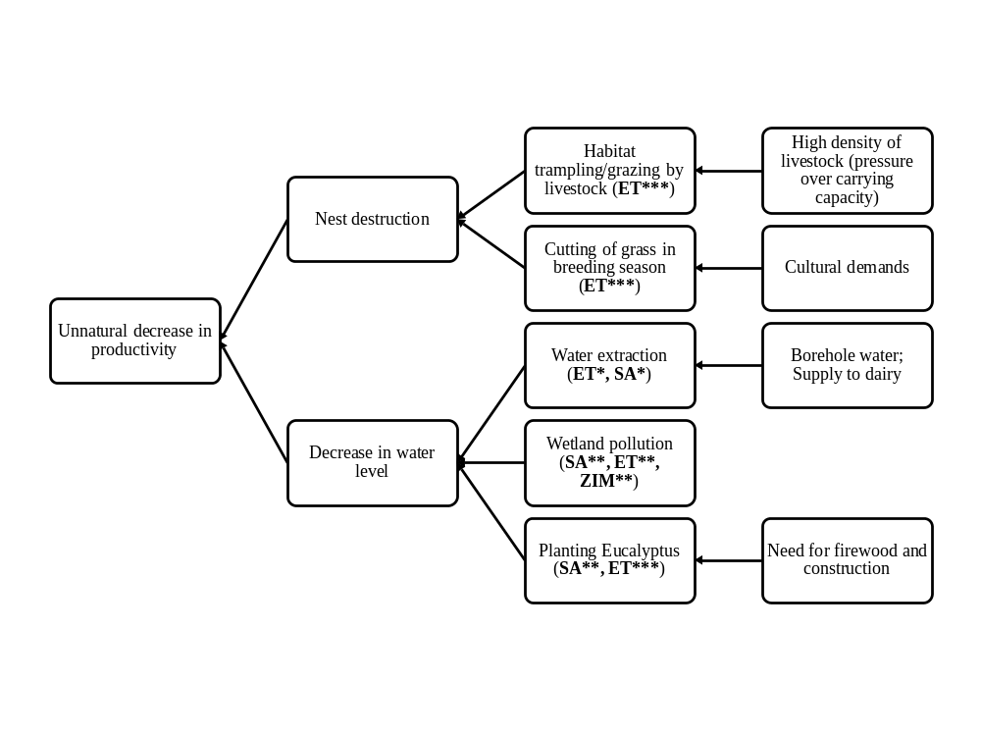
(c) Second branch of the Problem Tree analysing problems leading to unnatural increase in mortality of the species
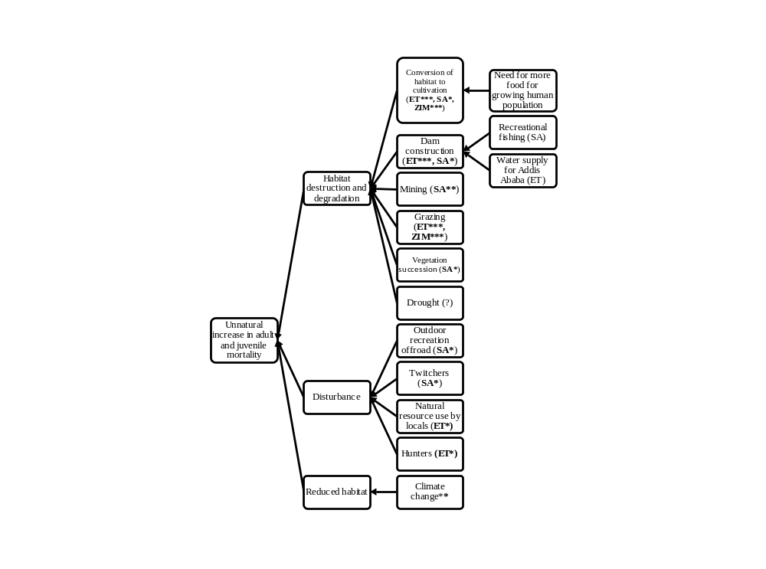
(d) Third Branch of the Problem tree analysing problems leading to existence of limited knowledge on the species
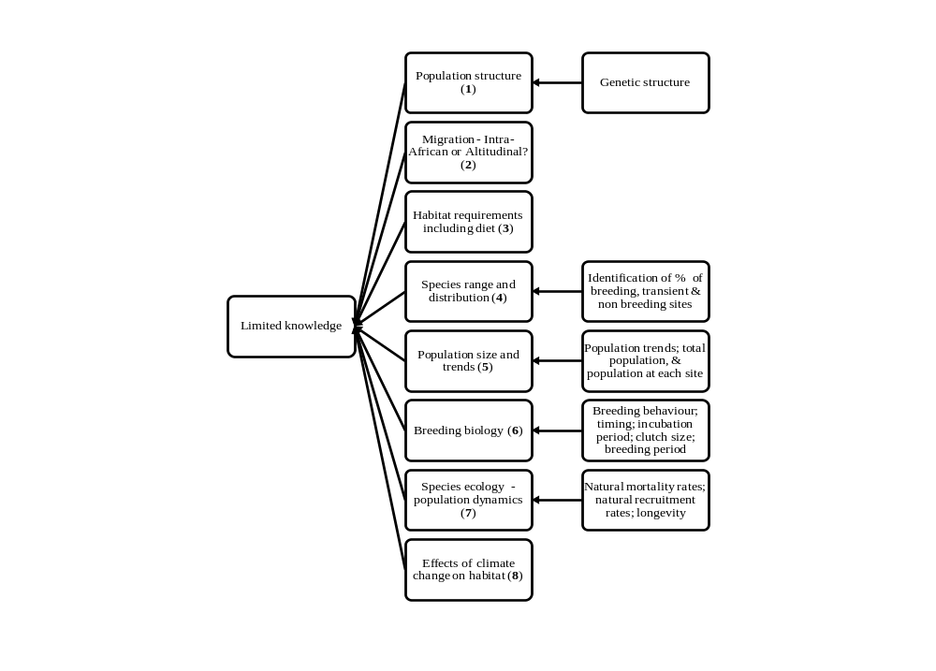

The main threats facing the White-winged Flufftail are in Ethiopia, where the bird is confirmed to breed. The critical threat that contributes to decreasing productivity is the cutting of grass by humans and the heavy overgrazing with livestock during the breeding season. These activities directly and/or indirectly lead to increased adult and juvenile mortality. In addition to these activities, the increased conversion of the wetland habitat to arable lands, dam construction, unsustainable natural resource use by locals, habitat trampling by livestock and afforestation by eucalyptus are some of the serious threats that significantly affect the persistence of this species in Ethiopia (Table 3.1).

White-winged Flufftail is listed as Endangered by the IUCN, because it has a declining small population estimated at approximately 700 individuals, a limited distribution range and breeding confirmed at only three locations in Ethiopia (BirdLife International 2008). This is further complicated by a dearth of knowledge. Still not known is whether or not the White-winged Flufftail populations of Ethiopia and South Africa are one and the same, or separate. This question relates to whether the species is an intra-African or altitudinal migrant. Further key topics for research are the species diet, species range and distribution, and population size and trends. (Table 3.2).

Table 3.1: Main threats in Ethiopia, South Africa and Zimbabwe

Main threats | ET | SA | ZIM
Grazing | 4 | - | 4
Cutting of grass in breeding season | 4
Increased conversion of habitat to cultivation | 3 | 2 | 4
Dam construction | 3 | 1
Natural resource use by locals | 3 | -
Habitat trampling by livestock | 3 |  | 3
Planting of Eucalyptus | 2 | 2
Wetland pollution | 2 | 2 | 2
Outdoor recreation including off-road | - | 1
Hunters | 1 | -
Water extraction | 1 | 1
Mining | - | 2
Vegetation succession | - | 1
1=Low, 2=medium, 3=high, 4=critical

Table 3.2: Data knowledge gaps in order of priority

Research problem | priority
Determination of population (Are the populations of Ethiopia and South Africa the same or two separate?) | 1
Migration (Intra-African or altitudinal?) | 2
Habitat requirements, including diet | 3
Species range and distribution | 4
Population size and trends | 5
Breeding biology | 6
Species ecology (population dynamics) | 7
Effects of climate change on habitat | 8

4. Policy and legislation for relevant management

4.1: Membership of range states in International Conservation Conventions and Agreements

 | CMS | AEWA | RAMSAR | CITES
Ethiopia |  |  |  | X
South Africa | X | X | X | X
Zimbabwe |  |  | X | X
Zambia |  |  | X | X

4.2: White-winged Flufftail conservation and protection in range states

Country | Status in National Red Data Book | Legal Protection | Year of protection status | Penalties | Highest Responsible Authority
Ethiopia | N/A | None |  |  | EWCA
South Africa | Critically Endangered | National Environment Management: Biodiversity Act 8 of 2004. | 2004 (national legislation) | Totally dependant on the activity | National government
South Africa | Critically Endangered | KZN Nature Conservation Ordinance 15 of 1994  KZN Biodiversity Bill | 1994 (provincial legislation) | Totally dependant on the activity | Ezemvelo KZN Wildlife
Zimbabwe | N/A. Red Data Book in process | None |  | N/A | Parks and Wildlife Management Authority
Zambia | N/A | Wildlife Act |  |  | Zambia Wildlife Authority

5. Framework for action

Goal: To ensure favourable conservation status of the White-winged Flufftail.

Purpose: To increase the species’ population through improving and increasing the extent of suitable habitat within 10 years.

Table 51: Objectives and indicators

Objective | Indicator(s)
- To limit and reverse habitat destruction and degradation at all sites | Site-specific direct interventions taken to significantly control habitat destruction in 10 sites in ten years at a rate of one site per year
- To reduce and manage human disturbance at all sites | No human disturbance during the presence of species at sites other than managed visits
- To prevent nest destruction caused by unnatural factors | No unmanaged access by people and animals in core areas during breeding season
- To maintain favourable hydrological conditions at all sites | -Managed indigenous and natural reforestation in catchments (ET)  -No trees planted in the wetlands (ET & SA)  -No additional afforestation in SA grassland catchments
- To determine if there are multiple populations of the species | Research outputs of scientific investigations
- To identify migration routes and stop-over sites of the species | Research outputs of scientific investigations
- To determine the habitat requirements and preferences | Research outputs of scientific investigations
- To establish the extent of the species’ range and distribution | Range and distribution mapped
- To determine the population sizes and trends | Populations and trends determined
- To determine the species’ breeding biology | Research outputs of scientific investigations
- To understand key ecological determinants influencing the species’ population dynamics | Research outputs of scientific investigations
- To establish the potential effects of climate change on the species | Research outputs of scientific investigations
- To increase awareness at all levels

Table 5.2: Actions, their relative importance, time scale and lead agencies

Activities | Lead implementing agency | Time scale | Priority
Objective 1: To limit and reverse habitat destruction and degradation at all sites
1.1 Designate all qualifying sites as Ramsar sites | - Environmental Protection Authority(EPA)  - Department of Environment and Tourism(DEAT) | 5 years (SA)  3 years (ET) | Critical
1.2 Engage local communities in seeking local solutions to habitat destruction through community-based habitat conservation initiatives | - Environmental Protection Authority(EPA) | 5 years (ET) | Critical
1.3 Designate all sites under national protected area legislation | - Federal & regional government (ET)  - Provincial nature conservation agencies (SA) | 5 years | Critical
1.4 Facilitate enforcement of legislation to stop cultivation inside the breeding wetlands | - Ethiopian Wildlife Conservation Authority (EWCA) | Ongoing | High
1.5 Design and implement site management plan(s) | - Provincial nature conservation agencies (SA)  - Ethiopian Wildlife Conservation Authority (EWCA) | 5 years (SA)  3 years (ET) | High
1.6 Prevent any change of the species’ habitat arising from dam building | - Provincial nature conservation agencies (SA)  - Environmental Protection Authority (EPA) (ET) | Ongoing | High
1.7 Stop pollution of wetlands caused by humans and agriculture | - DEAT and National Department of Water Affairs and Forestry (DWAF) (SA)  - Environmental Protection Authority (EPA) (ET) | Ongoing | Medium
1.8 Prevent mining which will affect the species’ habitat | - DEAT, provincial nature conservation agencies and DWAF (SA) | Ongoing | High
1.9. Prevent development which will affect the species’ habitat | - DEAT and provincial nature conservation agencies (SA)  - EWCA and Regional Wildlife Conservation Authorities | Ongoing | Critical
1.10 Develop and implement schemes for managing pressure of grazing at all sites | - Provincial nature conservation agencies (SA)  - Ministry of Agriculture and Rural Development (MoARD) (ET) and Regional Bureau of Agriculture and Rural Development | 5 years | Critical
1.11 Develop and implement suitable burning regimes at relevant sites | - Provincial nature conservation agencies (SA) | 3 years | Low
1.12 Secure reserves in the western parts of greater Harare, Zimbabwe | - Government authorities (ZIM) | 5 years | Critical
Objective 2: To reduce and manage human disturbance at all sites
2.1 Maintain non-issuance of snipe-hunting permits to breeding sites | - EWCA and Regional Wildlife Department (ET) | Ongoing | Low
2.2 Develop and implement site visitation protocol for birdwatchers at the species’ sites | - MWT, BLSA and landowners  - Ministry of Tourism and Culture, EWNHS and SSGs | 1 year (SA)  2 years (ET)  and ongoing | Low
2.3 Implement community-run prevention of access to sites during the breeding season by resource users | - Local government authorities, EWNHS and SSGs | Ongoing | Critical
Objective 3: To prevent nest destruction caused by unnatural factors
Same as activity 1.2, 1.10 & 2.3
Objective 4: To maintain favourable hydrological conditions at all sites
4.1 Facilitate the enforcement of legislation to stop afforestation inside the breeding wetlands | - DEAT, provincial nature conservation agencies and DWAF (SA)  - Regional Bureau of Agriculture and Rural Development (ET) | Ongoing | High
4.2 Contribute to the regulation of afforestation and other activities which may affect the wetlands and watersheds of the species’ sites | - DEAT, provincial nature conservation agencies and DWAF (SA)  - Regional Bureau of Agriculture and Rural Development (ET) | Ongoing | Medium
Objective 5: To determine if there are multiple populations of the species
5.1 Undertake genetic and isotopic investigations | - Research institution | 5 years | Table 3.2
Objective 6: To identify migration routes and stop-over sites of the species
6.1 Design and implement a scientific study | - Research institution | 10 years | Table 3.2
Objective 7: To determine the habitat requirements and preferences
7.1 Design and implement a scientific study to undertake a thorough assessment of habitat requirements, including understanding the hydrological functioning of the plateau floodplains in which it nests. | - Research institutions | 5 years | Table 3.2
Objective 8: To establish the extent of the species’ range and distribution
8.1 Identify and explore potential sites in South Africa and Ethiopia | - MWT (SA)  - EWNHS and EWCA (ET) | 5 years | Table 3.2
8.2 Confirm suspected localities in Zimbabwe, Zambia and Rwanda | - BLZ, ZOS and ACNR  - Coordination: BirdLife Africa Secretariat | 3 years | Table 3.2
8.3 Undertake comprehensive assessment of the state of the dambo ecosystems in the western parts of greater Harare, Zimbabwe | - Government authorities, Research Institution (ZIM) | 5 years | Critical
Objective 9: To determine the population sizes and trends
9.1 Develop a suitable census technique | - Scientific institution | 3 years | Table 3.2
9.2 Perform coordinated censuses in all sites | - MWT and BLSA (SA)  - EWNHS and EWCA (ET) | Ongoing | Table 3.2
Objective 10: To determine the species’ breeding biology
10.1 Design and implement a scientific study | - Research institutions | 10 years | Table 3.2
Objective 11: To understand key ecological determinants influencing the species’ population dynamics
11.1 Design and implement a scientific study to identify the population determinants | - Research institutions | 9 years | Table 3.2
11.2 Undertake population modelling | - Research institutions | 10 years | Table 3.2
Objective 12: To establish the potential effects of climate change on the species
12.1 Conduct modelling exercise | - Research institutions | 10 years | Table 3.2
Objective 13: To increase awareness at all levels
13.1 Compile and disseminate Species information | - EWNHS, MWT and relevant government agencies | Ongoing | Critical
13.2 Support and expand SSGs and their activities |  |  | Critical

6. Implementation

The coordination of the implementation of this plan will be conducted by an international species working group, which shall be supported by a coordinator, ideally paid staff. The working group should comprise of national representatives from the government accompanied by representatives of the NGOs and other interested stakeholders. Interested international organisations will participate in the work of the group too.

Official reporting by the range states on the implementation of the plan will be done through the AEWA review on the progress in preparation and implementation of single species action plans (as per AEWA Action Plan paragraph 7.4). The international working group is encouraged to establish more frequent (possibly annual) internal reporting to facilitate coordination and guide better further implementation.

References

Allan, D.G., McInnes, A.M. and Wondafrash, M. 2006. White-winged Flufftail Sarothrura ayresi in Ethiopia: notes on the habitat, densities, morphometrics, nests and eggs and associated waterbirds. Bulletin of African Bird Club 13: 25-36.
Anon. 1999. White-winged Flufftail (Sarothrura ayresi). Draft project concept for application to Global Environment Facility.
Anon. 1997. White-winged Flufftail sightings. World Birdwatch 19(4): 2 - 2.
Atkinson P, Robertson P, Delklegn Y, Wondafrash M, Atkins J. 1996. The recent rediscovery of White-winged Flufftails in Ethiopia. Bull. Afr. Bird Club 3(1): 34 - 36.
Bannerman, D.A. 1911. Description of a new rail - Ortygops macmillani sp. Bull. Brit. Orn. Club. 29: 38
Barnes, K. N. 2000. The Eskom Red Data Book of birds of South Africa, Lesotho and Swaziland. Johannesburg: BirdLife South Africa.
BirdLife International. 2004. Threatened birds of the world 2004. CD-ROM. Cambridge, U.K.:BirdLife International.
BirdLife International. 2008. Species factsheet: Sarothrura ayresi. Downloaded from http://www.birdlife.org on 4/6/2008.
Bowyer-Bower, T.A.S., Mapaure, I. and Drummond, R.B. 1996. Ecological degradation in cities: impact of urban agriculture in Harare, Zimbabwe. Journal of Applied Science in Southern Africa. 2:53-67
Brooke RK. 1964. Avian observations on a journey across central Africa and additional information on some of the species seen. Ostrich 35(4): 277 - 292. (Annotated species list).
Cizek et al. (in prep). Birds to Watch in Zimbabwe.
Collar, N. J. and Stuart, S. N. 1985 Threatened birds of Africa and related islands: the ICBP/IUCN Red Data Book. Cambridge, U.K.: International Council for Bird Preservation, and International Union for Conservation of Nature and Natural Resources.
De Smidt, A. 2003 Ethiopian White-winged Flufftail (Sarothrura ayresi) action plan. Johannesburg: BirdLife South Africa.
De Smidt, A. and Evans, S.W. 2003. South African White-winged Flufftail (Sarothrura ayresi) action plan. Johannesburg: BirdLife South Africa.
Dowsett-Lemaire, F. 1990. Eco-ethology, distribution and status of Nyungwe Forest birds, Rwanda. Pp. 31-85 in Dowsett, R.J., ed. Enquête faunistique et floristique dans la Forêt de Nyungwe, Rwanda. Ely, U.K.: Tauraco Press (Tauraco Research Report).
Dowsett, R.J. and Forbes-Watson, A.D. (1993) Checklist of birds of the Afrotropical and Malagasy regions. Liège, Belgium: Tauraco Press.
Guichard, K.M.. 1948. Notes on Sarothrura ayresi and three birds new to Abyssinia. Bull. Br. Ornithol. Club 68: 102 - 104.
Gumbo B. 2005. Short-cutting the Phosphorus Cycle in Urban Ecosystems. Taylor and Francis.
Gurney, J.H. 1877. Additional notes on the ornithology of the Republic of the Transvaal by Thomas Ayres. Ibis 4: 352-354
Hopkinson, G. and Masterson A.N.B. 1977. On the occurrence near Salisbury of the White-winged Flufftail. Honeyguide 91: 25-28.
Hopkinson, G. and Masterson A.N.B. 1984. The occurrence and ecological preferences of certain Rallidae near Salisbury, Zimbabwe. Proceedings of the Fifth Pan-African Ornithological Congress: 425-440.
Hustler K. and Irwin MPS. 1995. Fifth report of the OAZ Rarities Committee. Honeyguide 41(2): 103 - 106.
Maclean, I.M.D., Rehfisch, M.M., Delany, S. and Robinson, R.A. 2007. The Effects of Climate Change on Migratory Waterbirds within the African-Eurasian Flyways. Report of work carried out by The British Trust for Ornithology under contract to the AEWA Secretariat.
Sibley, C. G. and Monroe, B. L. (1990) Distribution and taxonomy of birds of the world. New Haven, USA: Yale University Press.
Sibley, C.G. and Monroe, B.L. (1993) A supplement to 'Distribution and taxonomy of birds of the world'. New Haven, USA: Yale University Press.
Tarboton, W. 2001. A guide to the Nests and Eggs of Southern African Birds. Cape Town, South Africa: Struik Publishers.
Taylor, P. B. and Grundling, P. L. 2003. The importance of South African mires as habitat for the endangered Whitewinged Flufftail (Sarothrura ayresi). Int. Mire Conserv. Group Newsl. July: 8-12.
Taylor B and van Perlo B. 1998. Rails - A Guide to the Rails, Crakes, Gallinules and Coots of the World. Pica Press, Sussex
Taylor, P. B. 1996. Rallidae (Rails, Gallinules and Coots). Pp. 108-209 in del Hoyo, J., Elliott, A. and Sargatal, J., eds. Handbook of the birds of the world. Barcelona, Spain: Lynx Edicions.
Taylor P. B. 1997a. The status and conservation of rallids in South Africa: results of a wetland survey in 1995/96. ADU Research Report 23: 1-41
Taylor B. 1997b. Hope for the White-winged Flufftail. Africa - Birds & Birding 2(5): 14 - 15.
Taylor B. 1998. Africa's Flufftails - A guide to their identification. Africa - Birds & Birding 3(3): 63 - 66.
Taylor B. 1999. White-winged Flufftails in Ethiopia - Another mystery solved. Africa - Birds & Birding 4(5): 23 - 25.
Taylor, B., Wondafrash, M. and Demek, Y. 2004. The nest, eggs and chicks of the White-winged Flufftail Sarothrura ayresi. Bull. Brit. Ornithol. Club 124: 233-238.
Taylor P. B. 1994. The biology, ecology and conservation of four flufftail species, Sarothrura (Aves: Rallidae). PhD thesis, University of Natal, Pietermaritzburg.
Wetlands International. 2006. Waterbird Population Estimates – Fourth Edition. Wetlands International, Wageningen, The Netherlands.

For species listed in Appendix I of CMS, states strive towards strictly protecting the species, conserving or restoring the habitats in which they live, mitigating obstacles to migration and controlling other factors that might endanger them.
AEWA provides for coordinated and concerted action to be taken by the Range States throughout the migration system of waterbirds to which it applies. Category 1: (a) Species which are included in Appendix I to the Convention on the Conservation of Migratory species of Wild Animals; (b) Species which are listed as threatened (BirdLife International 2004); or (c) Populations, which number less than around 10,000 individuals.

