Doc: AEWA/MOP Inf.3.7
Secretariat provided by the United Nations Environment Programme (UNEP)

Date: 1 September 2005
Original: English

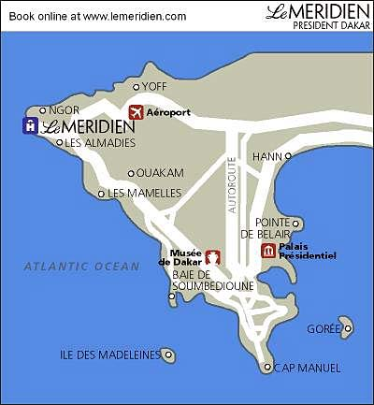Senegal in brief
The Republic of Senegal is situated in Western Africa, bordering the North Atlantic Ocean, between Guinea-Bissau and Mauritania. It has a surface area of 196,190 sq km, with a total of 11 national Parks and reserves.

Population : 10.3 millions inhabitants.
Capital : Dakar, 2 millions inhabitants.
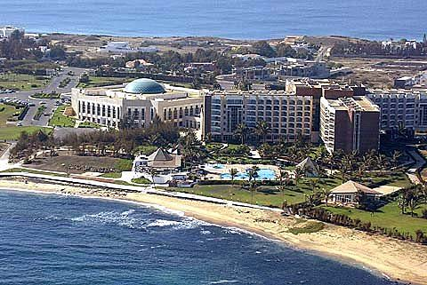Principal towns: Thies, Saint-Louis, Ziguinchor, Kaolack, Diourbel, Louga
Official Language: French.

Visa: according to our information an entry visa is required by citizens of: Albania, Algeria, Andorra, Angola, Armenia, Azerbaijan, Bahrain, Belarus, Botswana, Bulgaria, Burundi, Cameroon, Chad, Comoros, Congo, Croatia, Czech Republic, Egypt, Equatorial Guinea, Eritrea, Estonia, Ethiopia, FYR of Macedonia, Gabon, Georgia, Hungary, Iran, Island, Jordan, Kazakhstan, Kenya, Kuwait, Latvia, Lebanon, Lesotho, Liechtenstein, Lithuania, Libyan Arab Jamahiriya, Madagascar, Malawi, Malta, Moldova, Monaco, Mozambique, Namibia, Norway, Oman, Poland, Qatar, Romania, Russian Federation, Rwanda, San Marino, Sao Tome and Principe, Saudi Arabia, Serbia and Montenegro, Seychelles, Slovakia, Slovenia, Sudan, Syria, Tanzania, Turkmenistan, Turkey, Uganda, Ukraine, United Arab Emirates, Uzbekistan, Zimbabwe.

The Town of Dakar
Health: Dakar is well covered in terms of health structures. The standard vaccinations are recommended; it is highly recommended to vaccinate against Yellow Fever. Malaria is a known scourge, but may be treated relatively easily with quinine. Symptoms range from fever, chills and sweating, headache, diarrhoea and abdominal pains to a vague feeling of ill-health.

Security: Dakar is globally a safe town. But some easy rules are to be followed: be careful when you are in markets or other public places with pickpockets sometimes, avoid wearing costly jewels, be careful with camera, cellular phones, etc., avoid walking alone during the night in empty streets, and you will enjoy your stay. Senegalese are very warm!

Weather and climate in Senegal: The best time to visit is October-June, when it is as cool, dry and comfortable as it ever gets. But even then, it is hot and humid during the day (but cooler at night). During the rainy season, July-September, the humidity gets very high and the days very hot. (Be aware that in the southern part of the country, the rainy season can extend through October.)

Banking services: The local currency is the CFA Franc of the zone of the Economic and Monetary Community of West Africa (BCEAO). 1 Euro corresponds to 655 Frs CFA. Services are available in banks and change can be done in some hotels. Credit cards are accepted for payments (Visa International, Mastercard)

Urban transport fares: Individual fare: from the airport to town centre: 3500 Frs CFA during the day and 5000 during the night (official tariff). Prices can be bargained. Means of transportation ranged from taxis (painted in yellow and black), to buses (painted in blue and cream, ticket price 150 Frs cfa), “cars rapides” (painted in blue and yellow, 50 to 100 Frs cfa), and “taxis clandos” (informal sector, no more than 200 Frs cfa).

Cuisine: Here you have a great choice from Senegalese restaurant to African ones, but also French, Lebanese, Chinese, etc. However, in most great restaurant a wide choice is offered. Count 1500 to 10 000 Frs CFA according to your budget. Fast-food restaurants are also available (600 to 1200 Frs CFA)

Sites to visit: Lac Rose, Gorée Island, Iles de la Madeleine, Marché Kermel, Marché Sandaga, Ifan Museum, National Gallery of Art, Dakar is also the town of painting Galleries, and traditional arts like sous-verre Painting, Djembé making, traditional jewellery, cloth making, antiquities.

