DELINEATION OF BIOGEOGRAPHIC POPULATIONS OF THE

BLACK-LEGGED KITTIWAKE (RISSA TRIDACTYLA TRIDACTYLA), THE COMMON MURRE (URIA AALGE AALGE AND U. A. ALBIONIS) AND THE

ATLANTIC PUFFIN (FRATERCULA ARCTICA)

Prepared by David Stroud (UK observer to the Technical Committee)

Black-legged Kittiwake Rissa tridactyla tridactyla

ISSUE

East Atlantic population of R. t. tridactyla should include birds breeding in Greenland (and possibly also Canada) on the basis of ringing data which shows clear movements across the northern Atlantic.

Waterbird Population Estimates 5 (WPE5) considers there to be three populations of the nominate race ‘tridactyla’:

- East Atlantic 6,600,000 individuals
- Greenland 100,000 – 1,000,000 individuals
- West Atlantic 600,000 – 750,000 individuals

Conservation Status Review 6 (CSR6) gives a single East Atlantic population of tridactyla (6,400,000 – 7,600,000) as occurring in the Agreement area. Presumably this relates to the East Atlantic population of WPE5.

The world population of R. t. tridactyla includes Greenland and Canada – but there are recoveries of Greenland-ringed Kittiwake in Europe and a considerable number of recoveries of birds ringed in UK and other NE Atlantic countries in Greenland (Lyngs 2003, below), so it seems reasonable to continue to treat birds in NE & NW Atlantic as comprising a single population given this clear evidence of exchange across the Atlantic (or at least the Greenland and East Atlantic populations are clearly linked).
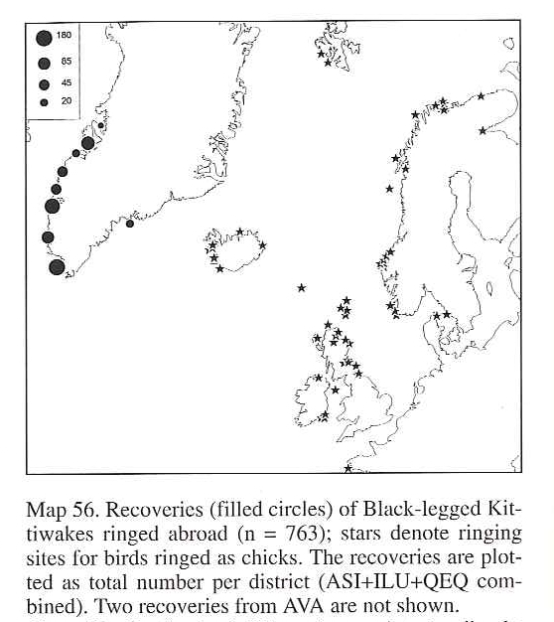

Common Murre Uria aalge aalge and U. a. albionis

ISSUE

The population of U. a. aalge is currently considered as a single population across the northern Atlantic. However, it should comprise separate NE & NW Atlantic populations on the basis of evidence of lack of trans-Atlantic interchange

Two races of Common Murres occur in the NE Atlantic: Uria aalge aalge and U. aalge albionis.

A number of published sources delineate the two races differently especially in respect of the different status of Irish and UK breeding birds. Detailed review for the third review of the UK’s SPA network (Stroud et al. 2016 in press) suggest that the most robust assessment of population boundaries in Ireland and Britain is that of Harris & Wanless (2007):
- Murres in England (other than Northumberland), Ireland and SW Scotland north to, and including Ailsa Crag, are U. a. albionis (Table 1).
- Murres elsewhere in Scotland and in Northumberland are U. a aalge.
- Races are separable but there is a degree of clinal change, so at their interface, the split between races is not absolute.

Table 1. Country allocation of Common Murre races following Harris & Wanless (2007) is as follows:

 | alge | albionis
UK: Scotland (N, W & E) | alge
UK: Scotland (S) |  | albionis
UK: England (Northumbria) | alge
UK: England (minus Northumbria) |  | albionis
UK: Wales |  | albionis
UK: Northern Ireland |  | albionis
Ireland |  | albionis
France | alge
Germany | alge
Spain | alge
Portugal | alge
Sweden | alge
Denmark | alge
Finland | alge
Faeroes | alge
Iceland | alge
Norway | alge
Bear Island | alge
Jan Mayen | alge
Spitzbergen | alge
Russia | alge

Lyngs (2003) states “ … birds of W Palearctic origin winter off Iceland eastwards to the E Atlantic coasts and no others have been recovered in Greenland or Canada despite large numbers being ringed… Canadian populations winter off Newfoundland, Nova Scotia and New England…”

del Hoyo et al. (1996) state “ … no trans-Atlantic migrations known,…” On this basis it seems valid to consider aalge breeding in the NW & NE Atlantic as two separate populations.

CSR 6 presents a single estimate for U. a. aalge related to “E North America, Greenland, Iceland, Faeroes, Scotland, S Norway, Baltic” sourced from a single source for the period 1997-2014.

The species is not included in WPE5.

There seems no basis to treat NW & NE Atlantic aalge as comprising as single population as CSR5 does, given the lack of evidence on any trans-Atlantic movements (especially notable given the large number of ringed birds on both sides of the Atlantic).

Atlantic Puffin Fratercula arctica

ISSUE

The validity of Fratercula arctica grabae as a taxon.

Stroud et al. (2001) used the total population of Fratercula arctica grabae as the reference population for the UK SPA network for Puffin. This was derived from breeding populations of UK, Ireland, Faeroes, France and S. Norway. However, Harris & Wanless (2004) noted:

“In recent times, the Atlantic Puffin has usually been considered to comprise three subspecies, separated solely on size, although probably only two deserve recognition. Nominate F .a. arctica breeds in Iceland, most of Norway and Russia, and the west Atlantic. Atlantic Puffins breeding in Britain, Ireland, France, the Faeroes and southwest Norway tend to be smaller, and were assigned the name grabae. However, within Europe there is a continuous latitudinal cline in wing length, with large birds in the north and small birds in the south, and no obvious discontinuity that makes it easy to assign geographical limits to grabae and arctica. Protein evidence also suggests that there is no justification for separating grabae in the southeast Atlantic colonies from arctica in the north, and thus the name grabae is best discarded (Moen, 1991; Lowther et al., 2002).”

Accordingly Harris & Wanless (2004) concluded that “grabae … is now considered to be indistinct from arctica … and so [we have] treated those national estimates previously assigned to grabae as arctica.”

Accordingly, Stroud et al. (2016) has used an estimate for NE Atlantic arctica - derived as for former grabae but with the addition of arctic breeding birds in N Norway, Iceland and Russia (Table 2) i.e. F. a. arctica sensu lat.

Table 2. Derivation of population estimate for arctica Puffin sensu lat as given by Harris & Wanless (2004).
 | pairs min | pairs max
GB, IoM & CI | 600,000 | 600,000
All-Ireland | 21,000 | 21,000
Faeroes | 550,000 | 550,000
France | 257 | 257
Norway | 1,500,000 | 1,500,000
Iceland | 2,500,000 | 2,500,000
Russia | 5,000 | 5,000
 | 5,176,257 | 5,176,257 | pairs
 | Midpoint = 5,176,257 | pairs
 | 10,352,514 | individuals

CSR6 gives two populations:
- Fratercula arctica arctica (Hudson Bay & Maine E to S Greenland, Iceland, Bear Is, Norway to S Novaya Zemlya), and
- Fratercula arctica grabae (Faeroes, S Norway & Sweden, Britain, Ireland, NW France).

The CSR 6 estimate for grabae (1,167,000 pairs) is significantly less than the Harris & Wanless estimates for the same countries (3,843,000 pairs). It is not possible to calculate an arctica sensu lat. estimate with data more recent than that of Harris & Wanless (2004) without access to the national totals used by CSR 6.

There seems to be doubt as to the validity of grabae as a valid taxon, although Harris & Wanless (2004) give no source for their assertion. This needs to be resolved.

References

del Hoyo, J., Elliot, A. & Sagatal, J. eds. 1996. Handbook of the Birds of the World. Vol. 3. Hoatzin to Auks. Lynx Edicions, Barcelona.

Lowther, P.E., Diamond, A,W., Kress, S.W., Robertson, G.J., Russell, K. 2002. Atlantic Puffin (Fratercula arctica). In: Poole, A., Gill, F. (eds) The birds of North America. The Birds of North America, Inc, Philadelphia, PA . Pp 1–23.

Lyngs, P. 2003. Migration and winter ranges of birds in Greenland. Dansk Ornitologisk Forenings Tidsskrift 97(1): 1-167.

Harris, M.P. & Wanless, S. 2004. Atlantic Puffin Fratercula arctica. Pp. 392-406. In: Mitchell, P.I., Newton, S., Ratcliffe, N. & Dunn, T.E. (eds.) Seabird populations of Britain and Ireland. T. & A.D. Poyser.

Harris, M. & Wanless, S. 2007. Common Guillemot Uria aalge. Pp. 845-849. In: The Birds of Scotland. eds. Forrester, R.W. & Andrews, I.J. Scottish Ornithologists’ Club, Aberlady.

Moen, S.M. 1991. Morphologic and genetic variation among breeding colonies of the Atlantic Puffin Fratercula arctica. The Auk 108(4): 755-763.

Stroud, D.A., Chambers, D., Cook, S., Buxton, N., Fraser, B., Clement, P., Lewis, P., McLean, I., Baker, H. & Whitehead, S. (eds.) 2001. The UK SPA network: its scope and content. JNCC, Peterborough. Three volumes. (90 pp; 438 pp; 392 pp)

Stroud, D.A., Bainbridge, I.P., Maddock, A., Anthony, S., Baker, H., Buxton, N., Chambers, D., Enlander, I., Hearn, R., Jennings, K.R, Mavor, R., Whitehead, S. & Wilson, J.D. - on behalf of the UK SPA & Ramsar Scientific Working Group (eds.) (2016). The status of UK SPAs in the 2000s: the third network review. JNCC, Peterborough.

Wetlands International 2015. Report on the Conservation Status of Migratory Waterbirds in the Agreement Area. Sixth Edition. Wetlands International. Available at: http://www.unep-aewa.org/sites/default/files/document/mop6_14_csr6_including%20annexes.pdf

Wetlands International 2014. Waterbird Population Estimates. Fifth edition. Available at wpe.wetlands.org

