DELINEATION OF BIOGEOGRAPHIC POPULATIONS OF THE
SOCIABLE LAPWING (VANELLUS GREGARIUS)

Note to the Technical Committee

Prepared by Ian Fisher (Coordinator of the AEWA Sociable Lapwing International Working Group) and
Paul Donald (Royal Society for the Protection of Birds UK, Principal Research Scientist)

The 2012 International Single Species Action Plan for the Conservation of the Sociable Lapwing describes the species as monotypic, with no scientific evidence for distinct sub-populations. It notes, however, that there are two distinct wintering areas, and that birds wintering in north-east Africa and on the Indian subcontinent have been assumed to originate from different populations in the west and east of the breeding range respectively, assuming that a migratory divide exists.

The RSPB and ACBK (BirdLife Partners in the UK and Kazakhstan respectively) have been fitting small numbers of satellite tags to birds since 2007, and to date there has been no correlation between the breeding area and which route an individual bird takes on its migration. As the Sociable Lapwing is not faithful to its breeding grounds, choosing an area opportunistically dependent on habitat quality, it is unlikely that the breeding populations are distinct.

As an example, the tagged birds from 2015 can be seen in Image 1, with no clear origin evident for a particular migration path. This year's data have also shown that the migration strategies may be more variable than previously thought, given the unexpected direct route across the Caspian Sea taken by three of the birds (usually only seen on autumn migration), and the unexplained change of direction of the bird called Vyan (seeming to start on the eastern route, but then going north-west and finally across to Azerbaijan).

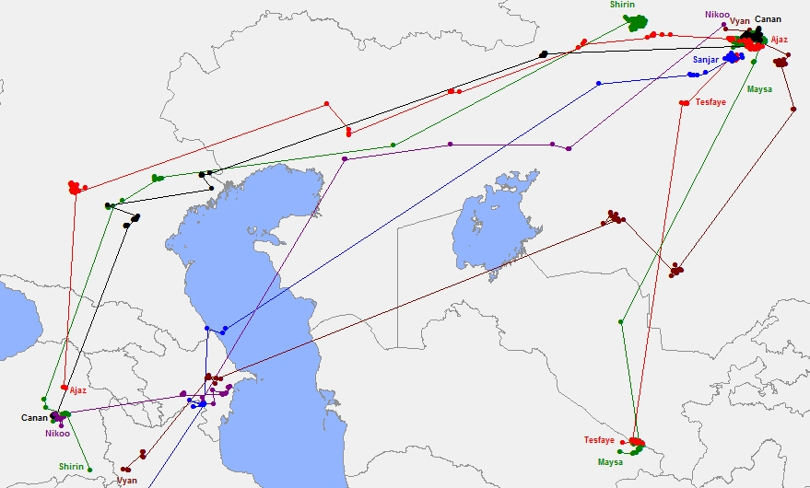

Image 1: tagged birds to mid-October 2015

Since 2010, several Sociable Lapwings fitted with satellite transmitters have staged at an area known as Tallymerjen (or Talimarzhan), which straddles the border between south-eastern Turkmenistan and south-western Uzbekistan (the southern location of Tesfaye and Maysa in Image 1). The birds tracked along this migration route stopped here for prolonged periods, suggesting that it might be an important staging site for birds en route to wintering grounds in India and Pakistan.

In September and October 2015, there were coordinated counts on either side of the border to assess for the first time the number of birds using the site, their habitat use and diet and the threats they may face. Maximum counts of 4,225 in Uzbekistan and 3,675 in Turkmenistan represent the highest numbers of the species recorded anywhere since the nineteenth century. Movements of birds between the two countries were hard to quantify because of the restricted border zone, but the total number of birds using the area was probably between 6,000 and 8,000. This may be all of the birds on this flyway, and perhaps a third of its global population.

There appear to be no taxonomic differences between birds using the western and eastern flyways, and no evidence yet to determine whether the choice of route/wintering area is coincidental or genetic.

As observations suggest that the species is panmictic, there is no reason to continue the assumption that the Sociable Lapwings using the western flyway are a distinct population from those using the eastern route.

