PROPOSAL TO AMEND THE DEFINITION OF SIGNIFICANT LONG-TERM DECLINE AND ESTABLISH A CRITERION ON SHORT-TERM DECLINE TO APPLY WHEN CLASSIFYING POPULATIONS IN TABLE 1 OF ANNEX 3 OF THE AGREEMENT

(Proposed by the Technical Committee)

Background

Categories 3 of Column A and 2 of Column B include a criterion to identify respectively populations in risk or that are in need of special attention as a result of significant long-term decline.
AEWA Resolutions 3.3 and 5.7 provided an evolving definition of significant long-term decline and guidance for the application of this criterion. The former has established that a population should be classified as being in significant long-term decline if it its decline is equivalent to 25% over 25 years or 7.5 generations, whichever is the longer. Resolution 5.7 has added that a population can also be considered as being in significant long-term decline on a precautionary basis when similar decline can be predicted based on at least 10 years of the most recent data.
The rate of decline used in the 25% over 25 years or 7.5 generations, is almost equal to the definition of 20% over 20 years used in Tucker & Heath (1994) as a threshold for moderate decline and with the 10% over 10 years or three generations, whichever is the longer used in the Birds in Europe and European Red List of Birds (BirdLife International 2004, 2015, Figure 1).

The latter publication is the basis of the European Environmental Agencies assessment of the EU27 overall trend based on the EU Birds Directive Article 12 reporting. BirdLife International (2004) has shortened the assessment period from 20 years to 10 years or three generations to be consistent with the IUCN Red List criteria related to population decline.

Figure 1. The multiplicative rate of change required by the significant long-term decline definition of AEWA and the Declining category of the European Red List of Birds.

Problems to be addressed

The trend analyses and reporting for the 7th edition of the AEWA Conservation Status Report (CSR7) highlighted the following problems with the AEWA definition of significant long-term decline.

- Although the annual rate of decline is the same, the AEWA assessment period used by AEWA (25 years or 7.5 generations) is 2.5-times longer than the one used by other international assessments implemented in the agreement area (10 years or three generations) by other treaties and conservation organisations and which assessments provide an important input in the AEWA Conservation Status Reports.

- The generation lengths of most waterbirds are rather long. No species on Annex 2 of AEWA would have a generation length shorter than four years according the data on the BirdLife International DataZone calculated following IUCN Red List criteria definitions. Most AEWA species would have a generation length between seven and 14 years (see Figure 1 in AEWA/MOP 5.22). This would result in very long assessment periods over 7.5 generations (i.e. 52 and 104 years in case of generation lengths of seven and 14 years, see Figure 2 in this document).

- The difference in number of generations taken into account by AEWA and other instruments makes the use of data reported in other processes less efficient (i.e. it costs more time and money to extrapolate the results to 7.5 generations) and can lead to different status assessments (which is confusing to all stakeholders) and most importantly resulting in conflicting policy consequences.

- In case of the short-term decline (i.e. over 10 years), which was introduced by Resolution 5.7 to provide early warning for rapid declines, there are usually an insufficient number of data points in the light of natural fluctuations and sampling variation to objectively identify genuine declines that really require attention.
- A number of problems also relate to the term significant long-term decline. One issue is that the word "significant" can be interpreted as statistically significant or as "substantial". Resolutions 3.3 and 5.7 have already established that the latter meaning is used. However, the same rate of decline in other assessments is considered more "moderate" and the European Red List calls the equivalent change simply "declining". Another issue related to the term is that the criterion is also used to consider rapid short-term changes.

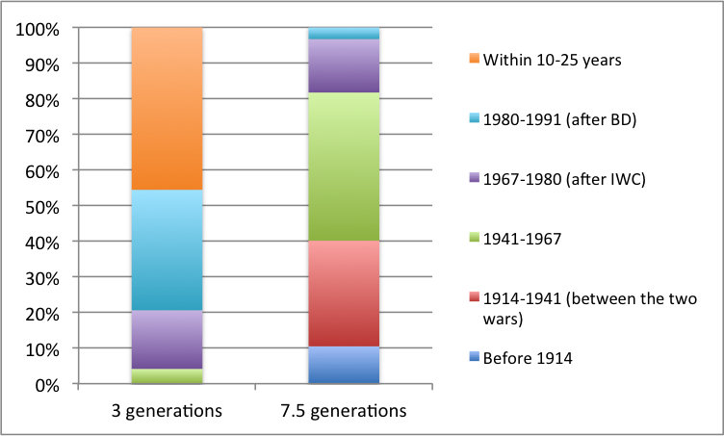

Figure 2. Percentage of the AEWA populations according to the start of the three and 7.5 generations periods
Proposed solution

This proposal suggests the following changes:

- To remove the word "significant" from criteria A3(c) and B2(c);
- To create a new criteria A3(e) and B2(e) for rapid short-term decline;
- To reduce the assessment period for long-term decline from 7.5 generations to three generations; and
- To increase the threshold for rapid long-term decline that is equivalent to 30% decline over three generations based on 10 years of the most recent data. (This threshold is equivalent to the relevant criteria for Vulnerable on the IUCN Red List).

Expected consequences

The proposed changes would result in more consistency with other assessment systems and easier use of data collected through them.

The shorter assessment periods would allow AEWA to react to changes in time. In case of rapid declines, it would allow addressing the problem before it is too late and would provide a gradual shift from one category into another. On the other hand, it would allow relaxing restrictions earlier in case of recovering populations.

However, assessment periods for long-term decline would still range between 21 and 42 years for species with a generation length of 7-14 years. Together with the increased threshold for rapid short-term decline, this would provide more stability to Table 1.

Separating long-term and short-term declines would provide better guidance to national authorities.

Action Requested from the Standing Committee

The Standing Committee is requested to review and approve this proposed revised definition and guidance, as well as the accompanying draft resolutions (Doc StC 13.DR.6 and StC 13.DR.9), for submission to the
7th Session of the Meeting of the Parties to AEWA.

