ANNEX 3

DOCUMENT TC14.7

7th EDITION OF THE CONSERVATION STATUS REPORT (CSR7)

The following pages provide the names and, where available, the organisational logos of the coordinators of the International Waterbird Census within the African-Eurasian flyway. Many other individuals and organisations contribute to the IWC in different countries, for more details on the scheme in a particular country please visit www.wetlands.org/our-network/iwc-coordinators.

We thank the contribution of all national coordinators and the many thousands of individuals who undertake the International Waterbird Census. We gratefully acknowledge the various sources of national and international funding that contributes to the continuation of the IWC.

Africa
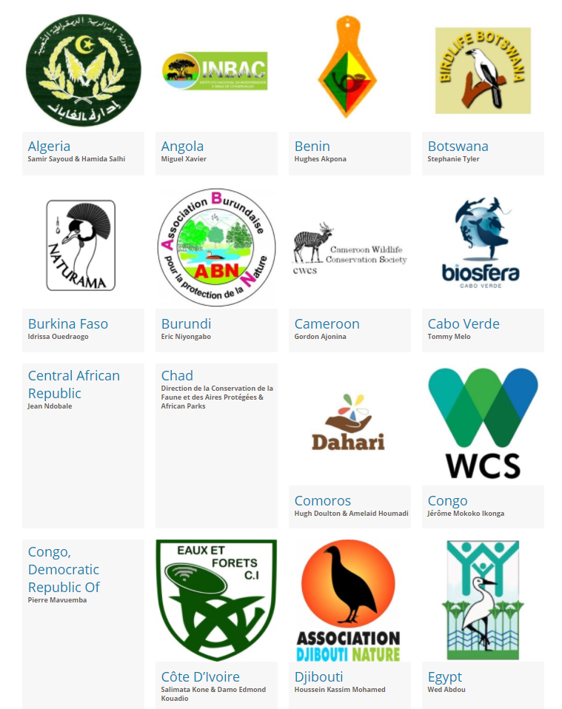

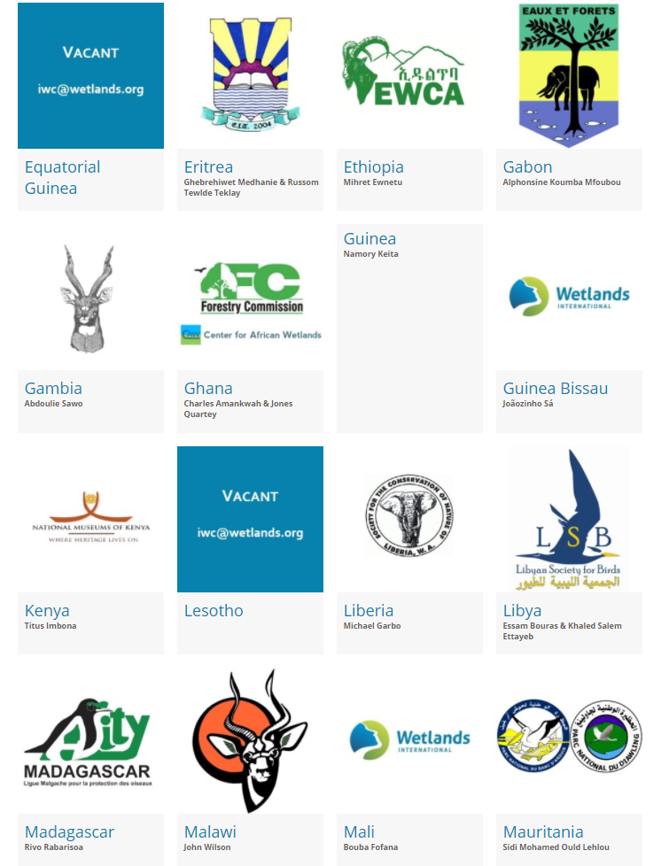

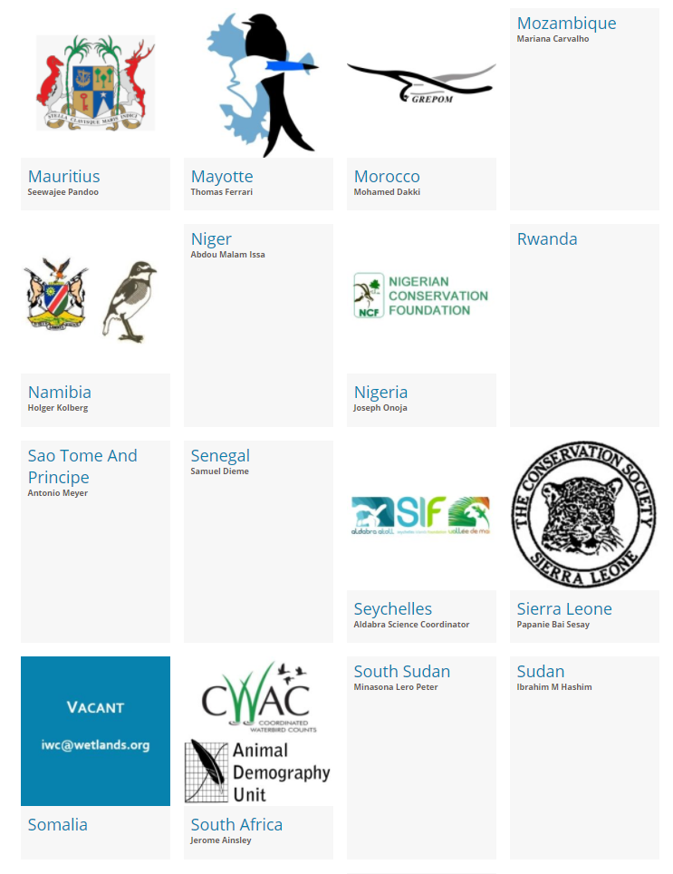

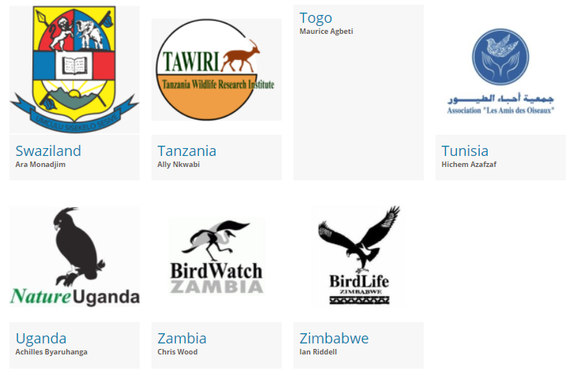

Europe

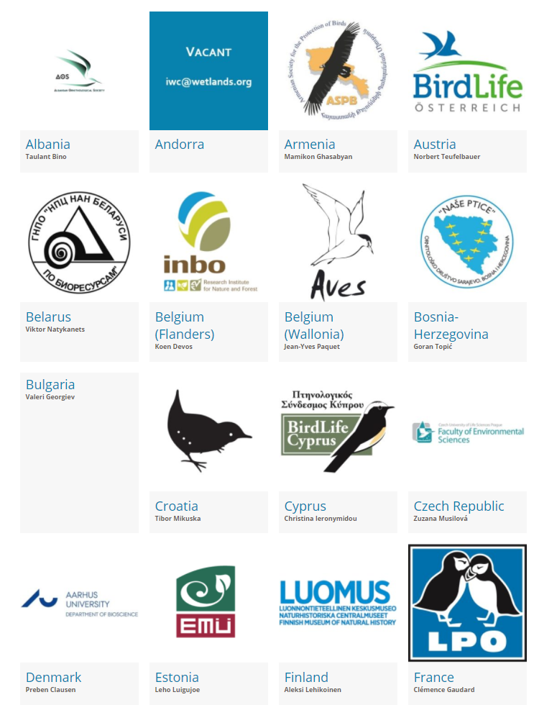

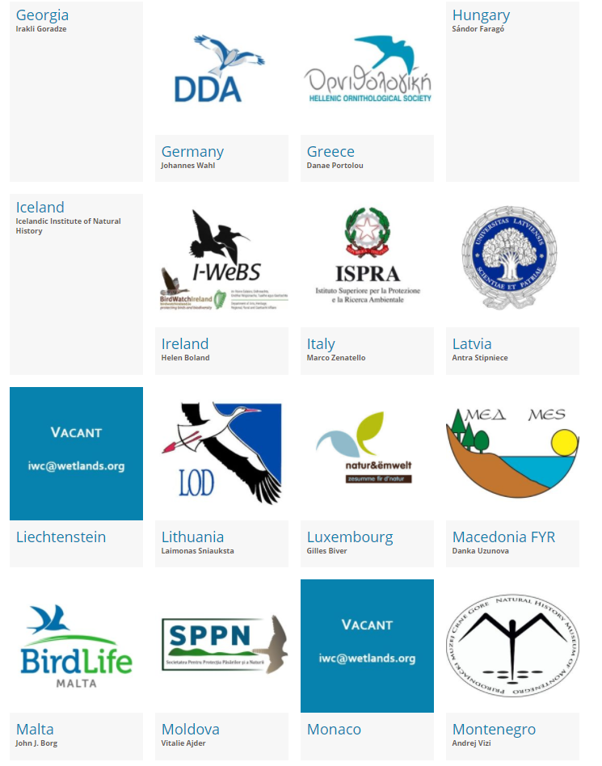

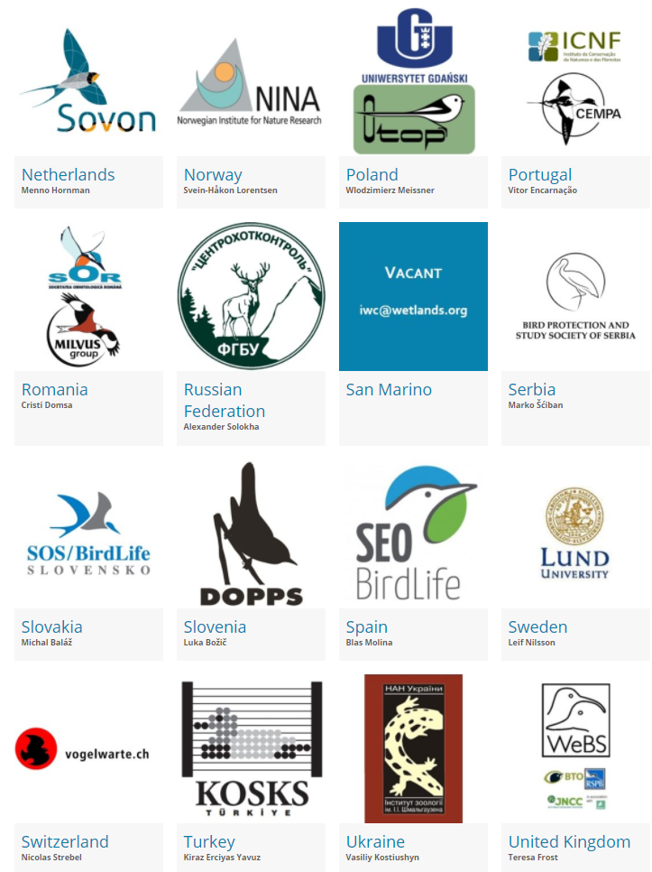

Central & South-west Asia
