- LIST OF DOCUMENTS -

MEETING DOCUMENTS
Doc No. | Title
SPfG IWG 2.1 | Annotated Agenda
SPfG IWG 2.2 | Svalbard Pink-footed Goose Population Status Report 2013-2014; DCE Technical Report No 39
SPfG IWG 2.3 | Adaptive Harvest Management for the Svalbard Population of Pink‐Footed Geese 2014 Progress Summary; DCE Technical Report No. 40
SPfG IWG 2.4 | Agenda item notes: harvest regulations
SPfG IWG 2.5 | Agenda item notes: crop damage assessment
INFORMATION DOCUMENTS
SPfG IWG Inf. 2.1 | List of Meeting Documents
SPfG IWG Inf. 2.2 | Meeting Information Sheet – accommodation and logistics
SPfG IWG Inf. 2.3 | List of Participants
SPfG IWG Inf. 2.4 | Meeting report of the 1st Meeting of the AEWA Svalbard Pink-footed Goose International Working Group, 23 April 2013, Copenhagen, Denmark.

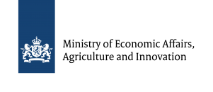 | Hosted by the Dutch Ministry of Economic Affairs,  Agriculture and Innovation.  Organized by Aarhus University, Denmark

